A Good, Good Father June 19, 2016
Genesis 12

Introduce Alpha team - table leaders, kitchen crew and set up.
Share results - 9 weeks, 1 weekend, 22 guests
Decisions - many took significant steps towards God and some welcomed him into their lives. Comments from team members or participants

Show video of #How to Dad
Question: What was the best statement made in this video?
Share your thoughts with another person as you go to get a cup of coffee/tea.

Feedback

We return to our study of the book of Genesis.
At the end of our teaching this morning, there will be opportunity if you have questions related to the theme and passage we’ll study.

The book of Genesis covers more than 2000+ years and more than 20 generations.
Yet almost a third of the book tells the story of Abraham - Genesis 12-25.
Did you know it’s the same in Hebrews 11? That chapter tells the faith story of 15+ people, but 30% of the chapter is devoted to Abraham’s story.

Abraham’s name occurs 234 times in the OT and 74 times in the NT.
Apart from Moses, no other OT character is identified by name as many times.

Abraham was the father of the Jewish nation.
But he was also the father of the Arab nations.
Judaism, Christianity and Islam all hold Abraham in high regard.

Let’s read the text for today – Genesis 11:27-12:5

v.27 - the naming of three sons might not seem significant until you realize Moses is repeating a pattern. There’ve been two other individuals who had three named sons –
Adam and Noah. Moses wanted the reader to take note that something significant is about to happen in the story of God’s rescue of humankind.

v.27 - Lot is mentioned because he was a major character in the story of Abraham.

v.28 – in addition to telling us the name of the city and the people group Abraham belonged to (Ur); we are also told why Lot went with Abraham. Lot’s father had died,
and Abraham assumed responsibility for him.

v.29 – the marriage of Abraham’s brother Nahor is mentioned because he was the grandfather of Laban and Rebekah, both of whom were major characters in the story
of Abraham’s grandson Jacob.

v.30 –as Abraham’s story unfolds, Sarai’s infertility was the disappointing reality that
would severely test hers and Abraham faith.

But in Abraham’s family line there were two other women, Rachel and Rebekah,
who were unable to have children until…God intervened in their lives.

As God enabled these these women to become pregnant, we are reminded,
as they were, that one of the ways God exhibits his power and sovereignty over human history and genealogy is by “opening a womb,” causing a woman who had been infertile
to be able to conceive.

v.31 - it sounds like the move from Ur to Harran was Terah’s idea.
But that particular family’s move was actually initiated by God when he appeared to and spoke with Abraham. Hebrews 11:8: By faith Abraham, when called to go to a place he would later receive as his inheritance, obeyed and went, even though he did not know where he was going.

Abraham lived in the city of Ur, which was located in what is now present day Iraq.
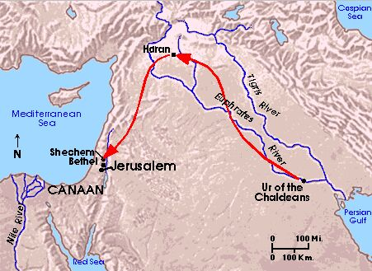
Based on recent archaeological discoveries we know that Ur was a large city with a population of approximately 250,000.
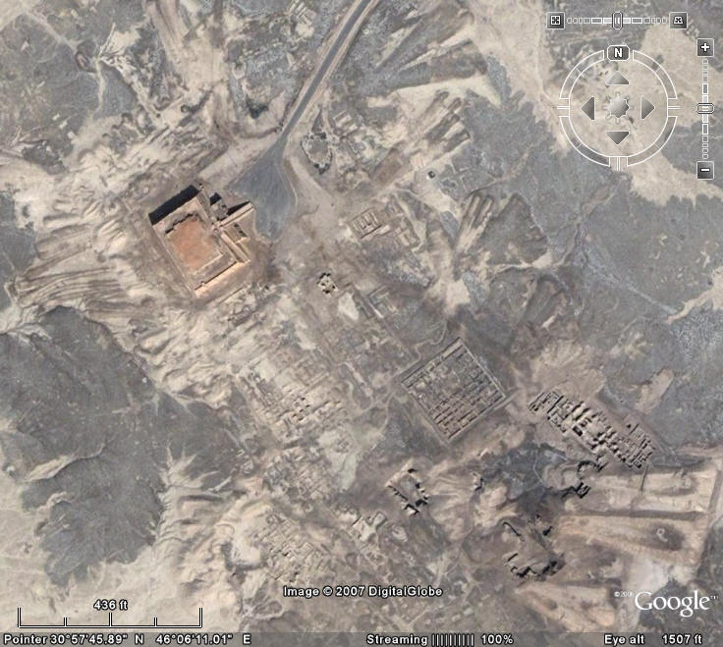
The people of Ur worshiped the moon goddess, Nanna.
To this day, in the ruins of Ur, there remain a pyramid type temple called a ziggurat,
which had been dedicated to her worship.
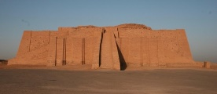
The city of Ur was thickly populated with private residences. Some of these homes were several stories high; had as many as 14 rooms and were equipped with running water.
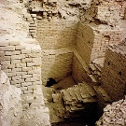
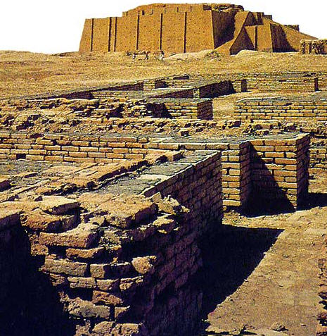
Ur was a wealthy city.
Trade was carried on by its merchants with India and Africa through the Persian Gulf.
Its people were highly creative. They valued the arts and education.
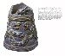
From Ur of the Chaldees came the Code of Hammurabi, which is a legal code
that continues to influence Western legal thought.
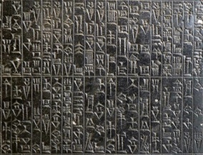
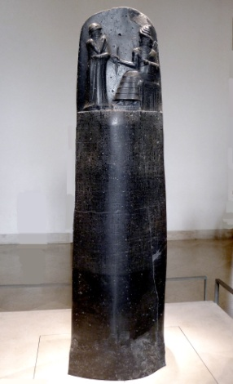
You and I need to think of Ur, not as ruins in a desert area.
Ur, in her day, would have been the equivalent of New York, London, or Paris.

In that place and at that time, God chose to reveal himself to Abraham because
before the creation of the world, the Father, Son and Spirit had decided they would
rescue humanity, and their plan was that the Rescuer would come through the family
line of Abraham.

But why Abraham?
When it comes to the answer of that question we really need to get the right answer.
There is no indication in the Bible that God appeared to Abraham because of Abraham’s goodness or because Abraham himself was looking for God.

In fact, it was quite the opposite - we learn from the book of Joshua that Abraham
and his family didn’t know or worship God.

Joshua 24:2: Joshua said to the people, “This is what the Lord, the God of Israel, says: Long ago your ancestors, including Terah, the father of Abraham and Nahor, lived beyond the Euphrates River... and they worshiped other gods.

It’s because of God’s goodness that he makes himself known and invites people into relationship with him.
Acts 7:2: “The God of glory appeared to our father Abraham while he was still in Mesopotamia, before he lived in Harran. ‘Leave your country and your people,’ God said, ‘and go to the land I will show you.’”

God appeared to and spoke with Abraham.
Abraham listened.
God told Abraham to go.
Abraham responded and went.

People respond to God’s presence and voice in many different ways.
Some choose to ignore him.
Some acknowledge him.
Some choose to argue with him.
Some act on what he has said.

We learn from Abraham that putting one’s faith in God and entering into a relationship with him begins with a yes.
Yes… to God’s existence.
Yes… to God’s explanation of what reality really is.
Yes…to who he says you are.
Yes… to the fact that you need him.
Yes…to living in a relationship with him.
Yes… placing your life and destiny in his hands.

What is meant when Hebrews 11:8 says that Abraham didn’t know where he was going?
Hebrews 11:8: By faith Abraham, when called to go to a place he would later receive as his inheritance, obeyed and went, even though he did not know where he was going.

Abraham didn’t know where he was going in the sense that he didn’t have firsthand knowledge of what the land of Canaan was like. He hadn’t been there before.

One could say that all Abraham had from God…
was the name of the place he was to go to – Canaan;
a direction in which he was to head – west;
and some pretty incredible promises – I will make you into a great nation and will bless
you and all nations through you.

But that was more than enough.

Let’s re-read these promises – 12:2-3.
There is something very, very important that we must not miss.
When Adam and Eve sinned, God had pronounced curses upon them.
But in his work of rescue, as it unfolded, we see in these two verses God beginning
to reverse those curses.

>Adam and Eve had been exiled.
Abraham and Sarai were promised a home in the land of Canaan.
>Adam and Eve had been cursed.
Abraham and Sarai were blessed.

>Through Adam and Eve had come pain and suffering and death.
Through Abraham and Sarai would come blessing to all the peoples of the earth.
[How? Through their family line came Jesus the Messiah.]

Look at v.4a – So Abraham went…
From where? Not from Ur, but from Harran.
When he and his family had arrived in Harran, their trip was interrupted.
Genesis 11:31 – But when they came to Harran, they settled there.

Whatever happened, and we are not told what that ‘whatever’ was; but when they
reached Harran “they settled there.”
In other words, they put down roots.

However, when Abraham’s father Terah died, Acts 7:4b informs us,
“God sent him [Abraham] to Canaan.”

We are not told how God did this, only that, as Genesis 12:4 says,
‘Abraham left as the Lord had told him...’

What have we seen so far about God?

* We’ve seen that God makes himself known to people.
But why? Why to Abraham? Why to me? Why to you?
God makes himself know because he is a good, good father as we sang.
And good fathers make themselves known to their children.

* We’ve seen that with Abraham God made the first move.
But why?
Why did he make himself known to Abraham; why does he make himself
known to us when we don’t even know or care about him?
Because he is a good, good father and that’s what good fathers do; they love their kids unconditionally and always make the first move.

* We’ve seen that God invited Abraham into a relationship with him.
But why?
Wasn’t Abraham’s life ok without God? Aren’t our lives ok without him?
Why would a person want to complicate things by having to re-order their lives In order
to make room for God?

Because for Abraham and for you and me, we all need God to be our good, good father. Our lives aren’t ok without him.
And just as Abraham discovered, if there is anything you and I need to make room for in
our lives…its’ our good, good father.

* We’ve seen that God was incredibly patient with Abraham, when he settled in Harran.
We will see God’s patience demonstrated many more times in Abraham’s life as Abraham
failed to trust God; tried to rush God; took matters into his own hands.
And every time God patiently interacted with Abraham. Why?
Because he is a good, good father.

Like Abraham we too can be slow to learn; slow to trust God; slow to obey God;
and like Abraham we too can be easily sidetracked.
We too can miss opportunities.
We too go can down rabbit trails.
And yet, our good, good father never gives up us.
He is as patient with us as he was with Abraham.

* We’ve seen and will see it many more times... that one life given over to God
can make an incredible difference.
Why does God give such significance to our efforts in his name and on his behalf?
Because he is a good, good father and he wants his children to be world changers.
* It wasn’t just to Abraham that God made staggering, stunning, incredible promises.
This book (the Bible) is full of promises God has made to us.
Don’t you wonder, what have we done that would cause God to commit himself to us
like he does?

I wish I could say its’ because of something we’ve done.
But Abraham was loved, as are we, because of who God is.
He is a good, good father.
And he is generous with his love and his grace.

If we follow God as Abraham did, will he insist on being in charge of our life? Yes.
Will he want us to live our life in the way he says is best? Yes.
But he won’t force us.
Instead, like a good father he teaches and encourages us to choose his way,
and as we do, we learn by experience that his will for us is always the best.

But what if we make mistakes? Will he throw us under the bus? No.
A good, good father never abandons his child; never ceases to love them;
never gives up on them; never disowns them.
We’re going to see this truth about God emphasized, again and again, in Abraham’s life.

If we follow him will we have to give up stuff? Yes.
But whatever our good father asks us to give up is because he wants to give to us something even better.
We let go of things… in order to receive from him his best.

If you and I follow him will our life change? Yes.
But everything that God leads us to do is because...he is a good, good father and he loves
us and his destiny for us really is beyond our wildest imagination.

Putting our faith in God is not trusting and following someone who is unknowable.
God appeared to Abraham.
God spoke to Abraham.
God gave promises to Abraham that revealed the character of God to Abraham.

And you and I, 3500 years later, we know so much more of who God is.
Not only do we have this book; but Jesus has already come and made God known to us;
and when we trust our lives to Jesus, his holy Spirit comes to live in us as the Teacher
and the Counselor.

The One who makes himself known to us and asks us to follow him is...
a good, good father.

Songs:
Good, Good Father
Refiner’s Fire

The Blessing
Galatians 3:7-9, 26, 29

