Abram’s Choices July 17, 2016
Genesis 14

Question from last week: Why was Pharaoh punished for Abram’s sin?
- ignorance of the law is not an excuse
- in his discipline of Pharaoh, God made himself known

Read Genesis 14:1-16
My intent this morning is to help you understand the events recorded in this chapter. But more than that I want to help all of you to grasp WHY this incident was included in Scripture, and what it says to us of who God is and how we live in response.

I remind you that when God directed Abram and Sarai to move from Ur to Canaan, while they didn’t know, God did - that Canaan was not uninhabited land.
So we must be attentive, as the story of Abram unfolds, as to why, God did that.
We also want to pay attention to what this teaches us about God’s relationship with this world, particularly the rise and fall of nations.

With the help of maps put together by Galyn Wiemers (Generation Word) let’s walk through the story again.

It’s a story of conflict between two alliances
This is also the first recorded war in the Bible.

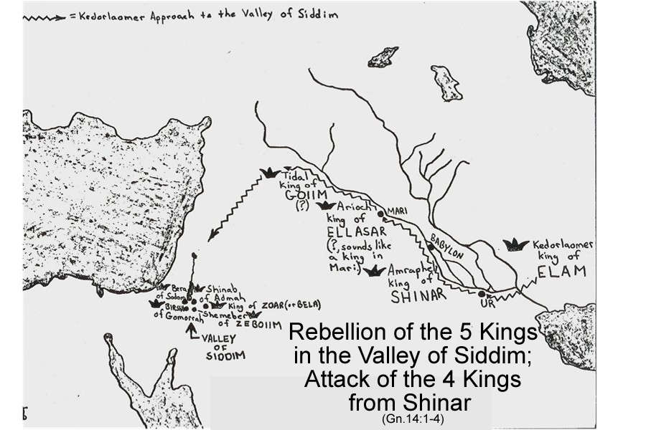

Mesopotamian alliance Valley alliance
Amraphel (Shinar) Bera (Sodom)
Arioch (Ellasar) Birsha (Gomorrah)
Kedorlaomer (Elamd) Shinab (Admah)
Tidal (Goyim) Shemeber (Zeboyim)
______ (Bela)

The Mesopotamian alliance, led by Kedorlaomer, had subjugated, for 12 years the Valley alliance. But in the 13th year they rebelled.

This is a story of how the Mesopotamian alliance re-asserted control over a lucrative trade route
In the 14th year, the kings of Mesopotamia mobilized and embarked on a military campaign, to both bring their rebel subjects back into line, and to solidify their control over the trade route known as “the king’s highway.”

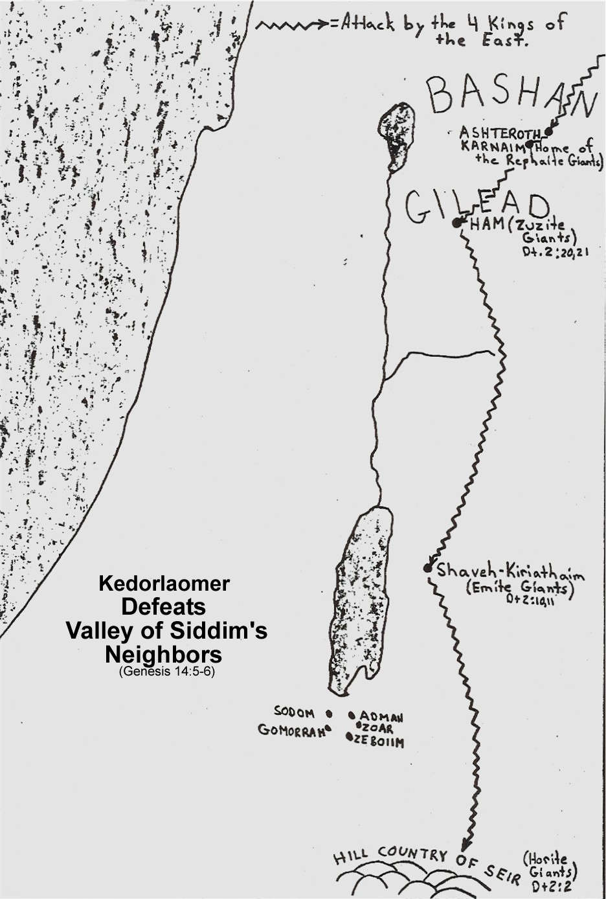

The kings of Mesopotamia first conquered four people groups on the east side of the Jordan River and the Dead Sea:
Ashteroth Karnaim - Rephaites
Ham - Zuzites
Shaveh Kiriathaim - Emites
Hill country of Seir, as far as El Paran - Horites

Why did they do this?
Because these towns and different people groups lived along the king’s highway.
By subjugating them they ensured they would pose no threat to the flow of commerce, nor attempt to impose their own taxes or duties on the merchant caravans; thus diverting income away from the Mesopotamian kings.
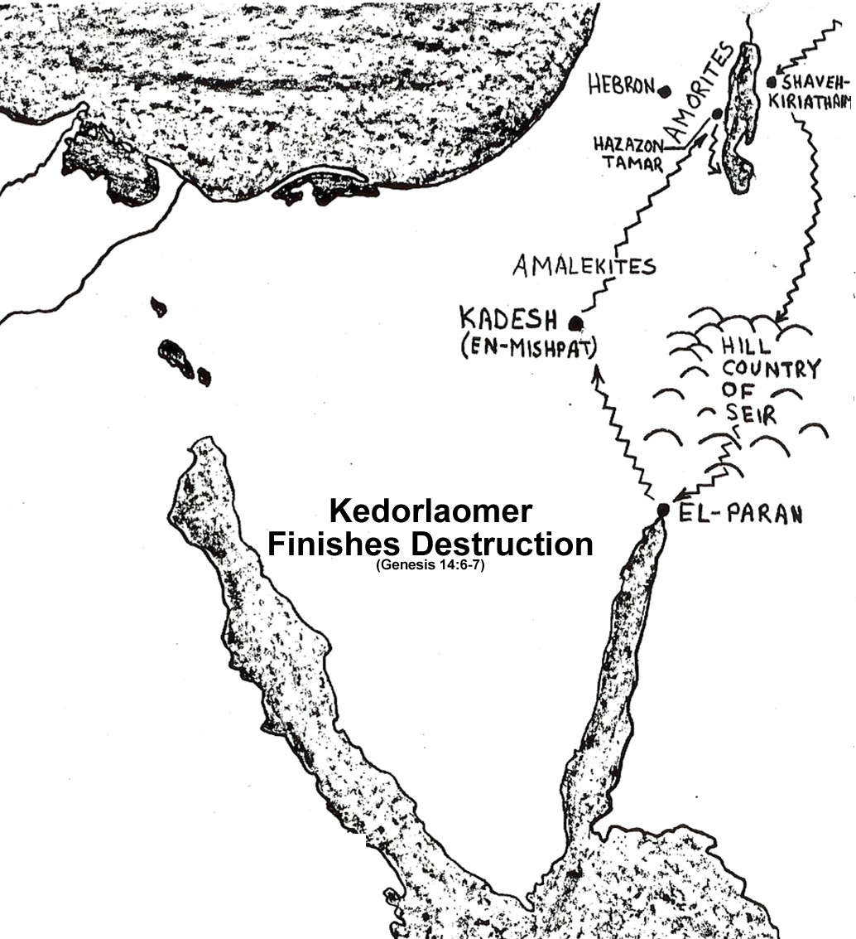

The second phase of the campaign was to conquer the territory of the Amalekites, as well as the territory of the Amorites living in Hazezon Tamar.

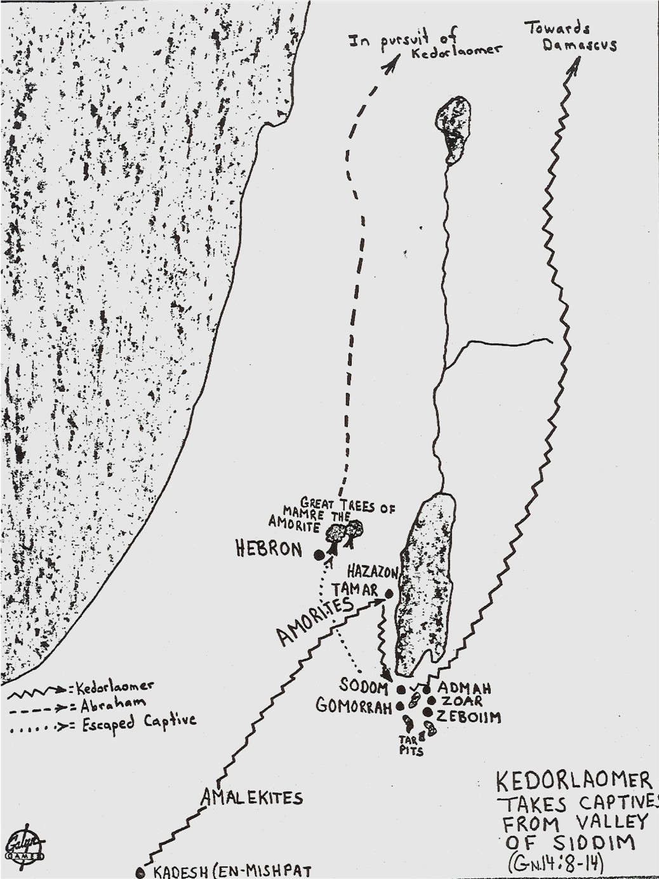

And the final phase was to deal with the five rebel kings.
In the battle that ensued the five kings were defeated, and the people, goods and food of Sodom and Gomorrah, were carried off, as spoils of war.

Here’s where this story connects to the greater story being told in the Bible; and where we discover why it is included in the book of Genesis.
Lot and his family, no longer lived near Sodom; they now lived IN Sodom.

One man, who had managed to escape, went to Abram and told him the news of what had happened. Abram mobilized the men of his household (318), along with Mamre, and his two brothers, Eshkol and Aner, and their men, who were in an alliance with Abram, and together, they went in pursuit of Kedorlaomer with the intent to rescue Lot.
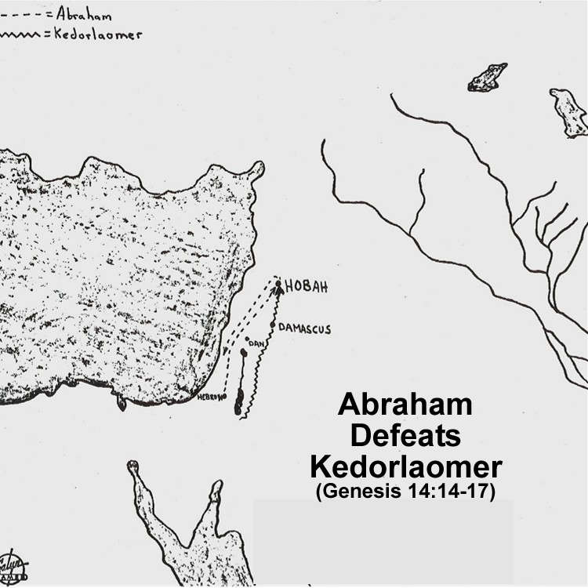

400 kms later, Abram caught up to the Mesopotamian kings, attacked them in the night, and successfully routed them, recovering everything and everyone that had been taken as plunder, including his nephew Lot.

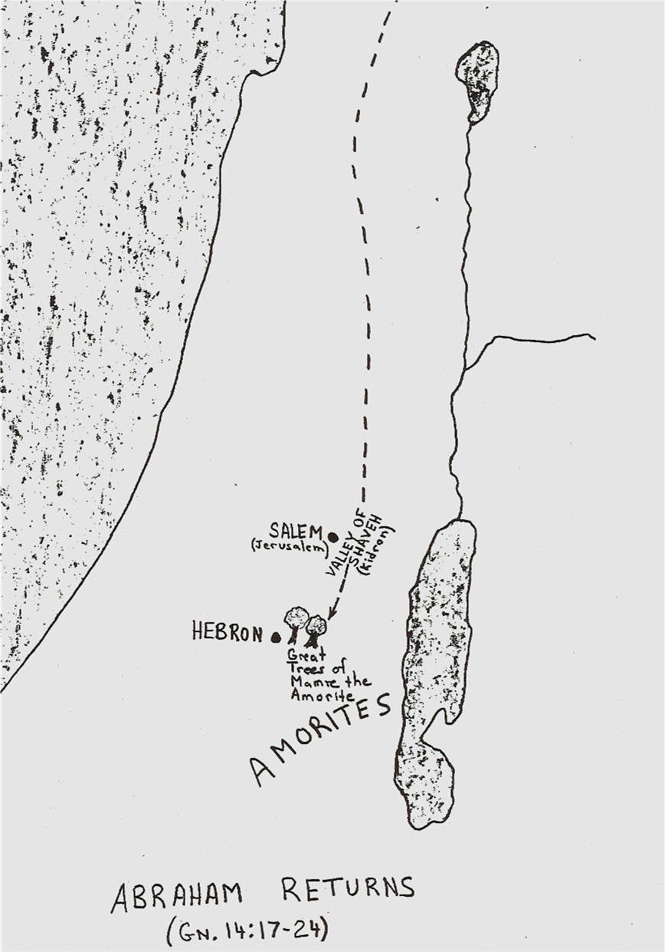
Upon their return, the king of Sodom and the king of Salem met the victors in the valley of Shaveh. Let’s read what happened - v.17-24.

It sounds like the king of Sodom met Abram first, but it was the king of Salem who spoke first with Abram. These two kings – Melchizedek and Bera – are just about as different as any two men could be.

Melchizedek is one of the most intriguing men in the Bible.
He comes out of nowhere, and then just as quickly, is gone again; only to be mentioned hundreds of years later in Psalm 110 and thousands of years later in the book of Hebrews.

But “who” Melchizedek was, pointed ahead to who God’s Messiah would be.

As our kids are learning in “the Gospel Project,” the story of the Old Testament is the story of Jesus. I can’t stress this enough. Unless we read the Old Testament, through the lenses of Jesus, these 39 books, in addition to being difficult to read, will be incredibly confusing to understand.

So what it is about Melchizedek that pointed ahead to Jesus?

Hebrews 7:1 informs us that Melchizedek’s name means “king of righteousness,” and king of Salem means “king of peace.” When put together – we learn Melchizedek was a king of righteousness and peace.

In addition to being king, he is also identified as being “a priest of God Most High.”
This is the first mention in the Bible of anyone being a priest. We don’t know to whom he was a priest or how he became a priest or even how he learned of God.

But in Melchizedek, these two roles – king and priest had come together.
And it’s here that he points us ahead to God’s Messiah, who would in a much fuller and enduring way, bring together these two roles.

We speak of Jesus as our friend; as the leader of our lives – and he is.
But these roles of king and priest are meant to deepen and enrich our understanding of who Jesus is and the ways in which he interacts for us and with us.

As our king, Jesus reigns - from heaven over earth.
He is in control - not just of the universe; or of this world; but also of our lives.
Daily we are to come back to this reality.
A function of the OT priests was to make sacrifice for the sins of the people.
As our priest, the sacrifice for sin which Jesus made on our behalf was himself.
And we learn from Hebrews 9:28 his sacrifice was a one-time sacrifice that was forever sufficient to cover our sin.

Another function of the OT priests was to intercede to God on people’s behalf.
In this present time, “Jesus always lives to intercede for his own.” Hebrews 7:25
You and I never slip under the radar with Jesus.
He is constantly aware of what is happening to us.

But more than that - Jesus speaks to the Father on our behalf.
You and I pray - asking God for help. The Holy Spirit helps us as we pray and additionally prays for us. And here we learn from the book of Hebrews, as our great high priest, Jesus does the same.

Let’s come back to the story.
v.18 - Melchizedek brought with him bread and wine.
I think we need to be careful to not read more into this than was intended.
In bringing with him bread and wine, Melchizedek brought food for the warriors and the people with them.

Grace meets practical needs.

Having given Abram the bread and wine, Melchizedek then spoke blessing over Abram.
In v.19, Melchizedek addressed God as El Elyon – God Most High.
It is a human tendency to want options.
The people of Canaan worshiped many different gods.

Melchizedek in his blessing reminded Abram that while the two of them lived in a pluralistic culture, the Lord is God Most High.
God has no rivals, nor equal.
Jesus reaffirmed this exclusivity when he said, “I am the way, the truth and the life.”

The clear word from God to you and I is that Jesus alone saves - “there is no other name under heaven by which we must be saved.” He is God Most High.

Melchizedek in his blessing also reminded Abram of something else about the person of God that speaks to our earlier question of why God brought Abram to Canaan and promised to give him a land that was already inhabited by others.

God Most High is the Creator of heaven and earth.
This word ‘creator’ can also be translated ‘possessor.’
The two are inseparable.
We understand this. Someone who creates something owns it.
The earth belongs to the LORD because he created it.
This explains why as Paul said in Athens, the Lord determines “the times and the exact places where every nation should live.”

Lastly, Melchizedek reminded Abram of God’s sovereignty, v.20 – “he delivered your enemies into your hand.”

Abram and the men with him had fought bravely.
They had used brilliant military strategy.
But as they went after Lot, and then fought the four kings of Mesopotamia, Melchizedek reminded Abram that alongside of him had been God, who in unseen ways, had influenced events so that, although he and his men were smaller in number and less skilled, they nonetheless won the battle and recovered both hostages and the wealth of Sodom and Gomorrah.

This is all that was recorded of what Melchizedek said to Abram.
But this is what God wanted Abram and us to know.
- He owns it all – everything in heaven and earth.
- Out of his goodness he had been present to bless Abram by giving him victory.

Melchizedek’s words not only brought God’s perspective to the events that had just happened; they were also instructive to Abram, and guided him in responding to the offer of the king of Sodom.

But before Abram spoke with Bera, in response to Melchizedek’s blessing, Abram gave to Melchizedek a tenth of everything. Everything referring to the goods that had been recaptured from the Mesopotamian kings.

In gratitude Abram gave.
In recognition of God’s sovereign presence with him and care of him, Abram gave.
This is at the heart of the motivation for God’s people practicing generosity.

Once Melchizedek finished and left, Bera stepped forward to speak with Abram.
I’m certain Bera flattered Abram for his great military victory, before offering him all the wealth of Sodom and Gomorrah.
Maybe Bera hoped his offer would enable him to convince Abram to enter into alliance with him. Can you blame him? After their stunning victory, who wouldn’t want such warriors to be on your side?

But Abram flat out rejected Bera.
He would not in any way allow himself to become entangled with him and the other valley kings and the cities they ruled over and the kind of lifestyle that went on in those cities.

Abram’s example challenges us to be likewise committed to God, and to keep the Lord Jesus as the priority of our lives.
Doing so, will then require us to be wise in the alliances we make with others - be it in business; in marriage; or community involvement.

We are to be in the world as Jesus prayed; but our involvement never is to compromise our primary allegiance to our God.

Abram could have become fabulously wealthy if he had said yes to Bera.
But Bera’s offer carried with it too high a price tag.
Abram through his interaction with Melchizedek discerned the true cost of Bera’s offer and he chose God.

Since his time, all who’ve walked with God, including many of you in this room, have made similar choices - give me Jesus; he’s the true treasure!

We choose him, because he first chose us.
We love him, because he first loved us.
We commit ourselves to him, because he first committed himself to us.

Our closing songs speak of God’s incredible person - he is the faithful One and he is the God of angel armies. This is who we are in relationship with. Use these songs to affirm your commitment to him.

And if you are not yet in relationship with Jesus, I invite you to come to him this morning. As you do, you will experience his faithful presence with you in every aspect of your life and in every circumstance you face.

The Blessing
You are blessed by God Most High, Creator of heaven and earth, who will never leave you nor forsake you.

