Easter Sunday 2017 April 16, 2017
Matthew 28:5-7

Coffee/Question:
Share with someone something your family did or does at Easter.

Let’s revisit the story of the morning Jesus rose from the dead.
When the women arrived at the tomb where Jesus’ dead body had been placed, things were not as they had been three days earlier.

For one thing, the stone that had covered the opening into the tomb, had been rolled away.
And for another, sitting on top of that large rock was a supernatural being, which the Bible describes as an “angel of the Lord,” who had come “from heaven.”

The angel was both fearsome and awe-inspiring: “his appearance was like lightning,” and “his clothes were white as snow.”

The army sent to enforce the Roman occupation of Israel was comprised of war hardened military men.
It was these soldiers who had been assigned by Pilate to guard the tomb of Jesus.
They were men who would not have been easily rattled.

So, how did they respond to the appearance of this angel?
Matthew 28:4 – “The guards were so afraid of him that they shook and became like dead men.”
Those Roman soldiers were so gripped by terror and paralyzed with fear, that they couldn’t move. All they could do was watch and listen.

The women, upon arriving at the tomb, saw the same “supernatural being.”
But the angel spoke to them, saying, “Do not be afraid...”
He assured them, “...for I know that you are looking for Jesus…

Things had happened so fast on Friday, that all Joseph of Arimathea had been able to do, was take down the dead body of Jesus, and wrap it in a clean linen cloth, before placing it in his own new tomb which he had cut out of rock.

That Sunday morning, the women had come to the tomb with one goal in mind.
They had brought with them spices, in order that, they might properly prepare Jesus’ dead body for burial.
“…who was crucified.”
Jesus had been crucified by the Romans.
Like it was with anything they did, the Romans were thorough.
A crucified person never came down off of a cross, until...the soldiers were absolutely, 100% certain, that the person was dead.

If there had been a coroner’s report for Jesus, it would have read –
Cause of death: crucifixion.

The angel was sitting on the rock, because he was waiting for the women.
He had been sent by God.
Yes, he had come to roll away the stone, but not to let Jesus out.
He’d rolled away the stone in order to show Jesus wasn’t there.

The angel had a message those women needed to hear.
It was a message that they would then need to pass on.

“He is not here...”
“Not here” in the sense that the dead body of Jesus had been moved.

Yes, Jesus’ body had been placed in a borrowed tomb.
But Joseph of Arimathea had not spent the last few days locating a permanent burial spot for Jesus’ body, and when he found one, then moved it.

Nor had the Jewish religious leaders, conspired with the Roman authorities
to snatch away the body of Jesus and take it to an undisclosed location, because they didn’t want that tomb to become a martyr’s shrine.

What did the angel mean when he said – he is not here?

“he has risen...”
The angel was not speaking poetically; somehow suggesting that in spite of his death, Jesus’ teaching and mission would live on, in even greater ways.

Nor was he speaking in some kind of mystical sense, saying that Jesus’ spirit had risen to heaven.

Something unique; something extraordinary had happened to Jesus.
His body was not in the tomb, because…he was no longer dead.
John Stott says, “We live and die; but Jesus Christ lived and died and lived again!”
http://unlockingthebible.org/resurrection-easter-quotes-bible-verses/
“just as he said...”
What had Jesus repeatedly told his followers?

Mark 8:31-32a: “He then began to teach them that the Son of Man must suffer many things and be rejected by the elders, the chief priests and the teachers of the law, and that he must be killed and after three days rise again. He spoke plainly about this...”

Mark 9:30b-32: Jesus did not want anyone to know where they were, because he was teaching his disciples. He said to them, “The Son of Man is going to be delivered into the hands of men. They will kill him, and after three days he will rise.” But they did not understand what he meant and were afraid to ask him about it.

Mark 10:32b-34: Again, he took the Twelve aside and told them what was going to happen to him. “We are going up to Jerusalem,” he said, “and the Son of Man will be delivered over to the chief priests and the teachers of the law. They will condemn him to death and will hand him over to the Gentiles, who will mock him and spit on him, flog him and kill him. Three days later he will rise.”

The resurrection was an often-repeated emphasis of Jesus.
But do you know what is puzzling?
Not one of Jesus’ followers suggested on that Sunday – “Hey! Remember Jesus said that after he died, three days later he would rise again. We should go hang out at the tomb today, and be there, to see, if what he said would happen, happens.”

No one was expecting Jesus to rise.
Why was that?
Because they knew, like us, while sick people recover from an illness, dead people… never... recover from death.

“Come and see the place where he lay.”

There was no cover-up.
After the angel finished saying, “He is not here; he has risen; just as he said,” he didn’t jump down off of the rock and roll the stone back in place.
He invited them to go into the tomb and see for themselves.

Unknown: “The Gospels do not explain the Resurrection; the Resurrection explains the Gospels. Belief in the Resurrection is not an appendage to the Christian faith; it is the Christian faith.”
http://unlockingthebible.org/resurrection-easter-quotes-bible-verses/

You can go to the burial site of the founders of many of the world’s major religions.

The Buddha's body was cremated and then relics from it were placed in monuments or stupas. At the Temple of the Tooth in Sri Lanka you can see the right tooth of Buddha.
Muhammad is buried in the Al-Masjid an-Nabawi ("Mosque of the Prophet") in the city of Medina in Saudi Arabia.
Located in Bahji near Acre, Israel, are the remains of Bahá'u'lláh, founder of the Bahá'í Faith.
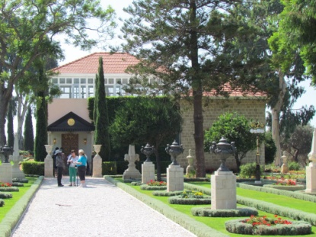
The grave of Confucius, founder of Confucianism, is in his home town of Qufu, Shandong Province, China.
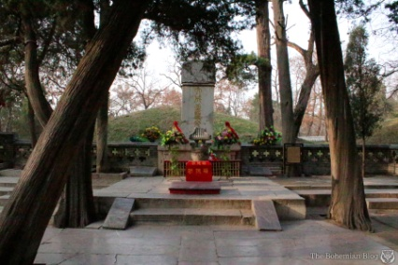

Sam Morris wrote: “The tomb of Jesus Christ is famous because of what it DOES NOT CONTAIN.” H ttp://unlockingthebible.org/resurrection-easter-quotes-bible-verses/

It is empty.
There are no physical remains of Jesus.
Not because they’ve been lost.
But because he is risen from the dead.

“Then go quickly and tell his disciples: ‘He has risen from the dead…

The women, Mary Magdalene, Mary the mother of James, Joanna, Salome, and other unnamed women, were given a task.

They weren’t to go to market on the way home; or to wait until later that day or the next day or a few days from then. They were to “go quickly and tell...” the disciples of Jesus what they’d heard and seen – Jesus was alive!

…and is going ahead of you into Galilee. There you will see him.’
The promise of the angel was that Jesus’ disciples would soon see him.
He was going ahead of them.
Not into heaven.
But into Galilee!

His disciples wouldn’t see his dead body.
They’d see him.
And not just at the end of time.
But here on earth - in Galilee.

These women were entrusted with world changing news.
How significant was that?
Here’s what you need to know about the culture of that day.

Celsus, a Greek philosopher, lived in the 2nd century AD.
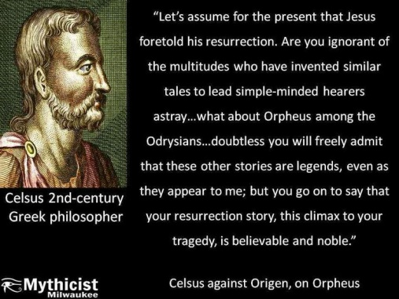
He was highly antagonistic to Christianity, and wrote a number of books against it. Celsus believed that one of his most powerful arguments was this: ‘Christianity can’t be true, because the written accounts of the resurrection are based on the testimony of women – and all know that women are hysterical.’

“In ancient societies women were marginalized. Their testimony was never given much credence, if at all. If the gospel writers of that day were making up these stories about the resurrection…they would never have cited women as the first eyewitnesses to Jesus’ empty tomb.” King’s Cross, Tim Keller, p.217.

Now I have told you.”
The gospel of Jesus is news.
It is not a philosophy.
It is not a scientific hypothesis.
It is news of an historical event which happened once - but then, that is what historical events are like.

Tim Keller says, “The resurrection of Jesus is the hinge upon which the story of the world pivots.” King’s Cross, Tim Keller, p.221

The resurrection of Jesus radically changed the lives of those early Christians.
They changed from cowards who ran when Jesus was arrested, to those who were fearless in speaking about him.
Even when threatened with suffering, imprisonment and death, they refused to recant their allegiance to Jesus.
What made the difference?
Read Luke 24:36-48.

There is something about interacting with a dead man who is now alive forever, that will change one’s life.

What do you and I do with the news that Jesus rose from the dead?
Two things I want to put before you.

First Thing
The following events changed the world.
I’ve not placed then in order.
- Gutenberg’s Printing Press - World War I and 2 - the Reformation
- the tearing down of the Berlin Wall - the Pax Romana - the Renaissance
- the American Revolution - the birth of Mohammed - 9/11

But the resurrection of Jesus surpasses all of these events and so many others.
The world changed the day Jesus walked out of the Tomb.
Events were set in motion that cannot be undone.
The ripples from his rising from the dead, have not diminished with the passing of years, but have grown in scope and intensity.

Because Jesus walked out of the tomb…
> Anyone who believes in him and receives him, “crosses over from death to life,” John 5:24, and are “forgiven of all of their sins,” Colossians 2:13. The number of those whose follow Jesus is growing exponentially.

> The reign of evil was struck a death blow.
“The reason the Son of God appeared was to destroy the devil’s work.” 1 John 3:8

“[Jesus] disarmed the powers and authorities, and made a public spectacle of them, triumphing over them by the cross.” Colossians 2:15
Jesus triumped over them.

> the countdown began on this present age. All of creation, seen and unseen, is waiting for that moment when God the Father says, “Now!” and the risen Jesus visibly returns to earth as King.

> Jesus’ followers have a rock-solid hope - all that is good about this life, will be redeemed, and all that is wrong, will be made right.

> his followers are assured that Jesus will ultimately transform their bodies - from mortal to immortal; from perishable to imperishable.

> his followers are assured that to be absent from the body is to be present with the Lord. We do not fear death, because Jesus has overcome it; he has taken the sting out of death as we earlier sang.

Second Thing: Change your mind.
You may have more questions about Jesus. Ask them.
Don’t commit yourself to Jesus on my word or somebody’s else’s word.
Investigate for yourself. Scrutinize the facts. Check out the sources.
But know this – the news of Jesus’ resurrection will ask you to change your mind about Jesus (that’s what the word repent means) and follow him.

C. S. Lewis was an Oxford educator and a writer who became an atheist as a young man. But influenced by his own reading of the Bible and by arguments made by Christian thinkers, in his own words, Lewis said, he changed his mind and "...came into Christianity kicking and screaming."

Lee Strobel was a journalist and an atheist. He set out to disprove Christianity and confirm why he was an atheist. But quite unexpectedly, he found that as he read the Bible, the evidence he encountered led him instead to the Christian faith. He changed his mind about Jesus.

Josh McDowell set out to disprove the Christian faith as a college student only to arrive, after studying the Bible for many months, at the conclusion that Jesus Christ was who he claimed to be. He changed his mind.

Francis S. Collins M.D. Ph.D. is a physician-geneticist, famous for his landmark discoveries of disease genes, and his leadership of the Human Genome Project. An atheist at the completion of graduate school, Collins later changed his mind about Jesus and became a believer as a result of his own study of the Bible, along with philosophical and scientific considerations.

Dr. Ralph O. Muncaster was an atheist with a skeptical nature and sharp critical thinking skills. While doing research to dispute the Bible, Dr. Muncaster, was surprised to find strong evidence that supports the Bible's claims and he changed his mind and became a believer.

Dr. Hugh Ross was the youngest person ever to serve as director of observations for Vancouver's Royal Astronomical Society. After testing the scientific and historical data, Dr. Ross became convinced that the Bible is truly the Word of God. He changed his mind. http://www.awakeandamazed.com/id66.html

For many of us in this room, we remember first hearing the news, and then as we investigated, how, we too, became convinced that Jesus is who he claimed to be.
That’s when we changed our mind and believed in him and received him into our lives.

If I can be of help to you in your quest, please speak with me. Or if you’re ready to change your mind about Jesus and to commit yourself to him today, please speak with me. I’d love to help in introducing you to him, or to be of assistance as you begin the greatest adventure of your life!

The Blessing
Revelation 22:20

Jesus: “Yes, I am coming soon.”

Life Group Discussion Question, Matthew 28:1-10

Read Matthew 28:1-10.
(1) Why did Mary Magdalene & the other Mary “(go) to see the tomb” early in the morning? What were they expecting to see?

(2) Why do you think only the women came early to the tomb? What emotions do you think they were feeling as they walked? How would you have felt if you were with them?

(3) The Scriptures are clear that the women were at the tomb early, and the men were not. Should the men have been there? Why or why not? Would you have been at the tomb early? Why or why not?

(4) Make 3 columns with the headings:
“Who?” “What?” “How?”

Name all of the characters found in verses 1-10.
Write them down under the “Who?” column.

Now discuss “What” each person(s) did, and “How” you think they felt (i.e. what emotions were they feeling or displaying). Some characters may have multiple actions & emotions.

(5) What is the significance of the earthquake? Try for a moment to envision how the angel looked (“like lightening,” “clothing white as snow”). Why do you think these details were significant to Matthew? How would you have felt if you saw this “being” amd what would have been your response?

(6) Why do you think the angel told the women not to be afraid (who are not described in the text as being afraid) but did not speak to the guards (who are described as being extremely afraid)? What reason does the angel give the women for not being afraid (“Do not be afraid for . . .)?

(7) What evidence does the angel give to the women to prove his claim that Jesus has risen? Why is this evidence important?
(8) The angel said that Jesus had risen “just as He said.” According to Matthew’s gospel, what had Jesus said to the disciples concerning His death (see 16:21; 17:22-23; 20:17-19; and cf. 12:40)? Do you think the disciples should have expected the crucifixion and empty tomb? Would you have expected these events or would you be sharing the same confused emotions as the women at the tomb?

(9) What major event is assumed but not described in these verses? Why do you think there was not an eyewitness to the actual, physical, bodily resurrection of Jesus Christ? Since there was not an actual eyewitness to the resurrection, what evidence do you find in this passage that proves it to be true?

Other observations? questions?

(10) What about the testimony of Francis Collins most resonated with you and why?
See website for article - sookebaptistchurch.com - select sermons, Uniquely Jesus, Easter Sunday.

http://www.cabotbible.com/PDFs/JobPDFs/Matt28v1-10Easter.pdf

Noted geneticist turned from atheism to faith after trying to disprove God
March 31, 2015

By Michael Ashcraft and Mark Ellis
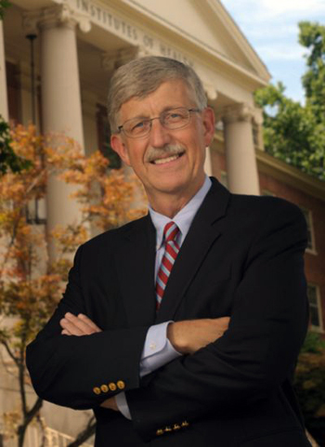
Francis S. Collins
The current head of the National Institutes of Health, Francis S. Collins, came to faith after he set out to disprove God.
“I had always assumed that faith was based on purely emotional and irrational arguments and was astounded to discover that one could build a very strong case for the plausibility of God,” he noted on CNN. “My earlier atheist’s assertion that ‘I know there is no God’ emerged as the least defensible.”

A geneticist, Collins was appointed director of the $3 billion international Genome Project in 1993, which completed sequencing the 3.3 billion pairs of nucleotides by 2004. The resulting gene map offers hope to cure genetic disorders.

It also gave Collins a spectacular view into the magnificence, order, and finely-tune perfection of the DNA molecule, God’s software for every living thing. Directorship of the Genome Project was touted as the most prestigious job in science at the time.

At the most fundamental level, it’s a miracle that there’s a universe at all,” he told National Geographic. “It’s a miracle that allows the possibility of complexity and laws that follow precise mathematical formulas. Contemplating this, an open-minded observer is almost forced to conclude that there must be a ‘must’ behind all this. To me, that qualifies as a miracle, a profound truth that lies outside of scientific explanation.”
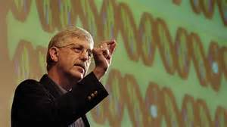
He compiled his thoughts in a 2006 book, The Language of God, which posits that biology, astrophysics and psychology all argue in favor of faith in God. During the following year, he founded BioLogos, an organization that brings together scientists who wish to pursue science and faith in a cohesive unity.

“Science and faith can actually be mutually enriching and complementary once their proper domains are understood and respected,” he says. “There are some really important questions that science cannot really answer, such as, why is there something instead of nothing? Why are we here? “In those domains, I have found that faith provides a better path to answers.”

Of particular importance to his faith is the concept of “moral law” – the denunciation of oppression, murder, treachery, falsehood and the injunction of kindness to the aged, the young, the weak and helpless, to paraphrase C.S. Lewis. “After 28 years as a believer, the Moral Law stands out for me as the strongest signpost of God,” he writes in his book.
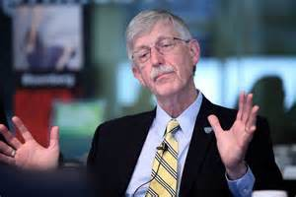
Collins grew up in a family of agnostics in Virginia’s Shenandoah Valley. By the time he graduated medical school, he described himself as a full-fledged atheist. But then a patient queried him about his own faith. Prodded thus, he decided to research the point and debunk faith.
“When I got to college and was challenged about what my beliefs were, I realized I had no idea what they were,” he told PBS. “I listened to others make an argument that religion and beliefs were basically a superstition, and I began to think — Yeah, that’s probably what I believe, too.”

As a graduate student at Yale, he marveled at how virtually everything in the universe could be described by a “second-order differential equation,” he said.

After obtaining a degree in quantum mechanics, he decided to change paths in life and pursued medicine. As a resident he watched people suffering terminal disease without blaming God. To the contrary, faith seemed to give them strength and, in many cases, improve their symptoms, he said.

“They had terrible diseases from which they were probably not going to escape, and yet instead of railing at God, they seemed to lean on their faith as a source of great comfort and reassurance,” he said. “They weren’t, somehow, perceiving it as the really awful thing that it seemed to me to be. And that was interesting and puzzling and unsettling.
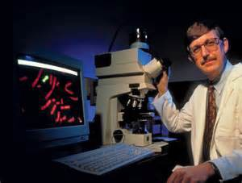
“I had made a decision to reject any faith view of the world without ever really knowing what it was that I had rejected. And that worried me,” he said. “As a scientist, you’re not supposed to make decisions without the data. It was pretty clear I hadn’t done any data collecting here about what these faiths stood for.”

So he turned to C.S. Lewis’ Mere Christianity. As he read, his assumptions about faith in God were shaken. It wasn’t easy or fun reading. It was painful, he said.

“The idea that you would arrive at faith because it made sense, because it was rational, because it was the most appropriate choice when presented with the data, that was a new concept,” he said.
He was 27. After months of wrestling over the question of God, he finally broke down. One day, hiking in the Cascade Mountains, admiring the grandeur of God’s creation, he said “yes” to God.
“I’ve never turned back,” Collins said. “That was the most significant moment in my life.”

At first, sharing his faith wasn’t easy. “Like most scientists, I had this fear that having accepted something in the way of a spiritual worldview, I would be perceived as having gone just a little bit soft,” he noted. “That this was not compatible with the rigorous ‘show me the data’ attitude that a scientist is supposed to have towards all things.”

But now he’s so open about belief that he’s drawn fire from vocal atheists. Atheist Sam Harris criticized his nomination to head the NIH by President Barak Obama: “Must we really entrust the future of biomedical research in the United States to a man who sincerely believes that a scientific understanding of human nature is impossible?”
Collins assumed the NIH office in 2009. He is 65 as of April. He loves motorcycle riding and playing rock. He’s formed a band of NIH scientists that duels with a band of scientists from John Hopkins University.

In 2005, Collins was named jointly with genome colleague Craig Venter America’s Best Leaders by U.S. News & World Report and the Harvard University Center for Public Leadership.

“I did have a moment where I became a believer,” he told Anderson Cooper. “I had struggled for two years with this debate within myself gradually coming to the conclusion that belief in God was the most plausible of the choices. After many months of struggling whether to make that leap, on a beautiful Fall day hiking in the Northwest, with my mind a little more clear than usual because there were not the usual distractions, I felt like I could no longer resist. I became a believer that day.”

http://blog.godreports.com/2015/03/nih-director-turned-from-atheism-to-god-as-he-contemplated-science/

After a criminal does his time in jail and completes their sentence, the law has no more claim on them. They are able to walk out of jail, free.
Jesus died in the place of humanity.
He paid the penalty of our collective sin.
You could say, he did our jail time.

But how do we know his sacrifice on our behalf was accepted; was effective?
How do we know he broke the power of, and overcame the curse of death?

Because he walked out of the grave.

Jesus said to the apostle John, “I am the Living One; I was dead, and now look,
I am alive forever and ever! And I hold the keys of death and Hades.”
Revelation 1:18

Do you know anyone else in all of history who was dead, and is now alive,
forever and ever?
Is there anyone else who can claim what Jesus claimed - to hold the keys of death and Hades?
To hold those keys meant that Jesus had overcome death; he had defeated hell.
Their combined power had been broken by him.

This is why Jesus can set free any and all who come to him.
That’s why he said, “If I set you free, you will be free indeed.” John 8:36.

Leon Morris says: “The resurrection is the public display... of the triumph of [Jesus] the crucified one.” http://unlockingthebible.org/resurrection-easter-quotes-bible-verses/

The resurrection of Jesus calls us to take action; to respond to what God has done for us.

A person can choose to do nothing, if they so wish.
They can continue to keep God out of their life.
But I have to tell you, there is no future there.
Life without God leads to a dead end; to a place of desolation.
The Bible says, “Work hard for, (live for) sin your whole life and your pension is death. But God’s gift is real life, eternal life, given to us by Jesus, our Master.” Romans 6:23 The Message

What Jesus did on the cross, and when he walked out of the tomb proved, that through him, God had made the way... for all to come home to him.

