Uniquely Jesus August 13, 17
Mark 16, Part Three

When the apostle Paul wrote the church at Corinth, he reminded those believers of the priority of the gospel of Jesus. He said (1 Corinthians 15), “For what I received
I passed on to you as of first importance: that Christ died for our sins according to the Scriptures...

We’ve looked in detail at the things Mark wrote regarding those eyewitnesses who saw Jesus die on a Roman cross. Jesus gave his life in order to ransom humanity.
And he did so… as the Scriptures had foretold.

Paul also wrote to the church at Corinth, “...that he was buried...”

Mark wrote of Joseph of Arimathea - and told us how he took down the dead body of Jesus off of the cross; wrapped it in linen cloth, placed it in a tomb that had never before been used, and then rolled a large stone in front of the tomb’s opening.

Jesus’ dead body was not left on the cross; nor was it taken down and thrown into the garbage dump. Jesus the Christ was buried.

Paul also said, “...that he was raised on the third day according to the Scriptures...”

Today we are going to continue to unpack Mark 16:1-8.

Let me recap the two key points from last week, and then we’ll look at two more.
v.5. * Who was the young man in the tomb?
He was angel.
God had sent him to the women, and entrusted him with a message of good news.

His presence, on resurrection morning, reminds us of the remarkable privilege, angels and Jesus’ followers are given - to partner with the Father, Son and Spirit in their rescue of the human race and the remaking of the created world.

As I said last week, the town of Sooke has a great volunteer culture.
So many people give time and energy to numerous service clubs and agencies that operate in our community.
But I must remind you, that we who follow Jesus are more than volunteers.
We are co-workers with Jesus.

Jesus’ own example explains what that means.
In John 5:16-21 Jesus said that the Father is always at work here on the earth.
Because Jesus was loved by the Father, the Father showed him where he was active.
The Father did this - in order that Jesus might join him and work alongside of him.

ie. Zacchaeus.
While the Father could have done everything himself, he didn’t.
He involved Jesus.

Now what the Father did with Jesus, is what the Triune God does with you and I.
Whenever we become aware of a need or an opportunity...that’s God, opening our minds and hearts to see what he is doing.
And when he does so, it is important for us to realize, that’s his invitation... to us...
to work with him in bringing grace and life to others.

So, I need to ask:
What is God showing you?
Who are you noticing?
Who keeps showing up in your path?
What opportunity does Jesus keep putting before you?
What is it that grabs your imagination; your heart?

When Jesus does this, the question you and I have to answer is - will we join him?
He’s inviting you to partner with him.
Will you step out; step into; engage with Jesus... in what he is doing with a person or a group of people?

There’s another point of connection.
It is a part of our fallen human nature to claim things as “ours.”
But when we follow Jesus, and serve with him, whatever he lets us be a part of,
is not “ours;” but “his.”

The angel in the tomb was not free-lancing.
He was doing what the Father had sent him to do.
What that angel did is what Jesus had done his entire life.

He saw what he did as being the Father’s work.
In his prayer to the Father on his last night on earth, Jesus said, John 17:4, “I have brought you glory on earth by finishing the work you gave me to do.”

This is something, no matter how long we’ve followed Jesus, that we continue to learn.
After 46 years, I’m still prone in subtle ways to act as if it’s God who gets the privilege to join me, instead of the other way around.

I’m still capable, because of residual pride, to act as if something I do for Jesus is “my ministry,” instead of approaching everything I do, as a trust, a task, a responsibility... he has given to me.

I’m still learning that Jesus doesn’t work for me; but that I work for him.

I think we all want people to see Jesus for the incredible Savior he is.
I think we want them to come to him and experience the life that is really life;
to be born of the Spirit, and to have the love of God poured into their mind and heart.

Are you ever tempted to want to take the credit for what Jesus is doing in your life or through your life?
Do you ever want, sometimes, to be recognized, noticed, praised?

In 2 Chronicles 29:14 King David, in a prayer to God, said this: “Everything comes from you, and we have given you only what comes from your hand.”

This is something we are to constantly keep before ourselves – in everything we serve at Jesus’ pleasure and invitation, and by his enabling.
And that really is enough.

v.5. * The young man’s clothes.
Mark described the young man as wearing, not just a robe, but a “white” robe.
Luke’s gospel described the angels, who were present at the tomb, as wearing clothes that “gleamed like lightning.” 24:4

The brilliance that radiates from angels is because they see the face of God, and are in the presence of him, who, as 1 Timothy 6:16 says, “lives in unapproachable light.”
While you and I can experience being in the presence of God; we don’t radiate brilliant light like angels do.
But Jesus, nonetheless, does make an observable difference in us.
Paul described this difference to the church at Philippi - Philippians 2:12-16a.
He said that the lives of Jesus’ people “shine...like the stars in the sky.”

When you carefully read the verses surrounding this statement in Philippians 2 you realize that our distinctiveness as followers of Jesus is evidenced:
...in our identity
...in our relationships
...in our morality
...in how we love and what we love.

These are where Jesus intends his presence to shine out of us.
Let me ask: does the awesomeness of Jesus radiate out of you?

Paul reminded the believers at Corinth, that their lives were like a jar of clay in which was placed a great treasure - 2 Corinthians 4:7.
Paul told them that the ordinariness of their lives, rather than distracting from; actually, enhanced and highlighted just how extraordinary Jesus is.

Jesus when he lived on the earth, always pointed people to the goodness of God the Father.

Luke 5:17-26 tells the story of the paralyzed man who was healed by Jesus.
Luke carefully tells us that on that particular day the power of the Lord was with Jesus to heal the sick.

When Jesus told the paralyzed man his sins were forgiven, and that he was to get up and walk, he stood up in front of everyone, and walked out the front door.
Listen to what Luke wrote regarding the reaction of those who were there that day:
“Everyone was amazed and gave praise to God. They were filled with awe and said, ‘We have seen remarkable things today.’” v.26

As we sang last week, the theme of our lives is… “All glory be to Christ!”

Two additional points I want to make today.
* The young man… was sitting… in the tomb.
Not that long ago, in our culture, most people who died were buried in the ground, though that is changing with the growing practice of cremation and emerging “green” burial options.

When a body is buried in the ground, a hole is dug - 2.5 feet wide, 8 feet long, and 6 feet deep. But that was NOT how it was done in Jesus’ day.
A body was not placed in the ground; but in a stone cave.

Justin Taylor interviewed Dr. Leen Ritmeyer.
From that interview, he wrote an article entitled, ‘What Did Jesus’ Tomb Look Like?’
that was posted on the Gospel Coalition website.
I quote from one small segment of that article.

“Over 1,000 tombs have been studied around Jerusalem, and we know now that the first stage in tomb construction was the cutting out of a single chamber with benches arranged along the three sides, leaving a pit in the middle, so that the workmen could stand upright while working.

Such a newly hewn tomb could be used for the first phase of burial, the so-called "primary burial," where the body was laid out on a bench. A year or so later, when only bones were left, these were placed in "ossuaries" or bone boxes. This was called "secondary burial." https://blogs.thegospelcoalition.org/justintaylor/2008/07/24/what-did-jesus-tomb-look-like-interview/

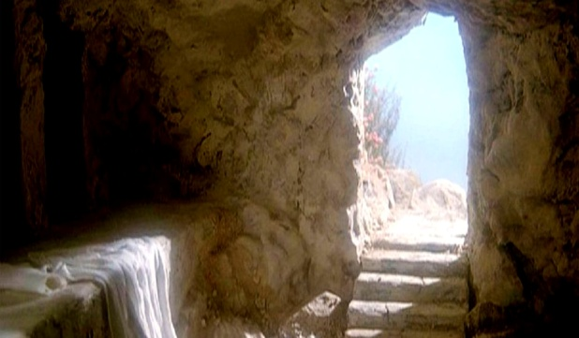

What was the young man, in the tomb, sitting on?
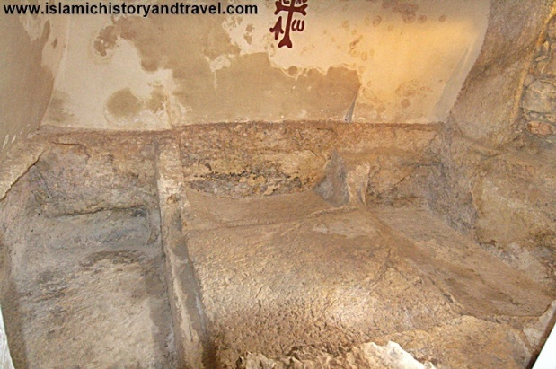
One of three benches that Joseph of Arimathea would have had carved into the rock.
What’s the point?
This detail is what you would expect to hear from someone who had been there.

One last detail.
* The women were alarmed when they saw the angel.

The presence of this young man in the tomb, frightened the two women.
When you read in the Bible of others who saw angels, their response was similar to that of the women.

When the angel Gabriel, appeared to Daniel, Daniel wrote, “As he [Gabriel]
came near the place where I was standing, I was terrified and fell prostrate.” 8:17.

When Isaiah the prophet saw the majesty and holiness of God he wrote, Isaiah 6:5:
“Woe to me! I am ruined. For I am a man of unclean lips, and I live among a people of unclean lips, and my eyes have seen the King, the LORD Almighty.”

When the apostle John, who had been Jesus’ closest disciple, saw Jesus in all of his glory, on the island of Patmos, where he had been exiled to, he wrote this, Revelation 1:17: “When I saw him, I fell at his feet as though dead.”

Daniel, Isaiah and John were men who were in close relationship with God.
Why did the glory of God impact them in this way?

Show a piece of rope hopelessly knotted.
Show the pieces of a shattered cup.
Show metal badly twisted.

When it comes to our sin, we cannot undo it; we cannot make ourselves like we once were; we can’t straighten what has been twisted within.

Whenever anyone, whose story is told in the Bible, encountered one of God’s holy angels, or saw the beauty and holiness and goodness of God, they were painfully aware of how sin had marred their life.

There is an important connection here we need to make. Tim Keller says:
“One of the main tensions in the story of the Bible is this – since humanity has forsaken God, will God forsake us? It is true that God is love. But will his love be overwhelmed by his holiness and justice? Or will his holiness give way to his love? Will he overlook sin?

Jesus answers that tension. He is the Judge of all the earth. But when he came to earth the first time, it was not a sword that was put into his hands, but nails.

He came not to bring judgment, but to bear it.
Jesus the Judge was judged.
When Jesus died, because he took on himself our sin, God ended evil without having to end us. We are pardoned because he was condemned.

Sin left us exposed. From the garden forward, we’ve tried to cover ourselves.
Jesus was stripped naked, so we can be clothed.
Because of him, our shame, caused by sin, is now covered by grace.”
Tim Keller, Preaching.

Because of grace, the angel was sent by God to the women.
This is the repeated theme of the Bible.
We turn our back on God; but he doesn’t abandon us.
We move away from God; but he pursues us.
We were lost... but our Savior found us.
Our sin was great, beyond our ability to remedy.

In the words of Revelation 3:17, we were wretched, pitiful, poor, blind and naked.
But Jesus came to us and he opened the eyes of our heart and mind; and covered us with his grace.
We were the undeserving.
But Jesus came to us and lavished his love upon us.

Why do we unabashedly identify with and love Jesus?
We love him because he first loved us.
It’s why we constantly speak of his goodness; why we with gratitude serve him.

In a few moments, we’ll come to the Table.
As you eat the bread and drink the cup, which represent the body and blood of Jesus,
I encourage you to bask in his love, and speak back to him your gratitude; your words of praise and love.

Because he came to us, and saved us... all of us who follow Jesus desire that our love for him would stay constant, fervent, undiminishing...
but we know that there are times, when for varying reasons, other things somehow manage to slip into and then crowd our lives, competing for our affections and loyalty.
And when that happens, in the words of Revelation 2:4, we lose our “first love.”

Has your affection for Jesus cooled?
Do you find yourself, going through the motions, without the heart reality?
Has your faith, rather than being a source of joy, become a burden?
Has it somehow happened that Jesus bores you?

If I’m describing you, please listen to what Jesus himself says.
Revelation 2:5: Look how far you have fallen! Turn back to me...and do the works you did at first. If you don’t repent, I will come and remove your lampstand from its place among the churches.

A cold heart is an issue that needs to be dealt with immediately. But how?
Listen to what Jesus said in Revelation 3:19-20.
“...Be earnest and repent. Here I am! I stand at the door and knock.
If anyone hears my voice and opens the door, I will come in and eat with that person, and they with me.”

In a few moments, we’re going to have opportunity to respond to Jesus.
On both sides of the room, there will be people ready to pray with you.
If you’ve heard Jesus’ voice and his appeal to you to repent, don’t worry about what others may think of you - I invite you to “open the door” of your heart to him.
Come for prayer – confess what needs to be confessed and then recommit your life to him.

Before we come to the Table, make things right with your Savior, so that you might joyfully share in eating the bread and drinking the cup in remembrance of him.
He is the bread of life.
He is the water that satisfies the thirst of our souls.

We earlier talked of those opportunities God is making known to you.
As we respond to Jesus in song and prayer, speak out your commitment to him, to go where he leads you, to do what he shows you.
Come and pray with someone about this.

If the Lord has convicted you, regarding stealing his glory or claiming for your own, ministry that is his, confess that to him, and recommit yourself to spend your life to spread his fame; to make his awesomeness known.
Come and pray with someone about this.

If you’re not yet in relationship with Jesus; many of us here understand, what is going on inside of you.
Not that long ago, we too were suspicious of Jesus; we too were afraid to trust him with our lives.

But he came to us....just like he is coming to you.
He made himself known to us. He whispered truth and love into our heart and mind.
Just like he is doing with you right now.

Ravi Zacharias believes the true obstacles that keep people from God, are not intellectual, but are issues of the heart.

To come to Jesus is not to give one’s intellectual assent to an abstract theory.
To come to Jesus is to respond to his invitation to enter into relationship with him.
And all relationships, requires sacrifice, commitment and trust.

To come to Jesus is to give him your whole self.
Because he loved you, he gave himself to cover your sin.
I would urge you to trust his love and put your life in his hands.
On both sides of the room, there are people ready to help you welcome Jesus into your life.

The Blessing
Revelation 3:20

The blessing of renewed fellowship with Jesus.

