**God the Father Knows Best** June 17, 18

Acts 5:17-26

**Coffee/question**: have you ever questioned if what God the Father was doing in your life or what he was asking of you, was really the best?

Share with each other about a situation that caused you to wonder about this.

If you haven’t ever wondered about this, it will be a short conversation… and please feel free to talk about something else :)

This is an important question to ask: does God the Father really know what he is doing? Is Jesus absolutely trustworthy? Is the Holy Spirit a faithful Guide?

**Acts 5:17-18**

Weeks earlier, on the night before he died, Jesus said to his followers, John 16:33:

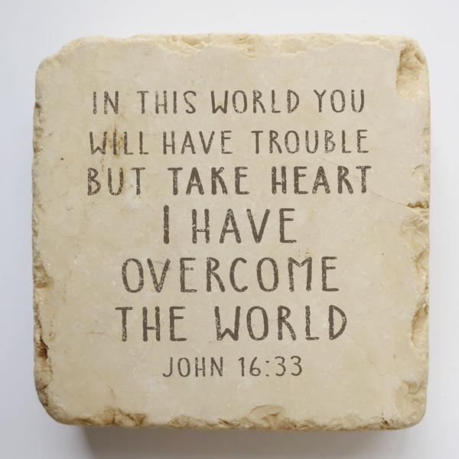

What was happening to the apostles was what Jesus had said would happen.

But Jesus hadn’t just told them – *“in this world you will have trouble.”*

He wasn’t simply saying to them that life will be hard.

What he said was… that to follow him in this world…would bring trouble into their lives.

But wat Jesus had to say to them didn’t end with – *“in this world you will have trouble.”* He went on to assure them – *“take heart.”*

*“Take heart”* in what?

Not in their troubles.

They were to *“take heart”* in this reality – *“I have overcome the world.”*

What kind of trouble can the followers of Jesus anticipate?

Paul told the church in Lystra, Iconium and Antioch, Acts 14:23:

*…we must go through many* ***hardships*** *to enter the kingdom of God.*

To the church in Thessalonica, Paul wrote, 1 Thessalonians 3:2-5

*We sent [Timothy] to strengthen you, to encourage you in your faith, and to keep you from being shaken* ***by the troubles you were going through****.*

*But you know that* ***we are destined for such troubles.****Even while we were with you, we warned you that* ***troubles would soon come****—and they did, as you well know.*

The Scripture is vague as to the specifics of what trouble looks like, because it can be many different things that puts pressure on a person because of their faith in Jesus.

But if Jesus has overcome the world - why does the follower of Jesus face trouble? Jesus himself explained, **John 15:18-19**:



* Jesus’ followers experience trouble because of him – the world hates Jesus.

But why?

Because of his exclusive claims – John 14:6: I am the way; the truth; the life;

John 10:30 – I and the Father are one.

Because of his insistence that we cannot save ourselves.

But if it is Jesus who is hated, why does that hatred of him spill out onto his followers?

* Because when we come home to God we now belong… to Jesus.

In gratitude, Jesus holds our highest allegiance.

Jesus identified something else in John 15.

* He has chosen those who follow him.

We are no longer “of” the world, because we have been chosen “out” of it.

Jesus’ choosing of us results in us being radically different.

How different?

Like the difference between night and day.



If Jesus was the Champion when he walked out of the tomb, how come his enemies still cause so much trouble in this world?

Look at **Matthew 13:24-30.**

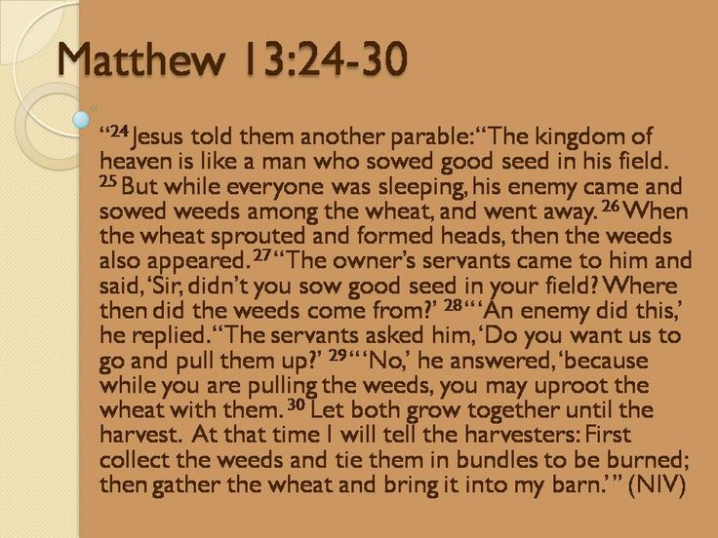

This parable tells us that even after the resurrection the world remains a spiritual battlefield.

But it is not a battlefield where the outcome is uncertain.

The risen Jesus told the apostle John in **Revelation 1:18**:



When Jesus walked out of the tomb, three days after he died, he did so, because he had defeated death.

Jesus’ victory also disarmed the fallen angels.

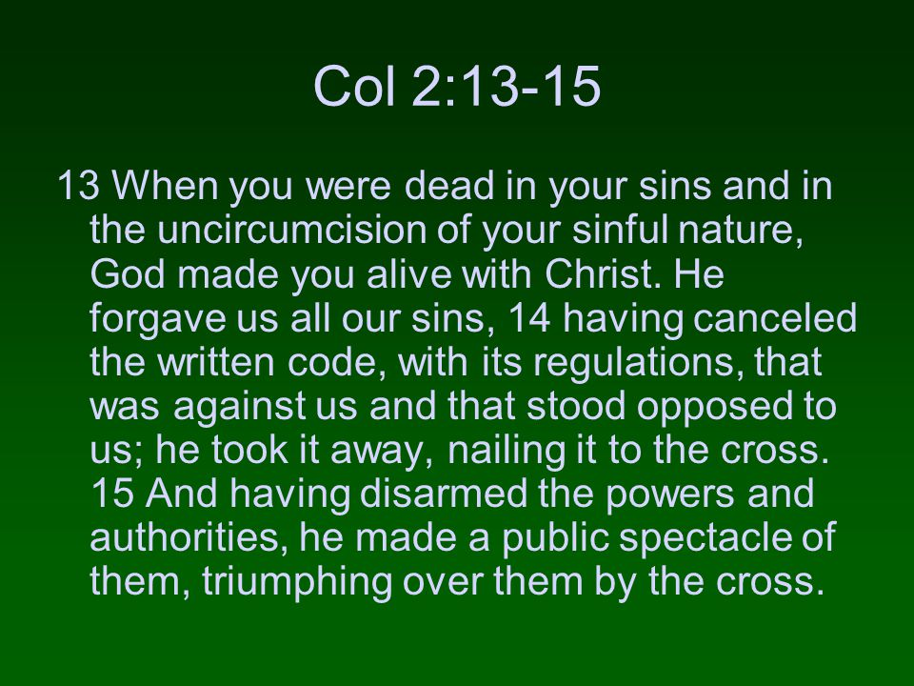

In this present time, the Father permits the world to be as it is – just like the man in the parable permitted his field to be as it was.

These days of waiting for the Father to say “now,” are days of opportunity for men and women to come home to God.

This perspective explains why the disciples were arrested.

It also explains why the apostle’s world didn’t collapse when they were.

They trusted that the Father knew what he was doing.

**Acts 5:19-21a.**

God remains active in this world.

At times, God intervenes to rescue his own.

At times, God uses angels to open locked prison doors.

Sometimes God puts prison guards to sleep.

God is able to do the seemingly impossible to help his people.

And he does so, not just then, but now.

Story of Brother Yun. 

Upon his release the Holy Spirit directed Yun to go into hiding.

But this was not the case with the apostles.

They were sent back to the very place they had been arrested.

As the apostles obeyed the Lord’s word, they knew…they would be re-arrested.

What does this teach us?

When a person comes home to God, when they are welcomed to take a seat at his table…they enter into the story of salvation…and are given by God a part to play in the outworking of that story.

When it comes to the part each follower is given, remember this…the Father:

- knows your birth and death date and all the days in-between

- chose where and when and to whom you would be born

- knows you so intimately – that he knows how many hairs are on your head

- gave you your natural abilities

- gives to every follower of Jesus giftings of grace

If God did all these things and more, can he be trusted to give to you the role you are to play… in his salvation story… for his glory? YES!!!

The Father directs each one of us where he wants us to be, and he gives assignments to us of his choosing.

Remember the story of the talents?



What is the point? (Matthew 25:14-30)

The story emphasizes:

- the goodness of the master.

- the importance of being found faithful.

“You have been faithful with a few things; I will put you in charge of many thing.”

Your faithfulness… here in this time that you live on earth… will determine your assignment in the time of the new heaven and the new earth.

**Acts 5:21b-24**

Why were the apostles’ “broken out of jail?”



* To assure them that God was with them.
* To tell the people “the full message of this new life.”

But is there anything else?

* To cause the captain of the temple guard and the chief priests to be puzzled and to wonder what was going on.

What does this say to us? What does this teach us?

You and I live in a culture that is self-focused.



For those of us who follow Jesus, that’s how we used to be.

But when a person comes home to God through faith in Jesus, God begins in us, by his Spirit, a life-long work – where we are being taught; where we are learning … to be God-focused.



Sometimes… often… always…???...the things that God permits to happen to us…are not just about us.

In Acts 5, we see that God used the circumstances of what happened to the apostles… to cause people who were far from him to think; to wonder; to puzzle about who God is and what he was doing.

What God did then, is what he does now.

The circumstances of our life, even when they are challenging, sometimes… often…always…are used by God to awaken curiosity in people not yet in relationship with him.



One could ask – but hadn’t the Father revealed himself – many times - to the members of the Sanhedrin?

Yes, he had.

* They’d had direct conversation with Jesus at his trial
* They’d seen the torn temple curtain after his death
* They’d heard the testimony of the Roman guards who stood watch at his tomb and had seen the resurrection.
* And they’d already had interaction with his followers.

What does this tell us about the Father?

He is patient with those who oppose him.

But remember…all of us, who now follow Jesus were at one time his enemies.

That is the message of Romans 5 – Jesus died in our place while we were sinners; while we were his enemies.

As we would connect the truth in this passage to our lives, let’s together…ask these questions – of the Holy Spirit.

* Do our lives… make people wonder about who God is?
* Do people… far from or near to God… connect who we are… to our faith in Jesus?
* Does our loyalty to Jesus surprise people?

Pablo Escobar said:

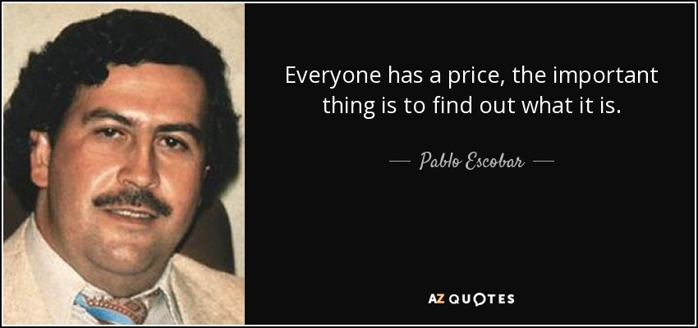

Do we have a price? Is there a point where we would compromise? Pull back?

* Is it obvious that it is our faith in Jesus and our love of him that determines and shapes our priorities?
* In our faith community, when we gather together – do people marvel and say as did some who gathered with the Corinthian church – 1 Corinthians 14:25:



**“God is really among you!”**

John F. Kennedy said:

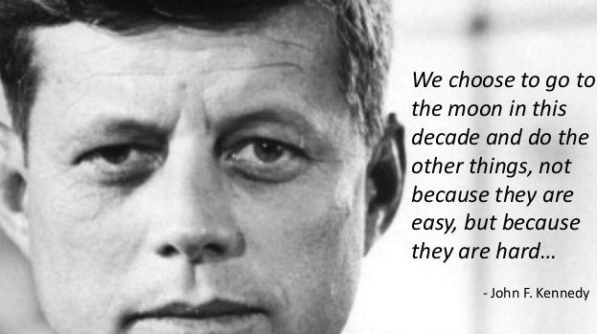

Following Jesus has been compared to:

fighting a good fight – 1 Timothy 1:18; 2 Timothy 2:3



running a race – Philippians 3:14; Hebrews 12:1



Both of these examples require perseverance… as well as confidence in the One we follow.

But we choose to do the hard things – to go into all the world - because we love the Savior who rescued us!



Never forget this - as Jesus’ followers we are not headed for death.

This is why we don’t live with fear or hold back in living whole heartedly for Jesus.

Because of him, we know with certainty that we are headed for an infinitely greater life.

To spend our life for Jesus is what we gladly choose to do.

Vince Vitale, Jesus among Secular Gods, wrote:

***“When God is at the center of it, the community that is possible is miraculous and unparalleled. We can find the unity we long for, not by bypassing disagreement, but by finding a love big enough to disagree well, and by finding a truth big enough to unite us.”***

This story reminds us we are part of God’s great salvation story.

Romans 5:3

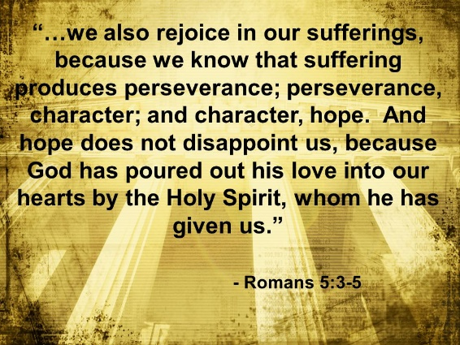

We read here that God is able to rescue his people.

As we see in this story – sometimes he rescues in dramatic ways.

Sometimes he sends an angel to open locked doors.

Sometimes he puts guards to sleep.

But you also need to know that sometimes he doesn’t rescue.

Acts 12:1-2: *It was about this time that King Herod arrested some who belonged to the church, intending to persecute them.****2****He had James, the brother of John, put to death with the sword.*

In James’ situation, an angel didn’t come to open a prison door.

God didn’t intervene to rescue him.

Instead, James was put to death by King Herod.

To follow Jesus is to enter into relationship with the Triune God; to enter into their incredible community; to live in and be a part of their story of rescue, reversal and redemption.

Last week we studied the invitation of the Father – come; come to me; come home; come to the table.

Why does the Father extend such a generous invitation?

Because as 1 Timothy 2:4 says – *God our Savior…wants all men to be saved and to come to a knowledge of the truth.*

This invitation of the Father’s resonates with our inner person; it tugs on our heart, because…we were created to be in relationship with God.

There is no cost to come home to the Father.

Jesus did everything necessary; he paid humanity’s debt in full.

That said, while you and I cannot do anything to earn favor with God, there is a cost to follow Jesus.

Jesus explained it like this, **Luke 14:26-35**:

***26****“If anyone comes to me and does not hate father and mother, wife and children, brothers and sisters—yes, even their own life—such a person cannot be my disciple.****27****And whoever does not carry their cross and follow me cannot be my disciple.*

The apostles in Acts 5 were 100% in.

They had given their lives to Jesus, and whatever he asked; however he chose to use their lives - they trusted him.

This sounds radical, but it is actually the norm for everyone who follows Jesus.

Western culture is infatuated with being safe.

This story in Acts 5 reminds us that the Father’s greatest good is not the safety of his own.

Yes, he is always with us.

Yes, he is a strong fortress.

Yes, he saves us.

But in Acts 5 he let the apostles be arrested.

He let them spend the night in jail.

He let them be re-arrested.

And for the last 2000 years, the Father has sent his people into dangerous places, asking them to do dangerous things.

What did this teach us?

The Father is not afraid to take risk, even great risk, when he uses our lives in his cause, and not because he is careless or casual.

In the south of Ireland, we spent three nights in a little town called Fethard on Sea, which unknown to us was very near the family homestead of John F. Kennedy. There they had built a small center to honor his memory. There I watched a video that compiled some of his most memorable speeches and statements.

Two greatly moved me.

The first – “Don’t ask what your country can do for you – ask what you can do for your country.”

The second – “We choose to go to the moon, not because it is easy, but because it is hard.”

It made me think of what the Father, Son and Spirit have done in securing our salvation. We chose to rescue humanity – not because it is easy – we do so because if we don’t, no one will be saved – all will be lost.

Together they did, what from our perspective was impossible.

They paid our sin debt, they defeated death, they disarmed the fallen angels.

Their work of rescue is ongoing.

It is not easy, but difficult, but so worthy.

When we follow Jesus, we

Typically, every person lives with this attitude - I must do what is good for me.

The followers of Jesus live with a radically different attitude - “my life is at your disposal to use as you so desire.”

I said this a radically different attitude - not in the sense that only a few live like this. Such an attitude is normal for the follower of Jesus.

Additionally, Jesus said that to come to him is to carry one’s cross and follow him.

What did Jesus mean by that?

When did Jesus carry his cross?

He carried it to Golgotha when he offered up his life in sacrifice; in obedience to the Father’s will.

Before we met Jesus, each of us invested time, energy and resources into our own pursuits.

But when we come to him, we offer our life to him as he did his to the Father – to spend it as he chooses.

Is this easy to yield to Jesus’ authority?

Was it easy for Jesus to yield to his Father’s will?

Adrift from God, each of us elevates our self to the place of pre-eminence.

We do what is good for us.

We promote our preferences; we insist on our way being done.

But from Jesus we learn that living like this – oriented around self… is to live a life that is upside down and inside out.

When a person comes home to God, the reason the Holy Spirit of God births within that person a new nature is because our existing human nature is hopelessly flawed; it cannot be renovated.

In fact, God’s word tells us that it has to die.

Yes, this is radical.

Jesus told a parable about mending an old garment and putting new wine into old wineskins. (Matthew 9:16-17)

Jesus was primarily speaking of spiritual practices and how the kingdom of God now operates in this world.

But his parable also applies to the work of the Spirit who births a new nature within those who come in faith to Jesus; who come home to the Father.

You don’t put a new patch on an old garment because – the patch will tear away and the tear will be worse.

God doesn’t make his home in our old nature – it is incapable of housing him.

And you don’t put new wine into old wine skins because as the new wine ferments it will burst the old skins.

The Holy Spirit abides in the person who is in Christ; the one in whom the old has gone and the new has come – 2 Corinthians 5:17.

While we can’t birth a new nature within – only the Holy Spirit can do that – we do cooperate with his work of making us new in every facet of our lives.

**Ephesians 4:22-24**

***22****You were taught, with regard to your former way of life, to put off your old self, which is being corrupted by its deceitful desires;****23****to be made new in the attitude of your minds;****24****and to put on the new self, created to be like God in true righteousness and holiness.*

Jesus doesn’t hide this in the fine print.

He is up front about it.

If you want to follow me, he says, count the cost – it will not be life as usual.

That’s his point in the two examples he gave in Luke 14.

***28****“Suppose one of you wants to build a tower. Won’t you first sit down and estimate the cost to see if you have enough money to complete it?****29****For if you lay the foundation and are not able to finish it, everyone who sees it will ridicule you,****30****saying, ‘This person began to build and wasn’t able to finish.’*

***31****“Or suppose a king is about to go to war against another king. Won’t he first sit down and consider whether he is able with ten thousand men to oppose the one coming against him with twenty thousand?****32****If he is not able, he will send a delegation while the other is still a long way off and will ask for terms of peace.****33****In the same way, those of you who do not give up everything you have cannot be my disciples.*

***34****“Salt is good, but if it loses its saltiness, how can it be made salty again?****35****It is fit neither for the soil nor for the manure pile; it is thrown out.*

*“Whoever has ears to hear, let them hear.”*