Uniquely Jesus: The Story Continues October 21, 18
Acts 7:30-36, The Story of Moses, Part Three

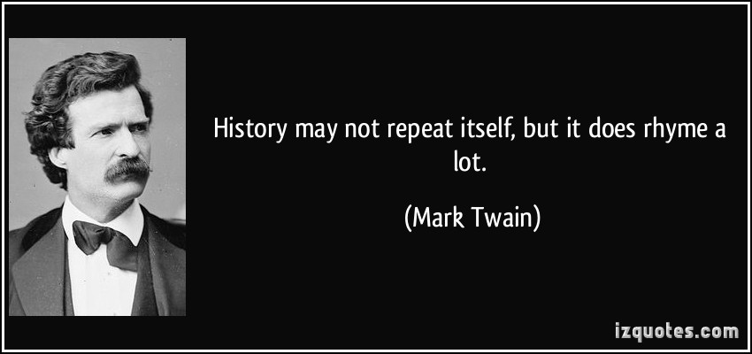

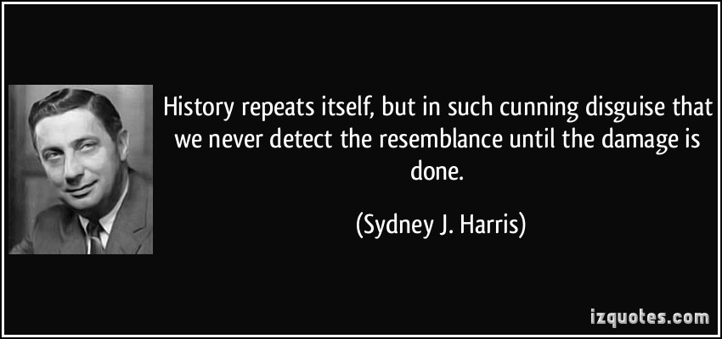

“As a people, we are not very good students of history; we keep repeating the same mistakes at dreadful costs.” ― Col Don Wilson https://www.goodreads.com/quotes/tag/history-repeating-itself
Coffee/question:
Which one of these quotes do you most agree with; and why?

Stephen as he defended himself to the members of the Sanhedrin in Acts 7 pointed out an historical pattern, that had been… often repeated… by the family of Abraham.

What was the pattern?
At different times in the Hebrew people’s history, an individual would be sent from God to function as a rescuer of the nation.
But again, and again and again, these rescuers would be rejected by those they’d been sent to.
However, in mercy God would intervene in the life of the rescuer, who would then be sent again by God to rescue the very people who’d earlier rejected them.

Point of Connection
The Lord is patient – 2 Peter 3:9.
To better appreciate this characteristic of God we need to add…. that in his patience God is… long-suffering.

What does that look like?
1 Peter 3:20 speaks of God delaying his judgment upon a wicked world while Noah built the ark – which took 100 years.

The reason why God is longsuffering is important.
He wants people to repent – 2 Peter 3:9.
Through his longsuffering God’s kindness is expressed – Romans 2:4.
Because God’s character doesn’t change, he is likewise long-suffering, patient and kind with you and me.

We continue today in the story of Moses.
Read Acts 7:29-36.

Stephen spoke to men who knew the story of the OT well.
This is why he could mention events and people without having to give much detail.

The reason I am stopping at various points is to ensure you and I grasp the greater story which is told in the OT.

When what Moses had done became public knowledge – kill an Egyptian who had been beating a Hebrew man - Moses was forced to flee.
He didn’t run because he imagined… he might be in trouble.

He ran because, as Exodus 2:15 says, “When Pharaoh heard of this, he tried to kill Moses…”

Moses made his way to Midian, where he lived as a foreigner.
We must not miss the significance of that word – foreigner – which Stephen used to describe Moses during those forty years.

A foreigner is someone who comes from another country.
A foreigner is different in many different ways – clothing worn; food eaten; accent with which they speak; mannerisms; etc.

Barb and I experienced being foreigners – first in Costa Rica, then in Colombia and then in Venezuela.
We understand feeling awkward and out of place; of missing the things that are familiar; of having to relearn everything.
It is not an easy thing to do; it is incredibly unsettling.

We know those early days in Midian were difficult for Moses because of the name he gave to his first-born son - Gershom, which means - “I have become an alien in a foreign land.”

Alien
Foreign

As Moses ran for his life, God directed him to Midian – which was predominantly a desert; a place of barrenness and solitude.
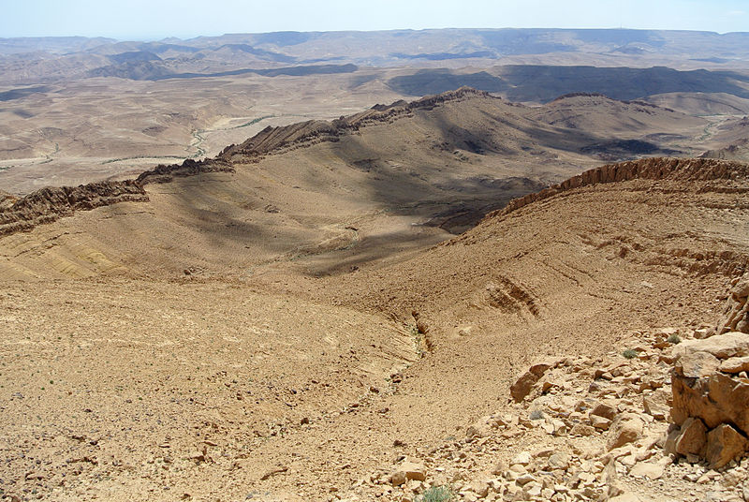
Moses had turned his back on his identity as the son of Pharaoh’s daughter.
He’d regarded disgrace for the sake of Christ as being of greater value than all the pleasures and treasures of Egypt that could have been his.
He moved out of the palace…
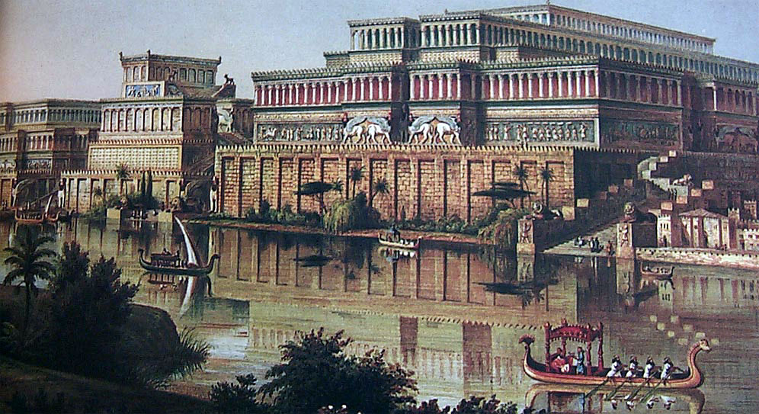
…and into a tent.

Moses had been educated in all the wisdom of the Egyptians and was powerful in speech and action.
It is even thought that he led the Egyptian armies into battle.

God finished equipping him to lead the nation of Israel, by having him lead sheep to their pasture, or to a well for water…not for a couple of week; nor for a couple of months, but for forty years.
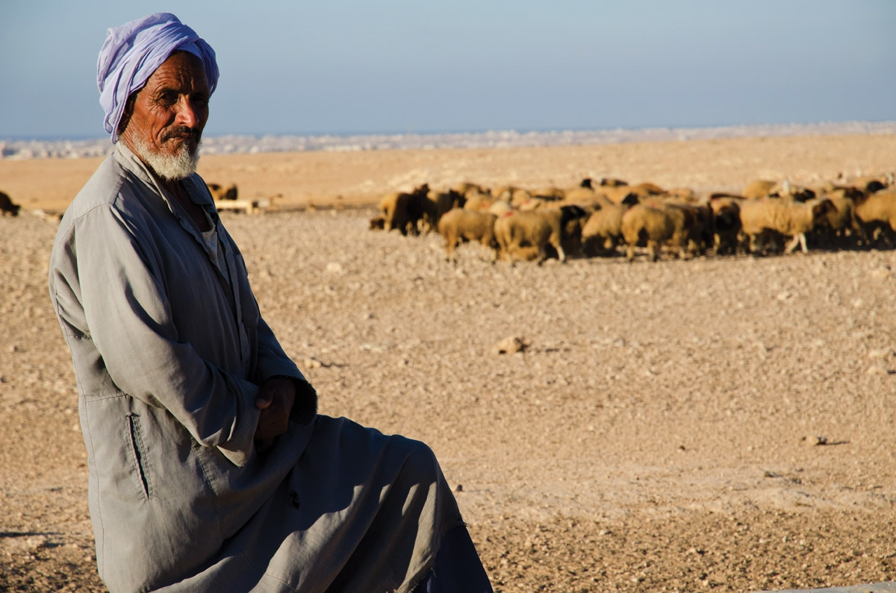
There is great irony in that Moses who was raised as an Egyptian… became… what the Egyptians despised – a shepherd. See Genesis 46:31-34.

There is an important point of connection here.
Our focus today is on that little phrase in verse 30 – “After forty years had passed…”

The emphasis of this phrase connects back to previous weeks.
God is not in a hurry as we understand hurry.
Those forty years in the desert were not wasted years.
In that time God forged the character of Moses.
The Lord made Moses ready for the great task of his life.


The Lord transforms his people… into his image.
This is what God did in Moses during those desert years.
This is what God is doing… in your life right now.

This transformation is not a one-time event; but an on-going work of the Spirit… that requires of a follower of Jesus their cooperation and participation.
Transformation is a progressive work.
It results in… an ever-increasing glory.

What specifically does the Lord do… to transform us?

The Lord through the Spirit transforms us by renewing our minds!
He changes how we think.
How does he do that?
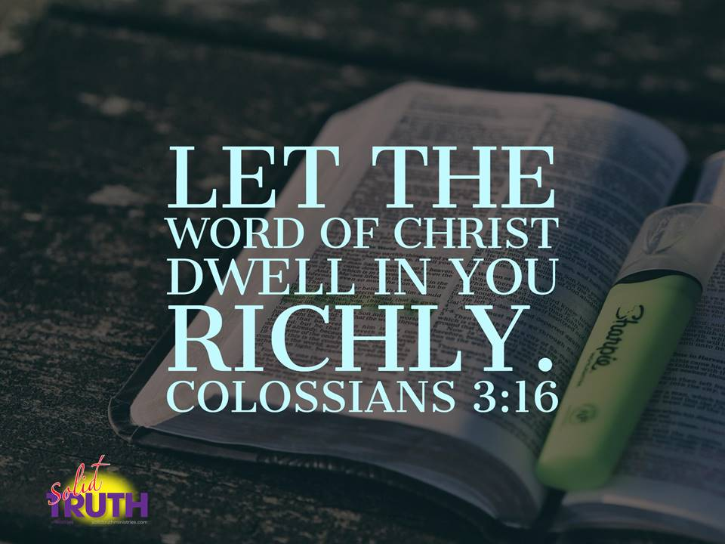

The Word of Christ is like a hammer; like a fire; like a sword; like a plumb-line.
It is living.
It is active.
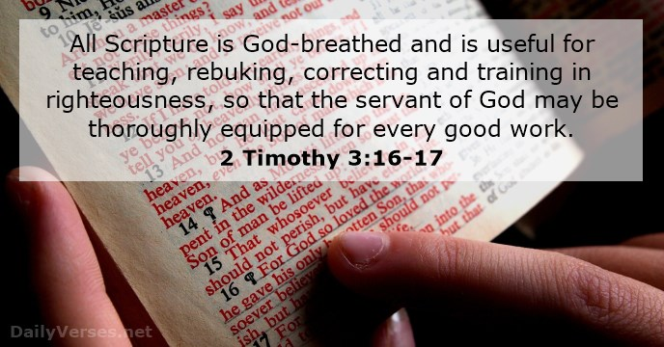
As the Word of Christ lives in us…richly…the Spirit uses this Word to renew our minds in order to transform our lives.

God’s word is useful – for teaching; rebuking, correcting, and training in righteousness.
This is why immersing our lives in his word is so important.

But there is another means by which God will renovate our characters, in order to make us ready for what he would have us do – in this present time, as well as for the time of the new heavens and the new earth.

We learn from what God did with Moses, that he will lead his followers into “desert places;” into times of “isolation;” into situations when there is “lack;” into “dead ends;” into great difficulties and/or challenges, where we may feel overwhelmed, or way past our comfort level and ability, or feel that our life is being wasted.

It is a common experience – and I stress that – it is common… for the follower of Jesus to be “put on a shelf” for a time; even an extended time, as Moses was in Midian.

- During those forty years God used obscurity to teach Moses humility.
“The blessing of obscurity.”
When we think of God’s blessing do we consider obscurity as one of them?

Because of his upbringing, education and experience, Moses was powerful in speech and action.
During those 40 years of obscurity in the desert… he learned to be powerful in the Lord.

What did that look like?
During those long years God refined Moses’ life.
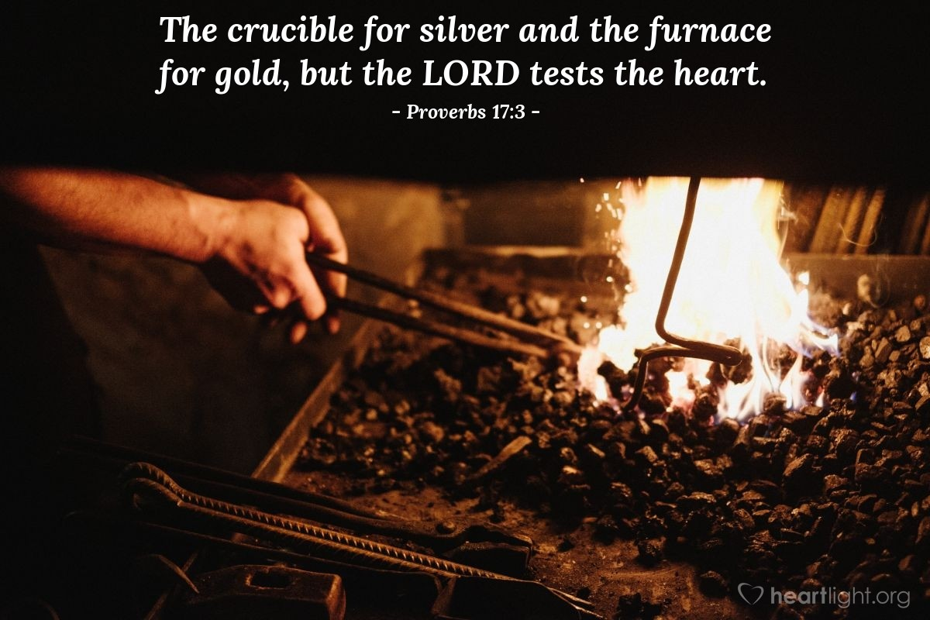
What had to be removed from Moses?
His sinful self-confidence and his natural default to trust in his own ability.
Moses had to learn to find his confidence in God and to trust God in everything.

Humility is a virtue whose development cannot be rushed.

I remind you that the first 30 years of Jesus life were also spent in obscurity.
And just like it was for Moses, those 30 years were not wasted years.
Those were years of preparation; where habits of prayer and fellowship with the Father were cultivated.
Those were the years when Jesus learned to depend upon the Spirit to lead his life every day.

What about you and I?
When God has puts us on a shelf, or in a corner, and it feels like life is passing us by, remember that because he loves you, he is teaching you to trust him; he is making you ready…

The circumstances that have come to you, have come… through… his hands.

Here’s another analogy from Scripture that is meant by God to encourage you.
Jeremiah 18:1-6

The Father is lovingly forming your life.
When what he is doing in you, is accomplished, he will move you; he will place you; he will bring you into the next season or the next chapter of your life.

God uses obscurity to teach us humility.

- God used those desert years to teach Moses obedience.
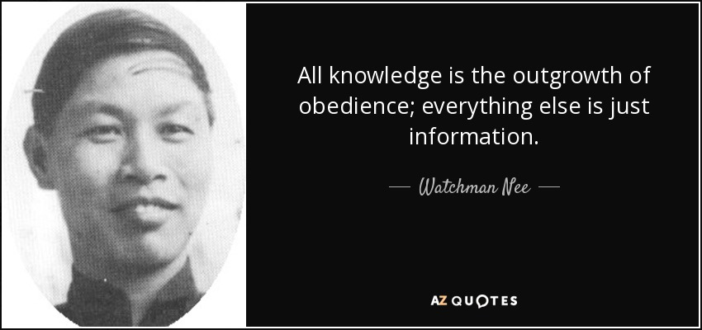

Everyone who follows Jesus has to learn obedience.
“If you love me, you will obey me. John 15.
Love for God is expressed through obedience of him.
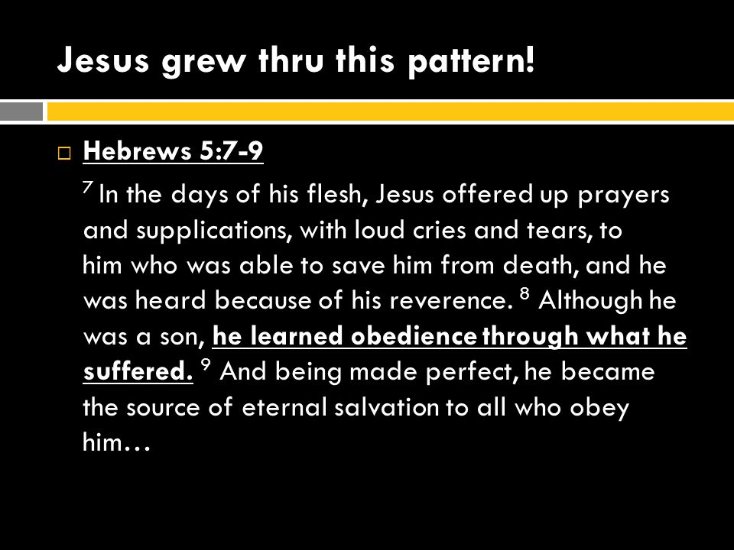
Jesus, who was sinless, learned obedience through what he suffered.
What does that mean?
In the difficult and challenging things that happened to Jesus; he never stepped out of the Father’s will.
Jesus always chose the Father’s way, even when it cost him to do so.

This tells us how important obedience is.
This also impresses upon us that while obedience is something we choose; it is also something we learn.

If Jesus learned obedience through what he suffered; why would we think he won’t teach us obedience through the difficulties and challenges he allows to come into our life?

This is why James wrote as he did in his letter.
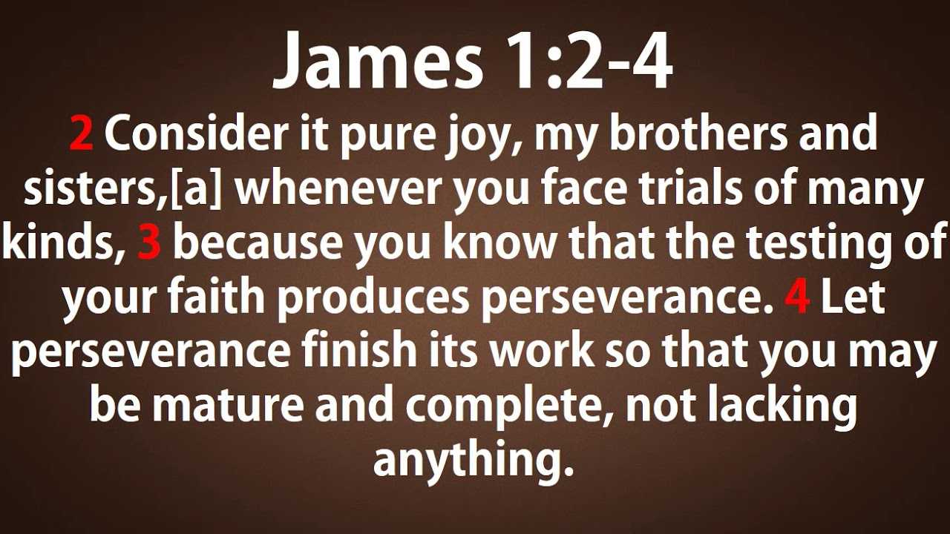
Pure joy!

We are not told to have joy in the trial itself, but to find joy in our good and loving God, and what he works in us through the circumstances he has permitted.
God wants us to learn to persevere.
But there is no other way to learn perseverance except by…having to persevere.

The Father wants us to not run from him…but to trust him as he uses trials to take off our rough edges and to remove from us what is worthless.

After his forty years in the desert, after his encounter with God at the burning bush, whenever God told Moses to do something, Moses obeyed – Exodus 40:16 – because… had learned obedience.

And what God did in Moses is what God desires to do in all of us who would walk with him.

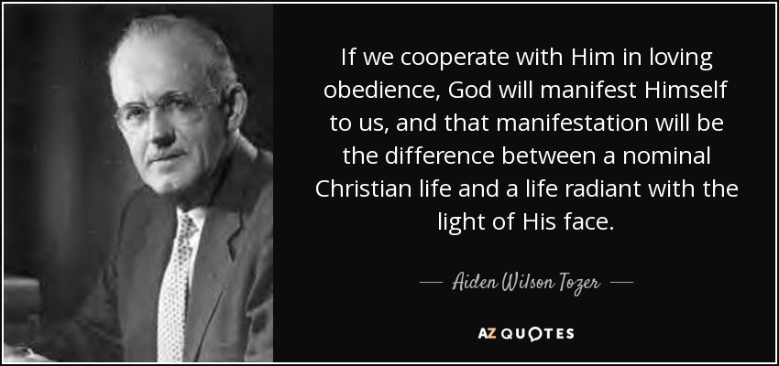

Connect to the song “New Wine”

New Wine
In the crushing, in the pressing, you are making new wine
In the soil, I now surrender you are breaking new ground
So I yield to You and to Your careful hand
When I trust You I don't need to understand

Make me Your vessel, make me an offering
Make me whatever You want me to be
I came here with nothing but all You have given me
Jesus, bring new wine out of me

'Cause where there is new wine there is new power
There is new freedom and the kingdom is here
I lay down my old flames
To carry Your new fire today (oh today)
Songwriters: Brooke Ligertwood
New Wine lyrics © Capitol Christian Music Group

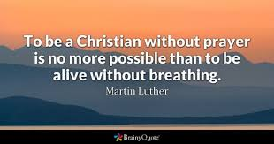The same was said of Noah, Genesis 6:22 – he did everything just as God commanded him.
The same was said of Joshua, Joshua 11:15 - he left nothing undone of all that the Lord commanded Moses.

This practice of obedience is one that the Lord is actively building in your life and he will use your current challenges and difficulties to accomplish his will.

But how?
Through solitude

Romans 5:3-4.



God
Because the life-lessons Moses needed to learn; the character qualities that needed to be developed in him; could only be learned where God had directed him to go – in the desert of Midian.

Stephen stated that after Moses fled, forty years passed.
Exodus 2:23 says this about those years – “During that long period…”

What happened forty years ago?

-> The Nobel Peace Prize was awarded to Anwar Sadat and Menachem Begin for
jointly negotiating peace between Egypt and Israel.
-> Saturday Night Fever and disco were the rave.
-> The Montreal Canadiens won the Stanley Cup.
-> The smallpox disease was completely eradicated from the Earth.
-> Sony built a prototype of the Walkman, the first portable stereo
-> In Guyana, Jim Jones leads his Peoples Temple cult in a mass murder-suicide
that claims 918 lives.
-> Two popes die in the same year – Pope Paul VI and Pope John Paul I

Coffee/Question

Forty years was a long time; not just for Moses but for the Hebrew people,
who “groaned in their slavery and cried out to God.”
During those years of isolation, while Moses took care of sheep, God forged the character of Moses.
During those years of ongoing slavery, God prepared the hearts of the Hebrew people to receive his rescuer.

Finally, the moment came that God had been waiting for – the moment of rescue.
Read verses 30-38.

God appeared to Moses and spoke to him out of the burning bush, not a temple.
Later he would speak to Moses and the entire nation from the top of a mountain in the Sinai desert.

Do you see the repeated emphasis being made by the Holy Spirit through Stephen?
God’s presence was not limited to the temple in Jerusalem.
God is not confined to one place.
He is the LORD of the earth – he is the King over all nations, as we earlier read in Psalm 2.

God is everywhere present.
He is not limited to what some would call “sacred space.”
The burning bush was not holy ground until the moment God appeared in the fire that didn’t consume.
We have here a picture of how God makes his home in us without consuming us.

The gospel of Jesus is both bad news and good news.

The men of the Sanhedrin were religious.
They were moral.
They knew the Scriptures.
And…they were spiritually dead, as is all of humanity.

There is a truth here that needs to be stated.
Human beings are incredibly resourceful and creative.
We love a challenge.
And while it is true that in some many fields, we are making huge strides – in medicine, technology, agriculture, knowledge – there is something we are incapable of solving; overcoming; fixing.

In Adam and Eve, humanity chose to turn away from God, and live life on our own terms.
That choice brought into our human nature the disease of sin and unleashed upon this world and all who live in it, the curse of death.

Like Humpty-Dumpty, we cannot repair the “Great Rupture.”
This is the bad news of the gospel of Jesus.

But what we could not do for ourselves, God in love and kindness, did for us.
He sent Jesus, who, in the words of John the Baptist, “takes away the sin of the world!” John 1:29

The good news of the gospel is that the grace of God is greater than our sin.
God’s grace, is able to make family of an enemy.

From the cross, as he looked out and down upon the very ones who had arrested him and taken him to Pilate, and then had stirred the mob to call out for his death, Jesus asked the Father, “Forgive them, for they do not know what they do.” Luke 23:34

As Stephen spoke to the Sanhedrin, this was now the third time the gospel of Jesus had been shared with them – the first after the healing of the crippled man; and the second after the apostles had been jailed and released by an angel.

Stephen as he spoke, pointed them to the kindness and the patience of God, in his dealings with Abraham; with Jacob’s sons, particularly Joseph; and then with Moses and the people of Israel.

God’s kindness is at the heart of the good news of Jesus.
Romans 2:4: …do you presume on the riches of [God’s] kindness and tolerance and patience, not knowing that God's kindness is meant to lead you to repentance?

Through Stephen Jesus pursued after those who sat in judgement of him.
Is that not incredible?

But then, how long did God pursue you?
How many times and through how many different people was the gospel of Jesus shared with you?
How many times did you shrug off the news of Jesus?
How long did you run from him, or try to avoid him?

And yet, in his kindness, he pursued after you; he pursued after me.
The love of God is meant to lead a person to repentance.

Who loves us like God does?
Who would invest such time and effort on our behalf?

God’s love is sweeter and higher and deeper and wider and stronger and purer.

Tragically, those men who listened to Stephen, chose to continue to reject Jesus.
They refused to change their minds.

“That is the key to history. Terrific energy is expended - civilizations are built up - excellent institutions devised; but each time something goes wrong. Some fatal flaw always brings the selfish and the cruel people to the top and it all slides back into misery and ruin.” ― C. S. Lewis
https://www.goodreads.com/quotes/tag/history-repeating-itself

Why did Moses go to Midian?
It’s here where some sleuthing needs to be done.

“The people of Midian were distant relatives of the Israelites… They were descended from Midian, the fourth son of Abraham and his second wife Keturah, (see Genesis 25:1-6).
Before Abraham died, he sent Midian and his five brothers "to the east" (Genesis 25:6), where they settled in territory to the east and south of the Dead Sea.

That was not the last time that these boys were heard from.
Remember - it was Midianite traders who took Joseph to Egypt as a slave, and then sold him to Potiphar, the captain of Pharaoh’s guard (see Genesis 37:36)…

After Moses led the Israelites out of Egypt, they headed across the Sinai Peninsula towards… Midian…Moses was leading the nation into and through territory he knew.

Jethro, Moses’ father-in-law came to visit when the nation was camped near Mt. Sinai. It was during this same visit that Jethro, a Midianite, provided wise counsel to Moses of how to govern and lead millions of people. (see Exodus 18:1-12)…

Forty years later, when Moses and the Israelites arrived in the Plains of Moab, it was Midianite women along with women from Moab, who played a part in leading the men of Israel into sexual immorality and idolatry (see Numbers 25:6-17; 31:1-18).

Later still, during the time of the Judges, Midianite raiding parties devastated Israel for seven years until Gideon defeated them (see Judges 6:1-6 & 7:1-25). https://www.thebiblejourney.org/biblejourney2/25-the-israelites-journey-from-egypt-to-mt-sinai/prince-moses-escapes-to-midian/

Why are these details important for us to take note of?
They actually emphasize an important point of connection.
If the Bible was simply a collection of myths, there would not be the kind of detail included, or the details included would be inconsistent or contradictory.

The other thing that would have happened if these stories were invented, is that the sordid, embarrassing details would have been airbrushed out, or at least have been greatly massaged in order to present in a better light, the individuals whose stories are being told.

God purposefully included such detail in the Bible that we might know… these things happened in space and time… to real people.

Again, there is a truth here that needs to be stated.
God did not extend a blanket amnesty to all of humanity, through the salvation Jesus accomplished in his death and resurrection.

God does draws people to himself.
Do you know why that is?
Jesus explained in John 6:44.
[Because] – “No one can come to me [Jesus] unless the Father draws them…”

God does whispers truth into a heart and bring light to a darkened mind.
2 Corinthians 4:6 – God made his light shine in our hearts to give us the light of the knowledge of the glory of God in the face of Christ.

As God reveals himself to us; it is his desire that his kindness would lead us to repentance; that we would choose to come home to him.
Peter wrote, 2 Peter 3:9 – “He is patient with you, not wanting anyone to perish, but everyone to come to repentance.”

The closings words of the book of Revelation extend this invitation,
Revelation 22:17: The Spirit and the church [the bride] say, “Come!” And let the one who hears say, “Come!” Let the one who is thirsty come; and let the one who wishes, take the free gift of the water of life.

Though it seemed Stephen’s defense had made no impact upon the Sanhedrin; and that his words had fallen on deaf ears; there was one there that day, who began his journey home to God – and that one was Saul of Tarsus.

But we’re getting ahead of ourselves in the story.

In addition to being a rescuer, Moses was also a prophet.
After leading the Hebrew people out of Egypt, God met with the nation at Mt. Sinai.

There he entered into a covenant relationship with them, where he became their God and they became his people.
But the sight of God when he appeared to the nation was so terrifying, that they pleaded with Moses to speak to God on their behalf.

Exodus 19:16-20:
On the morning of the third day there was thunder and lightning, with a thick cloud over the mountain, and a very loud trumpet blast.
Everyone in the camp trembled. ¹⁷ Then Moses led the people out of the camp to meet with God, and they stood at the foot of the mountain.

¹⁸ Mount Sinai was covered with smoke, because the Lord descended on it in fire. The smoke billowed up from it like smoke from a furnace, and the whole mountain trembled violently. ¹⁹ As the sound of the trumpet grew louder and louder, Moses spoke and the voice of God answered him. ²⁰ The Lord descended to the top of Mount Sinai and called Moses to the top of the mountain.

Look at Deuteronomy 5:22-27:
²² These are the commandments the Lord proclaimed in a loud voice to your whole assembly there on the mountain from out of the fire, the cloud and the deep darkness; and he added nothing more. Then he wrote them on two stone tablets and gave them to me.

²³ When you heard the voice out of the darkness, while the mountain was ablaze with fire, all the leaders of your tribes and your elders came to me. ²⁴ And you said, “The Lord our God has shown us his glory and his majesty, and we have heard his voice from the fire. Today we have seen that a person can live even if God speaks with them. ²⁵ But now, why should we die? This great fire will consume us, and we will die if we hear the voice of the Lord our God any longer. ²⁶ For what mortal has ever heard the voice of the living God speaking out of fire, as we have, and survived?

²⁷ Go near and listen to all that the Lord our God says. Then tell us whatever the Lord our God tells you. We will listen and obey.”

A prophet was someone who came near to God; who listened to his voice and then told others what God had said.
But through a prophet, God also foretold future events.
Many of the prophets spoke of the Rescuer who would come, including Moses.

Deuteronomy 18:15-18:
¹⁵ The Lord your God will raise up for you a prophet like me from among you, from your fellow Israelites. You must listen to him. ¹⁶ For this is what you asked of the Lord your God at Horeb on the day of the assembly when you said, “Let us not hear the voice of the Lord our God nor see this great fire anymore, or we will die.”

¹⁷ The Lord said to me: “What they say is good. ¹⁸ I will raise up for them a prophet like you from among their fellow Israelites, and I will put my words in his mouth. He will tell them everything I command him.

What an incredible irony.
The men from the Synagogue of the Freedmen accused Stephen of speaking blasphemy against Moses and God, when all Stephen had done was quote the words of God and Moses, who had foreseen the coming of Jesus, just as Abraham had – John 8:56: [Abraham] saw [my day] and was glad.

Read verses 39-43.

Stephen continued to build his case – demonstrating in the response of the nation towards Moses, this deeply entrenched pattern of resistance towards God.
This was the heart issue that Jesus had come to address and to remedy with the sacrifice of his life.

It’s in these verses, that Stephen, with no ambiguity, spoke to the second aspect revealed in this chapter regarding God’s character – the LORD will release a person to experience the full consequence of their sin.

The words Stephen used were frightening – “God turned away and gave them over to…”
In the situation Stephen referred to… it was the worship of idols that they were given over to – and specifically he named the god Molech.

Molech was the god who required newborn babies to be sacrificed to him.
When the hearts of the people turned away from God; when they refused to obey him; this was the horror they were taken to.

In Romans 1, this phrase is repeated three times – v.24, 26, 28.
And what Romans 1 describes; the place to which people can go when there is no God to stop them, is equally terrifying.

When God lets a person go…, he stops convicting them.
He stops giving to them the gift of guilt.
He lets them do, with no interference from him, whatever their hearts desire.

As rescuers, Joseph and Moses were rejected.
The family of Abraham also rejected Moses when he spoke to them as God’s prophet.

In their hearts they turned back to Egypt, worshiping the gods they knew there.
When they turned away from God, God turned away from them and gave them over to what their hearts desired.

I need to jump ahead in the story Stephen told to the application he made.
He told his accusers that they were just like their ancestors; their forefathers.
They were stiff-necked.
??
Their hearts and ears were uncircumcised.
??

Rather than listening to the prophets who spoke on God’s behalf, they persecuted and even killed some of them.

And when the Righteous One came, the One whom all the prophets had pointed to, they not only ignored him, they betrayed and killed him.

explains our need (that’s the bad news) and what God did to meet that need (that’s the good news).
And with the news shared there is always an invitation to repent and turn to God.

Those seventy men who made up the Sanhedrin, despite the fact that they had now heard the gospel for at least the third time, continued to reject God’s Savior.

He focused particularly on the lives of Abraham, Joseph and Moses – highlighting in the re-telling of their stories three characteristics of God – his patience; his justice; and his omnipresence.

Last Sunday we looked at what Stephen said about Abraham.
Today we will consider what he said about Joseph and Moses, for in the re

These emphases are as important today as they were in Stephen’s day.
Psalm 139: You have searched me, Lord, and you know me. ² You know when I sit and when I rise; you perceive my thoughts from afar. ³ You discern my going out and my lying down; you are familiar with all my ways. ⁴ Before a word is on my tongue, you, Lord, know it completely. ⁵ You hem me in behind and before, and you lay your hand upon me. ⁶ Such knowledge is too wonderful for me, too lofty for me to attain.
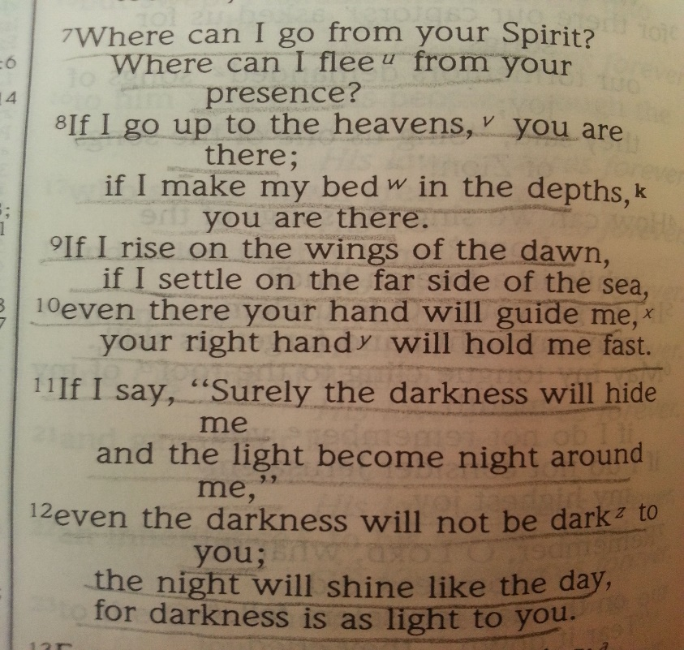
¹³ For you created my inmost being; you knit me together in my mother’s womb.
¹⁴ I praise you because I am fearfully and wonderfully made; your works are wonderful, I know that full well. ¹⁵ My frame was not hidden from you when I was made in the secret place, when I was woven together in the depths of the earth.
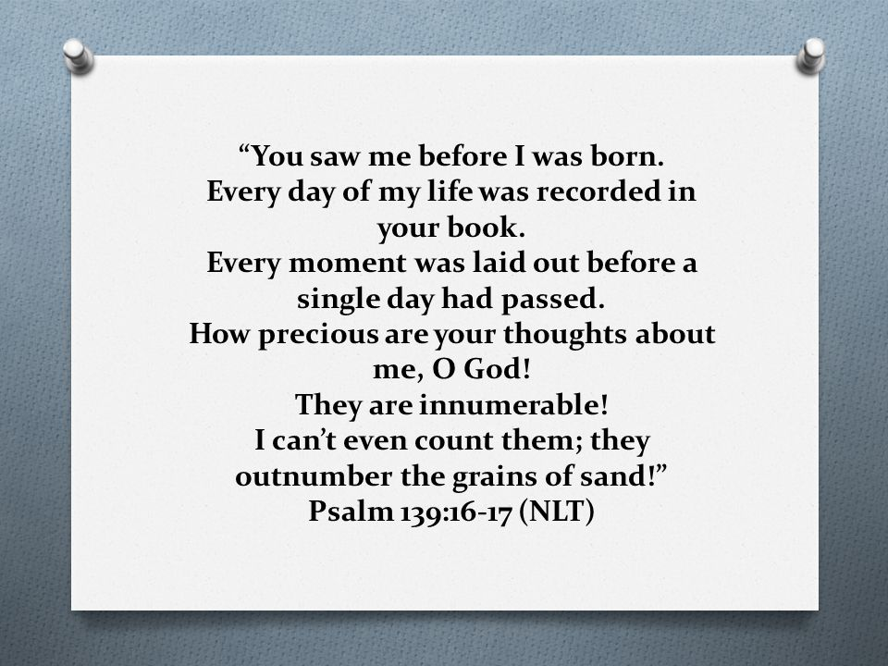

The patience of God was seen in his relationship with Abraham and Sarah - when they got stalled in Haran, God got them moving again.

After waiting eleven years for God to fulfill his promise, Sarah and Abraham took matters into their own hands.
Sarah gave her maidservant, Hagar, to Abraham to be his wife.
Hagar became pregnant and a son was born who was named Ishmael.
God’s justice didn’t clean up the mess that resulted from this decision.
Both Abraham and Sarah had to live with the consequences – which by the way, continue to this day.

In all of their journeys – from Ur to Haran to Canaan to Egypt to Canaan to the Negev to Canaan – God was present with them.

As Stephen moved on to the story of Joseph and then Moses, he again, demonstrated these emphases in the lives of these two men.



But God doesn’t live in any building.
We’ll consider next week what God himself said about this through the prophet Isaiah.

But what was true then is still true.
God doesn’t live in this building.
This structure and the land have been dedicated to being a place of worship; a place where Jesus is made known.

But when we go home, God doesn’t stay here, waiting for us… until we return.

When Jesus returned to his Father’s home, he announced that he and the Father through the Spirit would now make their home in the lives of those who follow Jesus.


Like Jesus, we, his followers, are portable temples.
Wherever we go, the presence of God goes with us.

We will unpack more of this incredible reality, next week.

When Abraham had arrived in Canaan, God told him that he and his descendants would not inherit the land for another 400 years, but rather would be strangers in a country, not their own.
There in that country, God said they would be enslaved and mistreated, until he rescued them and brought them back to Canaan to worship him.
________________________________________________
There is an important emphasis that we can’t unpack this morning.
But I do want to mention this truth to you.

Just as God determines the days of your life; so God determines the days of every nation. Just as God determines where you were born and what abilities you have, so he determines a nation’s boundaries.

Acts 17:24-27:
“The God who made the world and everything in it is the Lord of heaven and earth and does not live in temples built by human hands. ²⁵ And he is not served by human hands, as if he needed anything. Rather, he himself gives everyone life and breath and everything else.

²⁶ From one man he made all the nations, that they should inhabit the whole earth; and he marked out their appointed times in history and the boundaries of their lands. ²⁷ God did this so that they would seek him and perhaps reach out for him and find him, though he is not far from any one of us.

The Amorite people who lived in Canaan had been given that land by God.
But in that land, they did not seek God, but rather gave themselves up to the worship of the most despicable idols imaginable.

When Abraham was brought to Canaan by God, the LORD told him, the reason he had to wait 400 years, is because, Genesis 15:16, “…the sin of the Amorite has not yet reached its full measure.”

God gave an extended opportunity for the Amorites to turn in repentance to him. But they never did, and so God drove them out; and gave the land of Canaan to Abraham’s descendants that they might worship him there.
And when they chose to worship the same despicable idols they too lost the land.
__________________________________________

