The Little-Known Stories of Christmas December 16, 19
Jonah

I’m sure most of you know John 3:16.
Coffee Question:
What is the OT equivalent of John 3:16?
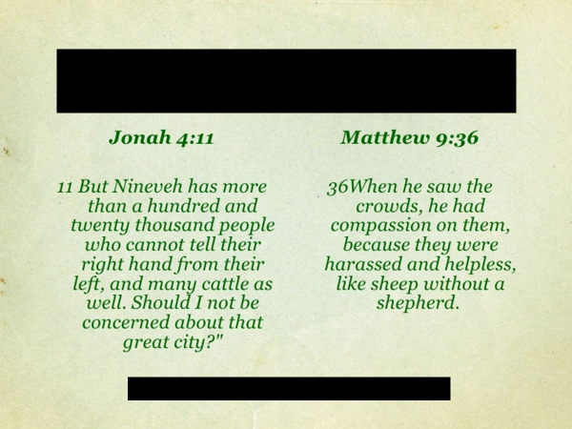
I’ve heard people say that the God of the OT is a bloodthirsty, angry God.
This is not the truth.
In what God did for the Ninevites, in sending Jonah to them, we see God’s heart.
And it is the same heart that was seen in Jesus.

In love God created the world, its creatures… and… humanity.
All that exists, is the result of love, not random chance.

The consequence of the choice made by Adam and Eve was three-fold.
- Human nature was irrevocably twisted by sin.
- Death entered into human experience.
- Adam and Eve became exiles as God drove them out of the Garden.

God dealt with them justly.
But he also dealt with them in love.
For in the promise God made to Eve – that a Rescuer would come – and in the action of God as he clothed them with the skins of animals – the Triune God put into motion, the plan that had been agreed upon by the Father, Son and Spirit, before…the creation of the world.

God who is both just and is love, identifies himself in Isaiah 63:1 as the One who is…
It is God’s intent that his plan of salvation reach…

When the Messiah was born, the angel told the shepherds, Luke 2:10-11:
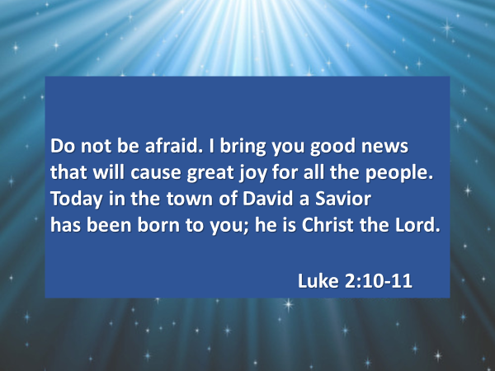

Isaac Watts almost 300 years ago, wrote a Christmas song that captured the excitement and the wonder of the angel’s message to the shepherds:
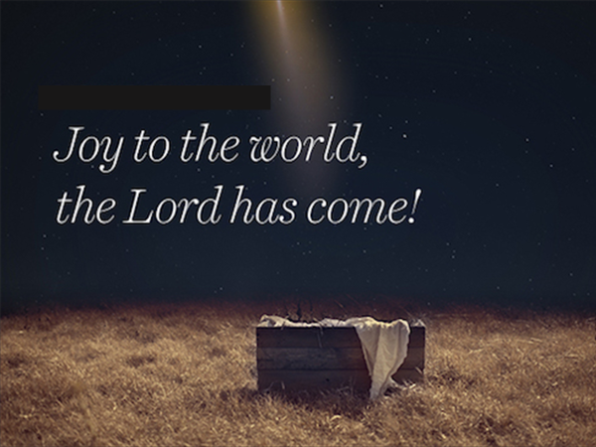
The birth of Jesus is the top news story of all time.
In the words of John 1:14 – the child born in a manger in Bethlehem… is the Lord; he is God in human flesh.
And his reason for coming to this earth?
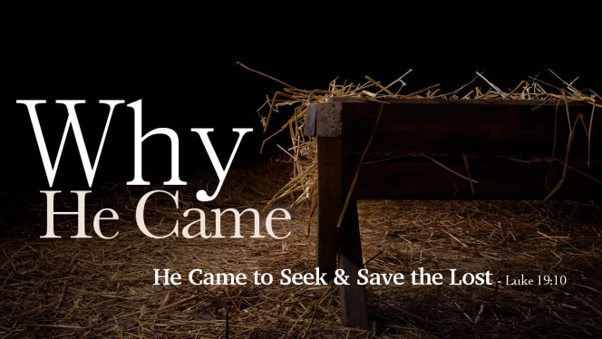

This is the backdrop for today’s little-known Christmas story.
An article by John McCallum, entitled “Christmas Stories: A Mission Story,” helped me greatly in my thinking for today’s teaching.

Jonah lived in the 700’s BC.
He was commissioned by God to speak for him.
Jonah 1:1-2.
When Jonah lived the nation of Assyria had already been the dominant world power for about a hundred years…and the cruelty [of its people] had become legendary.

The following pictures are taken from wall murals the Assyrians themselves created to commemorate their exploits as they conquered the nations surrounding them.
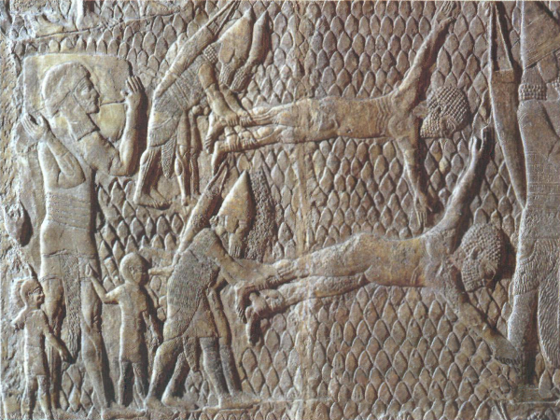

John McCallum writes, “The Assyrians had no shame, no conscience, no moral compass, no compassion. They made parades of [their captives] severed heads, requiring the friends of the deceased to carry them on elevated poles…”
John McCallum, “Christmas Stories: A Mission Story.”

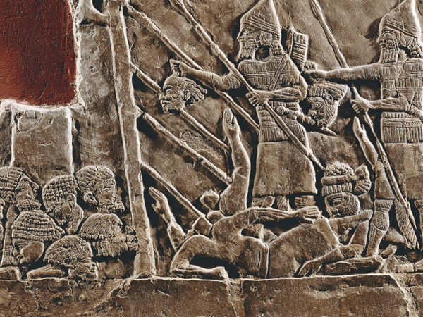

One of their kings, Ashurnasirpal II, bragged:
“I burnt their adolescent boy and girls…I captured many troops alive: I cut off some of their arms and hands; I cut off of others their noses, ears and extremities. I gouged out the eyes of many troops…. I hung their heads on trees around the city.” John McCallum, “Christmas Stories: A Mission Story.”
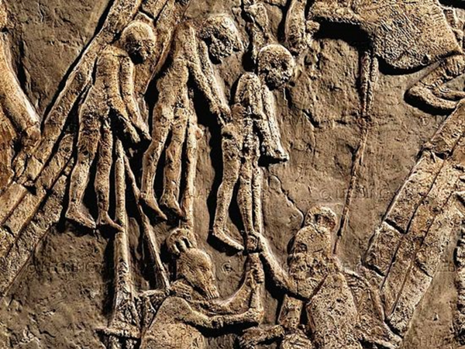

These…. were the people that God wanted Jonah to go to.
To gain a sense of the shock Jonah must have felt, imagine if God had asked you, in 2014, to go to Mosul, one of the main centers of the Islamic State, founded by ISIS.

And Jonah’s response to God’s commission?
Jonah 1:3.
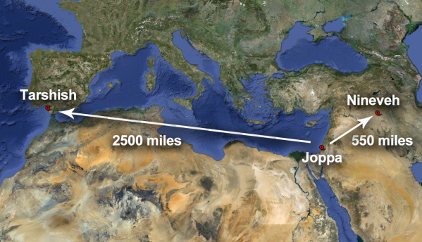

What Jonah discovered, was as important for him to learn as it is for you and me.
You can’t run or hide from God.

When Jonah ran, God took extraordinary measures to get him turned around.
Jonah 1:4-6.
That great storm was a wake-up call for Jonah – both literally and spiritually.
Jonah 1:7-11
In response to the sailors’ question, “What should we do to you to make the sea calm down?” Jonah’s answer at first read, seems strange.
But remember – his is a little-known Christmas story.

Jonah 1:12.
Jonah offered his life in order to save the lives of the sailors.
The sailors tried their best, unsuccessfully, to ride out the storm.
Jonah 1:13.
And when it became obvious, there was nothing more they could do, they reluctantly agree to do as Jonah suggested.
Jonah 1:14-17.

Through Jonah’s sacrifice, the lives of the sailors were saved from death by drowning.
And more importantly, they responded to God.

As Jonah sank into the ocean, his life too was saved.
Like the sailors, Jonah responded to God.
Inside the great fish, he repented.

Jonah 2:1-7

Disobedience to God creates turmoil within a person’s heart, mind and life.
But what happened with Jonah teaches us that the trajectory of a person’s life away from God can be changed – there can be a different outcome other than death - Jonah 2:9-10
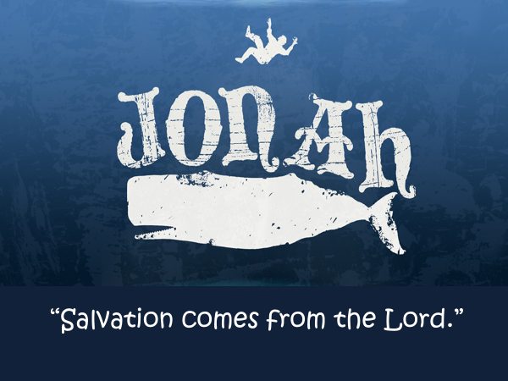
What happened next?
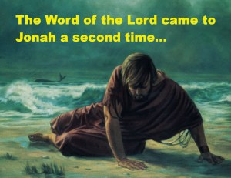
Jonah 3:1-3a
Jonah’s disobedience was not greater than God’s grace.
His initial reluctance did not frustrate God’s love.

Jonah 3:3b
Nineveh is located on the eastern bank of the Tigris River. Its ruins are across the river from the city of Mosul, in Northern Iraq. https://en.wikipedia.org/wiki/Nineveh
Some of its walls sill stand.
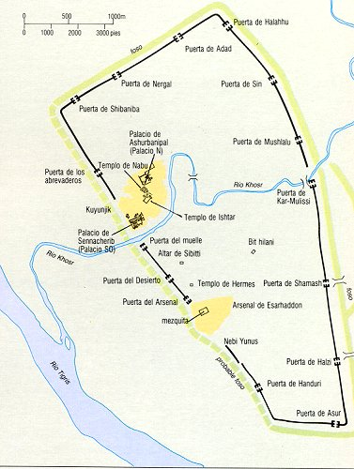
When Jonah got to Nineveh, he did as God asked – he spoke the message he had been given. Jonah 3:4.

This was probably the shortest sermon ever given.
No coffee question / no one or two key points / no application.
Jonah simply stated that in 40 days judgment would fall upon Nineveh.

Why did God warn the Ninevites?
The answer to this question speaks to who God is.
He is just, and he is love.

A hundred years later, God spoke through the prophet Ezekiel, to his people who were now exiled in Babylon, 18:30-32.
He spoke to them a similar message:
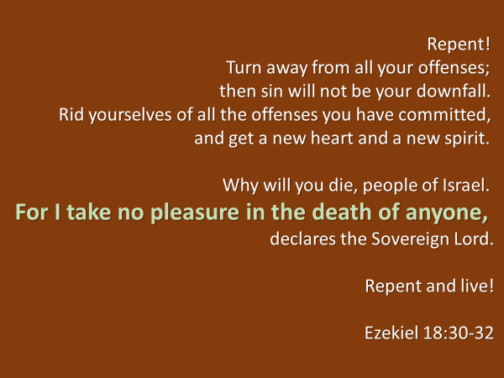
How did the people of Nineveh respond to Jonah’s message?
Jonah 3:5-10
While heaven rejoiced at the response of the Ninevites, Jonah did not.
Jonah 4:1-3

The Ninevites cruelty and their crimes were deserving of God’s judgment.
The Ninevites were so lost that they couldn’t even tell the difference between right and wrong.

Why was Jonah angry?
Not because God had threatened to judge them.
It would seem Jonah was happy to deliver that message.
What angered Jonah was that when they repented God forgave them.

God loves his enemies.
And the truth is, there is no human being who stands innocent before God; there is no one who is deserving of God’s mercy.
What all of us deserve…is God’s judgment.

God revealed himself through Jonah, and then most completely in the person of Jesus, to be a God who seeks after lost people in order to save them.
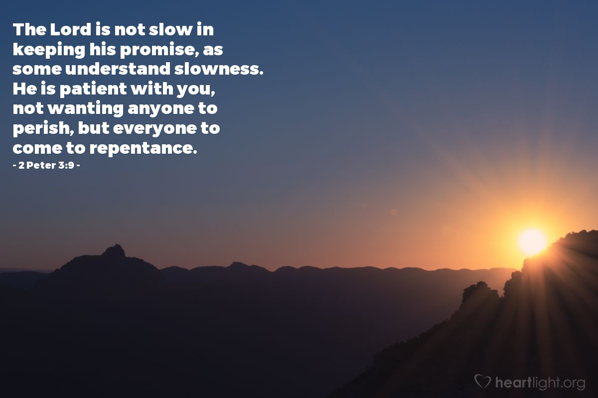

The story of Jonah is a Christmas story.
It speaks of God’s great love for the world of humanity.
It is God’s love for the spiritually lost that explains the extraordinary measures he took to get his messenger, Jonah, to speak his truth, “judgment is coming,” in order to save the people of Nineveh, who were not deserving of being saved.

The story of Jonah foreshadowed the greater story of Jesus.

Because of love, Jesus willingly came to live among us.
Because of love, Jesus willingly gave his life in sacrifice for us in order to pay in full our debt that we might go free.
And God raised Jesus from the dead so that all might know his plan had succeeded – there was now a way home.

Because God is gracious and compassionate, slow to anger and abounding in love,
the trajectory of a person’s life can be changed.
Many of us in this room are living proof of this.

There is a second way in which the story of Jonah is a Christmas story.
The good news of the gospel tells a person the truth of who they are – if they persist in a way of life that excludes God, their life will be overturned.

But if they believe God, as the Ninevites did, they will be saved.

Humanity’s only hope has always been God.
And the good news of God is that no one is beyond the reach of his salvation – as seen in the case of the Ninevites.

When a person repents of their sin, and believes God; when they stake this life and the one to follow death, upon the person of Jesus, they are saved and heaven rejoices.

It was God who enabled the Ninevites to understand and to respond.
Has God enabled you to understand who Jesus is and what he did…for you?
Do you sense his tug on your heart to turn to him?

I urge you to respond to the LORD.
As we sing our closing song, I’m going to wait here at the side for you, that we might pray together as you welcome Jesus into your life.
The promise of Jesus is that all who come to him he will receive.

There is a third way in which the story of Jonah is a Christmas story.
God uses his angels… and humans in the announcing of the good news that he is mighty to save.

If you are a follower of Jesus, like Jonah, your life… is his to do with… and to use as he pleases.
You and I live to make him known; to share the news that Jesus saves.
We live for his glory.

These four words are to describe our response to any request made of us by the One who has saved us.
Anywhere; any time; any place; anyone.

It is quite possible that some of you, like Jonah, have been running from God because of something you know he wants you to do.
You are not in the belly of a great fish, but you are in a hard place.

And this morning, God’s Spirit has helped you realize in the circumstances that are happening to you, he is at work to bring you back to the place where, as you did when you first came to him, willingly put your life in his hands, and agree to be and to do what he wants of you.

I urge you to respond to the LORD.
As we sing our closing song, I’m going to wait here at the side for you, that we might pray together as you again put your life in his hands.

The promise of Jesus is that all who come to him… he will receive.
