Membership and Baptism, Part Two January 27, 2019

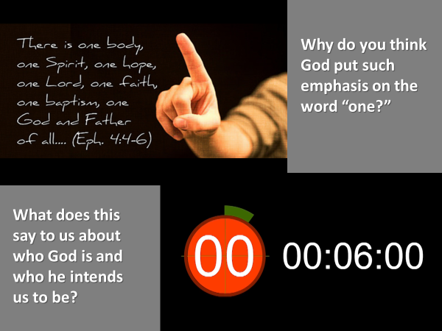

Two weeks ago, we started to study what the Bible says to us about “one body” and “one baptism.”
We want to hear what God says, in order to discuss and to discern together what our practice is to be.
There are unseen, spiritual realities that God intends to make visible in his people through our spiritual practices.
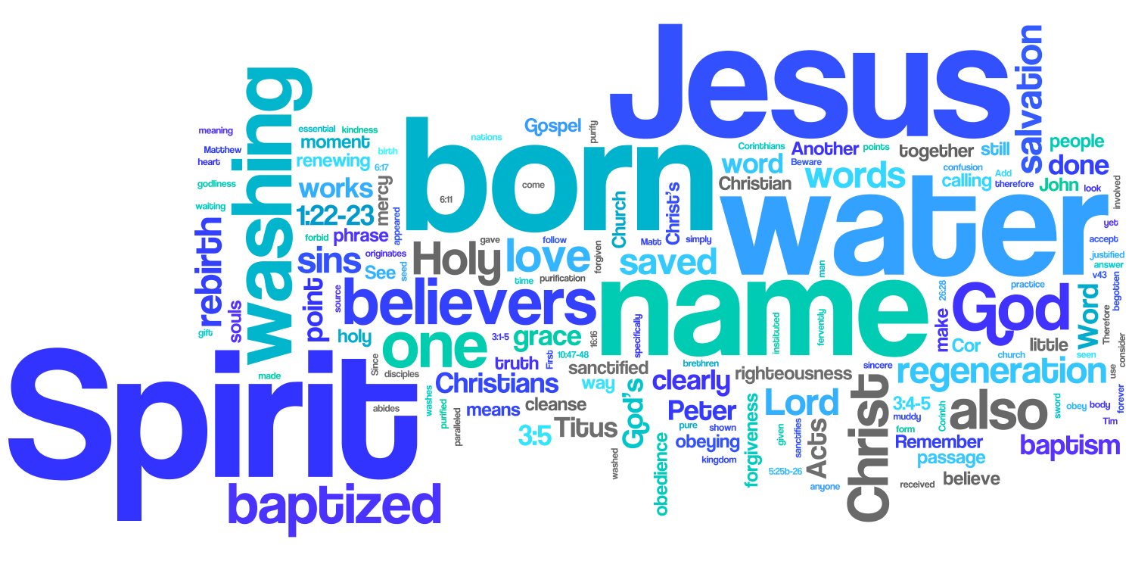
When a person responds to God’s pursuit of them… and believes in Jesus and receives him into their life, a miracle takes place within – God’s Spirit creates in them a new nature that is alive and responsive to God.

The Holy Spirit is a gift from God.
He comes not only to create, but to empower our new nature.
He comes as a guarantee from God that what he began in us will be completed. He comes to take up residence in the believer’s life, and in this way, the Holy Spirit fulfils the promise of Jesus – I will be with you to the end of the age.

As the Holy Spirit comes into a person, he baptizes them in the life of God – filling every aspect of their life with his life.

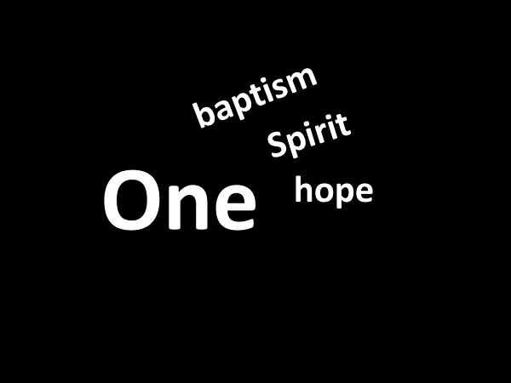
This unseen inner work is the one baptism … done by the one Spirit …. who gives to all of Jesus’ followers… the one hope… spoken of in Ephesians 4.

And it is this – the baptism of the Spirit … that is demonstrated when a follower of Jesus is water baptized.

Jesus when he was tempted by Satan, said to him, “May shall not live by bread alone, but by every word that proceeds from the mouth of God.” Matthew 4:4

Jesus is described in John 1 as, “The Word” …
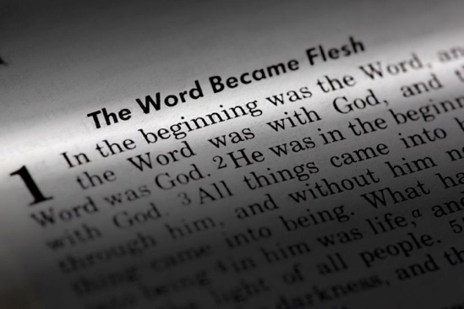
…who in the beginning was with God and is God, and who sustains and nourishes all those who are in relationship with him.

Jesus described himself in John 6 as the bread of life.
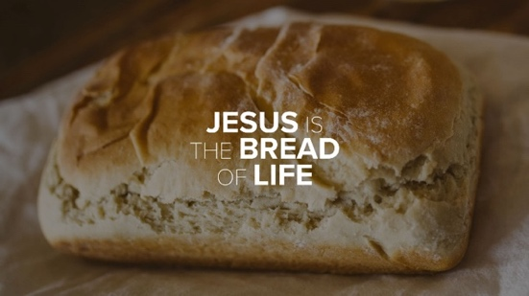

When we celebrate the Lord’s Table, and eat the bread and drink the cup, which together represent the body and the life of Jesus, who is the one Lord…
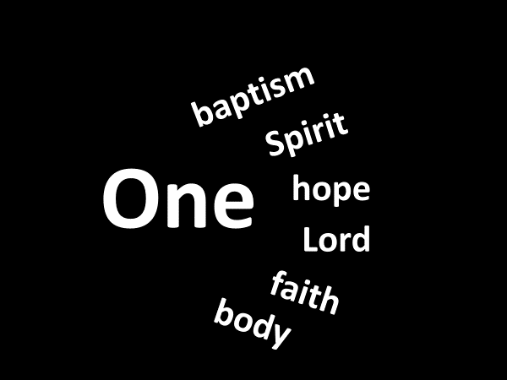
…we demonstrate in a tangible way, this unseen reality – the life of Jesus who nourishes (feeds) our new nature.

When a person trusts in Jesus, they become a part of his universal church,
the one body, comprised of believers who share one faith, from every nation on the earth, both living and those who are currently with Jesus in his home.

When a follower of Jesus becomes a declared member of a local church, they make visible this unseen reality.

Two weeks ago, we looked at what the Bible says regarding membership in a local church. Today we begin to study what the Bible say about baptism.
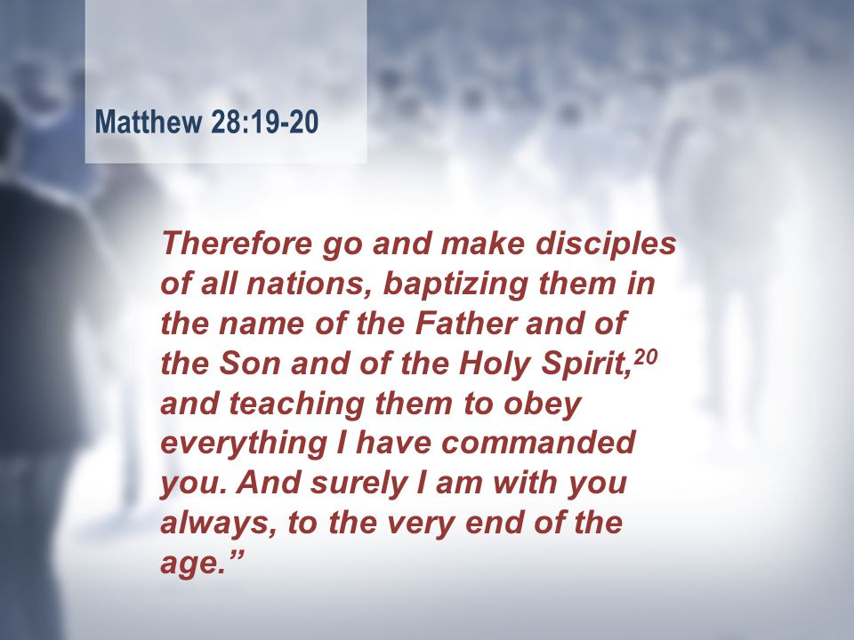

The mission of Jesus is to the world.
The mission of Jesus has been placed in the hands of his followers.
The mission of Jesus involves the making of disciples.

According to Jesus, how are disciples made?
Jesus identified two specific things in Matthew 28.
- “Baptize them in the name of the Father and of the Son and of the Spirit.”
- “Teach them to obey everything I have commanded you.”

We know this mission is of the utmost importance to Jesus because of his promise – “And surely I am with you always, to the very end of the age.”

In the making of a disciple, is a new believer to wait… until they are able to obey everything… before being baptized?

Look again at the verse in Matthew 28.
Being baptized is one of the first things a person does after being born of the Spirit through faith in Jesus.

There are numerous Biblical examples of this.
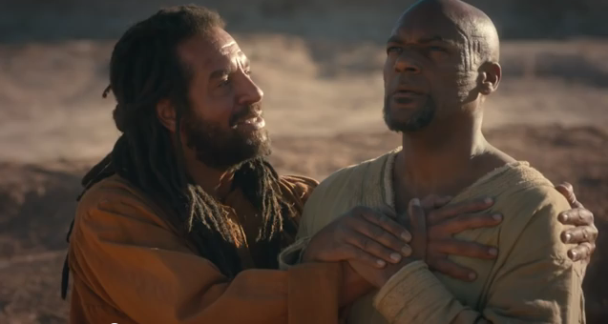
ie. Philip and the Ethiopian eunuch – Acts 8:26-40.

- v.26 – the Lord sent Philip to a specific place.
- v.27-29 – the Spirit directed Philip to a specific person.
- v.30-31 – Philip asked a specific question

What was the eunuch reading? v.32-34.
The eunuch could read – but he didn’t understand the meaning of what he read. v.35 - God had sent Philip to the eunuch to make known the truth of Jesus.
This is why God sends his followers to people.
The message of salvation through Jesus is “good news.”

- v.36 – the phrase – “as they travelled along” – is also important.
It lets us know that Philip and the eunuch talked together.
At some point the eunuch invited Jesus into his life.

His question – “Why shouldn’t I be baptized?” – tells us that the good news of Jesus which Philip had shared with him, had included the importance of being baptized in the name of the Triune God.

- v.38-39 – the two phrases “into” and “out of” is important.
We’ll come back to these.
But what I want us to see from this passage, is that as soon as the eunuch believed and received Jesus, he was baptized.

It was the same with the jailor and his family in Philippi – Acts 16:16-40.
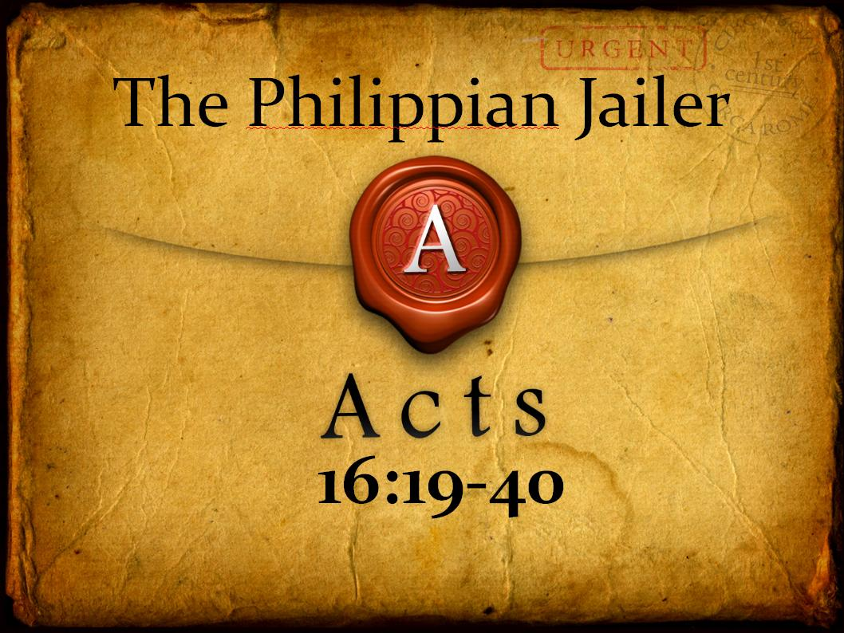

The teaching of the Bible is that being baptized is what a person does after they have believed in Jesus.
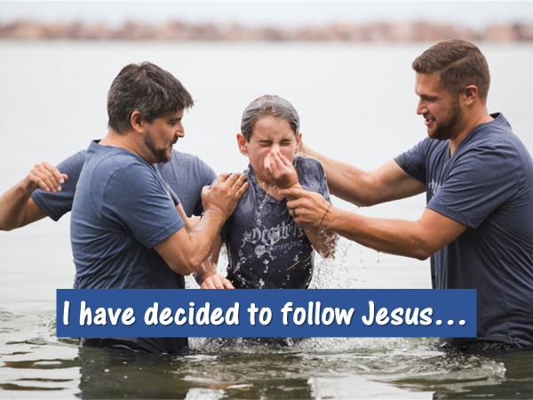
Before we go any further in our study of the relationship between baptism and membership, it is important for us to look at Jesus’ baptism and to learn from his example.

The OT prophet, Isaiah, had foretold of one who would come before the Messiah; who would prepare the way for him.
John the Baptist was the one, described in Isaiah 40, as the voice.
John’s ministry was a ministry of preparation.
What does that mean?
John called people to repent of their sin, and to give evidence of their repentance by being water baptized.
For what reason?
To make their hearts ready.
Ready for what?
Listen to how John explained it.
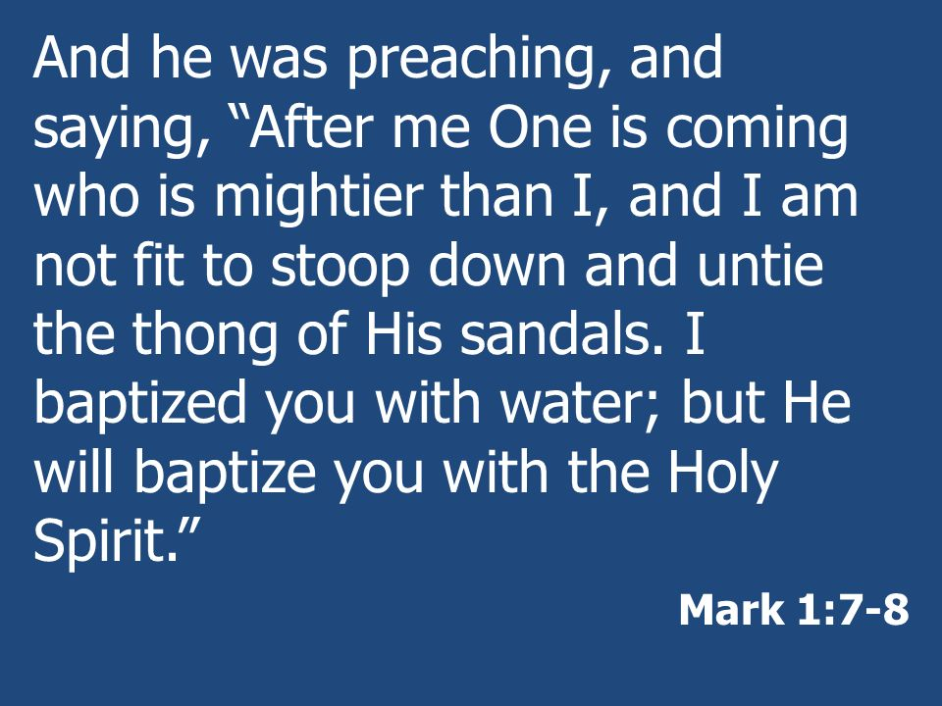

This baptism of repentance would prepare a person for a greater baptism – the baptism of the Spirit.

There is a question we must ask.
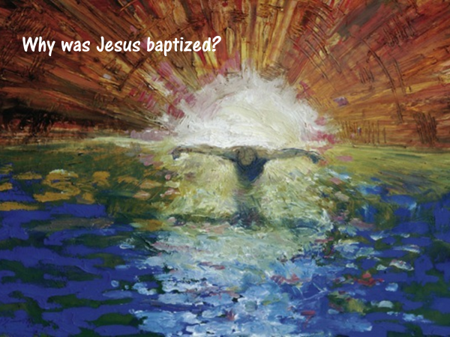
Why did Jesus, the One who would baptize with the Holy Spirit, participate in a baptism of repentance?

Let’s look at what Matthew’s gospel says to us, and see what we can discern.
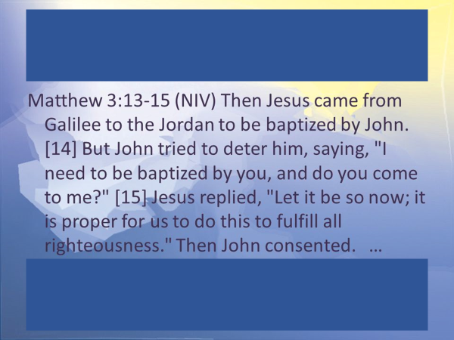
Key points
- Jesus came to John to be baptized
- John tried to dissuade Jesus
- Jesus insisted John baptize him saying, “It is proper for us to do this to fulfill all righteousness.”

There is an Old Testament passage, quoted in Hebrews 10 that helps us to understand why Jesus insisted that John baptize him.
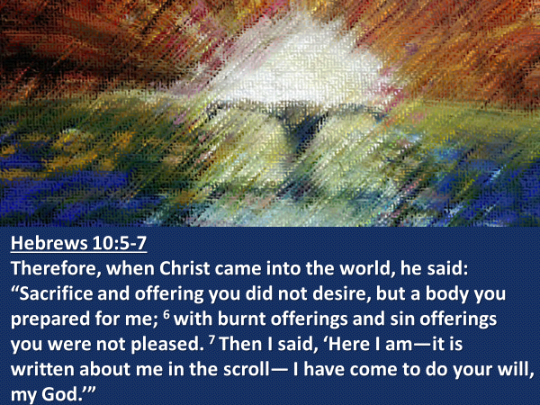

It was God the Father who prepared a body for Jesus—through the incarnation…
When Jesus came to John, he had come to to carry out, as Hebrews 10 says… the will of God. https://bible.org/seriespage/5-baptism-jesus-matthew-313-17
What was the will of God the Father that Jesus said yes to, at his baptism?
To answer that question, we have to go back to Isaiah 53.
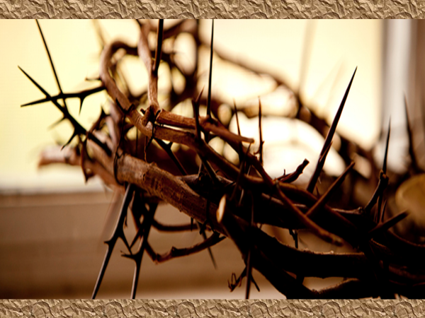
It was God the Father’s will…
v.4 – that Jesus take up our infirmities and carry our sorrows.
v.5 – that Jesus be pierced for our transgression and crushed for our iniquities.
v.6 – that our iniquities be laid on Jesus.
v.8 – that Jesus be punished for our transgression.
v.10a – that Jesus be crushed and suffer.
v.10b – that Jesus’ life be an offering for sin.
v.11 – that Jesus justify many by bearing their iniquities.
v.12 – that Jesus pour out his life unto death.
v.12 – that Jesus be numbered with the transgressors.

This is what Jesus said yes to.

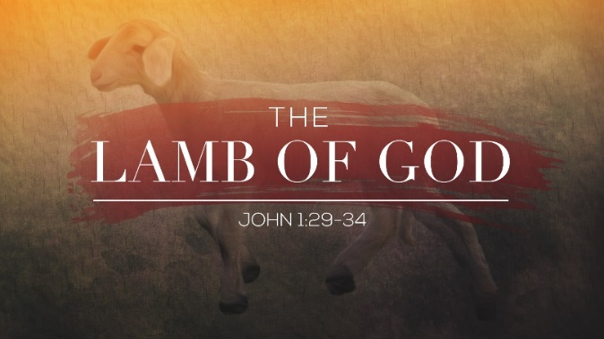
It had been made known to John the Baptist that Jesus was, John 1:29, “the Lamb of God, who takes away the sin of the world.”

This is why John was confused and why he tried to deter Jesus.
Why would the One who takes away the sin of the world, need to undergo a baptism of repentance?
As he came to John to be baptized, Jesus knew he was the Suffering Servant.
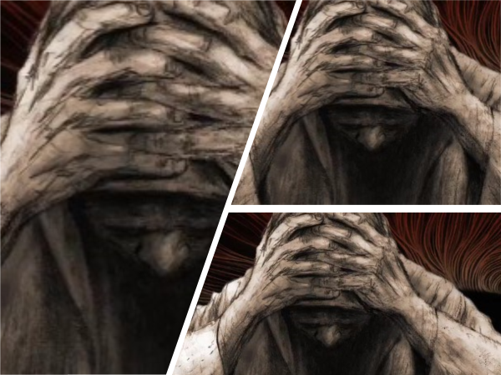
In the waters of the Jordan River, as he was baptized, Jesus identified himself with the fallen sons and daughters of Adam and Eve.

Devon Wiens writes: “So crucial to an understanding of Jesus’ mission is his baptism that Jesus himself categorizes his whole life’s work… as a baptism.”
directionjournal.org

Mark 10:35-39 - Then James and John, the sons of Zebedee, came to him. “Teacher,” they said, “we want you to do for us whatever we ask.” ³⁶ “What do you want me to do for you?” he asked. ³⁷ They replied, “Let one of us sit at your right and the other at your left in your glory.” ³⁸ “You don’t know what you are asking,” Jesus said.
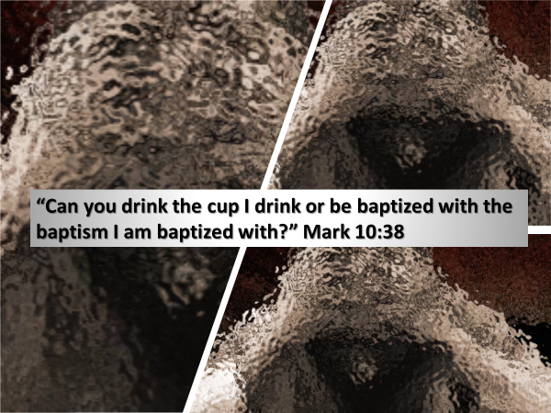

Another time Jesus said:
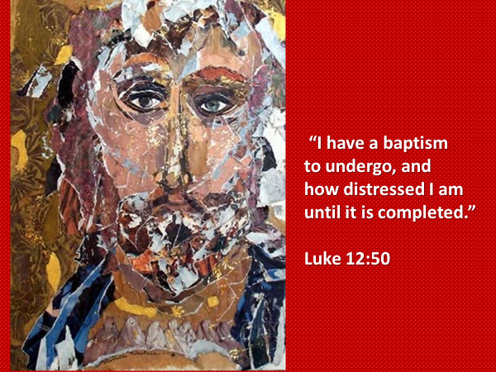

At the cross, on the hill of Golgotha, as the sin of the world was placed on him, Jesus’ soul underwent a baptism none of us can ever comprehend.
Its intensity was so profound, so horrific, that Jesus cried from the cross, “My God! My God! Why have you forsaken me?”

This baptism on the cross is what Jesus’ baptism in the Jordan River pointed ahead to.

Let’s go back to the text in Matthew
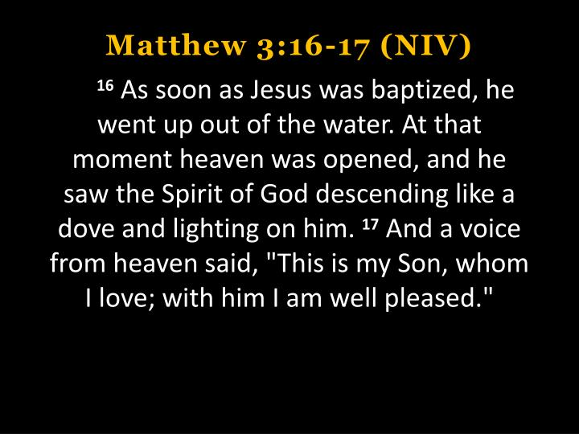
Key points
- Jesus went up out of the water.”
- The Holy Spirit descended like a dove and settled on him.
- The Father spoke from heaven affirming his love and delight in Jesus

At the beginning of his public ministry, after identifying with fallen humanity by being baptized, it is significant that Jesus was anointed with the Holy Spirit.

The Spirit came upon Jesus in order to give him power from heaven.
To do what?
Jesus answered that question in his hometown synagogue:
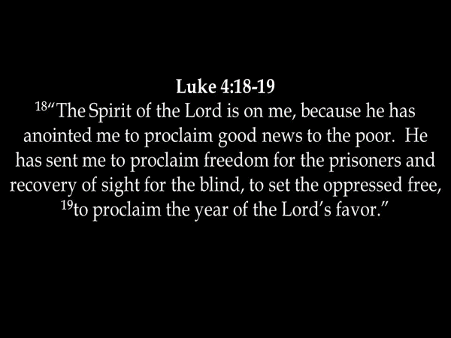
The emphasis of the gospels is that the Spirit didn’t just descend upon Jesus, but that he descended like a dove.
What does that mean?

A dove symbolizes gentleness.

One of the characteristics of the person of Jesus, who, remember, is God in human flesh, is his gentleness.
But how and in what way was Jesus gentle?
Isaiah 42:1-4, which Matthew quotes in 12:18-21 as being fulfilled by Jesus, says:
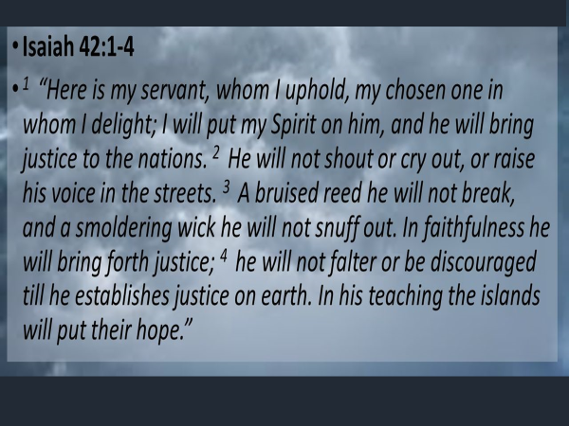
Throughout the gospels, the gentleness of Jesus is repeatedly seen in his interactions with people.

Through the Spirit’s enabling, Jesus taught with authority.
He spoke the truth – in love and with grace.
- a woman at a well
- a dad whose son was demonized
- a woman caught in sin
- a man who lived in a graveyard

In addition to the Spirit descending like a dove and resting upon him, the voice of the Father spoke from heaven to Jesus, at this crucial moment.
What was it that pleased the Father?

Jesus’ willingness – to be the suffering servant.

Let me draw several applications to our own lives from Jesus example.
I simply remind you in order to encourage you.

-> Jesus chose to go from his hometown in the Galilee down to where John was.
We learn from Jesus … that in regards to baptism, our willingness matters to God.

-> We learn from Jesus when he said to John that he needed to be baptized in order to “fulfill all righteousness,” that baptism is a response of obedience to God.
When we put these two together, we learn that willing… obedience… is what God looks for; it’s what he delights in; it is what pleases him.

-> We learn from what the Father said to Jesus, “This is my Son whom I love,” that the relationship between the Father and Jesus was a relationship of love.
This is at the heart of understanding who God is and the relationship he invites us to have with him.

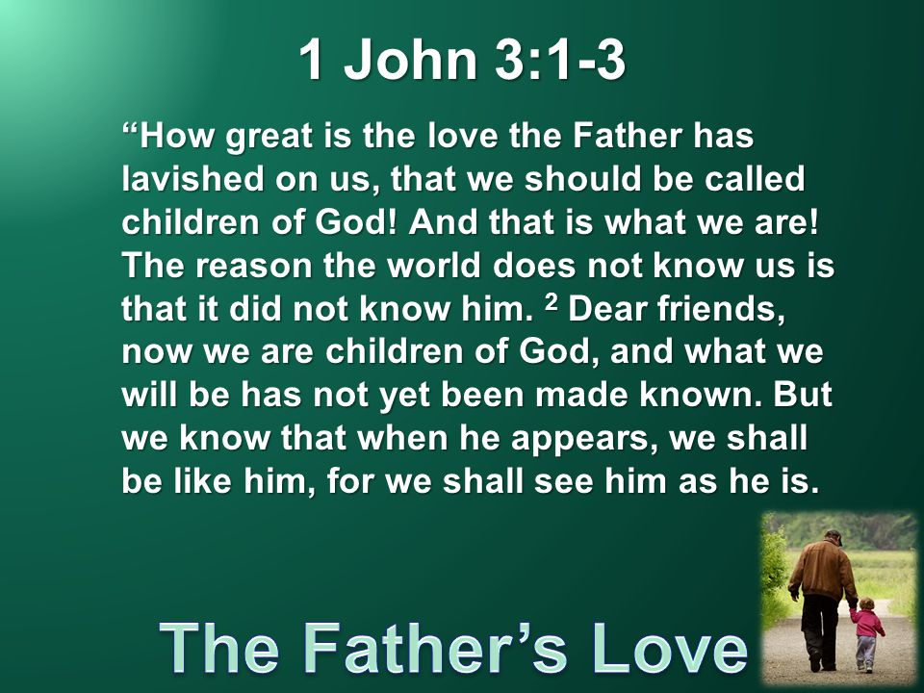
All that God has done and does in his interactions with you and me is because of his lavish, extravagant love for us.

Our response to God in receiving and believing in Jesus; as well our decision to be baptized… is a response of love.

-> We learn from Jesus that baptism is a declaration of commitment.
There at the Jordan River, as he was baptized, Jesus’ committed himself to the Father to be the Suffering Servant.

Our baptism is also an expression of commitment to God.
Commitment in what sense?

When a man and a woman establish a covenant of marriage, they make vows to one another, in the presence of God:
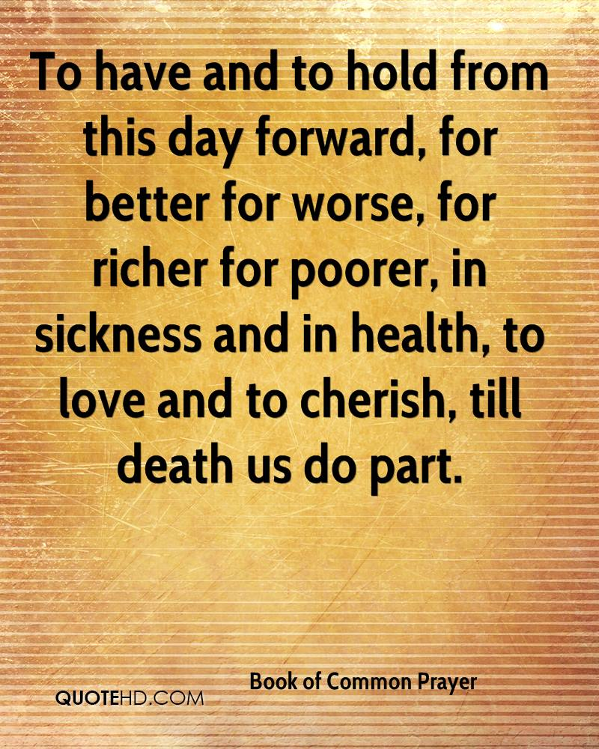

A couple making such promises has no idea of what the future will bring.
But that’s the whole point of their vows.
They promise to be there for one another, regardless.

In a similar way, the follower of Jesus has no idea what the future will bring.
They don’t know the situations, circumstances, pressures, temptations or trials that will come into their life.

But having been gripped by the immense and enduring love of the Father, Son and the Spirit, at their baptism they commit themselves, publicly, to follow Jesus until he returns or they pass from this life to the next.

Put all of this together… wee learn from Jesus that water baptism is the love motivated, willing commitment of obedience to the One who loved us first and gave himself for us.

Prayer

Next week we will press further into this teaching on baptism and membership.

We come to the Table this morning to remember Jesus and his sacrifice for us.
We come with gratitude and love.

As our next songs express, the table is an invitation to come near to Jesus;
to confess any sin, he convicts us of; to lay down anything that has kept us from him.

Because of his sacrifice you and I can know peace with God and forgiveness.
Come to him.
At any point, there are people ready to pray with you if you so desire.

It is the work of the Triune God who has brought about our salvation.
In the OT era, the mark that signified membership in the covenant people of God was circumcision. But this mark was placed only on the men.
In the NT, baptism has replaced circumcision, and is a mark of membership for both men and women.

Membership n the new covenant people of God is not by physical birth but by spiritual birth. JP
You must be born again, said Jesus.

But a mark for whom and a mark indicating what?
Colossians 2:11-12 - In him you were also circumcised with a circumcision not performed by human hands. Your sinful nature was cut off when you were circumcised by Christ, having been buried with him in baptism, in which you were also raised with him through your faith in the working of God, who raised him from the dead.

The follower of Jesus has had – their sinful nature cut off.
Who cuts this sinful nature off?
This spiritual circumcision is done by Christ.

When does this spiritual circumcision happen?
Is this passage suggesting that water baptism

Romans 6:3-4
“…all of us who have been baptized into Christ Jesus were baptized into his death. We were therefore buried with him by baptism into death…”

What is the truth being put on display by baptism?
Galatians 2:20 – I have been crucified with Christ…

Romans 6:3-4
“…in order that, just as Christ was raised from the dead by the glory of the Father, we too might walk in newness of life.”

What is the truth being put on display by baptism?
Galatians 2:20 - …and I no longer live, but Christ lives in me. The life I live in the body, I live by faith in the Son of God.

As I said last time, there are three visible practices by which we act out internal
heart realities – water baptism; the Lord’s Table; membership in a local church.

Water baptism demonstrates the baptism of the Spirit that took place when a person receives and believes in Jesus.

