Easter Sunday 2020 April 12

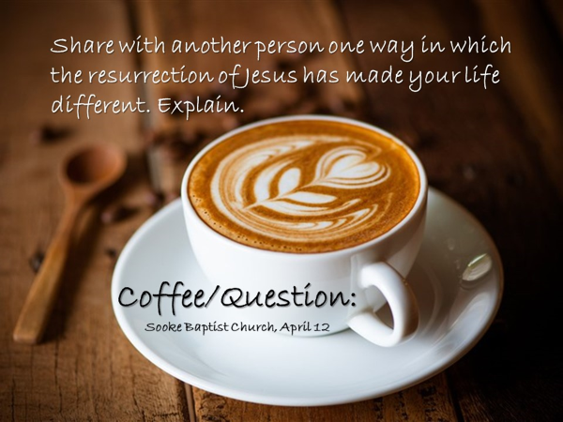
Last Sunday we saw from the Scriptures that Jesus was the great King which king David had pointed ahead to.

Through the prophet Zechariah, five hundred years before Jesus came,
God promised the exiles who returned from Babylon, that their King, would return to Jerusalem.

God gave to them a sign by which they would recognize the great King – he would ride into Jerusalem on a donkey.
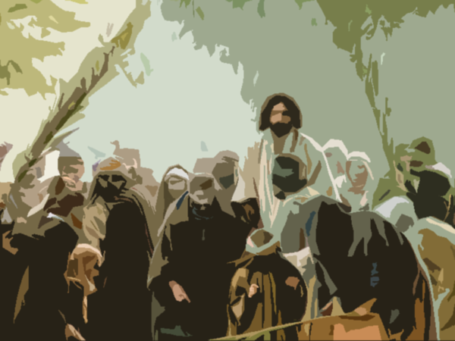
God assured the exiles that when the great King came, he would sit upon the throne of his father David and that his kingdom would stretch from sea to sea and to the ends of the earth.

This morning, I want to do two things.
On Good Friday, we studied how the Passover sacrifice had pointed ahead to Jesus, who was the Lamb of God.
I want us to look today at another OT signpost that remarkably illustrated what Jesus’ death accomplished.

On Good Friday, we also considered the conversation Jesus had with Moses and Elijah…
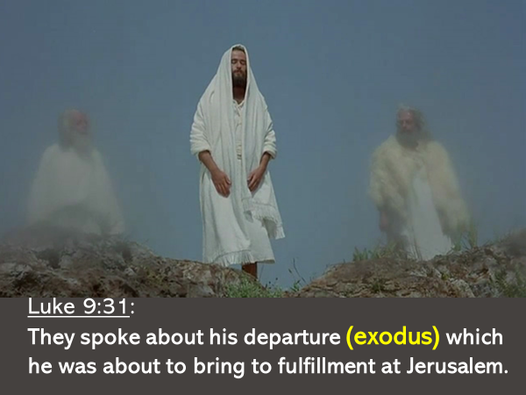
… regarding his exodus which took place in Jerusalem.

The second thing I want to do today, is connect this extraordinary theme
of exodus to Jesus’ resurrection from the dead.

Let’s start with the OT signpost.
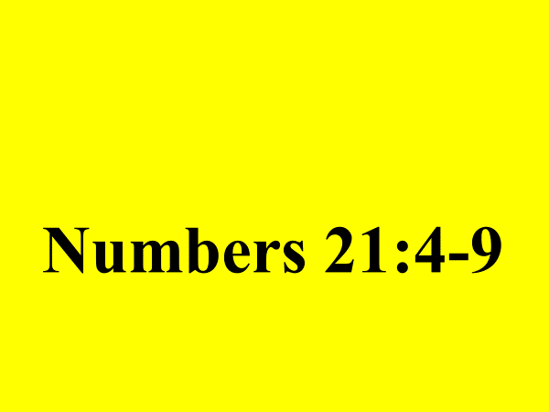
This incident took place 40 years after the exodus from Egypt.
.
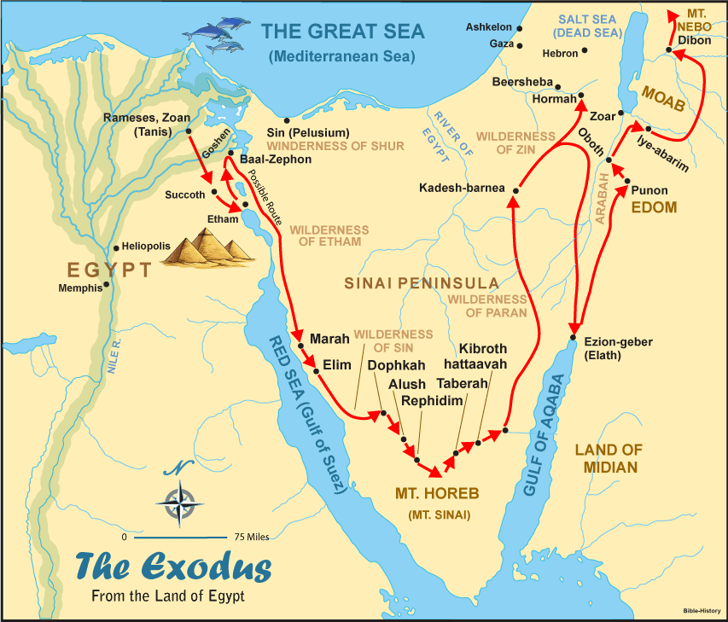
What was the mood of the people?
Look at v.4 - they were impatient.
How did the people respond to God and to Moses?
Look at v.5 - they spoke against them.
There were four threads to their complaint.
- Why have you brought us here to die?
- There is no bread!
- There is no water!
- We detest this miserable food!

I need to let you know that those who complained against God in Numbers 21 were children when the nation of Israel left Egypt.
They had been forced to wander in the desert for forty years because of their parent’s sin… of grumbling against God…and here they are doing the same thing.

What happened as a result of their grumbling? Look at v.6.
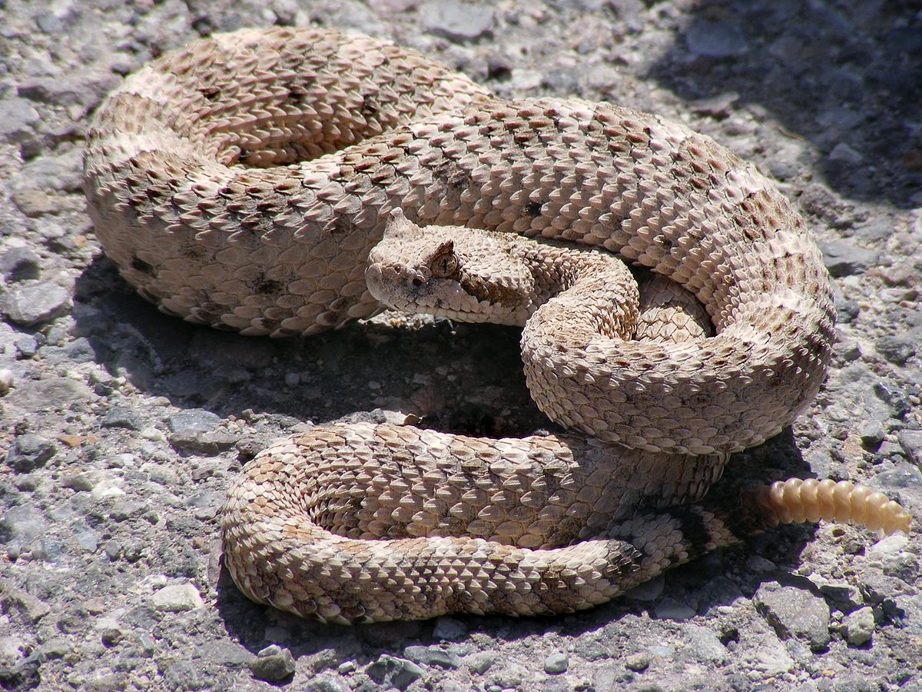

God’s severity is meant to impress upon the reader, the seriousness of sin.
In God’s eyes, sin is no small thing.
It never leads to life.
It always poisons and kills, just like the snakes that came into the camp.

What did God do when the people acknowledged their sin?
He provided for them an antidote.
God told Moses to make a snake… and then attach that snake to a pole… that was placed in a strategic location in the camp.

Then word was sent out to everyone…
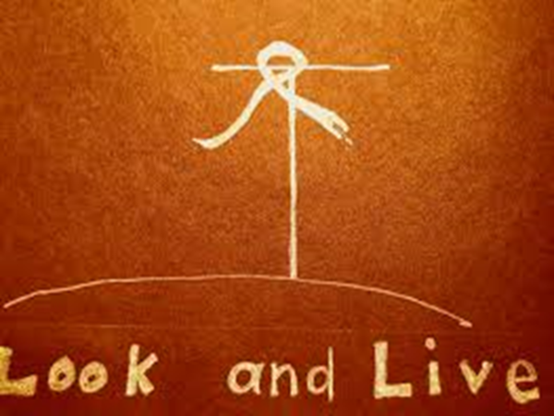
– if you are bitten, look at the bronze snake on the pole… and you will live.

God’s cure did not require an infected person to walk a long distance to a designated location; or to undertake a difficult task; or to purchase a costly tonic.
The cure was simple – look and live.

The presence of the snake on a pole did not automatically cure those who had been bitten and were dying.
It was not enough that the antidote…. was in the camp.
In order to live, one had to look to the bronze snake.

This is the aspect of the story that pointed ahead to Jesus, revealing how he through his death would save.
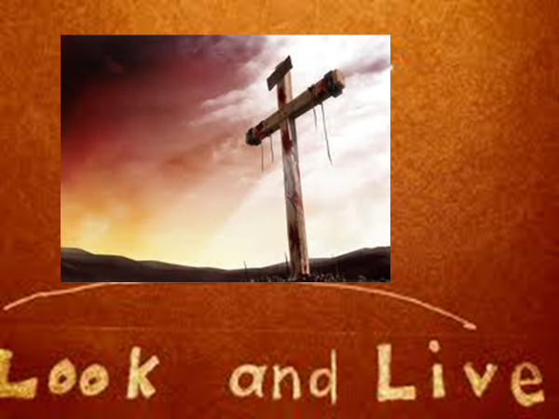

In John 3, a religious leader named Nicodemus came to Jesus at night to speak privately with him about the kingdom of God.
Jesus told him:
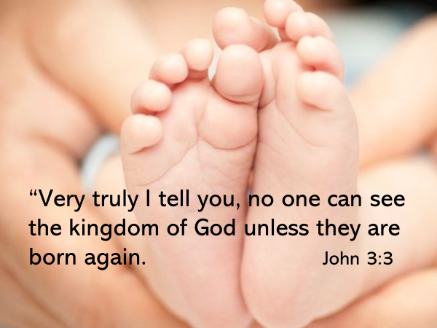

Nicodemus struggled to understand what Jesus meant by…. born again.
Using the analogy of the wind and how it blows, Jesus endeavored to illustrate to Nicodemus this concept.
But Nicodemus was still confused and asked, “How can this be?”

In explaining how one is born of the Spirit, Jesus connected who he is – the Son of Man who had come down from heaven – and what he would do – be lifted up.
Jesus said..
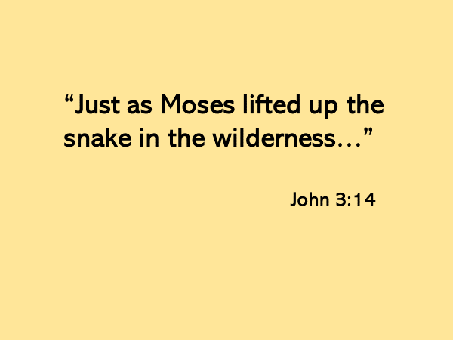
As the snake on the pole was the cure for the bite of a venomous snake, Jesus said to Nicodemus…
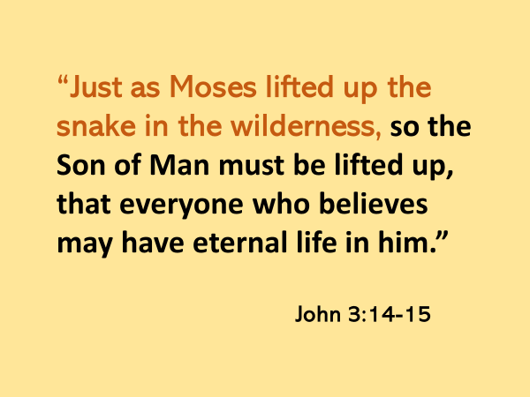

Looking to Jesus… is the cure… for the poison of sin that kills.
And that look… that believes in Jesus… welcomes God the Holy Spirit to perform within a person the miracle of the new birth.

This was not the only time that Jesus used the story in Numbers 21 to explain who he is and what he had come to do.
After Palm Sunday, but before he ate the Passover meal with his disciples, in John 12, Jesus spoke a second time of being lifted up.
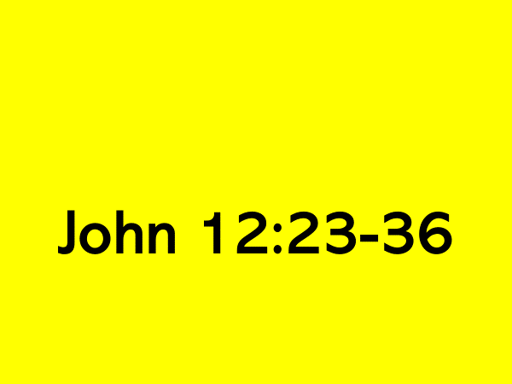
When Jesus was lifted up on the cross, the Father revealed Jesus to be… the hope of the world; the One who came to save.
By Jesus’ death the prince of this world would be judged and driven out.
Through his death, a great measure of grace was given for Jesus to draw all people to himself.

As Jesus had assured Nicodemus, here again in John 12, he urged his listeners to “look to him… and live.”

Let’s now consider this remarkable theme of Jesus’ exodus and see it’s connection to his resurrection.

God created humanity to live, not die.
The temptation of Satan to take and eat, when acted upon, opened the door for death to “sting” humanity and bring us under its rule and power.

The reign of death has been an agony, and a bitter bondage.
But on the day, humanity fell, God promised a Rescuer would come, who would crush the head of our enemy.

That Rescuer was Jesus, and he knew what it would cost him to save us.
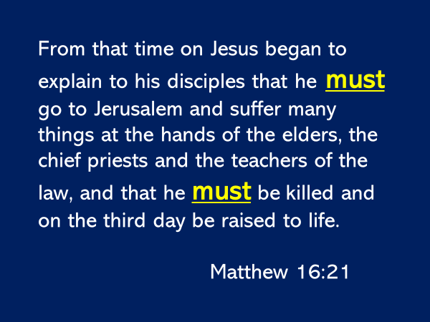
Like the Exodus from Egypt which followed the sacrifice of the Passover lamb,
so too… Jesus’ exodus followed the sacrifice of his innocent life.

Jesus faced the enemy of death on our behalf, and he defeated it.
How do we know this?
Because God brought Jesus out of the grave.
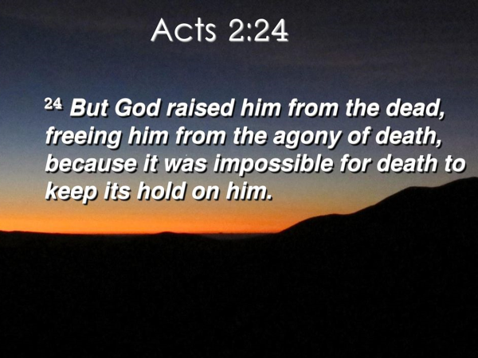
As Jesus’ death provided the cure for sin, his resurrection provides, for all who look to him, an exodus… out of … the bondage to death.
The Scripture in 1 Corinthians 15 explains.
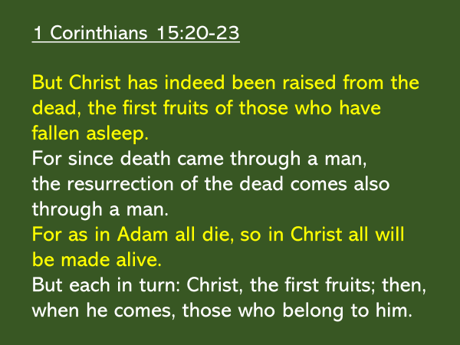
Jesus is described in this passage as the first fruits.
What does that mean?
We have a peach tree in our yard.
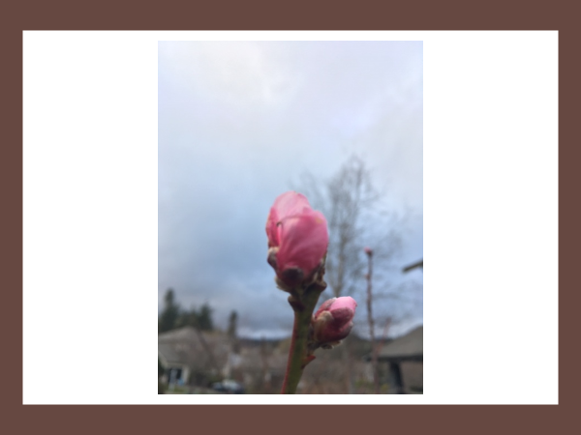
All over the branches of the tree are blossom buds.
But several of these buds are already opened.
You could say…they are the first fruits – they speak to what will soon be true of every blossom bud.

As we look to Jesus in faith, we are born of the Spirit… our inner person which was dead to God is now alive to him…the life of heaven is in us.
But our salvation, which God promises to complete in us (see Philippians 1:6), is a salvation, not just of our spirit, but of our soul and body.

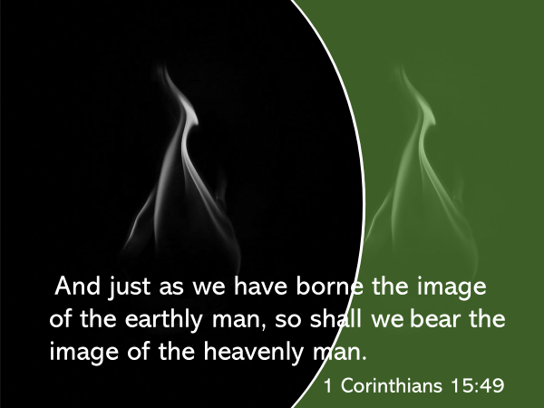
Jesus is the second Adam.
He lived the life we could not.
When he died in our place, he died the death we deserve.
When he rose from the dead, he did so, in order to lead a great exodus out of the realm of death, and into the kingdom of his God.
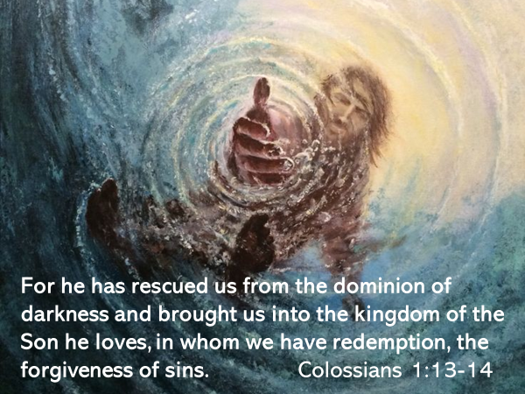

The exodus of Jesus not only changes our life after death, it changes how we live in the here and now.
Death is no longer a bitter agony nor a dreaded enemy.

Because the sting of death is gone, the follower of Jesus lives boldly… and when we die… we do so triumphantly.
For we know that to be absent from the body is to be present with the Lord.

We still weep when a loved one who knows Jesus passes, but our tears are not tears of despair.
We mourn, but our grief is tempered by the hope of what our loved one has gained – everlasting life!

Because the sting of death has been removed by Jesus, we stand firm in our faith… we let nothing move us… we give ourselves fully to the work of the Lord.
See 1 Corinthians 15:58

Our hope in Jesus inspires how we spend our lives.
I’ve been reading the prophet Jeremiah.
I am still pondering this, but I was struck this morning by what God said to the exiles.

Like their ancestors whom God brought out of Egypt, God promised the exiles he would lead them out of Babylon.
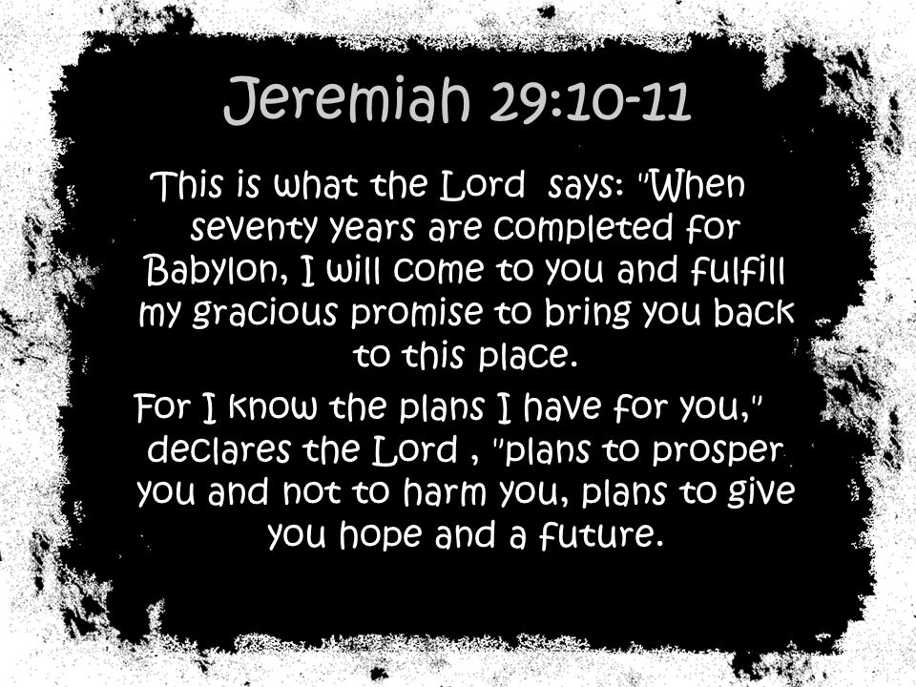

But before he promised them this, God gave them clear instructions.
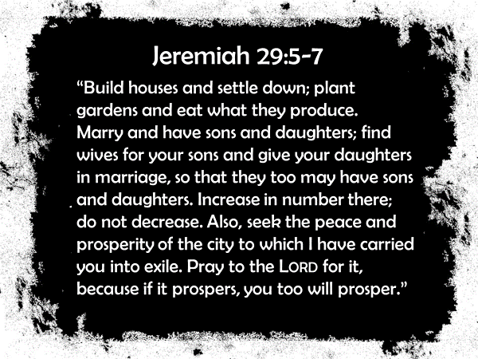

I see a connection between these verses and 1 Corinthians 15:58.

Because of our hope in Jesus we invest our lives in this town and region.
It’s why some of us serve in health care and find themselves on the front line.

It’s why some of us teach children and youth – understanding the importance of preparing them to take their place in society.

It’s why some of us work in various service industries and businesses – where we are the presence and light of Jesus as we help to build a thriving culture

It’s why we are planting seeds in Grace Gardens so that there might be a harvest to give to the food bank.

It’s why, when this crisis is over, we will again open our doors for BHB.

It’s why we are supporting Jenn Taylor, Rebekah Welsh, Rick Wismer, Nancy Cariger, the church at Caldas – we want people everywhere to know our good God and Savior, Jesus Christ

He has risen!!!!
And because he lives, we too live…now and forever more.
The Blessing

2 Thessalonians 2:13-17

