Maundy Thursday, April 9, 2020
“FORSAKEN”

Today we particularly reflect on the suffering of Jesus.

In Luke 9, Jesus had taken Peter, John and James with him to pray on a mountain.
As he prayed, Jesus’ appearance changed, and his clothes became as bright as a flash of lightning.
It was then that Moses and Elijah appeared and spoke with Jesus.

We are not told the specifics of their conversation.
But Luke does report the topic of which they spoke.
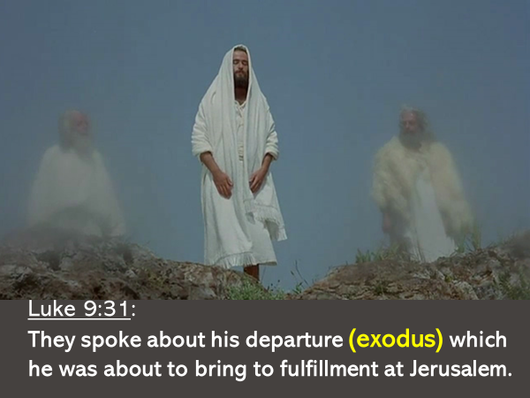

When Jesus rode into Jerusalem on a donkey, he came to bring about his exodus.

When Jesus began his public ministry, he announced in Nazareth:
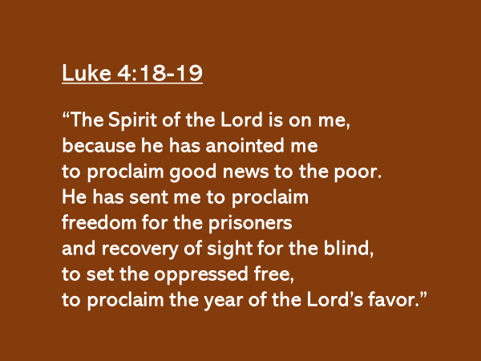

What Jesus had begun in Nazareth, he completed in Jerusalem at his exodus.

Think back to the first exodus when Moses led Israel out of Egypt.
The final plague struck down the firstborn of both people and animals.

To protect the nation of Israel, God, through Moses told his people of the only means, which if appropriated would result in the plague passing over them.
Each family was to sacrifice a sheep or a goat, and the blood of the animal was to be put on the sides and on the top of the doorframe to their home.

True to his word, when the LORD struck down all the firstborn in Egypt, not a single person died in all of Israel.
The blood which had been shed protected them.
And on that very night… Moses led the nation of Israel out of Egypt.

This…is what the Jewish people remembered every year at the Passover.

We asked the question on Sunday – what kind of king was Jesus?

Upon entering the city, as Israel’s king, Jesus did not go to the Roman garrison and drive the soldiers out of Jerusalem.
Nor did he go to Pilate’s home and tell him to pack and return to Rome.

When Jesus rode into Jerusalem on a donkey, he came, not to liberate Israel from the bondage of Rome, but to liberate all of humanity, from the bondage of death.

Similar to the first Passover, before there could be this greater exodus, there had to be a greater sacrifice.

Jesus came to be that sacrifice.
He was, as John the Baptist had announced..
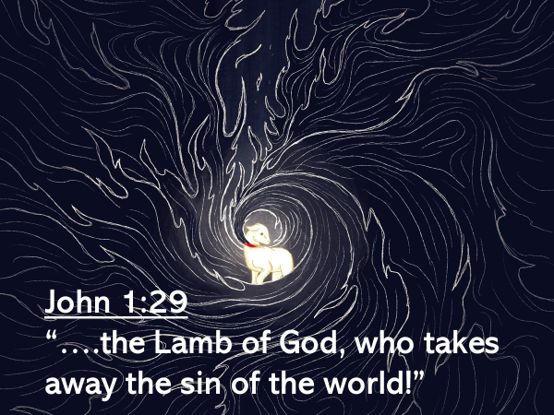

How would Jesus do this?
2 Corinthians 5:21 explains.
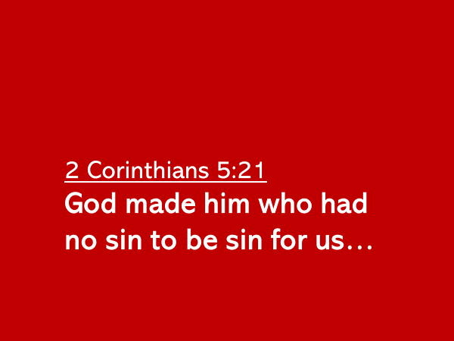

Isaiah had foreseen this, seven hundred years earlier and written…
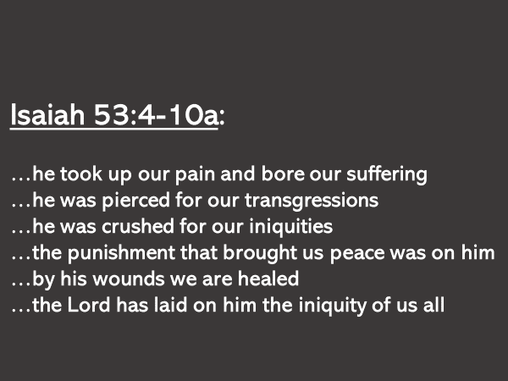

There was no other way.
Jesus had to be crushed.
Before there could be an exodus, there had to be a sacrifice.

Who could have envisioned that this was how, as the angel had told Mary, that her son, Jesus would take the throne of his father David and reign forever.

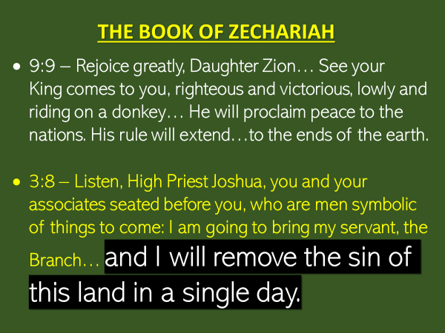

This was how as Zechariah had prophesied…the sin of the land would be removed in a single day.
Jesus, the King would pay in full… the sin debt of the fallen sons and daughters of Adam and Eve.
It is important that you and I see the connection between the sacrifice and the exodus.

- Before the Scepter of Judah was placed in his hands, a Roman staff was used to strike Jesus’ head and face.
- Before fragrant oil was poured upon his head and body, Jesus was spit upon and mucus ran down his cheeks.

- Before he was crowned Lord of heaven and earth, the soldiers mockingly thrust upon Jesus’ head a crown of thorns
- Before he was dressed in clothing befitting a king, Jesus was stripped naked.

- Before he sat on David’s throne, Jesus hung on a Roman cross.
- Before he ascended to heaven in triumph, his dead body laid in a tomb for three days.

Jesus did not suffer because he was guilty of sin.
He was the Innocent One, who willingly took our place in order that his greater exodus might be fulfilled.
This was how Jesus would bring home to the Father many sons and daughters.
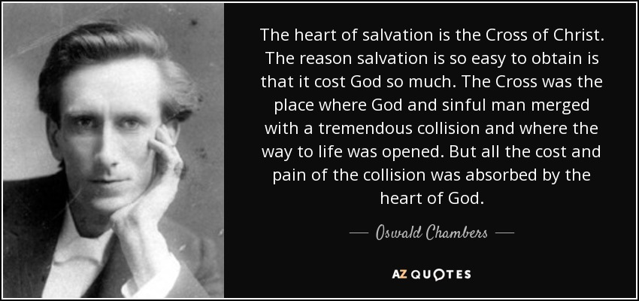

Through his exodus, Jesus leads… all who come to him… out of death and into life.

Today on Good Friday we remember Jesus.
We remember his cross.
We remember his suffering.

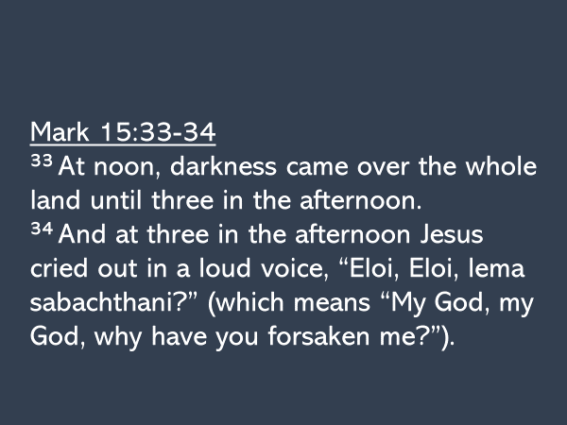

“MAN OF SORROW WHAT A NAME”

The words which Jesus cried out from the cross, come from Psalm 22.
The forsaken one in the psalm states:
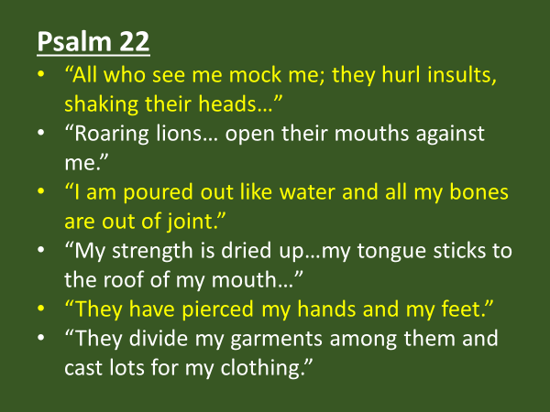

HOW DEEP THE FATHER’S LOVE
WHEN I SURVEY THE WONDROUS CROSS
Jesus’ physical suffering was horrific.
But his cry from the cross was not, “My God, my God, why am I suffering such great physical pain?” It was, “why have YOU forsaken me?”

Jesus was forsaken because God so loved the world; because God so loved you.
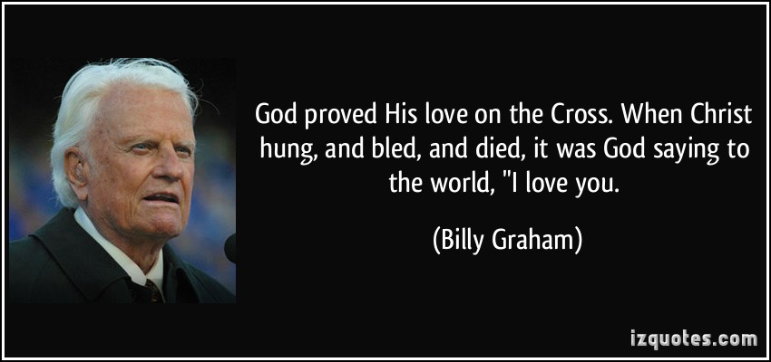

This sacrifice of love, in the apostle John’s words…
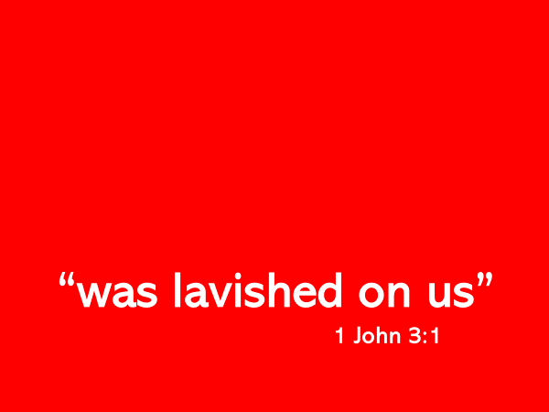

Jesus Messiah
At the Cross (Love Ran Red)

Judas’ betrayal greatly troubled Jesus. John 13:21.
Peter’s denial hurt him deeply. Luke 22:61.
But when the Father forsook him - that was an agony almost too great.

The word forsake means to abandon.
It was knowing he would be forsaken by the Father that had caused such anguish of soul to Jesus in the Garden of Gethsemane.

There, Jesus had said to Peter, James and John…
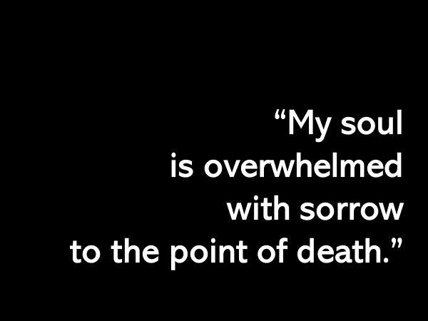

No one who comes to Jesus will ever know the agony of being forsaken as Jesus was forsaken.
The cost of our salvation was the life of Jesus.
He bore our sin.

This is what we remember when we eat the bread and drink the cup

The Lord’s Table

ALAS! AND DID MY SAVIOR BLEED?

