The Timing of God January 17, 2016
Genesis 7-8

You and I live our lives within the confines of time.
Our life is measured by moments. Show the powerpoint.
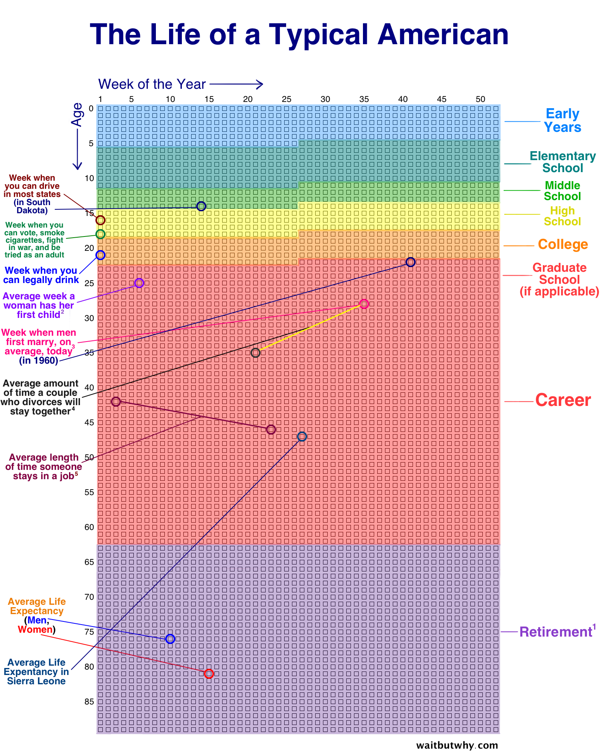
Here’s our question to talk about as we go to get our coffee:
What is your response to seeing the years of our lives on a graph like this?
How does it make you feel? What impact does it make on you?
Is there anything you think God would want you to learn from this?
Feedback

The question/ the issue we want to dig into this morning, is how do we live in relationship with our Creator God and Savior who is eternal; who exists outside of time?

And what do we learn about God as we see him acting in time?
And how does this impact our lives?

Let’s consider what Genesis 7-8 teaches us.
As we read we are watching for the emphasis on time.

7:4 - Seven days from now I will send rain on the earth for forty days and forty nights...
7:10 - And after the seven days...
7:11 - ... on the seventeenth day of the second month...

7:12 - ...forty days and forty nights.
7:13 - On that very day...
7:17 - For forty days...
7:24 - ...a hundred and fifty days.

8:3 - At the end of the hundred and fifty days...
8:4 - On the seventeenth day of the seventh month...
8:5 - ...on the first day of the tenth month...

8:6 - After forty days...
8:10 - [Noah] waited seven more days...
8:12 - [Noah] waited seven more days...

8:13 - By the first day of the first month of Noah’s six hundredth and first year...
8:14 - By the twenty-seventh day of the second month...

There are six emphases in these verses we’ve just read that I want to point out and apply to our lives.

1. Our God and Savior who lives in eternity is fully capable of and in no way restricted or limited to operating in the context of time as we know it.

Our world is not closed to God.
Neither humanity’s fall into sin; nor Satan’s usurping of mankind’s authority that allowed him to become the god of this world, shuts out God or limits him.

The Creator of heaven and earth has and always will be the Lord of heaven and earth. How do we know this from these two chapters?

No one could stop the rains from falling.
No one could speed up the process of the earth drying.
The timing of both was God’s decision.
He is sovereign.

The One who operates without restriction in this world, has his hands on world affairs, and…your life.

What else?
2. As God actively works in our world, he does so for the sake of his glory.

In Genesis 7-8 the glory of God is seen in how God’s justly made right what had been grievously wrong. The earth and humanity were corrupt.
The glory of God is also seen in how he provided for and cared for Noah and his family and the creatures with him. They did not drown or starve or die from disease.

Genesis 7-8 points us to the magnificent person God is.
What else do we learn?
3. God is so capable and powerful that he was able to work on a global scale over the year that the earth was flooded, while still personally interacting with and caring for Noah and his family and the creatures with him.

You and I have a limited capacity when it comes to interacting with and caring for people. There is a phrase that describes what happens to a person when they exceed their capacity – compassion fatigue.

At any given moment there are only so many balls we can keep in the air, as the saying goes. There are a limited number of things we can properly focus on.
And when we exceed that limit …something gets missed or dropped.

The story of the flood reminds us that our limitations are not shared by God.
He does not experience compassion fatigue.
Nor do we have to fear that there may come moments when God has more to deal with than he can handle.

Nothing escapes God’s attention...ever!
Nothing happens outside of his will.
He is never distracted or preoccupied.

What else?
4. God’s justice is not always instantaneous.

We’ve already learned that God’s justice is not immediate.
He waited 969 years before he sent the rains.
When the rains began to fall they fell for forty days and nights.

This impresses upon us that God’s justice is thorough.
He does not act in half-measures.
God’s justice is exacting.
What he does when he does it, is precisely what is needed to make right what is wrong.

The Bible assures us that the Lord always does what is right.

What else?
5. While Noah and his family were not destroyed by the flood, they nonetheless experienced it.

There are times when God rescues his people and spares them from adverse circumstances.
And there are times when God takes his people through great challenges.

The choice of which option and even the duration of that option is always God’s.
But when God takes his own through something, he is there present with them.
God with Noah made all the difference.

It was the same with later generations of Abraham’s family.

Isaiah 43:1b-3a: “Do not fear, for I have redeemed you; I have summoned you by name; you are mine. When you pass through the waters, I will be with you; and when you pass through the rivers, they will not sweep over you.
When you walk through the fire, you will not be burned; the flames will not set you ablaze. For I am the Lord your God, the Holy One of Israel, your Savior…

What else?
6. There are unique moments when God accelerates or slows down time.
But often God works in the normal passage of time.

Once the rains stopped, it took eleven months for the flood waters to recede and for the earth to completely dry.
God had the power to do it quicker; but he didn’t.

This impresses upon us that for the sake of revealing to us the amazing person that he is, God is always deliberate and intentional and purposeful in his actions and in the timing of those actions.

These two chapters in Genesis and the six emphases we’ve drawn out of them, impress upon us that God is wise and powerful, capable and trustworthy, he is just and his timing is always perfect.

For all of us there is some challenging circumstance before us.
The issue may or may not even be of our own doing.
But at this point that doesn’t matter - it’s there, before you.
And what you should do... isn’t clear.
You feel perplexed; in over your head.

In light of what we’ve studied this morning, the choice before you is whether or not you can place that issue or person in God’s hand. Will you trust God?

And if and when you do so, to choose to trust is to choose to wait for God’s timing and his solution, instead of trying to manipulate or force your will to be done, instead of his.

Our closing song speaks of choosing the Jesus way.
Oh may God’s Spirit help each of us in the choices we are making right now.

Blessing

Psalm 31:14 expresses the psalmist’s commitment to God.
“But I trust in you, Lord; I say you are my God. My times are in your hands.”

This expression of commitment is also a blessing.
Our times are in God’s hands.
The Lord knows what each day brings.
What an incredible blessing to realize that everything passes through his hands.
He is in control.

