**Follow the Leader** July 10, 16

Genesis 12-13

Introduction: an uncle and nephew story

Coffee/Question: when God gives directions, how vague or explicit are they?

And why do you think he communicates like that?

Feedback:

**Recap:**

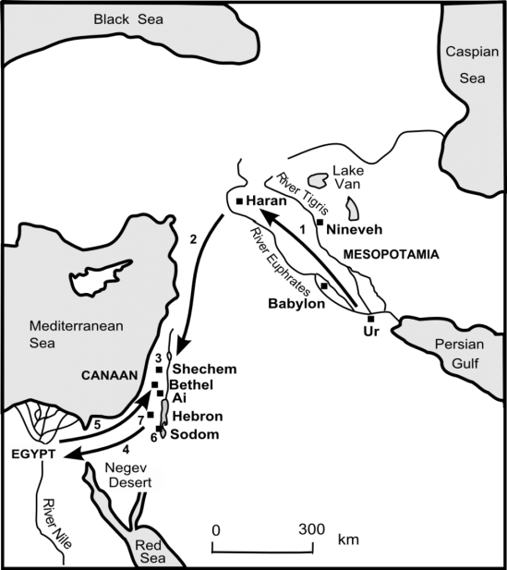

* Abram travelled from Ur to Harran (approximately 1000km), where he and his family then settled for an extended time.

* After the death of his father, when Abram was 75 years old, he and his household, left Harran and journeyed to Canaan (approximately 800 km).

* While we can travel by car, 800 km in a single day, remember they journeyed by foot and they travelled with animals. 10-12 km a day would be a good day’s travel.

After approximately 80+ days, Genesis 12:5 confirms - "they arrived...” in Canaan.

Canaan was a big piece of property, and upon arriving, Abram discovered it was already inhabited **- v.6b**.

He also quickly found out that the land was in the grip of a severe famine - **v.10**.



Because of a severe shortage of water and food, Abraham kept moving “through the land” - **v.6, 8, 9, 10**.

Don’t you wonder if Abram asked himself:

*“Why did we leave Ur?”*

*“Did I hear God right?”*

*“Is this really where the LORD wanted us to come?”*

When Abram really needed to hear from God, he did - **v.7a.**

We are reminded this is who God is - he doesn’t maliciously hide from us.

When we need to hear from him, we will.

We are not told how God appeared - just that Abram saw the LORD, and heard him speak: (v.7) *“To your offspring I will give this land.”*

In this situation God was neither vague, nor explicit.

He told Abram he would have “offspring” - just not when.

And he assured him, you’re in the right place; this is the “land” I will give to you.

**As we work our way through Abram’s story we need to keep reminding ourselves that Abram was being trained to live, not on the basis of sight, but, by faith in God.**

The part I want to emphasize to you; the part you and I need to remember as we follow Jesus, is that he is also training us. For what? To live by faith in God.

We don’t know when or how, but at some point in his journeys, Abram heard that there was no famine in Egypt, and so he headed there.

Was it God’s will for Abram to go to Egypt?

Logically, it would seem like it was. If you have a household that needs food and water and you’re in a place where there is a critical shortage of both, you go to wherever those needs can be met.

But did God want Abram to remain in Canaan, trusting him to provide for him?

We’re simply not told.

What we do know is that what Abram did in Egypt... was definitely not God’s will.

As he trains us, God places in front of us opportunities where we can choose to trust God or we can choose to act on the basis of sight alone.

**In Egypt, fear, not faith in God, influenced the decisions made by Abram.**

What happened?

I’m going to let Abram himself tell you - **v.11-13**.

The problem facing Abram, if you could call it a problem, was that Sarai was drop dead gorgeous. I wonder, as they journeyed towards Egypt, if Abram would glance over at Sarai, thinking, *“Is there any way we can make her less attractive?”*

What a problem to have - a wife who is just too beautiful!

Somewhere as they plodded along the dusty road to Egypt, Abram came to the conclusion, *“No amount of dirt on her face, messy hair and baggy clothes is going to hide how beautiful she is.”*

It was then he came up with his “brilliant” plan B.

But for the plan to work, Sarai had to agree to confirm Abram’s lie - which she did.

She didn’t want her husband to be killed.

But there was one tricky part to Abraham’s plan - what if some Egyptian approached Abram and asked him, “her brother,” for Sarai’s hand in marriage?

I’m sure Abram assured Sarai, “It will never happen.”

Well, what wasn’t supposed to happen, happened. **v.14-15**.

I’m certain that Abram never thought that it would be Pharaoh; the ruler of the mightiest nation of that day, who’d show interest in Sarai.

Now what was Abram to do?

We know what he didn’t do.

He didn’t come clean and tell the truth, “She’s really not my sister, she’s my wife.”

Instead, he silently watched as Sarai was escorted into the palace, and became Pharaoh’s wife - **v.19b**.

You’ve heard the saying: sin never pays.

There is small print that goes along with that saying.

And the small print reads...sometimes; initially; for a short time... it does.

Look at **v.16**.

While Abram didn’t intervene to protect his wife’s virtue, God did - **v.17**.

At the end we will return to this theme of God’s intervention and rescue in the lives of his people. For now, just note that it happened.

Again, God reveals who he is - he does not abandon his followers.

I particularly like how Jesus expressed it the night before his death:

*I will not leave you as orphans.* John 14:18

When Abram’s deception was uncovered, Pharaoh had strong words with him

- **v.18-19**. I think Abram wasn’t put to death, because Pharaoh feared that even worse things might happen to him and his household, if he did.

Instead, **v.20** - Abram and Sarai were kicked out of Egypt.

With nowhere else to go, they headed back to Canaan.

It’s here that the Scripture reminds us, **13:1**, that nephew Lot was still present and had observed first hand, his uncle’s fiasco, as well as God’s intervention.

Before I turn it over to Tim, I must point out to you, when Abram came back to the place between Bethel and Ai, where he had earlier camped and built an alter, he again called on the name of the Lord - **13:4b**.

Part of being trained by God to walk by faith, and not by sight, is the opportunity God gives us to dust ourselves off and start fresh, when we make mistakes, when we stumble, when we let God and others down.

Back in Canaan, Abram called on the name of the Lord. What does that mean?

He worshiped God publicly.

He re-aligned his life so that it was again fixed on and centered in God,

I can’t help but think he also sought direction from God - what do I do now?

What is your plan for us here?

**TIM**

**\*\* We all need to be rescued** - Sarai, Abram, Lot, even Pharaoh.

When he rescues, God meets us in our specific circumstances.

Sometimes he rescues us from others foolishness or recklessness; other times he rescues us and others, from our own poor choices or decisions.

God’s rescue typically will bring into the open; into the light; things that have been hidden. This can cause embarrassment, even pain and hardship.

Abram’s lie was exposed.

Lot’s inner compromise, in spite of his righteousness, was uncovered.

You and I need to remember that when God uncovers, and it causes us pain, he is not doing so, sadistically. What God does in our lives is always **motivated by love** and his **goal is always to restore**. His love compels him to be thorough in his dealings with us.

God’s rescue may sideline a person for a short or extended time - God himself knows how much time is needed. When it comes to the building of a character, God won’t be rushed - he always takes the long view. Abraham’s story will confirm this.

**\*\* Lot’s choice.**

Why did Lot choose the area close to Sodom and Gomorrah?

Why did he eventually move in to the city?

Was his choice an indication he was headed down the path of moral compromise?

Was he imitating his uncle; doing something similar to what Abram had done in Egypt? Was he cutting corners? Choosing the easy way?

Or was it something else?

Look at **2 Peter 2:7**.

Indignant compassion.

How do you and I live as followers of Jesus in this world? Is our distinctiveness to be evidenced by our isolation from people who don’t know him?

We have Jesus’ example - Matthew 11:19 - he was a friend of sinners.

Jesus would have us engage with people like he did.

Remember Jesus’ prayer in John 17:15 - *protect them from the evil one.*

There is a risk to indignant compassion - if we do not remain profoundly connected to Jesus, the source of our life, instead of being influencers and shapers of the culture in which we live, the evil one, like a python, will try his best to squeeze us back into the mold of the lifestyle we used to live when we didn’t know God.

I think this is why Jesus in his conversation with the disciples in John 15, stated 7 times - remain in me/my love. v.4 - remain in me - 2x

v.5 - remain in me

v.6 - remain in me

v.7 - remain in me

v.9 - remain in my love

v.10 - remain in my love

**\*\* Life together will be messy at times.**

Anglican church kids program - “Messy church.”

They mean ‘messy’ in the sense of crafts and games and activities.

But it is also can describe what it sometimes looks like when a community of Jesus followers are learning to live by faith; to choose by faith; to respond by faith; to cooperate with God’s Spirit by faith; to love one another in faith; to encourage and spur one another in love by faith; to go into the world by faith.

[**Nadia Bolz-Weber**](http://www.goodreads.com/author/show/1685874.Nadia_Bolz_Weber) writes:

*“God's grace is not defined as God being forgiving to us even though we sin. Grace is when God is a source of wholeness, which makes up for our failings. My failings hurt me and others and even the planet, and God's grace to us is that our brokenness is not the final word ... God says "I love the world too much to let your sin define you and be the final word. I am a God who makes all things new.”*   
 [Pastrix: The Cranky, Beautiful Faith of a Sinner & Saint](http://www.goodreads.com/work/quotes/24064768)

I am so grateful that because of God’s grace, our brokenness is not the final word.

Who we are as a church today is not who we will be next year.

We are a community of people undergoing profound spiritual renovation.

Where did the idea ever develop that the church is comprised of perfect ones?

We are all in recovery.

Please take note of that word ‘recovery’ - it speaks of progress - it doesn’t mean we’re stalled; stuck; treading water.

Recovery means there is movement forward, however slow.

All of us who follow Jesus are in a process of being transformed.

And because we are not perfect, we will let each other down from time to time; we will disappoint one another. And our adversary Satan will try to utilize that.. to cause offense to take root.

We are to resist him and choose to allow love to cover a multitude of sins, and in doing so, we will then cooperate with God and his grace, in his intent to make all things new.

Transition to The Table - (the words of the song) and the invitation to come to the table.

**The Blessing**

Romans 15:13