**Life Group Discussion Question, Easter Sunday 2017, Matthew 28:1-10**

Read Matthew 28:1-10.

(1) Why did Mary Magdalene & the other Mary “(go) to see the tomb” early in the morning? What were they expecting to see?

(2) Why do you think only the women came early to the tomb? What emotions do you think they were feeling as they walked? How would you have felt if you were with them?

(3) The Scriptures are clear that the women were at the tomb early, and the men were not. Should the men have been there? Why or why not? Would you have been at the tomb early? Why or why not?

(4) Make 3 columns with the headings:

“Who?” “What?” “How?”

Name all of the characters found in verses 1-10.

Write them down under the “Who?” column.

Now discuss “What” each person(s) did, and “How” you think they felt (i.e. what emotions were they feeling or displaying). Some characters may have multiple actions & emotions.

(5) What is the significance of the earthquake? Try for a moment to envision how the angel looked (“like lightening,” “clothing white as snow”). Why do you think these details were significant to Matthew? How would you have felt if you saw this “being” amd what would have been your response?

(6) Why do you think the angel told the women not to be afraid (who are not described in the text as being afraid) but did not speak to the guards (who are described as being extremely afraid)? What reason does the angel give the women for not being afraid (“Do not be afraid for . . .)?

(7) What evidence does the angel give to the women to prove his claim that Jesus has risen? Why is this evidence important?

(8) The angel said that Jesus had risen “just as He said.” According to Matthew’s gospel, what had Jesus said to the disciples concerning His death (see 16:21; 17:22-23; 20:17-19; and cf. 12:40)? Do you think the disciples should have expected the crucifixion and empty tomb? Would you have expected these events or would you be sharing the same confused emotions as the women at the tomb?

(9) What major event is assumed but not described in these verses? Why do you think there was not an eyewitness to the actual, physical, bodily resurrection of Jesus Christ? Since there was not an actual eyewitness to the resurrection, what evidence do you find in this passage that proves it to be true?

Other observations? questions?

(10) What about the testimony of Francis Collins most resonated with you and why?

See website for article - sookebaptistchurch.com - select sermons, Uniquely Jesus, Easter Sunday.

http://www.cabotbible.com/PDFs/JobPDFs/Matt28v1-10Easter.pdf

Noted geneticist turned from atheism to faith after trying to disprove God

March 31, 2015

By Michael Ashcraft and Mark Ellis

[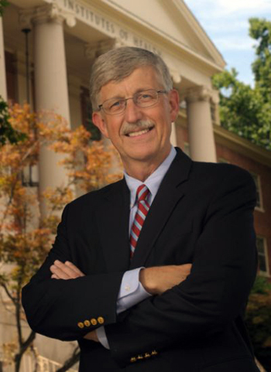](http://blog.godreports.com/wp-content/uploads/2015/03/nih_director_collins_ok.jpg)

*Francis S. Collins*

The current head of the National Institutes of Health, Francis S. Collins, came to faith after he set out to disprove God.

“I had always assumed that faith was based on purely emotional and irrational arguments and was astounded to discover that one could build a very strong case for the plausibility of God,” he noted on CNN. “My earlier atheist’s assertion that ‘I know there is no God’ emerged as the least defensible.”

A geneticist, Collins was appointed director of the $3 billion international Genome Project in 1993, which completed sequencing the 3.3 billion pairs of nucleotides by 2004. The resulting gene map offers hope to cure genetic disorders.

It also gave Collins a spectacular view into the magnificence, order, and finely-tune perfection of the DNA molecule, God’s software for every living thing. Directorship of the Genome Project was touted as the most prestigious job in science at the time.

At the most fundamental level, it’s a miracle that there’s a universe at all,” he told National Geographic. “It’s a miracle that allows the possibility of complexity and laws that follow precise mathematical formulas. Contemplating this, an open-minded observer is almost forced to conclude that there must be a ‘must’ behind all this. To me, that qualifies as a miracle, a profound truth that lies outside of scientific explanation.”

[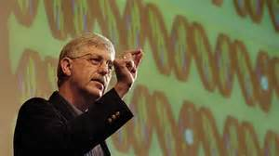](http://blog.godreports.com/)

He compiled his thoughts in a 2006 book, *The Language of God,* which posits that biology, astrophysics and psychology all argue in favor of faith in God. During the following year, he founded BioLogos, an organization that brings together scientists who wish to pursue science and faith in a cohesive unity.

“Science and faith can actually be mutually enriching and complementary once their proper domains are understood and respected,” he says. “There are some really important questions that science cannot really answer, such as, *why is there something instead of nothing? Why are we here?* “In those domains, I have found that faith provides a better path to answers.”

Of particular importance to his faith is the concept of “moral law” – the denunciation of oppression, murder, treachery, falsehood and the injunction of kindness to the aged, the young, the weak and helpless, to paraphrase C.S. Lewis. “After 28 years as a believer, the Moral Law stands out for me as the strongest signpost of God,” he writes in his book.

[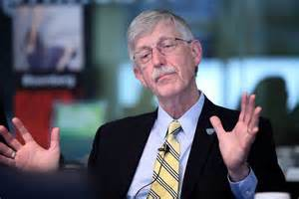](http://blog.godreports.com/)

Collins grew up in a family of agnostics in Virginia’s Shenandoah Valley. By the time he graduated medical school, he described himself as a full-fledged atheist. But then a patient queried him about his own faith. Prodded thus, he decided to research the point and debunk faith.

“When I got to college and was challenged about what my beliefs were, I realized I had no idea what they were,” he told PBS. “I listened to others make an argument that religion and beliefs were basically a superstition, and I began to think — Yeah, that’s probably what I believe, too.”

As a graduate student at Yale, he marveled at how virtually everything in the universe could be described by a “second-order differential equation,” he said.

After obtaining a degree in quantum mechanics, he decided to change paths in life and pursued medicine. As a resident he watched people suffering terminal disease without blaming God. To the contrary, faith seemed to give them strength and, in many cases, improve their symptoms, he said.

“They had terrible diseases from which they were probably not going to escape, and yet instead of railing at God, they seemed to lean on their faith as a source of great comfort and reassurance,” he said. “They weren’t, somehow, perceiving it as the really awful thing that it seemed to me to be. And that was interesting and puzzling and unsettling.

[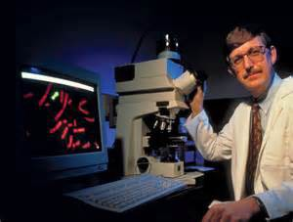](http://blog.godreports.com/)

“I had made a decision to reject any faith view of the world without ever really knowing what it was that I had rejected. And that worried me,” he said. “As a scientist, you’re not supposed to make decisions without the data. It was pretty clear I hadn’t done any data collecting here about what these faiths stood for.”

So he turned to C.S. Lewis’ *Mere Christianity*. As he read, his assumptions about faith in God were shaken. It wasn’t easy or fun reading. It was painful, he said.

“The idea that you would arrive at faith because it made sense, because it was rational, because it was the most appropriate choice when presented with the data, that was a new concept,” he said.

He was 27. After months of wrestling over the question of God, he finally broke down. One day, hiking in the Cascade Mountains, admiring the grandeur of God’s creation, he said “yes” to God.

“I’ve never turned back,” Collins said. “That was the most significant moment in my life.”

At first, sharing his faith wasn’t easy. “Like most scientists, I had this fear that having accepted something in the way of a spiritual worldview, I would be perceived as having gone just a little bit soft,” he noted. “That this was not compatible with the rigorous ‘show me the data’ attitude that a scientist is supposed to have towards all things.”

But now he’s so open about belief that he’s drawn fire from vocal atheists. Atheist Sam Harris criticized his nomination to head the NIH by President Barak Obama: “Must we really entrust the future of biomedical research in the United States to a man who sincerely believes that a scientific understanding of human nature is impossible?”

Collins assumed the NIH office in 2009. He is 65 as of April. He loves motorcycle riding and playing rock. He’s formed a band of NIH scientists that duels with a band of scientists from John Hopkins University.

In 2005, Collins was named jointly with genome colleague Craig Venter America’s Best Leaders by U.S. News & World Report and the Harvard University Center for Public Leadership.

“I did have a moment where I became a believer,” he told Anderson Cooper. “I had struggled for two years with this debate within myself gradually coming to the conclusion that belief in God was the most plausible of the choices. After many months of struggling whether to make that leap, on a beautiful Fall day hiking in the Northwest, with my mind a little more clear than usual because there were not the usual distractions, I felt like I could no longer resist. I became a believer that day.”

<http://blog.godreports.com/2015/03/nih-director-turned-from-atheism-to-god-as-he-contemplated-science/>

After a criminal does his time in jail and completes their sentence, the law has no more claim on them. They are able to walk out of jail, free.

Jesus died in the place of humanity.

He paid the penalty of our collective sin.

You could say, he did our jail time.

But how do we know his sacrifice on our behalf was accepted; was effective?

How do we know he broke the power of, and overcame the curse of death?

Because he walked out of the grave.

Jesus said to the apostle John, *“I am the Living One; I was dead, and now look,*

*I am alive forever and ever! And I hold the keys of death and Hades.”*

Revelation 1:18

Do you know anyone else in all of history who was dead, and is now alive,

forever and ever?

Is there anyone else who can claim what Jesus claimed - to hold the keys of death and Hades?

To hold those keys meant that Jesus had overcome death; he had defeated hell.

Their combined power had been broken by him.

This is why Jesus can set free any and all who come to him.

That’s why he said, *“If I set you free, you will be free indeed.”* John 8:36.

Leon Morris says: “The resurrection is the public display... of the triumph of [Jesus] the crucified one.” <http://unlockingthebible.org/resurrection-easter-quotes-bible-verses/>

The resurrection of Jesus calls us to take action; to respond to what God has done for us.

A person can choose to do nothing, if they so wish.

They can continue to keep God out of their life.

But I have to tell you, there is no future there.

Life without God leads to a dead end; to a place of desolation.

The Bible says, “*Work hard for, (live for) sin your whole life and your pension is death. But God’s gift is real life, eternal life, given to us by Jesus, our Master.”* Romans 6:23 The Message

What Jesus did on the cross, and when he walked out of the tomb proved, that through him, God had made the way... for all to come home to him.