**Uniquely Jesus** May 28, 2017

Mark 14:18-52, Part Two

There are three challenging, sobering themes found in Mark 14:18-52 – betrayal, desertion and temptation.

Without question, these three themes are dark, they are troubling, but they are part of our human story, as well as God’s salvation story.

As we looked last week into the awful events which happened the last night of Jesus’ life – we were surprised, to see the goodness and mercy of Jesus being displayed in ways, we could never have imagined, given the circumstances that were happening to him.

Last week we looked at the first two themes; today we will unpack the last one.

**Coffee/question:**

Interact with someone about one or two or all of these quotes.

“The only way to get rid of temptation is to yield to it.”

[**Oscar Wilde**](http://www.goodreads.com/author/show/3565.Oscar_Wilde), [**The Picture of Dorian Gray**](http://www.goodreads.com/work/quotes/1858012)

“There is a charm about the forbidden that makes it unspeakably desirable.”  [**Mark Twain**](http://www.goodreads.com/author/show/1244.Mark_Twain)

“The problem with temptation is that you may not get another chance.”   
[**Laurence J. Peter**](http://www.goodreads.com/author/show/182617.Laurence_J_Peter)

Before we consider how this theme of temptation impacts us – because everyone of us has faced, is facing, and will face temptation –we need to first see how Jesus himself, not only faced, but overcame temptation.

There is much for us to learn from our Savior.

**v.32-34**.

After the Passover supper was over, Jesus and his followers, went to Gethsemane.

This is a place just east of the temple mount area in Jerusalem, across the ravine of the Brook Kidron, and on the lower slopes of the Mount of Olives.



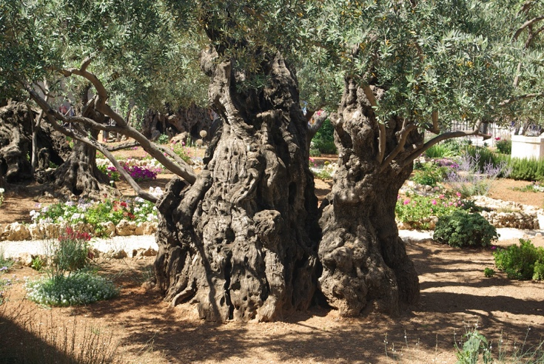

Gethsemane was a garden of ancient olive trees.

The word gethsemane means "olive press" - it was a place where olives from the neighborhood were crushed for their oil.

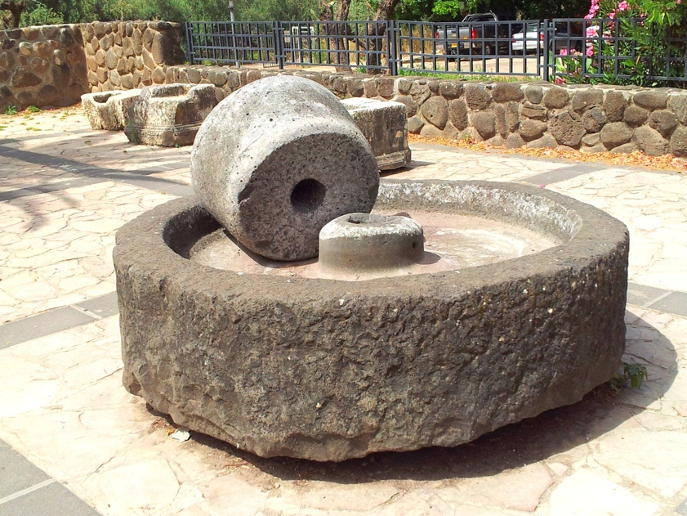

It was not by accident that Jesus went to the garden of Gethsemane that night.

Where he was, when he faced what he faced; when he was deeply distressed and troubled (v.33), helps us to better grasp what was happening to him.

At the supper table Jesus had warned Peter that Satan had asked and had been given permission to sift him like wheat.

Jesus too was sifted that night; or better said, was crushed, like olives from the trees were crushed when placed in a press.

Hebrews 2:15 says: Jesus *“…suffered when he was tempted…”*

This is what Jesus meant when he said to Peter, James and John, *“my soul is overwhelmed with sorrow to the point of death”* – v.34.

Some of you have faced intense sorrow.

Some of you have been in circumstances that you thought you were beyond what you were capable of enduring.

What you have passed through helps you to understand in some measure what Jesus experienced that night.

The sorrow that enveloped Jesus, was almost more than he could handle.

What was it that caused Jesus such great angst?

It was being made sin on our behalf.

On him was placed our collective guilt.

He took on himself the righteous wrath of God that we deserve.

This was the cup which he asked the Father if it was possible to remove.

And there in the garden, at that moment, Satan was permitted to test Jesus; to present him with the option to save himself, instead of us.

C.S. Lewis wrote in Mere Christianity: “We never find out the strength of the evil impulse inside us until we try to fight it: and Christ, because he was the only man who never yielded to temptation, is also the only man who knows to the full what temptation means.”

**v.35-36**.

Just as Satan had pressed Jesus hard, three times, in the desert, when Jesus began his public ministry, so that night, in the garden of Gethsemane, three waves of temptation crashed in on Jesus’ soul.

So much was at stake that night.

If Jesus stayed the course... if he went to the cross... in him and through him, the way would be opened for those who believed in him, for sin to be forgiven, their nature to be recreated; and the prince of this world to be driven out.

What do we learn from Jesus about how to overcome temptation?

**v.37-41.**

Two things – watch and pray.

Why these two?

Because, as Jesus said, *“The spirit is willing, but the body is weak.”* v.38.

Peter in his spirit had said to Jesus that he would die for him.

But when push came to shove, in a courtyard, in the middle of the night, Peter’s sense of self-preservation overcame his loyalty to Jesus.

The same weakness is in all of us.

**Watch**

The Greek word for “watch” in Mark 14:38 is “gregopeo.” This word has the sense of “being vigilant,” “of keeping awake,” “of being on the alert,” like a guard at night.

<https://www.neverthirsty.org/bible-qa/qa-archives/question/jesus-told-his-disciples-to-watch-and-pray-what-does-watch-mean/>

“In the daytime, danger can often be spotted from a distance. But in the night, everything is different. A night watchman must use senses other than sight to detect danger. There may be no indications of an enemy attack until it happens, so the watchman must be hyper-vigilant, suspecting it at any moment. This is the type of watching Jesus spoke about.”

“When Jesus found Peter, James and John asleep, the first time, and the second time, and then the third time, he was grieved, knowing, because they had not remained spiritually vigilant, they would be overcome and severely sifted by the evil one.” https://www.gotquestions.org/watch-and-pray.html

The fallen angels are astute students of human beings.

They have watchedhumanity across the millennia.

They know our common vulnerabilities.

Think of a house whose windows are open and whose doors are unlocked.

Where do you think a thief will attempt to enter?

Wherever there is an opening that gives easy access.

It is the same with our lives.

The demonic tempts each of us in those areas where there is access, created by old sin habits, or old nature responses, or unresolved issues.

They seek to gain a foothold within us wherever “our will” is done, instead of God’s.

And their goal, always is, to steal, to kill and to destroy.

This is why we are to watch.

Do you know where you are vulnerable?

What are you doing to close that opening?

* Confession.

* Cultivate new habits.

* Invite the Holy Spirit to work in you.

**Pray**

What do we learn, from how Jesus prayed?

There are six things to consider.

-> Posture is important.

Mark 14:35a, Matthew 26:39 – Jesus fell with his face to the ground.

Luke 22:41 tells us Jesus knelt before the Father.

It may sound strange to us, but the posture of our body, impacts our interaction with God.

Jesus posture before the Father communicated what? Submission.

Why is this so important?

Who does God listen to?

Look at Isaiah 66:2.

-> What we focus our minds on, as we pray – who the Father is - determines where our hearts will settle.

Jesus reminded himself that the Father is – Abba.

Abba was the affectionate Aramaic expression used by a child when addressing their father.

For us today, that expression is “daddy.”

Jesus focused on the tender love of the Father, who never abandons or fails.

This is why Jesus was not shaken; not overwhelmed with despair, nor destroyed,

-> Remember the Father’s ability.

Jesus stated as he spoke with the Father what he knew to be true– “everything is possible for you.”

Satan seeks to plant doubt within the mind, not only regarding the character of God, but also doubt about the ability of God.

We are to remember as we pray - the Father has no limits; there is nothing he cannot do.

-> The Father’s will is good and perfect.

This is why Jesus said – “your will be done.”

Through prayer and by prayer, Jesus kept his will, in line with the Father’s.

-> Communicate truthfully with the Father

Jesus didn’t pretend that the temptation before him was nothing.

Jesus said – “take this cup from me.”

He spoke openly and with great emotion to the Father.

The psalms affirm that God can handle our strong emotions.

If we are to resist temptation, then we must not bury our questions, our doubts, our uncertainties, but rather, speak them out to the Father, in order that he might speak truth into our minds and hearts.

-> Keep communicating with the Father until the temptation is overcome.

Three times Jesus spoke to and with the Father.

Three times Jesus affirmed, ‘Your will be done.’

See v.39.

If Jesus, who is perfect had to do this, that is, come back to the Father, three times, we who are works in progress, shouldn’t be surprised that we have to do the same.

But do you know what is surprising about Jesus’ prayer?

The Father didn’t answer Jesus, as Jesus had asked - he didn’t take away the cup.

Rather, in response to his prayers, the Father sent an angel from heaven who appeared to Jesus (Luke 22:43).

The Father sent this angel to strengthen Jesus, to be able, not only to take the cup, but to drink it.

Luke adds that after the angel appeared to him and strengthened him, that Jesus *“prayed more earnestly.”*

What does that mean – to pray more earnestly?

Hebrews 5:7 says: *[Jesus] offered up loud cries and tears to the one who could save him from death...*

There was nothing casual, or laid back about Jesus’ conversation with the Father.

It was intense because Jesus was at war with Satan.

What did it look like as Jesus prayed more earnestly?

Luke tells us that *“his sweat was like drops of blood falling to the ground.”* (22:44)

Praying more earnestly, required of Jesus great effort, because, resisting temptation is no easy thing.

The Father will also strengthen us.

Listen to this promise from 1 Corinthians 10:13.

***“****No temptationhas overtaken you except what is common to mankind.”*

Satan will attempt to sneak up on all of us.

But God wants you to know that there are actually only a limited number of ways in which the fallen angels seek to get us to turn away from God.

*“And God is faithful; he will not let you be tempted beyond what you can bear.”*

This specific attribute of God – his faithfulness – is what we are to focus on, as we pray, when facing temptation.

God is faithful. God keeps his word.

He will finish in us what he began.

He will not leave us to be ravaged by Satan.

God knows us intimately and he knows what we can bear.

If Satan attempts to cross a line, God will restrain him.

This is God’s promise to us.

*But when you are tempted,he will also provide a way out so that you can endure it.*

God does his part.

But we have our part to play.

We are to choose God’s way out.

And as we choose God’s way, our new nature is strengthened.

This is how we over a lifetime, displace old habits and desires.

After three sessions of prayer, look at what Jesus said to Peter, James and John,

**v.42 - “Rise. Let us go.”**

There was much more to come that night and the following day.

But the victory of Jesus, was won that night in the garden, as he knelt before the Father and battled through to the place where he said, “Your will be done.”

Charles Spurgeon once said: *“We may be certain that whatever God has made prominent in His Word, He intended to be conspicuous in our lives.*

*If He has said much about prayer, it is because He knows we have much need of it. So deep are our necessities, that until we are in heaven, we must not cease to pray. A prayer-less soul is a Christ-less soul.”*

*http://amazingdiscoveries.org/ad-magazine-archive-fall-2012-watch-pray*

Jesus wanted his disciples to pray as he had prayed, because there was no other way for them to resist temptation.

“Jesus knows our weaknesses.

But He also knows the strength that earnest prayer provides to keep a person faithful to God.” http://amazingdiscoveries.org/ad-magazine-archive-fall-2012-watch-pray

This is why he says to us, “Watch and pray.”

**Life Group Discussion Questions**

**Mark 14:32-42**.

1. Why do you think Jesus separated Peter, James, and John from the other disciples and keep them close while He prays?

What did Jesus expect these three men to do when He commanded them to “remain here and watch?”

2. How would you expect these men to act in this situation given their former statements (cf. 10:35-40 & 14:29-31)?

3. Jesus uses three strong and rare words to describe His emotional state (translated in the ESV as “greatly distressed,” “troubled,” & “sorrowful”).

Why are these emotions just now beginning (“began to be” in v. 33)?

4. To what does “the hour” refer?

To what does “this cup” refer?

5. What do you learn about Jesus from His prayer?

What do you learn about Jesus’ view of His Father?

6. Did God answer Jesus’ prayer? Explain.

**Read Hebrews 5:7-10**.

Explain how Jesus “learned obedience through what He suffered” (Heb. 5:8), and what it has to do with Jesus’ person & work as God incarnate.

**7.** To what do “spirit” and “flesh” refer in v. 38, and how does the weakness of the flesh affect the willingness of the spirit?

8. What was the physical cause of the disciples’ sleepiness?

What was the spiritual cause of the disciples’ sleepiness?

9. To what does the “it” refer in Jesus’ phrase, “It is enough” (v. 41).

**10.** Since Jesus knew His death was the Father’s plan, was His prayer a sign of weakness? Explain.

11. In what ways are you strengthened and encouraged by Jesus’ distress, trouble, and sorrow over the prospect of His suffering & death and the way He expressed these emotions?

12. Considering the importance of being on guard and staying awake (cf. Mark 13:6, 9, 23, 33-37; 14:34. 37, 38, 40-41), write down at least 4 specific and concrete ways in which you will fight against spiritual laziness and sleepiness.

13. Meditate on the connection between Jesus’ obedience and His character, person, & work.

How does your obedience both reflect and flow from your status as a believer?

Is obedience important since salvation is by grace through faith? Explain.

cabotbible.com/wp-content/uploads/2012/11/Mark-14v32-42DG.docx

Here we see Jesus’ humanness.

I remind you…

Hebrews 2:14 says Jesus *“shared in our humanity.”*

Hebrews 2:17 adds, he was *“made like us in every way.”*

Except, unlike us, Jesus was not born with a predisposition to sin.

When the newborn Jesus drew his first breath, he was not spiritually dead, like all of us were when we were born.

In this regard, Jesus was like Adam and Eve, the first humans – who were created perfect; and who were fully alive to God, and in relationship with him.

Hebrews 4:15 says – even though Jesus was perfect, he *“was tempted in every way, just as we are – yet was without sin.”*

What Jesus faced in the garden of Gethsemane deeply impacted him.

So why did Jesus let Satan have a go at Peter?

Because in spite of 3+ years of investment into Peter’s life by Jesus, Peter still perceived himself, and acted as if he was more spiritual, stronger, gifted, etc., than he really was.

Though Satan was the supernatural power behind Peter’s failure, it was Peter’s own prideful heart that was the earthly means to his fall.”

When Satan sifted Peter, Peter became painfully aware of his pride and self-reliance, and just how easy he had denied Jesus. A little girl took him down.

How humbling that must have been for him, a fisherman!

The teaching of Jesus earlier that night, around the supper table, was applied to his life when Peter turned back – apart from Jesus he could do nothing; the life of Jesus had to flow into and through him.

Jesus had prayed that Peter’s faith would not fail; that his sifting by Satan would not leave his life in pieces.

And Jesus’ prayer was answered.

“Whatever their bodies do affects their souls. It is funny how mortals always picture us as putting things into their minds: in reality our best work is done by keeping things out...”  [**C.S. Lewis**](http://www.goodreads.com/author/show/1069006.C_S_Lewis), [**The Screwtape Letters**](http://www.goodreads.com/work/quotes/2920952)

Think accurately of yourself

Hebrews 2:15: Jesus is able to help those who are being tempted.