**Uniquely Jesus** July 16, 2017

Mark 15:33-39

Read the passage.

There are three incidents mentioned that I want us to hone in this morning.

1. Darkness came over the whole land (for three hours).

2. The curtain of the temple was torn in two from top to bottom.

3. (The centurion) said, “Surely this man was the Son of God!”

1. Darkness came over the whole land (for three hours).



You need to know that the Jewish Passover always coincided with a full moon.

What does that mean?

Eclipses only happen when there is a **new moon**, not a **full moon**.

So, on the day Jesus died, the darkness that came over the land, from noon to 3pm, wasn’t due to an eclipse.

Also, even if there had been an eclipse, absolute darkness, only lasts a few minutes; and never longer than 7 ½ minutes; and for sure, not three hours.

<https://eclipse2017.nasa.gov/how-long-does-longest-possible-total-solar-eclipse-last>

Some have questioned whether the darkness could have been caused by a desert windstorm that carried enough sand to block out the sun.



Here’s something else you need to know.

Passover always happened in the rainy season.

There were rain storms at that time of year – but not sand storms.* King’s Cross, p.201.

The darkness that came over the whole land, that blocked out the sun, was supernatural - it was caused by God.

Why would God have caused darkness to come upon the land?

Look at **Exodus 10:21-23**.

Darkness that happened during the day, was regarded as a sign of God’s judgment.

Who was God judging the day Jesus died?

The Romans?

The religious leaders?

The nation of Israel?

Look again at Mark 15:34.

It was Jesus who was being judged.

And what happened to Jesus as he was judged?

Jesus himself tells us: he was forsaken.

You can lose someone you love.

I was lost once when I was five years old.

I don’t remember this event.

But my parents tell the story that in a department store I went missing.

After a frantic search, they finally found me, wearing my muddy boots, jumping up and down, on top of a pile of expensive carpets.

According to them, I refused to come down.

I was lost, but I wasn’t forsaken.

Only someone loved can be forsaken; abandoned.

Jesus loved the Father; and the Father loved Jesus.

That’s what made the Father’s judgment of Jesus so devastating.

Jesus’ question, “Why have you forsaken me?” wasn’t academic or rhetorical.

It was an anguished heart cry that expressed his excruciating sense of loss, as God’s anger for humanity’s sin fell on Jesus.

Our sin separated Jesus from the Father.

From all eternity, the Father and the Son had loved each other.

But for those hours as he hung on the cross, the Father turned his back on Jesus.

Jesus was abandoned by the Father... for you, for me, for us.

Why? Because of love!

Instead of washing their hands of us; instead of writing us off as a lost cause, in love the Father, Son and Spirit determined, that for their glory, they themselves, would make the way; they alone would assume all the cost, in order that the fallen sons and daughters of Adam and Eve, might have a way to come home.

The price of our rescue is beyond calculation.



The One who is light, who lives in light, and whose life is the light of mankind,

was engulfed by our darkness.

Timothy Keller writes, “The darkness that could have destroyed us forever...fell into Jesus’ heart.” King’s Cross, p.211.

Jesus, the Righteous One was made sin, so that we could become righteous -

2 Corinthians 5:21.

The eternal death that would have come upon us, came upon Jesus.

The religious leaders mocked Jesus; they taunted him to come down from the cross... if he really was the Messiah.

They thought because he didn’t, that he couldn’t.

Jesus could have.

But he chose not to.

It wasn’t the nails that kept Jesus on the cross.

It was his love for us that held him there.

Shortly after 3pm, with a loud cry, Jesus breathed his last.

As he did, something that had never before happened… happened!

And the implications of this event were earth-shattering.

2. The curtain of the temple was torn in two from top to bottom.

It’s here we need a little more understanding of the Temple in Jerusalem, if this event is to make sense to us.

The Temple consisted of two major parts: the Holy Place and the Most Holy Place.

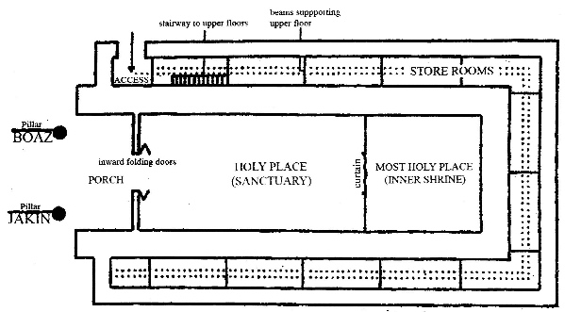

What was in the Most Holy Place?

The ark of the covenant.

The ark of the covenant was basically a box with an ornate top.

It was made of acacia wood, overlaid with gold.

Four cast gold rings were fastened to the feet.

Long poles fit through the rings so the priests could carry the box—which was the only method of transport authorized by God ([1 Chronicles 13:7-10](https://biblia.com/bible/esv/1%20Chron%2013.7-10)).

The ark was not a container for God—it was to be respected but not worshiped. Instead, it was a place where God and man could meet.

The lid of the ark was called the "mercy seat."

On the lid were two gold cherubim, facing each other, with wings spread upward and covering the seat.

God's presence hovered above the seat, between the cherubim.

https://www.compellingtruth.org/What-Ark-of-the-Covenant.html

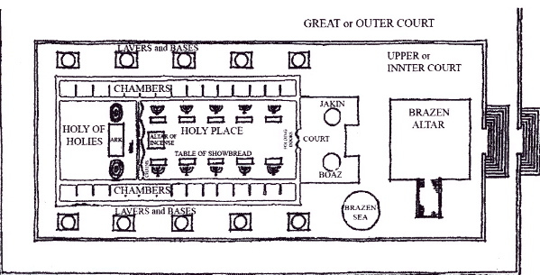

When Solomon finished building the Temple, and had the ark of the covenant brought to and placed in the Most Holy Place, the people praised God in song, singing, “He is good; his love endures forever;” and as they did, 2 Chronicles 5:13-14 says, *“Then the temple of the Lord was filled with a cloud...for the glory of the Lord filled the temple of God.”*

God promised his people that he would be present among them in the Most Holy Place; above the mercy seat, between the cherubim.

A thick curtain, made of fine linen and blue, purple and scarlet yarn, with figures of cherubim embroidered onto it, was hung between the Holy Place, and the Most Holy Place.

God had this curtain hung for the safety of His people.

God cannot tolerate sin.

Isaiah 59:2: *“...your iniquities have separated you from your God; your sins have hidden his face from you...”*

Though God was among his people, the curtain visibly emphasized the separation caused by humanity’s sin.

The sacrifice of animals provided only a temporary solution.

Something more; something permanent was needed.

No one could enter into the Holy of Holies; no one could near to God; except the high priest and then only once a year, on the Day of Atonement.

Listen to Hebrews 9:7: *“But only the high priest entered (the Most Holy Place), and that only once a year, and never without blood, which he offered for himself and for the sins the people had committed in ignorance.”*

On the day of Atonement, the high priest made meticulous preparations.

He had to wash himself, put on special clothing, bring burning incense with him

in order that the smoke might cover his eyes from a direct view of God, as he presented blood, in the Most Holy Place, in order to make atonement for sins.

The size and thickness of the curtain - 60 feet long, 30 feet wide, and about one inch thick - ensured that no one would accidentally stumble or fall into the Most Holy Place.

Here’s something else to be mindful of - the curtain was so massive and heavy that it took 300 priests to hang it. https://faithinthenews.com/3-facts-temple-veil/

It was this curtain, that was torn at the exact moment of Jesus’ death.

This event communicated astonishing news.

What had caused our separation from God - our sins - had been dealt with, and paid for, in full, by Jesus on the cross.

God’s presence was now accessible to all.

People could now come near to God and not die.

Look again at **v.38**.

The temple curtain was torn from the top down to the bottom, meaning this act of tearing had to have come from above.

Only God the Father, could have carried out such an incredible feat because, the curtain was too high (30’) for human hands to have reached it, and too thick (1”) for human hands to have torn it.

3. (The centurion) said, “Surely this man was the Son of God!”

The very first person to trust in Jesus, after he said, “It is finished,” and the curtain in the Temple was torn in two from top to bottom, was a Gentile, a soldier, someone who was not Jewish.

What does that say to us?

Jesus is the Savior of the world.

He, and he alone, dealt with humanity’s sin problem.

*“For God so loved the world…”*

Jesus died for every one of us.

*“For God so loved the world that he gave his one and only Son…”*

There is no limit on how many people can receive Jesus and have their sins forgiven, and be born of God’s Spirit.

The gospel of Jesus is the power of God that brings salvation to…. everyone who believes.

Jesus once and for all dealt with our sin problem.

As Hebrews 10:19 says, *“...we have* ***confidence*** *to enter the Most Holy Place by the blood of Jesus...”* h

As Hebrews 4:16 says, *“Let us then approach God’s throne of grace with* ***confidence****, so that we may receive mercy and find grace to help us in our time of need.”*

Don’t miss this word – confidence.

Confidence to do what?

To come near to God.

For what reason?

To receive mercy.

To find grace.

That was the experience of one of the thieves who hung beside Jesus.

He asked for mercy – he was shown mercy.

And not because he deserved mercy.

That was the experience of the centurion.

That is the experience of many of us here this morning.

We deserve death; but instead we are given life.

Has God changed his mind about sin?

Is he now tolerant of it?

No.

What changed?

Jesus sacrifice changed our status.

Hebrews 10:20-22:

***20****By his death, Jesus opened a new and life-giving way... into the Most Holy Place.*

Our confidence to come near to God is based on what Jesus did for us.

***21****And since we have a great High Priest who rules over God’s house,****22****let us go right into the presence of God with sincere hearts fully trusting him. For our guilty consciences have been sprinkled with Christ’s blood to make us clean...*

Jesus dealt with our guilty consciences by forgiving us, and then removing our sin

from us, “as far as the east is from the west.”

This is why we can come near to God “with a sincere heart and with full assurance.”

We are not made right with God because of the good things we’ve done.

We’re made right with God because of what Jesus did.

This is why our confidence that we’ve been accepted by God, is NOT dependent on our feelings, or our own efforts, but on what Jesus did.

The Holy Spirit makes his home in the lives of all who believe in and receive Jesus. It is the Holy Spirit who speaks into our hearts - you belong to God - you are his own – because of what Jesus did for you.

Hebrews 10:23:

Let us hold tightly without wavering to the hope we affirm,

for God can be trusted to keep his promise.

God is faithful and will do what he has promised.

You and I are to hold tightly to this hope.

The strength of our grip is not what our confidence is based on.

Our confidence is based on the strength of the One who holds us.

What we hold tightly to is the truth that Jesus has paid our debt.

Our hope is not in our efforts, but in his.

What God began in us, he will finish.

The Spirit births a new life in us, and then works with us in transforming our character. This is a lifelong process that will be completed when we see Jesus, either at our death or his return.

One last implication.

Because we can enter into the Most Holy Place by the blood of Jesus…

Hebrews 10:24-25a:

Let us think of ways to motivate one another to acts of love and good works. And let us not neglect our meeting together, as some people do, but encourage one another – and all the more as you see the Day approaching.

The Christian life is not a lone-ranger existence.

When you believe in Jesus you become a part of God’s family; you belong to a community of others who are in relationship with the Father, Son and Spirit.

We are to motivate each other, to spur one another on in our faith by encouraging each other.

What is God’s plan for how we are to do this?

Look at v.25 - by regularly meeting together.

What does that mean?

As we worship God together; pray together; study God’s word together, respond to God’s Spirit together; serve together, we encourage one another and spur one another on in our faith.

To follow Jesus is to follow him alongside of others.

You know the analogy - put lots of pieces of wood together and you will get a good, hot, burning fire.

Pull those pieces away from each other - and very quickly the fire will diminish.

God says we need to be together.

If we are to follow Jesus all the days of our life, we need each other to do so.

This is what

Our moral and spiritual

The consequence of sin is death and moral and spiritual blindness

As the Father turned away from Jesus, the darkness that

Have you ever been in a place where it was absolutely dark?

Where you couldn’t see your hand if you held it up in front of you?

This happened to me on a college retreat.

I woke up in the night completely disoriented, needing to use the washroom.

At first, I didn’t know where I was - but then I remembered.

But then I couldn’t remember how to get out of the room and it was pitch black.

I slowly felt my way around the room, trying to find the door; bumping into things, as I went.

To be in utter darkness for an extended period of time can disorient a person.

The same thing happens morally and spiritually.

Is there anyone in Sooke who doesn’t feel like they should do something important with their life?

Everyone does.

What is uncertain for people is just what that “something” is.

People spend their lives on all kinds of things that they think are important.

But a deep inner sense of purpose is elusive.

And what often happens is that when someone thinks they’ve finally found something, after a short while, they discover that something isn’t as satisfying, and that inner angst returns and the search starts again, or apathy, even despair settles in and becomes the norm.

Without our lives being centered in God, we are radically spiritually disoriented.

Without God in one’s life, who, as the gospel of John says in 1:4, is the light of all mankind, we don’t perceive what is truly important, and how to spend our life on what matters.

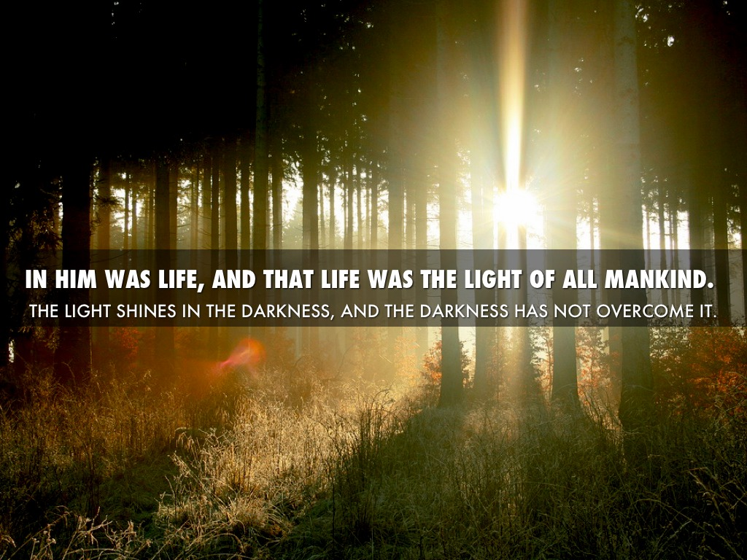

Why don’t we naturally perceive God?

It wasn’t that when humanity turned away from God, we turned from one light to another. It’s that we turned from the true source of light to darkness; from fullness to emptiness; from relationship to alienation; from belonging to separation; from peace to strife.

There’s been a lot of bad decisions made throughout history.

But turning away from God was humanity’s worst one.

And it was a choice we couldn’t fix or undo by ourselves.

In physical darkness, you easily lose your sense of direction.

It’s the same with spiritual darkness.

A person may think their life is headed in the right direction, but being absolutely confident that it is...that’s a whole other matter.