Uniquely Jesus: The Story Continues September 24, 17
Who Leads the Church?

Read Acts 1:15-26
Several things stand out in the verses we just read:
-> The leadership of Peter
-> The role of the Scriptures in directing the church
-> Leadership in the church
-> The making of decisions by the church

Leadership of Peter
A leader is one who goes ahead of others.
Vision is the ability to foresee; to perceive.
When put together, a leader sees where to go, or what needs to be done and then inspires and leads others to move in a particular direction, in order to pursue after, so as to achieve a particular goal; task; opportunity.

Example: when Nehemiah returned to Jerusalem, he shared with the people, 2:12, “the plans God [had] put into [his] heart.”
Then Nehemiah led the people in the rebuilding of Jerusalem’s wall.

It’s here, we do need to make an important qualification about spiritual leadership.
Erwin McManus writes: “Spiritual leadership is not the ability to define everything the future holds. It is the willingness to move forward when all you know is God. How does the church find its direction? From the compass of the purpose of God, fueled by the passions of God. As we move with God, doing what we know, God clarifies and directs.” An Unstoppable Force, p.77

What do we learn from this?
In the church, among God’s people, a leader must inspire others to “go with God.” This is what Peter did – he acted as a spiritual catalyst.
According to Peter, what task had the apostles’ and the church been given?
v.22 - to be a witness to the resurrection of Jesus.

What do we learn from this?
Tom Wright says, “If the church is not the movement which announces God’s new creation, it is just another irrelevant religious sect.” Acts for Everyone, p.20
Our identity and our purpose, is rooted in the resurrection of Jesus and the glory that is now his.

Glory means density. There is no one deeper or more profound than the Triune God. God’s density, (his glory) is what makes him compelling.
We who follow Jesus live to make known his fame.
The role of the Scriptures in directing the church
Why did Peter lead the church to choose a replacement for Judas?
After Jesus returned to heaven, that initial group of 120 stayed together in Jerusalem for 10 days.
During that time, according to v.14, they prayed together.
But it is also clear, they talked about Judas.

Judas’ betrayal had shocked them, and caught them off guard.
As they talked; and as they prayed - the Spirit of God brought to the awareness of Peter, specific Scriptures that addressed the questions the church had been asking and discussing regarding Judas.

v.20a – see Psalm 69:25, and the greater context of v.19-28.
v.20b – see Psalm 109:8, and the greater context of v.1-20.

Many of the psalms work on two levels.
First level: David wrote of events that were happening to him and how those events affected him; and how he turned to God in those circumstances.

What do we learn from this? Two things.
* Those who lived before us, faced the same things we do.
* God’s counsel is timeless.
This is why the psalms are always relevant; and an integral part of our worship.
They remind us that in every circumstance, the God who has called us into relationship with him, is good, wise, faithful, and close at hand.

Example told to me by Paulo of worship in Uganda.

Second level: a number of David’s psalms, in addition to speaking about the Messiah, spoke of a traitor, a close friend who would oppose God’s true king.
“In those particular Psalms, there is clear indication, that it is right for someone else to take the place of the one who has betrayed.” NT Wright, Acts for Everyone, p.18

What do we learn from this?
Judas betrayal hadn’t caught God off guard.
The greater story of the Bible tells us that even before he created, God had determined what he would do… to undo evil, and rescue the fallen sons and daughters of Adam and Eve.

Through these two psalms, 69 & 109, we learn that God’s plan had factored in Judas. It was true that none of the disciples had picked up on Judas’ corruption.
But God had known of it from the very beginning.

God also is not thwarted by evil.
He can turn what is intended for evil, into the accomplishing of good.
Remember Joseph in Genesis 50?

He was able to say to his brothers who had sold him into slavery: “You meant to harm me, but God intended it for good to accomplish what is now being done, the saving of many lives.” Genesis 50:20

The insight, given to Peter, in addition to encouraging, was intended to move the church to action.
This is why Peter said, verse 21-22 – “it is necessary to choose…”
The position held by Judas needed to be filled by someone else, who had been with Jesus from the time of his baptism until his return to heaven.

What do we learn about leadership in the church from this?
When God created humanity he originally created us to be a race of leaders who would steward the earth on his behalf.
It was the entrance of sin into human experience that corrupted what God had intended for humans to be… and to do.

God’s salvation through Jesus, when received, makes a person brand new.
Ephesians 4:24 – “put on the new self, [which is] created to be like God…”
Do you realize, that while we come to Jesus individually, there is a corporate component to our salvation?

The church is comprised of recreated women and men who, with God’s help, are learning to live and work together, like God originally intended - as a community of servant leaders.

Look at Ephesians 3:10.
Through the church, God displays his wisdom to the unseen rulers and powers.
Look at Ephesians 3:20-21.
Through the church God showcases his imagination, power, and creativity.

The church also models to a watching world that there is a different way to be human; and this includes the practice of leadership.

Tom Wright says, “Part of Christian obedience, right from the beginning, was the call to play great parts without pride and small parts without shame...
The different tasks and roles which God assigns to us are his business, not ours.”
Acts for Everyone, p.20.

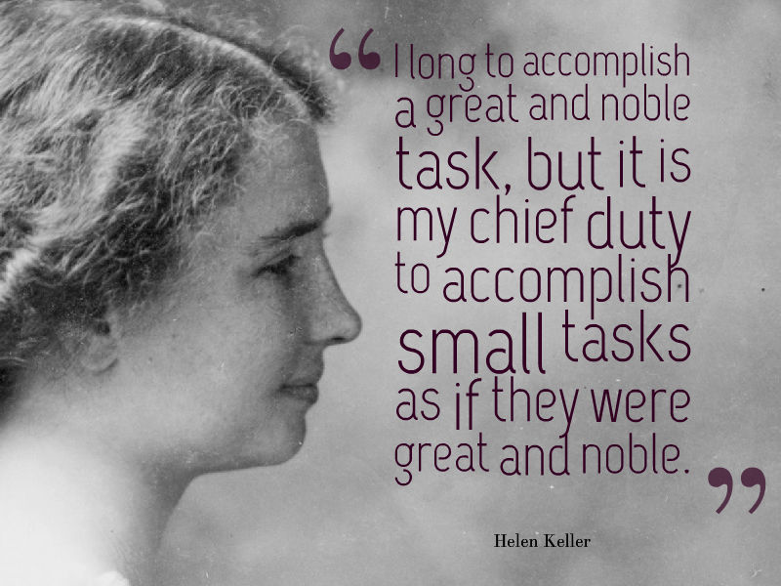
The range and the scope of leadership which God entrusts to each follower of Jesus, is determined by a number of factors: our age; our life experiences; our skill and spiritual giftings; our present circumstances; our spiritual maturity and our responsiveness to God.

As one continues to prove themselves faithful, then God is able to trust a person with more. Remember the parable of the talents – Matthew 25: “…since you have been faithful with a few things; I will put you in charge of many things…”

Jesus turns the practice of leadership upside down.
He said, whoever would be great in the kingdom of God, must be the servant of all.

Let’s quickly interact with the other issue raised by this passage - how did the church, a community of servant leaders, make decisions?
Peter identified the issue to be addressed: someone needed to replace Judas
in being an eye witness of Jesus’ resurrection.

What do we learn?
Our decisions are to be firmly grounded in Scripture.
The group of 120 didn’t engage in a discussion or a debate whether Judas should be replaced, because… Peter had set before them the Scriptures that indicated this is what needed to be done.

The making of decisions by the church

The church’s discussion was focused on “who.”
We’re not told the format of how the group put forward names.
Did they talk as a whole or break into smaller groups? Don’t know.
Neither are we told how long it took for them to reach a decision – whether it was the same day or the next.

What we do know is that the 120 were involved, and eventually two names were put forward. Why two names? Why not one or three or ten?
Again, we are not told. But one thing is clear.
In the decision that had to be made, what mattered most was what Jesus wanted.
After coming up with the two names, they prayed and asked – v.24:
“…[Lord] show us which of these two you have chosen…”

In the church, it is always about… what does Jesus want?
Because Jesus know every heart; because he knows everything, we can in confidence trust him to show us what is best.

How was their prayer answered?
v.26 – they cast lots, and the lot fell to Matthias.

In the teaching notes, there is additional information about this.
We don’t have time to unpack this; but for those life groups who are following the Sunday teachings, be sure to look into this.
___________________________________

The practice of casting lots is mentioned 70 times in the Old Testament and seven times in the New Testament.
The lots were called Urim and the Thummim.

Ralph Gower says, the Urim and Thummim were probably disks colored white on one side and black on the other. The casting of lots was instituted by God in the very beginnings of the priesthood - Exodus 28:30.

The lots were given to assist God’s people in seeking his mind when confronted with a pressing question. When the Bible speaks of casting lots, it’s never understood or viewed to be an issue of chance. See Proverb 16:33.

The casting of lots was an impartial way to find God's will when choices had to be made. The belief was that God would direct how the lots fell so that his will would be made known.
_____________________________________

What do we learn?
The question whether or not we should cast lots is secondary.
The real issue is this: “As a community of servant leaders, are we committed to living for the will of God, whatever that will would be, and however, that will would impact us?”

If our answer is yes, then we can have the confidence that as we ask God to make known his will to us, he will show us what to do. At the beginning, I had quoted Erwin McManus. I remind you of what he said, “As we move with God, doing what we know, God clarifies and directs.”

Recap:
-> Our identity and purpose is rooted in the resurrection of Jesus.

-> Through prayer and the Word, the Spirit of God teaches and guides the church in all matters, including its decisions.

-> Nothing catches God off guard. In everything, he is sovereign; fully able to turn into good, what is intended by evil to harm.

-> The church is a community of servant leaders, whose responsibilities and scope of influence is determined by God based on our faithfulness.

-> As a church we live to carry out the will of God.

Before we vote in a little whole about bringing Maddi on staff, we will pray, and ask God to show us his will. And as we use ballots, instead of lots, it is with this confidence – that our Sovereign God is fully capable of leading each one of us in the decision to be made; just like he led the church in the choosing of Matthias.

The Blessing
Hebrews 10:20-12

