Uniquely Jesus: The Story Continues week of September 24, 17
Life Group Discussion Questions

Read Acts 1:15-26
Several key things stand out in these verses:
-> Specifically, the leadership of Peter; and in general, leadership in the church
-> The role of the Scriptures in directing the church
-> The making of decisions by the church

Leadership of Peter
Describe your understanding of leadership.

Interact with Erwin McManus’ quote:“Spiritual leadership is not the ability to define everything the future holds. It is the willingness to move forward when all you know is God. How does the church find its direction? From the compass of the purpose of God, fueled by the passions of God. As we move with God, doing what we know, God clarifies and directs.” An Unstoppable Force, p.77

What do we learn from this? In the church, among God’s people, a leader must inspire others to “go with God.”
How and in what ways?

According to Peter what task had the apostles’ and the church been given?
verse 22 - to be a witness to the resurrection of Jesus. What do we learn from this? “If the church is not the movement which announces God’s new creation, it is just another irrelevant religious sect.” Acts for Everyone, p.20
Interact with Tom Wright’s quote.

Our identity and our purpose, is rooted in the resurrection of Jesus and the glory that is now his. What have you understood “glory” to be?
Try to describe it as best as you can.

Glory means density. There is no one deeper or more profound than the Triune God. God’s density, (his glory) is what makes him compelling.
Does this statement help your understanding of glory? In what way(s)?

The role of the Scriptures in directing the church
As Peter read through the psalms of David – see verse16, the Holy Spirit used two specific psalms to provide answers to the early church, as well as direction as to what they should do. Many of the psalms work on two levels. David wrote of events that were happening to him and how those events affected him; and how he turned to God in those circumstances. In addition, a number of David’s psalms, foreshadowed what would happen to the Messiah. Some of those psalms spoke of a traitor, a close friend who would oppose God’s true king. “In those particular Psalms it is made clear: it is right for someone else to take the place of the one who has betrayed.”
NT Wright, Acts for Everyone, p.18

verse 20a – see Psalm 69:25.
Read the greater context of Psalm 69:19-28.
What understanding do you gain?
verse 20b – see Psalm 109:8.
Read the greater context of Psalm 109:1-20.
What understanding do you gain.

What do we learn from this? Judas betrayal hadn’t caught God off guard.
God is not thwarted by evil. He can turn what is intended for evil, into the accomplishing of good. Remember the story of Joseph.
Read and interact with Genesis 50:20.
In what ways does God’s sovereignty and goodness change your perspective on the circumstances you are currently living?

The position held by Judas needed to be filled by someone else, who had been with Jesus from the time of his baptism until his return to heaven.
What do we learn about leadership in the church from this?

When God created humanity he originally created us to be a race of leaders who would steward the earth on his behalf. See Genesis 1:28.
It was the entrance of sin into human experience that corrupted what God had intended for humans to be… and to do.
God’s salvation through Jesus, when received, makes a person brand new; restoring in them, what had been broken. Ephesians 4:24 – “put on the new self, [which is] created to be like God…”

Do you realize, that while we come to Jesus individually, there is a corporate component to our salvation? The church is comprised of recreated women and men who, with God’s help, are learning to live and work together, like God originally intended - as a community of servant leaders.

The church models to a watching world – there is a different way to be human; and this includes the practice of leadership. The range and the scope of leadership which God entrusts to each follower of Jesus, is determined by a number of factors:
our age;
our life experiences;
our skill and spiritual giftings;
our present circumstances;
our spiritual maturity, and
our responsiveness to God.
How do you see each of the above factors influencing the range and scope of leadership exercised by every follower of Jesus?

As one continues to prove themselves faithful, then God is able to trust that person with more. Remember the parable of the talents – Matthew 25: “…since you have been faithful with a few things; I will put you in charge of many things…”
Jesus turns the practice of leadership upside down.
He said, whoever would be great in the kingdom of God, must be the servant of all.

Interact with the statements made by Helen Keller and Tom Wright.
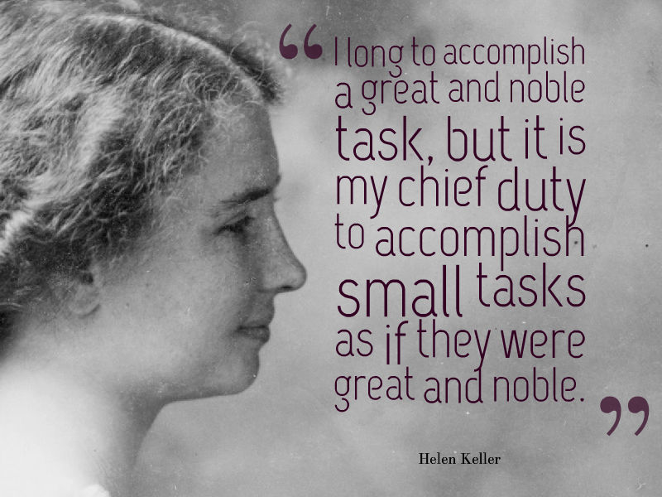

Tom Wright:“Part of Christian obedience, right from the beginning, was the call to play great parts without pride and small parts without shame...The different tasks and roles which God assigns to us are his business, not ours.”Acts for Everyone, p.20.

The making of decisions by the church
Our decisions are to be carefully and firmly grounded in Scripture.
The group of 120 didn’t engage in a discussion or a debate whether Judas should be replaced, because… Peter had set before them the Scriptures that indicated this is what needed to be done. Rather, the church’s discussion was focused on “who.”
In the decision that had to be made, what mattered most was what God wanted.
After coming up with the two names, they prayed and asked – verse 24: “…[Lord] show us which of these two you have chosen…” Because Jesus know every heart; because he knows everything, we can in confidence trust him to show us what is best.

How was their prayer answered?
verse 26 – they cast lots, and the lot fell to Matthias.

The practice of casting lots is mentioned 70 times in the Old Testament and seven times in the New Testament. The lots were called Urim and the Thummim.
Ralph Gower says, the Urim and Thummim were probably disks colored white on one side and black on the other. The casting of lots was instituted by God in the very beginnings of the priesthood - see Exodus 28:30; see also Proverb 16:33.
What impresses you about this practice?

The casting of lots was an impartial way to find God's will when choices had to be made. The belief was that God would direct how the lots fell so that his will would be made known.

Which of the five key principles most resonates with you?
Which one is the Spirit encouraging you to work on putting into practice in greater ways?
-> Our identity and purpose is rooted in the resurrection of Jesus.
-> Through prayer and the Word, the Spirit of God teaches and guides the church in all matters, including its decisions.
-> Nothing catches God off guard. In everything, he is sovereign; fully able to turn into good, what is intended by evil to harm.
-> The church is a community of servant leaders, whose responsibilities and scope of influence is determined by God based on our faithfulness.
-> As a church we live to carry out the will of God.

How can we quicken the pace of obedience within our church?

Read Isaiah 43:18-19.
What new things is God wanting to do in and through our church?

