Uniquely Jesus: The Story Continues July 15, 18
Conflict Resolution: The Godly Alternative, Acts 6:1-7

Today we move into chapter six of the book of Acts.
I remind you that the book of Acts tells the story of Jesus that continued here on earth for the next 30 years after he returned to his Father’s home.
It tells us how he… with his people and among his people and through his people built his church.

Let me give you today’s Coffee/Question:
Which one of these quotes do you most agree with?
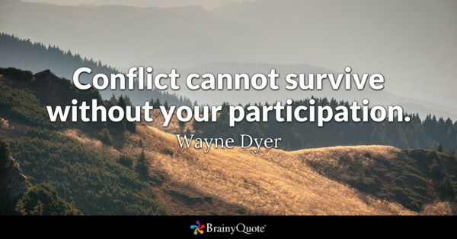
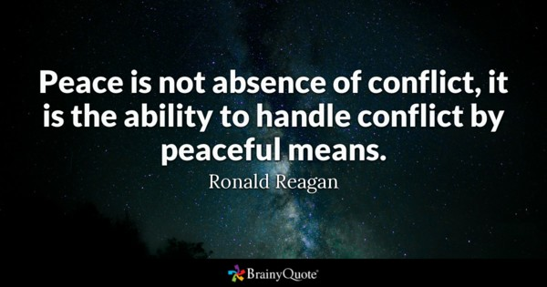
\\\\\

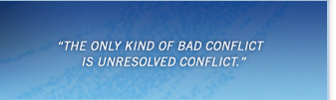

Is there anyone who has NEVER had conflict happen in their family?
Is there anyone who has NEVER had conflict with their spouse?
Is there anyone who has NEVER had conflict happen in their workplace?
Is there anyone who has lived in a city or town, where conflict has NEVER happened?

While some may enjoy it, most of us do our best to avoid conflict.
Why is that?
Because typically conflict is messy… and awkward…. and painful… and destructive.
But whether we like it or not, conflict is part of the human experience.

There is an important qualification I need to make here that will help us as we interact with this passage.

- There is conflict that happens between people who are not in relationship with Jesus.

- There is conflict that happens between a follower of Jesus and someone who doesn’t know him.

- There is conflict that happens - between people who are both followers of Jesus.

Bill Hybels wrote:
“[As followers of Jesus] we expect disagreements…
The popular concept of unity is a fantasyland where disagreements never surface
and contrary opinions are never stated…
Let’s not pretend that we never disagree…
Let’s not [hide our] concerns to protect a false sense of unity.
Let’s face the disagreement and deal with it in a godly way.

Here’s today’s big idea:
The mark of true Biblical community and unity, is not the absence of conflict, but the presence of a reconciling spirit.”

The type of conflict that happened in chapter six happened in the church of Jesus; between those who followed him.
And it happened because all followers of Jesus are a work in progress.

The Holy Spirit has given us a new nature… a new life…and new desires.
And he is active within us to complete what he has begun.
But the old person we used to be, still shows up…from time to time…in our thoughts and feelings… and occasionally expresses itself… in our actions and reactions.

And when conflict happens between us because of our old nature, Acts 6 provides us with incredible insight, not just how to resolve it, but how our reconciling God leads us to repair and restore our relationships with one another.

Issues that cause conflict, when rightly faced and dealt with in a godly way, can be turned by God into good, in the lives of his people and church; while demonstrating to those looking on, the power of the gospel to reconcile.

Jesus told his followers, “In this world you will have trouble.”

The situation in Acts 6, was now the third instance that carried with it the potential to inflict serious harm on the church.
The first had been fear – the threats of the Sanhedrin.
The second had been hypocrisy – the lies of Ananias and Sapphira.
The third was offense.

Let’s press into today’s passage (Acts 6:1-7).
v.1.
You need to know, that at this point in time, everyone in the church was a Jew.
Luke doesn’t explain, but somehow, a distinction began to be drawn between the Jews of Hebrew origin and the Jews of Greek origin.

If you have ever lived in a place where multiple languages were spoken, or you were learning a second language – you probably experienced the draw; the pull… to be with; speak with; interact with those who share your first language.

It “could be” that this was what happened in Jerusalem - people of similar language and culture gravitated towards one another.

v.1c.
“…the Hellenistic Jews among them complained against the Hebraic Jews because their widows were being overlooked in the daily distribution of food.”

There is a detail here you might not be aware of.
Typically, this was a responsibility that would have fallen to a widow’s family – her children; her extended family – to take care of her.
But if a widow didn’t have family, the church then stepped in to help.
We are not told how many widows there were.
We are not told how many of the widows were of Hebrew or of Greek origin.
We are not told where the food came from that was distributed.
We are not told how the food was distributed.
We are not told who distributed the food.

-> What we do know is that for some reason, the widows of Greek origin were being overlooked.

-> And…it would seem that this overlooking had happened more than once, because when Luke reports it, the issue had grown to a point where the Hellenistic Jews were pitted against the Hebraic Jews.

We are given a clue as to how this situation had developed.
v.1a – …in those days when the number of disciples was increasing…

When Jesus returned to his Father’s home, the church numbered 120 people.
Forty days later, on the day of Pentecost, 3000 people were added - Acts 2:41.
From that point on, people were added to the church on a daily basis - Acts 2:47.
By Acts 4:4 the number of men in the church had reached 5000.
Acts 5:14 says that in spite of what had happened with Ananias and Sapphira, more and more men and women were being added to the church.

The situation that had happened, of widows being overlooked, was the result of growing pains as the church grew from 120 people to over 10,000 in a few months.
There may have been other factors.
But this was a primary one.

When the apostles became aware of what was happening, they called the church together. v.2-4.

Why did the apostles gather the church… in this instance, when in the issue concerning Ananias and Sapphira, it had been dealt with privately?
The answer is simple.
When a matter becomes public knowledge, as this one had, and is negatively impacting the church, then the church community needs to be informed and involved.

As the apostles gathered the church it was clear… they were not just reacting.
From what they said, it is obvious they had thought and discussed and prayed upon the way forward.

Tom Wright says: “The apostles were clear about what they shouldn’t do. They shouldn’t at once rush to do the work themselves….” Acts for Everyone, p.99.

The apostles were also clear as to what wouldn’t be done, by them or others, when the church gathered to address the situation.
There was no criticism of either side.
There was no pointing of the finger.
No excuses were made for either side.
The issue was not downplayed
The floor was not opened for people on opposite sides to vent or lay blame.

What is clear is that the church had gathered to solve the issue.

There were too many “widows” to “hope” that “someone” would make sure that “everyone” was taken care of.
A structure was needed to ensure equitable care for all.

How are we to understand the apostles statement? “It would not be right for us to neglect the ministry of the word of God in order to wait on tables.”

Tom Wright explains: “[At] the heart of the apostles’ reasoning was the priority of the word of God and prayer.” Acts for Everyone, p.99.

I remind you of Acts 2:42, of what the church devoted itself to:
the apostles’ teaching
the fellowship
the breaking of bread
prayer

I remind you of the what the angel told the apostles when they were released from jail – Acts 5:20 – “Go, stand in the temple courts, and tell the people the full message of this new life.”

The apostles’ teaching was at the top of the list of the defining marks of the church.

Again, listen to Tom Wright’s insight on this:
“The temptation from the earliest days until now, has always been to heave a sigh of relief at being spared the spiritually and mentally demanding task of preaching and teaching, of explaining scripture, opening up its great narrative and its tiny details, applying it this way and that, enabling people to live within its story and make its energy their own.

Running committees, though tricky at times, is not nearly so demanding. Sometimes people even dismiss the ministry of biblical teaching as a kind of extra option for those who like that kind of thing. But the early apostolic testimony stands solidly: the task of an apostle is the word of God and prayer.” Acts for Everyone, p.100

The apostles were in no way suggesting that the care of the widows was not important.
Do you know how we know this?
Look again at v.3: “Choose seven men from among you who are known to be full of the Spirit and wisdom.”

The church was to choose seven of their best to oversee and carry out this ministry.

The apostles clearly understood that their contribution in helping to build Jesus’ church
was to give their attention to prayer and the ministry of the word.

But for the church to continue to grow and reach out beyond Jerusalem, others would need to be entrusted to carry out the ministry to the widows.

Are you surprised by the kind of qualifications the apostles said were needed in the individuals who would oversee the food distribution program to widows?

Experience in working with widows? Not mentioned.
Management skills? Not mentioned.
Experience in food purchasing? Not mentioned.
Food safe trained? Not mentioned.
Experience in food preparation? Not mentioned.

The only qualification mentioned was that they be full of the Spirit and wisdom.
This is not saying that skills don’t matter.
But no amount of skills can ever take the place of a follower of Jesus being full of the Spirit.

The church is the only place where this beautiful partnership happens – between God’s Spirit and a community of people who follow Jesus.

Here’s what happened in Acts 6!
When those seven men moved into that ministry to widows, the Spirit’s presence in them, both influenced and assisted them to serve with a reconciling spirit.

When the issue that had divided was no longer an issue, look at what happened.

Verse 7a – the word of God spread.
Verse 7b – the number of disciples in Jerusalem increased…rapidly.
Verse 7c – a large number of priests became followers of Jesus.

What do we do with this?
Remember our big idea: The mark of true Biblical community and unity, is not the absence of conflict, but the presence of a reconciling spirit.”

Relational challenges give us the opportunity to:
* ask God for wisdom
* diligently read and think upon his Word
* choose humility by saying yes to the Spirit

When we, the followers of Jesus, live by the truth, we confirm the credibility, both of the claims and of the power of the gospel.



My role
The role of the church board
Each of our roles

The worship team is going to come and lead us in the singing of the song:
Lord Reign in Me

This is a song of response.

As we sing this song, prayer team members will be here at the front to pray with you about any matters that you need prayer for and to encourage you in the decisions you are making to live for Jesus.

They will also remain there for a time after the service ends.

The Blessing
Philippians 4:2-9

