Uniquely Jesus: The Story Continues August 12, 18
“Known to Be,” Acts 6:1-7

Coffee/question:
What kind of person do people know you to be?
What things can you do or make?
What skills or abilities are you known for?

For several weeks we have been studying in Acts 6.
Let’s read the passage together – Acts 6:1-8.

What was the threat that confronted the church?
(1) division between the Greek and Hebraic believers over neglect of the Greek widows; (2) that the apostles would neglect prayer and the ministry of the Word to wait on tables

We’ve previously noted:
the unseen, but incredible reality that Jesus prays for his church
the solution made known to the apostles
the impact of a reconciling spirit

“Known to be full of the Spirit and wisdom,” was the defining qualification of those who were to be chosen to oversee and carry out the food distribution ministry.
Last time we focused our study on the end half of the phrase – “full of the Spirit and wisdom.”
Today we want to unpack the front half – “known to be.”

Was this a rare quality; something that was true of only a few?

Let’s review some of the key truths regarding the Holy Spirit.
These will help us better grasp the significance of the phrase – known to be - and the implications of this phrase to our own lives.

Who is filled with the Holy Spirit of God?
* Every person who receives and believes in Jesus.
Acts 2:38: Peter replied, Repent and be baptized, every one of you, in the name of Jesus Christ for the forgiveness of your sins. And you will receive the gift of the Holy Spirit.

It sounds obvious, but the men to be chosen were to be men who had repented of their sin; been baptized in the name of Jesus; and who had received the gift of the Holy Spirit.

Is the filling of the Spirit a one-time event?
Ephesians 5:18: “Do not get drunk on wine, which leads to debauchery.
Instead, be filled with the Spirit.”

The tense of the verb in this verse reads – be continually filled with the Spirit.
The men chosen were to be men whose lives gave evidence of the continual filling of the Holy Spirit.

Is there something a believer must do in order for their life to be continually filled with the Spirit?
The answer is both no and yes.
No.
* The grammatical voice of the word – be filled – in Ephesians 5:18 tells us that being filled is something that is done to the believer.

Yes.
* You and I welcome the Spirit to continually fill our lives with his presence and power, as we yield to his leadership.
A yielded life is a filled life.

We can’t fill our lives with God’s Spirit.
But the Scripture does warn the follower of Jesus that we can quench, grieve or insult the Spirit.
We need to press into this truth.

Quench.
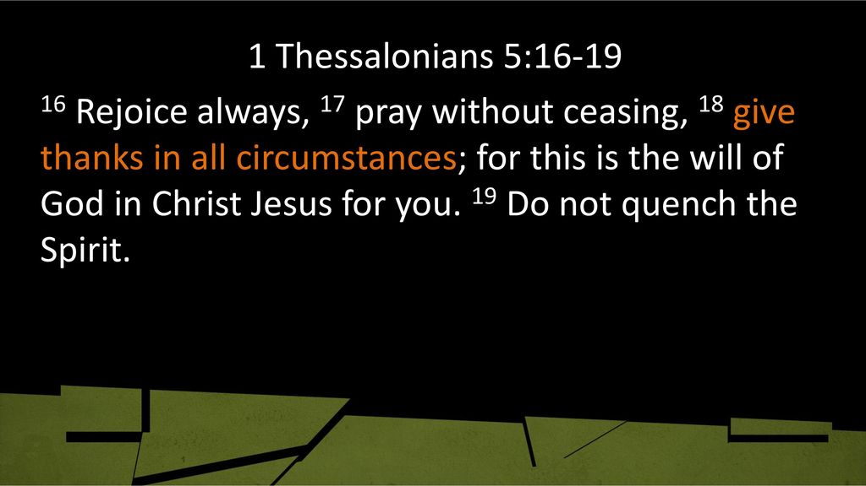
You and I cannot fill our lives with the Spirit’s presence and power.
But we can either welcome or quench the Spirit who lives in us.
What welcomes him?
What quenches him?

If we link this verse to Acts 6, we learn that those who are known to be full of the Spirit are what?
Always… joyful, continually… praying; thanking God… in every circumstance.

Grieve.
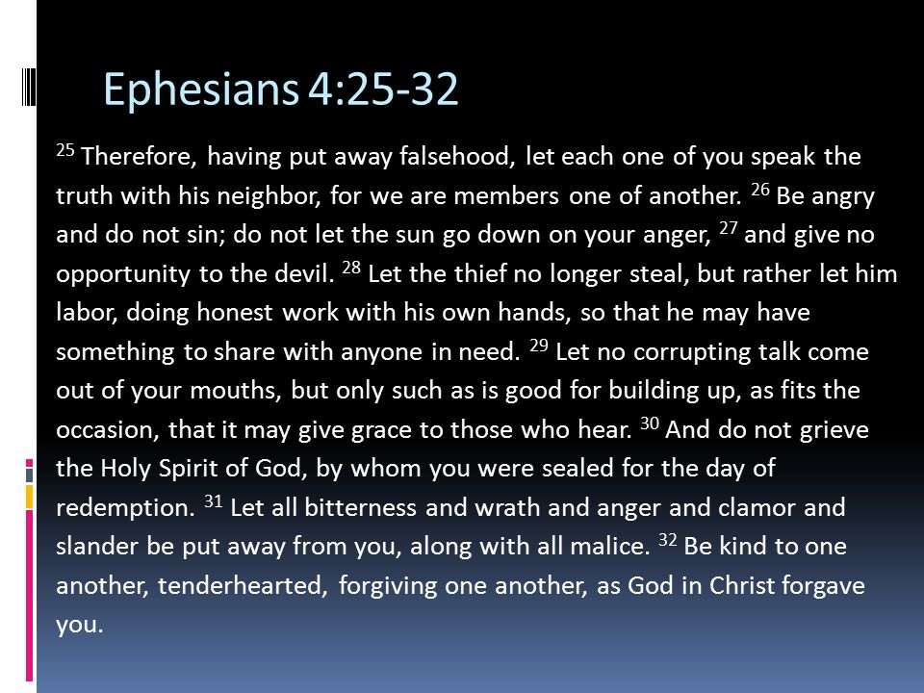
According to the passage what specifically is identified as…. grieving the Spirit?

- speaking lies…instead of truth
- harboring anger… instead of reconciling
- stealing… instead of working at a job and sharing with those in need
- speaking unwholesome words… instead of words that build up and benefit
- choosing to react with bitterness, rage, anger and slander… instead of acting
with kindness and compassion, forgiving as God forgave us in Jesus

The Spirit makes his home in the follower of Jesus – to empower them to live in a new way; because they have a new identity and a new purpose.
What “grieves” the Spirit is when a follower of Jesus chooses to remain in a lifestyle that Jesus died to set them free from.

If we link this passage to Acts 6, we learn that “known to be” means that the seven men chosen by the church… were to be truth speakers; were to be reconcilers; were to be men who earned a living and who were generous; were to be men who forgave as they had been forgiven.

Insult.
Hebrews 10:26-29: If we deliberately keep on sinning after we have received the knowledge of the truth…we insult the Spirit of grace.

Before we knew Jesus, our sin nature was in control of what we thought, what we said, what we did and didn’t do.

But when we receive Jesus, and believe in him, what he accomplished on the cross is applied to our lives.
Our sins are forgiven.
Our guilt is removed.
The power of our sin nature to control us is broken.
A new nature is birthed in us.
The Spirit makes his home in us.

As any follower of Jesus knows, our walk with Jesus has its ups and downs.
There are times when we respond to our circumstances… on the basis of… who we used to be, not who we now are because of Jesus.
If, and when that happens, the Holy Spirit who lives in us, immediately convicts us.
At that moment we have a choice.
Will we listen to or will we ignore the Spirit?
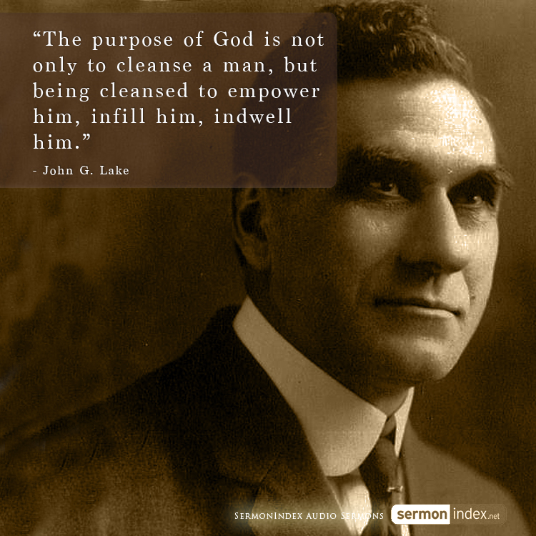

To ignore the Spirit’s conviction is to insult him and diminish his presence and power within our lives – for those he would empower must be those whose lives are clean.

In John 7:38 Jesus said the Spirit’s presence would be like “streams of living water [that] flow from within [the believer].”

Describe the mountain stream on Airport Road in Revelstoke.
You could hear it; see it; feel it.
Jesus said the presence of the Spirit in the life of a believer would be like streams of living water that flow out from within.

When the gift of the Holy Spirit is given, he is poured into our lives.
The Holy Spirit fills the believer in order to move them (like the wind fills the sails of a boat) to obey God and to go where he is leading; he fills the believer in order to permeate their life with the life of God; he fills the believer, in order to control them.

And he does all of this, so that life from heaven might overflow out of us.
This is normal Christianity.
His life in us, spilling out of us, like streams of living water.
This is God’s purpose for every one of his own – that we be known to be full of the Spirit.

For what reason does the Spirit flow from within the believer and out of them?
Psalm 32:8 answers that question– Taste and see that the Lord is good…

Example of Rocky Mountain Chocolates.
An employee was out front, offering samples of some of the products that they sold.
Why did they do this?
The store owners were convinced if a person could taste a sample of what they had within the store, they would come in and buy it for themselves.

Do you realize that you and I who follow Jesus are God’s samples of how good life is, when he is in charge?

Follower of Jesus, what are you known for?
The Father wants you to be known for being full of the Spirit.

What spills out of you? Better said, who spills out of you?
The Father wants his life to spill out of you.

When people interact with you, what taste do you leave in their mouths?
Through you the Father wants to leave with people a taste of heaven.

What is the Spirit saying to you?
As we sang in the song Jericho, God is the God of breakthrough.
Where is he wanting to break through in you this morning?

Life in the Spirit begins with a person repenting (turning around) and believing in Jesus that their sins might be forgiven.
If you do not have the Spirit within you, it is because you have not yet trusted in Jesus.

But I ask - are you sensing right now a tug on your heart to come home to God?
It is the Holy Spirit who opens the eyes of a person’s mind and heart to see the beauty of Jesus.
It is the Spirit of God who is speaking into your spirit urging you to receive Jesus and to trust him with your life.

If you have heard his voice, and felt his tug on your heart, come to Jesus.

I also remind you – God is the God of breakthrough.
He can breakthrough your past… your sin…. your circumstances…. your unbelief.

Come to him and see how good he is.
Come to him and experience his love.
Receive Jesus; believe in him… and he will come to make his home in your life.
Come to him and he will give to you the gift of the Holy Spirit.

Will you allow me to ask this question to those of you who are follower sof Jesus: does Jesus have free reign in you; does he control and influence all aspects of your life?
If he does, your life will be noted for being full of God’s Spirit.

But if he doesn’t have free reign, your experience of his presence within you
will be restricted; and as a result, you will find that living as a Christian is frustrating.
And that frustration is meant to persuade you to

Think about this phrase – known to be.
Isn’t it obvious that the presence of the Spirit within a person would be observable – so why state it as they did?

Look again at verse 4.
The apostles described “waiting on tables” as a responsibility.
What does it mean to be responsible?
-> having an obligation to do something, or having control over or care for someone, as part of one's job or role.
-> (of a job or position) involving important duties, independent decision-making, or control over others.

What this tells us is that all work… is a God-given responsibility.
But Jesus himself told us that apart from being yielded to him - no follower of his can do anything of lasting spiritual value – see John 15:5.

Once the church chose the seven, the apostles said in Acts 6:3 – “we will turn this responsibility over to them…”

The apostles would not micro-manage; because they wouldn’t need to.
The apostles trusted God’s Spirit.
Choosing men known to be yielded to the Spirit, meant these would be men who would follow and be led by the Spirit.

Being known to be filled with the Spirit, is why the apostles could trust these men with such crucial responsibility.
Yielded to the Spirit, the seven would be led by the Spirit.

Let’s now look at the first part of that phrase – “known to be…”
What is the evidence…what indicators are there that a person is full of the Spirit?
Verses 5 and 8 speak of three indicators.
v.5 – “Stephen, a man full of faith and of the Holy Spirit”
v.8 – “Stephen, a man full of God’s grace and power”

To be full of the Spirit is to be:
full of faith
full of God’s grace
full of God’s power

It emphasizes to us how important the Holy Spirit is.

We know this because when Jesus lived on the earth, despite the fact of who he was, his life was characterized by this distinction – he was full of the Spirit.

Luke 3:21-22; 4:1:
When all the people were being baptized, Jesus was baptized too. And as he was praying, heaven was opened, and the Holy Spirit descended on him in bodily form like
a dove. And a voice came from heaven: “You are my Son, whom I love; with you I am well pleased….”
Jesus, full of the Holy Spirit, left the Jordan and was led by the Spirit into the wilderness.
Luke 5:17:
And the power of the Lord was with Jesus… to heal the sick.

Acts 10:38:
God anointed Jesus of Nazareth with the Holy Spirit and power… and he went around doing good and healing all who were under the power of the devil, because God was with him.

There is a statement made in John 3:34 that is important for us to take note of - The one whom God has sent speaks the words of God, for God gives the Spirit without limit.
Jesus had the Spirit of God in his life…without limit.
Why was that?

Jesus had the Spirit without limit, because his obedience to God was without limit – there was no area of Jesus’ life, however small, where he acted independently of the Father.

Doing the Father’s will was so important to Jesus, that he described it like this to his followers outside of the little town of Sychar – “My food is to do the will of him who sent me.” John 4:34. Doing the will of the Father energized Jesus.

Let me say it again: Jesus experienced the Spirit of God in his life without limit, because he obeyed the Father without limit.

This is why he was able to teach as he taught; and to heal as he healed; and to answer his adversaries with such wisdom – because he was full of the Spirit.
This is why he loved his own as he did, in spite of their repeated failings – because he was full of the Spirit.
This is why he didn’t run from the cross – because he was full of the Spirit.

Full of Faith, God’s Grace and Power

Stephen was described in v.5 as being “a man full of faith...”
He had a deep trust in God.
His belief in God influenced him to live with the confidence that for God
“nothing is impossible.”

As a result of his faith in God, Stephen’s life was a conduit through which
God’s grace and power flowed to others.

Look at v.8. Stephen was a man “full of God’s grace….”
As Stephen personally experienced God’s grace, so his interactions with others was marked by that same grace.
The people, whom Stephen met and served, were treated by him in the same way, Jesus would’ve treat them had he been physically present.

Verse 8 also says that Stephen was “full of God’s power” and “…did great wonders and miraculous signs among the people.”
In what context did Stephen do great wonders and miraculous signs?
The food distribution program!

As a man of faith Stephen believed that no situation he came upon was beyond God’s intervention.
As a man of faith Stephen believed that in any circumstance there was hope because of God.

The people he met through the food program were the ones he brought before God, asking that God would intervene in their lives and circumstances.

Again I ask, was Stephen an aberration?
Was his experience of God working through his life unique?

I want to remind you of the kind of people through whom God displays his presence and power.
1 Corinthians 1:27-28 –
“God has chosen those the world calls foolish…he has chosen those the world calls weak…he has chosen those of little strength and small reputation…”

Are you familiar with the name Hudson Taylor?
Howard Taylor was the son of Hudson Taylor.
Listen to what he wrote about his dad.

“[My father] saw the Lord in answer to… prayer,
quell the raging of a storm at sea,
alter the direction of the wind,
and give rain in a time of drought.
He saw the Lord in answer to prayer,
stay the hand of would-be murderers
and quell the violence of enraged men.
He saw the Lord in answer to prayer,
rebuke sickness and raise up the dying
when all hope of recovery seemed gone.
As he trusted in God’s faithfulness,
again and again he saw God supply
the needs of his family
and work in answer to prayer.
It was his practice to encourage others to put their trust
in the love that cannot forget, and
the faithfulness that cannot fail.

Hudson Taylor himself wrote this about his experience with God:
“Let us see that we keep God before our eyes;
that we walk in his ways and seek to please and honor him
in everything, great and small.
Depend upon it, God’s work, done in God’s way,
will never lack God’s supplies.”

Both Hudson Taylor and Stephen, acted in faith, believing there was no limit to what Jesus could do.
They both believed there was no life that couldn’t be changed;
no situation that couldn’t be remedied
or in which grace could be granted so as to sustain a person.

They simply invited Jesus to act on behalf of the people they met, and Jesus did. The Scripture says, “[Jesus] is the same yesterday and today and forever.” Heb. 13:8.

On the basis of that promise I conclude that the Lord would want us, like Stephen did, to invite him to act on behalf of those we meet.

He would want us, like Stephen did, to live in faith of God so that our lives
can be conduits of his grace and his power.

God is still the Lord to whom nothing is impossible.
Which means, the real question is not whether we say we believe that phrase – “nothing is impossible with God” – but whether we live and act in our daily lives on the basis that our God is the God of the impossible?

He can do much more than we could ever imagine or ask through the lives of those who are yielded to him and who live in confidence of him.

Is this not a description of a man full of faith? Remember the definition of faith from Heb. 11:1? “Faith is being sure of what we hope for and certain of what do not see.”

As Hudson Taylor wrestled with the question of whether the China Inland Mission would be limited to people of one denomination, he and others reached the conclusion that the work was too great to do so. And so the Mission was open to fellow believers, irrespective of denominational views, who fully held the inspiration of God’s word and were willing to prove their faith by going to China with only the guarantee they carried in their Bibles.

What did he mean by that?

Again, we have the assurance, ‘No good thing will he withhold from those who walk uprightly.’ If anyone did not intend to walk uprightly, they’d better stay home. But if they meant to walk uprightly, they had all they needed in the shape of a guarantee fund. God owns all the gold and silver in the world, and the cattle on a thousand hills. We need not be vegetarians.

A prayer from the Welsh revival can help us to answer this question.
“Fill me, Holy Spirit, fill me, more than fullness I would know:
I am the smallest of your vessels, yet, I much can overflow.”

It is the desire of the Spirit to fill us so that our lives would be a means of blessing to the world, whether in large or small ways.

The word says, ‘Seek first the kingdom of God and his righteousness and all these things will be given to you as well.’ If anyone did not believe that God spoke the truth, it would be better for them not to go to China; but if they did believe, then the promise of God was sufficient…

But is there anything we are to do?

Why does the Spirit come to live in the believer?
I can only mention a few things.

* To assure us… and to keep reminding us of who God is and who we are because of Jesus’ gift of salvation.
Romans 8:16: The Spirit himself testifies with our spirit that we are God’s children.
Galatians 4:6: Because you are sons, God sent the Spirit of his Son into our hearts, the Spirit who calls out, “Abba, Father.”

“Known to be” tells us the seven men chosen knew who they were in Jesus.

* To take control.
Romans 8:9: "You, however, are controlled not by the sinful nature but by the Spirit, if the Spirit of God lives in you. And if anyone does not have the Spirit of Christ, they do not belong to Christ.”

* To teach us truth
John 14:26: But the Counselor, the Holy Spirit, whom the Father will send in my name, will teach you all things and will remind you of everything I have said to you.
* To lead and to guide us.
Galatians 5:25: Since we live by the Spirit, let us keep in step with the Spirit.

* To embolden us to speak as Jesus’ witnesses.
Acts 1:8: You will receive power when the Holy Spirit comes on you, and you will be my witnesses…

In the Bible, there are examples of many others of whom the same thing was said.
Let me point out one other.

King Nebuchadnezzar didn’t use Bible terms but look at what he said about Daniel. Daniel 4:8: …the spirit of the holy gods is in him.

Daniel was known to be full of the Spirit.
What indicators or character qualities were seen in Daniel that convinced King Nebuchadnezzar to make such a statement?

What Nebuchadnezzar saw in Daniel was humility, rather than boastful arrogance.
The incident that demonstrated Daniel was full of the Spirit, had to do with a dream that King Nebuchadnezzar demanded his wise men to interpret.

Daniel 2:1-11.

When Daniel did what none of the other wise men could do, and told the king what his dream was, he did not claim credit for the wisdom given to him but pointed Nebuchadnezzar to the great God of heaven.

Daniel 2:28, 30 – “There is a God in heaven who reveals mysteries. He has shown King Nebuchadnezzar what will happen in days to come…As for me, this mystery has been revealed to me, not because I have greater wisdom than other living men, but so that you, O king, may know the interpretation and that you may understand what went through your mind.”

And when Daniel told the King what his dream meant, he concluded by saying,
Daniel 2:45 – “The great God has shown the king what will take place in the future.
The dream is true and the interpretation is trustworthy.”

The Spirit of God lives to bring glory to Jesus, and in those who are full of the Spirit, they too now live to make much of Jesus.

The Bible tells the stories of Daniel and Stephen and many others like them, to encourage us… with the goodness of God and to inspire us… that this is what life is all about when the Spirit makes his home in us.

