Uniquely Jesus: The Story Continues August 26, 2018
The Power of the Gospel to Save and to Keep, Acts 6:8-15

There are many constants in our lives.
Some constants are big.
A day is always 24 hours long.
Our air is breathable.
The seasons – spring, summer, fall and winter

Other constants are smaller.
School and work typically start and end at the same time.
Normally your pension check shows up in your bank account on the same day every month.
If you make an appointment to see your doctor or dentist, unless told otherwise, they will be there.

There are also constants in our walk with Jesus.
Coffee/question: what do you consider to be a significant constant regarding the person of Jesus.

Feedback:

In our passage for today – two constants are highlighted.
Let’s read together – Acts 6:8-15.

- Followers of Jesus can expect to encounter trouble.
- The gospel of Jesus is powerful to save and to keep.

Let’s consider first the power of the gospel of Jesus as it was expressed in and through Stephen’s life.

Colossians 1:13 - For he has rescued us from the dominion of darkness and brought us into the kingdom of the Son he loves…
There is clear evidence that Stephen had been rescued… and that he was in relationship with God through faith in Jesus.

2 Corinthians 5:17 - Therefore, if anyone is in Christ, that person is a new creation: The old has gone, the new is here!
There is clear evidence that Stephen was a new creation.
The new nature the Holy Spirit had birthed in him, was seen in how he served others in Jesus’ name.

2 Peter 1:3 – His [God’s] divine power has given us everything we need for life and godliness…[Through God’s glory and goodness]…he has given us his very great and precious promises, so that through them you may participate in the divine nature, having escaped the corruption in the world caused by evil desires.

There is clear evidence that God provided for Stephen all that he needed as he served the widows of the church.

From the Bible we know God’s power:
cannot be exhausted,
cannot be frustrated or limited, and
is always sufficient.

From the Bible we know that God’s promises are not sometime yes and sometimes no.
2 Corinthians 1:20 – For no matter how many promises God has made, they are “Yes” in Christ.

There is also clear evidence that God provided Stephen with wisdom and grace when certain men argued with him, and again when Stephen was brought before the Sanhedrin, charged with blasphemy.

What God did for Stephen is what he will do for you and I.
As Jesus’ followers we have been rescued from darkness.
By the power of the Holy Spirit we are a new creation.
We have been and are being given everything we need for life… and godliness through God’s promises.
And I emphasis that word…everything.

Because of Jesus we have been given “a new power, a new purpose, and a new direction.”

Because of the life of God in us, you and I are different, and we live differently than when we didn’t know Jesus.
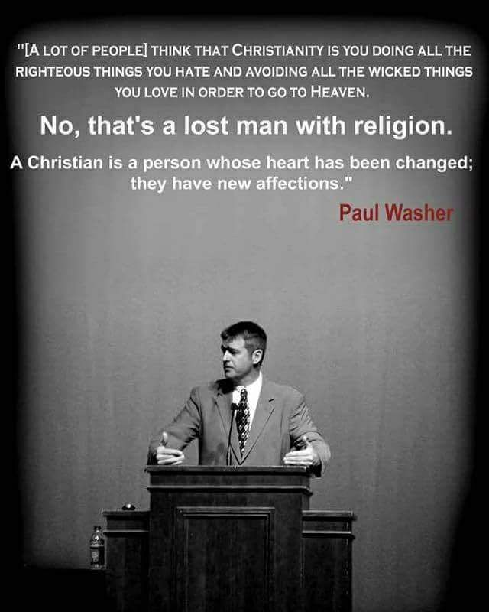

It is true as the hymn expresses – “Prone to wander, Lord, I feel it, prone to leave the God I love.”
It is true… that to become in practice, what God has declared us to be, will require a process of transformation that takes a lifetime.

We who follow Jesus, are not yet perfect; nor will we be until we see him face to face.
But neither are we who we used to be.

We have been saved by grace through faith – Ephesians 2:8-10.
We are being transformed into his image with ever increasing glory –
2 Corinthians 3:18.

Greg Morse writes, “[God’s grace] is the most precious jewel we can receive; the sweetest thing our souls can taste; the loveliest lyric our mouths can sing. But it is never a powerless thing.”
desiringgod.org/articles/sinners-saints-or-hypocrites

We’ve read in Acts 6 that Stephen was full of God’s Spirit and wisdom – v.3; full of faith – v.5; and full of God’s grace and power – v.8.
There is clear evidence that God was at work in Stephens’ life.
But Stephen was not a passive agent.

Philippians 2:12-13 – Therefore, my dear friends… continue to work out your salvation with fear and trembling, ¹³ for it is God who works in you to will and to act in order to fulfill his good purpose.

Stephen also was at work in his own life.
As the Spirit led him, Stephen kept in step with the Spirit.
Stephen applied the gospel to every facet of his life; and he drew upon heaven’s resources when he met individuals in desperate need.

It was in the context of serving the widows of the Jerusalem church, that Stephen encountered what Jesus had foretold would happen to his followers – “In this world you will have trouble.” John 16:33

Dr Luke writes that those who opposed Stephen were Jews from Cyrene and Alexandria as well as from the provinces of Cilicia and Asia.

The capital of Cilicia was Tarsus.
And Tarsus is where… Saul was from.
We will be introduced to Saul soon – in chapter 8.
But Dr. Luke wanted his readers to know that Saul was one of those who opposed Stephen.

What was at the heart of the dispute?
Let’s read v.9-14 again.
As Stephen waited on tables, he openly spoke of and shared the good news of Jesus. The apostles were doing the same thing. And I imagine the other six men chosen to serve the widows were doing likewise.

What happened?
v.7a – the word of God spread.
As the word of God spread, what happened?
v.7b – the number of disciples in Jerusalem increased rapidly.

Dr. Luke mentions one particular group of people.
v.7c – a large number of priests became obedient to the faith.

This gives us an important clue as to what the dispute was about.

At first, the opposition against Stephen was verbal – the men from the Synagogue of the Freedmen “argued” with him about the Scriptures that spoke of the Messiah.

And when they could not refute Stephen, that is, out-argue him, then they charged him with blasphemy.
Interestingly enough, the same charge brought against Stephen, was brought against Jesus.

In the case of Jesus, false witnesses declared that Jesus had said, “I am able to destroy the temple of God and rebuild it in three days.” Matthew 26:61

In the case of Stephen, false witnesses said, v.14, “We have heard him say that this Jesus of Nazareth will destroy this place and change the customs Moses handed down to us.”

In both cases, “false witnesses” were produced.
This tells us these witnesses had twisted what Jesus first said, and what Stephen had taught.

What exactly did Jesus say and in what context did he say it?
John 2:13-22.

- Jesus did not say, “I am able to destroy the temple of God.”
What he said was, “Destroy this temple…” referring to what the religious leaders would do to him.
- We know from John’s gospel that the temple Jesus referred to… was his body, not the building.
- We know that the “raising again” referred to his resurrection.
- And as to who would do the raising, there is no doubt. Jesus said –
“I …will raise it again.”

Jesus spoke these words when the religious leaders asked him to perform a sign to confirm his authority for driving the money changers and animal sellers out of the temple.

We need to press into this.
Those who spoke to Jesus in John 2 wanted to know who he was; and why he was doing what he did; and on whose authority he had acted.

Jesus’ statement – “Destroy this temple, and I will raise it again in three days” - was more than a claim by him that he would die and rise again.
This statement revealed who he is and why he had come and on whose authority, he was acting.

It’s here where we must use Scripture to interpret Scripture.
It’s here where we need to connect Dr. Luke statement in Acts 6:7… that a large number of priests became obedient to the faith…. to the statement made by Jesus… and how false witnesses twisted his words.

A common theme of Jesus’ teaching was that he had come to fulfill the Law and the Prophets.
Matthew 5:17-18: Do not think that I have come to abolish the Law or the Prophets; I have not come to abolish them but to fulfill them.
For truly, I say to you, until heaven and earth pass away, not an iota, not a dot, will pass from the Law until all is accomplished.

Everything in the OT had pointed to Jesus.
And all of those OT signposts had been like a candle… that was no longer needed because the sun had risen.

The temple had served its purpose.
Jesus is now the mercy seat; he is where the presence and the glory of God resides.

The animal sacrifices were no longer needed.
They had served their purpose.
Jesus “appeared once for all at the culmination of the ages to do away with sin by the sacrifice of himself.” Hebrews 9:26.
The priesthood was no longer needed.
It had served its purpose.
Jesus became our one and only high priest.
And… because he lives forever, he is able to save completely those who come to God through him, because he always lives to intercede for them.
Hebrews 7:25.

The Mosaic covenant was no longer needed.
It had served its purpose.
In the sacrifice of his life, and in the shedding of his blood, Jesus established a new covenant.
__________________________________________________
John Piper writes, “what Jesus meant when he said, ‘Destroy this temple and in three days I will raise it up,’ was that he himself was taking the place of the temple – by dying for sin once for all, and by rising from the dead to reign as the everlasting priest and Lord of glory.

When Jesus died, the temple system died. And when Jesus rose, he is now the temple; he is the sacrifice for sins; he is the intermediary between God and man; he is the presence and radiance of God’s glory.

The temple was finished…

This is why when John the apostle had a vision of heaven in Revelation 21:22-23, he wrote, ‘And I saw no temple in the city, because the Lord God Almighty and the Lamb are its temple. And the city has no need of sun or moon to shine upon it, for the glory of God is its light, and its lamp is the Lamb.’” desiringgod.org/stephens-crime-jesus-will-destroy-the-temple
___________________________________________________

Dr. Luke wanted his readers to know the power of the gospel to save.
And so, he wrote that as the gospel was preached, a large number of priests in Jerusalem came to believe in Jesus; understanding Jesus to be the fulfillment of the Law and the Prophets.

And as these priests came to Jesus and believed in him and received him into their lives, they also understood they were out of job.
These priests willingly gave up everything… to gain Jesus.
They did so because their eyes had been opened to see Jesus as their greatest treasure.

As it is today, so it was then.
Not everyone in Stephen’s day believed in Jesus the first time they heard the gospel. Not everyone immediately yielded the control of their life to Jesus and embraced his identity as theirs.

I didn’t, did you?
Saul didn’t.

Some continued in their folly – trying to shout louder than the truth, or to silence the truth speaker(s) through mocking or threats.
That was the case with Saul and the men from the synagogue of the Freedmen.

I didn’t shout louder, but I ran harder.
What about you?

This is how it is in this in-between time, as opportunity is given to men and women to respond to the gospel of Jesus – some will, and some won’t.
This is why Jesus had said, “In this world you will have trouble.”

Jesus knows the insanity of sin that turns the hearts of those he has created, against him; that convinces all of us to rebel against him, and some to fight him fiercely.

But the love of God for us is greater than our hatred of him.

Jesus came into the world, not to condemn, but to save sinners. John 3:17.
This is why he relentlessly pursues after us.
While we were his enemies, he died for us, in order to reconcile us to God.
Romans 5:10.

When he could have run from the cross, Jesus chose not to.
When he hung on the cross, it was love that held him there, not the nails.
When he could have called upon the Father to rescue him, Jesus finished what he had come to do, in order that he might rescue us.

The gospel of Jesus is powerful to save -for it transforms an enemy into a son or daughter of God.
But the power of the gospel doesn’t end at the new birth.
It then empowers those who used to be slaves to sin, to live new lives of radical holiness.

And the power of the gospel doesn’t stop there.
Just as the Father was prepared to see the Son die, so that you and I could come home to him, so Jesus is prepared to risk our lives so that others may come home as well.

And we who’ve experienced his great love, willingly trust our lives to him to use as he chooses.

This is why Jesus had said, “In this world you will have trouble.”
The story in Acts 6 and the trouble that came upon Stephen, tells us that the rescue of a human soul is no simple or easy thing.

While Jesus paid it all, we, his followers do share in the cost of taking the gospel to the people of our generation.
It will cost us time and resources.
It will require of us energy and effort.
It may cost us our reputation.
And sometimes that cost may require us to lay down our lives.

This story in Acts 6 reminds us and encourages us with the power of the gospel.
This story in Acts 6 also challenges and motivates us to fully live for Jesus.

Greg Morse writes: We have a mantle to carry. Our Savior has worked a mighty change in us. We now are to be his hands and feet…We are to bear witness to a watching world. We are a city on hill. We live as citizens of the world to come.



God help us to live more boldly, taste more salty and shine more brightly. desiringgod.org/articles/sinners-saints-or-hypocrites

The Blessing

