**Uniquely Jesus: The Story Continues** September 16, 18

Acts 7, Part Two

We’ve been studying in the book of Acts since last September.

Acts tells the ongoing story of what Jesus is doing through his church, after he returned to his Father’s home.

In chapter six we were introduced to a man named Stephen.

He was known to be full of faith; full of God’s grace and power; because his life was full of God’s Spirit.

Because of his dynamic relationship with Jesus, Stephen was chosen, by the church, to be one of seven men entrusted to take care of the widows, ensuring that all of them, regardless of their nationality, received a daily food allotment.

As Stephen served the widows of the church, he had many opportunities:

to speak the good news of Jesus; and

to pray for people in Jesus’ name.

As he did so, incredible things happened.

That said, the hostility of the religious leaders towards Jesus and his followers had not diminished in any way; but had actually grown and intensified.

As Stephen’s name became known, this hostility spilled out on him.

In Acts 6 two charges were brought against Stephen:

1. that he was slandering Moses and God
2. that he was attacking the central pillars of Jewish identity

In that time, if these charges against Stephen were to be proven true, they were punishable by death.

The high priest asked Stephen, **“Are these charges true?”**

In our court system, after the charges are read, the accused is asked by the judge, “How do you plead – ‘guilty’ or ‘not guilty?’”

I wonder if the high priest was looking for a similar response from Stephen –

a simple “yes” or “no.”

There are times when you and I need to be concise and to the point in our sharing of Jesus.

There are times when we need to be silent.

And there are times when we need “to give the long answer.”

How did Stephen know what he should do?

**Coffee/Question:**

How do you and I, who follow Jesus, know when:

to be silent

to speak

to be short and to the point

to elaborate

Jesus had promised his disciples, **Luke 12:11-12:**

*When you are brought before synagogues, rulers and authorities, do not worry about how you will defend yourselves or what you will say, for the Holy Spirit will teach you at that time what you should say.*

We know from Jesus’ promise, that it was God the Holy Spirit who prompted Stephen, in that instance, as to how he should answer the high priest.

What the Holy Spirit did with Stephen, is what he does with all of Jesus’ followers. **John 16:13-14:** *… he guides us into all the truth*

**Point of Connection**

**You and I can trust the leadership of the Holy Spirit.**



**This is easier to say, when you can see and understand what God is doing.**

**But sometimes the reason why the Spirit leads us into difficult situations, is that he might grow, both our confidence and our dependence upon him.**

**We learn to trust the LORD when we are in over our heads.**

**This is also when we learn to pray and to wait for him.**

**How else will we learn that our competency comes from God?**

**2 Corinthians 3:5**



When Abraham had arrived in Canaan, God told him – **Acts 7:6a** – *“For four hundred years your descendants will be strangers in a country not their own…”*

There in that country, God said – **Acts 7:6b** - *“and they will be enslaved and mistreated.”*

But God promised he would rescue them and bring them back to Canaan –

**Acts 7:7b** – *“to worship me in this place.”*

God never told Abraham, how, his descendant would end up in a country not their own, or how he would rescue them.

The LORD, however, did enter into – **Acts 7:8a** - *“a covenant of circumcision”*

with Abraham.

In that covenant he promised Abraham he would be forever faithful to him.

He promised Abraham he would be the father of many nations.

He promised… to Abraham the land of Canaan.

And what did God require of Abraham?

That he would walk faithfully before him and be blameless.

That he, along with all male descendants, would be circumcised, carrying in their bodies, the mark that signified they belonged to God.

**Acts 7:8b**

To Abraham and Sarah – Isaac was born.

To Isaac and Rebekah – twin boys, Jacob and Esau were born

To Jacob and his four wives – 12 sons were born, who became the patriarchs of the Hebrew nation.

**Acts 7:9-17**

Joseph was the eleventh son born to Jacob, and the first child… born to his mother Rachel.

Because Jacob loved Rachel, Joseph was favored by his father.

As a teenager, Joseph had incredible dreams in which his family members bowed down before him.

Joseph’s retelling of these dreams, along with his father’s blatant favoritism of him, caused his brothers to hate him.

Motivated by jealousy – **verse 9** – the brothers sold Joseph to some Midianite merchants, who took him to Egypt, where he was bought by a man named Potiphar.

This personal tragedy of Joseph’s was how God began to bring about the things he had foretold to Abraham.

Psalm 105:16-19 – *[the LORD] called down famine on the land and destroyed all their supplies of food; 17 and he sent a man before them— Joseph, sold as a slave.  
18 They bruised his feet with shackles, his neck was put in irons, 19****till*** *what he foretold came to pass,****till*** *the word of the Lord proved him true.*

In all of this, **verse 9** – *“God was with him.”*

It was God who sent Joseph to Egypt in order to place him in a position where he could rescue his family from famine.

**Verse 10a** – *“and [God] rescued him from all his troubles.”*

God could have rescued Joseph months after his arrival in Egypt.

But he didn’t; and it was not because he couldn’t.

Those years when Joseph was a slave and then a prisoner falsely accused, were not wasted years.

God used those years to forge Joseph’s character; making ready to be the ruler of Egypt.

During those years – **verse 10b** – *“[God] gave Joseph wisdom…”*

And it was this wisdom and God working in the heart of Pharaoh that enabled Joseph to gain the goodwill of Pharaoh.

**Verse 10c** – *“So Pharaoh made [Joseph] ruler over Egypt and all his palace.”*

Are not God’s ways astonishing?!?!

Yes, it was Pharaoh who made Joseph ruler over Egypt.

And yes, it was God who brought Joseph to Egypt; who made Joseph ready; who spoke to Pharaoh through two dreams; who prompted the king’s cup bearer to remember Joseph; who gave Joseph wisdom to interpret the dreams.

**Point of Connection**

**Many followers of Jesus love the promise found in Romans 8:28:**

***And we know that in all things God works for the good of those who love him, whohave been called according to his purpose.***

**This promise teaches us that the follower of Jesus does not live at the mercy of random chance.**

**There is no one more powerful than God; no one more loving; no one wiser. This is why… in all things – in our lives and in this world – he is able to work out his purposes.**

**This confidence in God is what shaped how Joseph lived.**

**Joseph said to his brothers after the passing of their father, when they feared Joseph might take revenge on them, Genesis 50:19-21:**

***“Don’t be afraid. Am I in the place of God? 20You intended to harm me, but God intended it for good to accomplish what is now being done, the saving of many lives. 21So then, don’t be afraid. I will provide for you and your children.”***

***And he reassured them and spoke kindly to them.***

**Think of the challenge(s) before you.**

**Think of what it is, or who it is… that has caused you to feel disappointment, or fear, or uncertainty.**

**Now hear God’s promise!**

**In all things he works for the good of those who love him.**

**There is no doubt - Joseph’s brothers meant to harm him.**

**Their intent was that his life as a slave… would be short and miserable.**

**But……. God turned what they intended for harm…. and used it to accomplish great good – the saving of many lives.**

**Did Joseph know as he walked in chains to Egypt… how God would turn the harm that his brothers had brought upon him?**

**Nothing is said in Scripture that he did.**

**Do you and I know how God will turn the challenging things in our lives for the accomplishing of good?**

**We don’t know… but the LORD does.**

**You and I can trust him with the “when” and the “where” and the “how.”**

**He will rescue us.**

**He will breakthrough.**

As Stephen spoke he pointed out to the Sanhedrin a repeated historical pattern; that had happened with Joseph, Moses; and other unnamed prophets.

**Verse 11-14**

Joseph, whom the patriarchs rejected, became the one God used to save them from famine.

Moses, whom the nation of Israel rejected, became the one God used to save them from slavery.

Other prophets, whom the nation of Israel rejected, became the ones God used to speak his truth, in order to save them from the deceptiveness of their sin.

Stephen’s intent in pointing out this pattern, was to show the men of the Sanhedrin that they were just like their ancestors…. they had rejected Jesus,

whom God used to save the world.

**Point of Connection**

**God keeps his promises.**

**In the beginning, he had promised Eve that an offspring of hers would crush the head of the serpent who had deceived her and Adam.**

**Through the long history of God’s relationship with the family of Abraham, God moved his rescue plan forward, in spite of repeated human and demonic attempts to derail God; to hinder God; to stop God… from fulfilling what he said he would do.**

Isaiah 55:6-11:

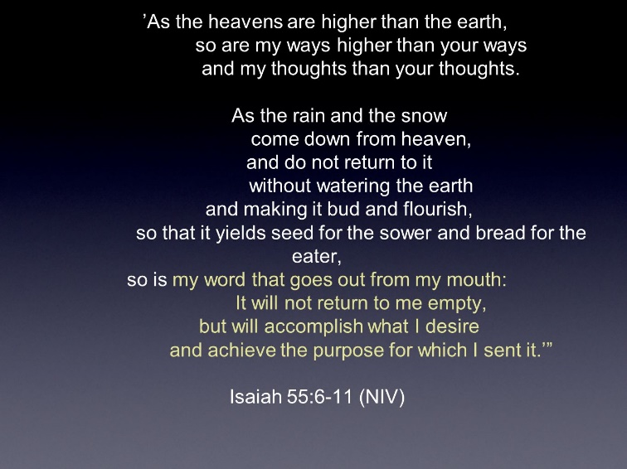

**Though it is beyond us to comprehend how the LORD directs history to achieve his purposes, he does – in surprising ways, using unexpected means and people.**

**Remember the words from the song, “The Lion and the Lamb?”**

**The verses and the bridge repeat the question – “Who can stop the LORD Almighty?” The answer is no one!**

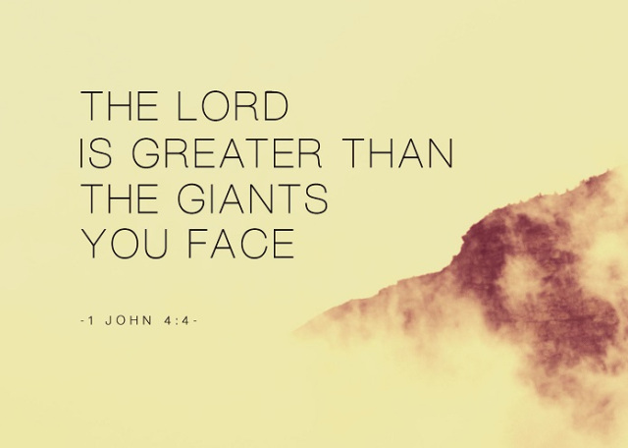

Though it is subtle, in Joseph’s story, Stephen did speak to the issue of identity.

Remember – Stephen was accused of attacking the core pillars of Jewish identity – the temple and the law.

What shaped Joseph’s identity?

His being the favored son?

His being a slave?

His being falsely accused of rape?

His long imprisonment?

His being ruler of Egypt?

Joseph’s identity was rooted in his relationship with God.

How do we know that?

Because of how he responded to Mrs. Potiphar.

She invited Joseph to have sex with her.

Listen to how he answered her.

**Genesis 39:8-9**: *“With me in charge my master does not concern himself with anything in the house; everything he owns he has entrusted to my care.****9****No one is greater in this house than I am. My master has withheld nothing from me except you, because you are his wife. How then could I do such a wicked thing and sin against God?”*

But Mrs. Potiphar persisted.

Day after day she propositioned Joseph.

And one day, when no one was home, she grabbed hold of Joseph, pleading, “Come to bed with me.”

If Joseph had said yes to her, no one would have known.

So why then did Joseph that day run out of the house?

Because his identity was rooted in his relationship with God.

**Point of Connection**

**What about you?**

**What is your identity rooted in?**

**This is not the first time in history these things have happened.**

**Our culture is not unique in this regard.**

**Others have faced similar identity crises.**

**The people of our culture are confused as to who they are… because they don’t know Jesus.**

**His absence in their lives has resulted in a great inner void.**



**This is why people are looking, some desperately, for something, anything… to give them a sense of meaning and purpose.**

**But the “something” they are looking for, is actually “someone” – and his name is Jesus.**

**What sets the follower of Jesus apart is our relationship with our Savior.**

**He has rescued us from an empty way of life.**

**He has forgiven us the guilt of our sin.**

**He has created a new nature in us.**

**He is with us, living in us.**

**He says who we are.**

**Before we started our service, we played Lauren Daigle’s new song entitled “You Say.”**

*I keep fighting voices in mind that say I’m not enough*

*Every single lie that tells me I will never measure up*

*Am I more than just the sum of every high and every low?*

*In You I find my worth, in you, I find my identity*

**I remind you follower of Jesus, “who” you are is because of “whose” you are.**

**I remind those of you, not yet in relationship with Jesus, the answer to who you are is to be found in the One who created you and who died and rose again to save you.**

**Joseph trusted God.**

**In his trust he proved that God knows what he is doing – he is working all things for the good of those who love him; and for the saving of many lives.**

**Nothing and no one can stop him.**

Having heard God’s truth, I now urge you to respond to the LORD.

Respond, using the closing song as a prayer…

of declaration

or trust

or commitment to the LORD.

Come for prayer – put into the LORD’s hand…

the pressing issue;

the doubt;

the fear;

the reservation… that is weighing on you;

your life.

This is his invitation – come to me all you who are weary of soul.

I will give you rest.

Learn from me…and you will find rest for your soul.

My yoke is easy and my burden is light.