Uniquely Jesus: The Story Continues October 14, 18
Acts 7:23- , The Story of Moses, Part Two

As he spoke with the members of the Sanhedrin, Stephen retold to them the history of the nation of Israel beginning with Abraham.
Stephen didn’t do this because these men were ignorant of their nation’s history.
They knew it well.
Stephen told them the story of Abraham’s family, in order to make a particular emphasis, which they had overlooked.

The members of the Sanhedrin were religious…
They were moral men – many of them were like the apostle Paul who truthfully claimed to the church in Philippi, that in regards to righteousness based on the law, he was faultless – see Philippians 3:6.

These men were meticulous in the keeping of rules.
They even tithed their garden herbs.
Jesus said this of them, Luke 11:42: “Woe to you Pharisees, because you give God a tenth of your mint, rue and all other kinds of garden herbs, but you neglect justice and the love of God. You should have practiced the latter without leaving the former undone.

These men not only had memorized large sections of the Old Testament; they diligently studied the Scriptures.

Jesus said this about them and to them - John 5:39a: You study the Scriptures diligently because you think that in them you have eternal life.
But listen to what Jesus went to say to them, John5:39b-40 – These are the Scriptures that testify about me, yet you refuse to come to me to have life.

Point of Connection
The goal of reading and studying the Bible is not simply to learn facts.
The Bible has been given to us by God in order that we might know him… and in knowing him, experience life to the full.

What was the emphasis Stephen made to them?
The men of the Sanhedrin were like their forefathers who had lived before them… they did the very same thing they had done – pattern.

They rejected the Rescuer God sent to them.
But their rejection didn’t stop God’s rescue plan.

Across lifetimes, and centuries, God has been at work.
He is not in a hurry as we humans understand hurry.
But neither is God ever late.
He is sovereign and in control.

Coffee/Question:

Do you agree/disagree? Why?
Feedback

Read verses 23-29.
At forty years of age, Moses decided to visit…his “fellow” Israelites.
Exodus 2 also speaks of this same moment, and tells us that…
“one day, after Moses had grown up, he went out to where his own people were and watched them at their hard labor.” 2:11

Moses had been raised as an Egyptian.
What we don’t know is when Moses realized he was born to Hebrew parents.
What we do know is that when he was forty years old, something spiritually profound happened to Moses.
Hebrews 11:24-26 – By faith Moses, when he had grown up, refused to be known as the son of Pharaoh’s daughter.
He chose to be mistreated along with the people of God rather than to enjoy the pleasures of sin for a short time.
He regarded disgrace for the sake of Christ as of greater value than the treasures of Egypt…

We are not told… how, but in some way, God made himself known to Moses.
His encounter with God is what motivated Moses to then act in faith of God.

- By faith… Moses turned his back on the privileges that had been his as the son of Pharaoh’s daughter.
- By faith… Moses regarded the God of his fathers as being more precious than all the treasures of Egypt.
- By faith… Moses chose to identify with the Hebrew people, and share in their mistreatment.

Point of Connection
There is a cost to following Jesus; to being in relationship with God.

Luke 14:25-27, 33 – Large crowds were traveling with Jesus, and turning to them he said: ²⁶ “If anyone comes to me and does not hate father and mother, wife and children, brothers and sisters—yes, even their own life—such a person cannot be my disciple. ²⁷ And whoever does not carry their cross and follow me cannot be my disciple… ³³ In the same way, those of you who do not give up everything you have cannot be my disciples.

David Platt wrote:


I fear for myself and for all of you, that in the challenging days in which we live, we may be unprepared to stand our ground; to run the race laid out for us – using those Biblical analogies – because somehow and in some way we’ve thought there existed a two-tier Christianity – radical obedience for a few and minimum obedience for the many.

I fear us being satisfied with those things that our culture says are important rather than the priceless treasure of knowing Jesus Christ.
We live in a time, when we have unprecedented access to the Bible.
I fear us never reading it; thinking upon it; memorizing it; praying it… with the enthusiasm with which we eat our daily meals.

I fear us wasting opportunity given to us by Jesus…either because we see being on mission with him as optional, or because we choose we refuse to call our pride or offense or any other sin that chokes the Spirit, for what it is – sin that God hates; sin for which Jesus died to set us from.

I fear us who are adults, modelling and passing on a faith to our children and youth, where Jesus is not our priority… or our everything; where he is easily bumped to 2nd or 3rd or 4th place; and then in the years to come, being in shock when our kids walk away from him.

Again I quote David Platt:
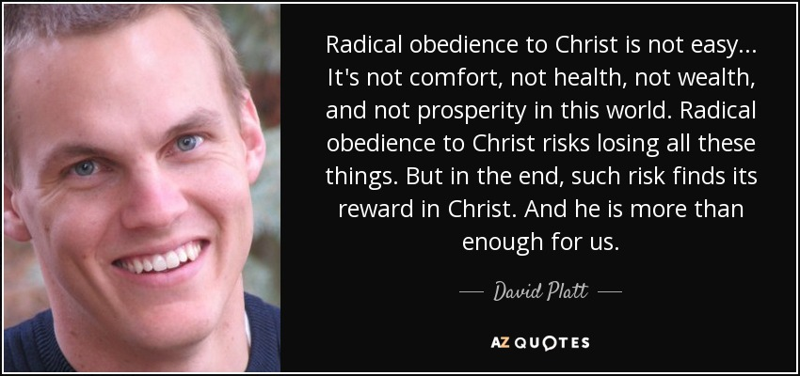

Jesus said to his disciples, Matthew 16:25 - …whoever loses their life for me will find it.
Then to make sure that his followers got it – that they would grasp the great treasure it is to know him, Jesus said this – What good is it for a person if they gain the whole world, yet forfeit their soul?

The church as an outpost of heaven, is a community of people who demonstrate to each other and to a watching world that Jesus is more than enough.

On that particular day, referred to by Stephen, Moses saw firsthand just how difficult life was for his people.
Did God’s call on his life come earlier or did it come on that day?
We are not told.
But what is clear – v.25 - Moses was convinced that God had chosen him to rescue the Hebrews.

Hadn’t Moses as a 3-month-old baby been miraculously spared from death?
Didn’t this indicate he had been rescued to rescue his own people?

Hadn’t Moses, growing up, been protected by the very man who made life miserable for the Hebrews?
Didn’t this indicate he had been saved to save his own people?

Hadn’t Moses been trained by the Egyptians to lead people?
Didn’t this indicated he had been equipped to empower his own people?

When Moses, on that particular day, saw an Egyptian mercilessly beating a Hebrew man, with anger, and with a deep sense of justice, Moses reacted as he had been trained to react.
He avenged the wrong; he killed the Egyptian.

Moses knew God had chosen him to be a rescuer.
But what Moses had yet to learn, is that with God there is a right time.

Point of Connection
Across lifetimes, and centuries, God has been at work.
He is not in a hurry as we humans understand hurry.
Neither is God ever late.
He is sovereign and in control, and… he is competent.



As we follow Jesus, and he is active in our lives, we learn to trust his love; to trust his power; to trust his ability to lead our lives; and… to trust his timing…
The LORD is competent and capable – in everything.

We are not told why he did so, but the next day Moses went back to where his fellow Israelites were working.
This time he came upon two Hebrew men fighting each other.
When he tried to reconcile them, he was dumbfounded by what the one man said to him: “Who made you ruler and judge over us?”

Yes, it’s true - it was only one man who said this.
But this man’s response was representative of the entire nation – see v.35.
How do we make sense of this reaction?
- Moses had… Hebrew parents.
- By faith Moses had turned his back on his Egyptian upbringing and identified himself as a Hebrew.

But in the eyes of the Hebrew people Moses was still… an Egyptian –
he spoke like an Egyptian;
he dressed like an Egyptian;
he had the mannerism of an Egyptian;
he thought like an Egyptian.

Moses was not who they thought God’s rescuer should be.

Point of Connection
We are prone to think we know best what we need, and how God should give it to us, and when.
This is why sometimes we don’t immediately recognize God’s provision.

Hebrews 13:8 – Jesus Christ is the same yesterday and today and forever.
We read that verse and can conclude that God will always do the same thing; misunderstanding that what this verse is describing is the character of Jesus.

What the story of the Bible teaches us is that what God did in the past may not be what he chooses to do in the present.
The LORD often, in his own words, does a “new thing.”
I
saiah 43:18-19: See, I am doing a new thing! Now it springs up; do you not perceive it? I am making a way in the wilderness and streams in the wasteland.
Remember, in these verses God is using descriptive language.
He is not just speaking of a road he will build in the wilderness; or of a stream that he will cause to flow in a wasteland.

The Lord finds great pleasure in bringing about things that are considered to be impossible.
This is why in each generation God does “new things” that surprise, and that reveal how incredible he is.

The LORD wants to build in us the habit of keeping our perspective fixed on him.
Psalm 123:2 – As the eyes of servants look to the hand of their master, as the eyes of a maidservant to the hand of her mistress, so our eyes look to the LORD our God, tell he has mercy upon us.

We are to look to the LORD; we are to wait for the LORD.

What have we seen this morning?

Point of Connection
There is a cost to following Jesus.
This prayer written by David Platt is my prayer for this church.
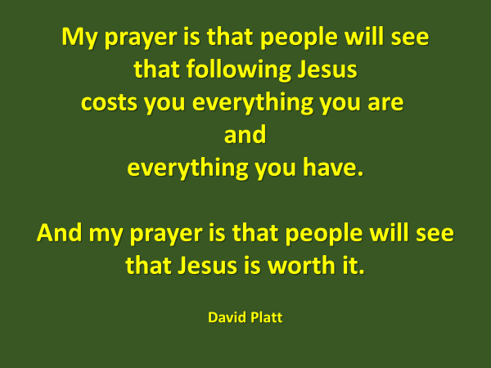
The reward of knowing Jesus far exceeds what we turn from, in order to gain him.
If a person doesn’t know Jesus, even if they were to possess the whole world, the truth is they have nothing of enduring value.

But when you know Jesus you have everything you need.
Is Jesus our everything?
Do we love him supremely?

Point of Connection
God is in control of everything…and he is competent.
That competency extends to how Jesus prays for us.
Do you ever feel like you don’t know how to pray?
This never happens to Jesus.
He always knows what we need and when we need it.
Robert Murray McCheyne wrote:


Our circumstances… and the means of God’s grace… along with his timing in providing for us… are always right and good… because… Jesus prays for us and he knows exactly what to ask the Father to give to us.

We can trust Jesus; we can trust the Father because he is competent.

Next week we will pick up the story with the second statement made by one of the men. It was a statement that was used by God to launch Moses into the second and most important phase of his preparation to be God’s rescuer at that point in time.

The Blessing
In what area of your life is the Holy Spirit bringing his truth to bear?
The blessing of God comes to those who having heard the words of Jesus, then put them into practice.

Matthew 7:24-27.

Moses was not who the Hebrew people thought God’s rescuer should be.
And Stephen’s emphasis to the Sanhedrin was that they had viewed Jesus the same way.

“Who made you the Messiah?”

The reaction of the Sanhedrin was not unique.
From then until now, every generation has repeated the pattern; devaluing and rejecting God’s rescuer.

The prophet Isaiah foretold this reaction.
Isaiah 53:2-3: He grew up before him like a tender shoot, and like a root out of dry ground. He had no beauty or majesty to attract us to him, nothing in his appearance that we should desire him. ³ He was despised and rejected by mankind, a man of suffering, and familiar with pain. Like one from whom people hide their face, he was despised, and we held him in low esteem.

Who of us before God revealed himself to us and we turned our lives towards Jesus and put our faith in him, saw his beauty or majesty and desired him?
All of us held him in low esteem.
And yet, thank God, he opened our eyes to see Jesus for the treasure that he is.

- Do you want to kill me like you killed the Egyptian yesterday?

What Moses had done in secret was now out in the open.

Though he believed he was to be God’s rescuer, Moses was forced to run for his life. I’m sure he thought, “What did I miss?” “Did I hear God wrong?”

For forty years he had been trained in all the wisdom of the Egyptians.
At forty years of age, Moses believed he was ready to lead a nation.
Though his training in all the wisdom of the Egyptians had given to him a great advantage, it was not enough.

Point of Connection
God is not in a hurry as we are.
Isn’t it fascinating?
At times we can feel we’re ready for…, ready to do…., and in God’s estimation we’re not.
And other times, we can feel we’re not ready for…, not ready to do…, and in God’s estimation we are.
What Moses would learn during the next forty years of his life, is what all whose lives have been greatly used by God have learned - “…our competence comes from God.” 2 Corinthians 3:5

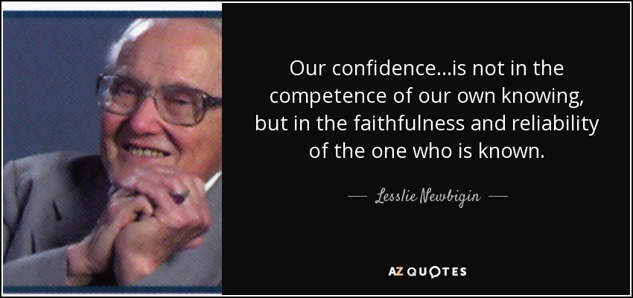

At forty years of age, Moses depended on his own understanding and strength.
Moses did what he thought was best.

He was about to enter into a season where he would learn to draw upon God’s understanding and strength and do what God thought was best.

When word reached Pharaoh as to what Moses had done, he had to run for his life. For the next forty years he lived in Midian as “a foreigner.”

Where was Midian?

Who were the Midianites?
Abraham had more sons than just Isaac (by Sarah) and Ishmael (by Hagar).
He also had six sons by Keturah, his wife after the death of Sarah: Zimran, Jokshan, Medan, Midian, Ishbak, and Shuah (Genesis 25:2).

The Midianites were the descendants of Midian and therefore children of Abraham. They settled in “the land of the east” (Genesis 25:6).
When Moses fled the wrath of Pharaoh, he traveled to Midian (Exodus 2:15). There, Moses met and married his wife, Zipporah, and served his father-in-law, Jethro, as a shepherd for forty years.

The fact that Jethro was “a priest of Midian” (Exodus 2:16) indicates that the Midianites, at least during Moses’ time, still retained the knowledge of the God of their father Abraham (cf. Jethro’s words and actions in Exodus 18:10-12).
https://www.gotquestions.org/Midianites.html

For the next forty years, God patiently waited – for a convergence of circumstances/events that would initiate him fulfilling the promises he made 400 years earlier:
the king of Egypt died.
the Israelites “groaned in their slavery” and cried out to God for help
– see Exodus 2:23-25.
Moses training was completed.

While God waited he did not do so impassively.
He heard the groaning of the Israelites and was concerned for them.
During those years of ongoing slavery, God prepared the hearts of the Hebrew people to receive his rescuer.
He remembered his covenant with Abraham, Isaac and Jacob.

During those years, while Moses took care of sheep, God forged the character of Moses.

Finally, the moment came that God had been waiting for – the moment of rescue.
Read verses 30-38.

God appeared to Moses and spoke to him out of the burning bush, not a temple.
Later he would speak to Moses and the entire nation from the top of a mountain in the Sinai desert.

God is everywhere present.
He is not limited to what some would call “sacred space.”
The burning bush was not holy ground until the moment God appeared in the fire that didn’t consume.

We have here a picture of how God makes his home in us without consuming us.

Do you see the repeated emphasis being made by the Holy Spirit through Stephen?
God’s presence was not limited to the temple in Jerusalem.
God is not confined to one place.
He is the LORD of the earth – he is the King over all nations, as we earlier read in Psalm 2.

In addition to being a rescuer, Moses was also a prophet.
After leading the Hebrew people out of Egypt, God met with the nation at Mt. Sinai.

There he entered into a covenant relationship with them, where he became their God and they became his people.
But the sight of God when he appeared to the nation was so terrifying, that they pleaded with Moses to speak to God on their behalf.

Exodus 19:16-20:
On the morning of the third day there was thunder and lightning, with a thick cloud over the mountain, and a very loud trumpet blast.
Everyone in the camp trembled. ¹⁷ Then Moses led the people out of the camp to meet with God, and they stood at the foot of the mountain.

¹⁸ Mount Sinai was covered with smoke, because the Lord descended on it in fire. The smoke billowed up from it like smoke from a furnace, and the whole mountain trembled violently. ¹⁹ As the sound of the trumpet grew louder and louder, Moses spoke and the voice of God answered him. ²⁰ The Lord descended to the top of Mount Sinai and called Moses to the top of the mountain.

Look at Deuteronomy 5:22-27:
²² These are the commandments the Lord proclaimed in a loud voice to your whole assembly there on the mountain from out of the fire, the cloud and the deep darkness; and he added nothing more. Then he wrote them on two stone tablets and gave them to me.

²³ When you heard the voice out of the darkness, while the mountain was ablaze with fire, all the leaders of your tribes and your elders came to me. ²⁴ And you said, “The Lord our God has shown us his glory and his majesty, and we have heard his voice from the fire. Today we have seen that a person can live even if God speaks with them. ²⁵ But now, why should we die? This great fire will consume us, and we will die if we hear the voice of the Lord our God any longer. ²⁶ For what mortal has ever heard the voice of the living God speaking out of fire, as we have, and survived?

²⁷ Go near and listen to all that the Lord our God says. Then tell us whatever the Lord our God tells you. We will listen and obey.”

A prophet was someone who came near to God; who listened to his voice and then told others what God had said.
But through a prophet, God also foretold future events.
Many of the prophets spoke of the Rescuer who would come, including Moses.

Deuteronomy 18:15-18:
¹⁵ The Lord your God will raise up for you a prophet like me from among you, from your fellow Israelites. You must listen to him. ¹⁶ For this is what you asked of the Lord your God at Horeb on the day of the assembly when you said, “Let us not hear the voice of the Lord our God nor see this great fire anymore, or we will die.”

¹⁷ The Lord said to me: “What they say is good. ¹⁸ I will raise up for them a prophet like you from among their fellow Israelites, and I will put my words in his mouth. He will tell them everything I command him.

What an incredible irony.
The men from the Synagogue of the Freedmen accused Stephen of speaking blasphemy against Moses and God, when all Stephen had done was quote the words of God and Moses, who had foreseen the coming of Jesus, just as Abraham had – John 8:56: [Abraham] saw [my day] and was glad.



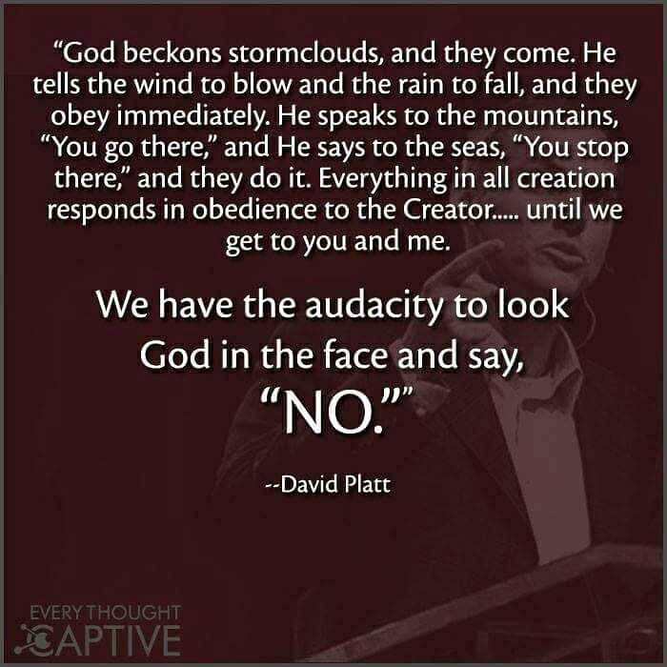

It is a human tendency to create means to get back to God

The gospel of Jesus is both bad news and good news.

The men of the Sanhedrin were religious.
They were moral.
They knew the Scriptures.
And…they were spiritually dead, as is all of humanity.

There is a truth here that needs to be stated.
Human beings are incredibly resourceful and creative.
We love a challenge.
And while it is true that in some many fields, we are making huge strides – in medicine, technology, agriculture, knowledge – there is something we are incapable of solving; overcoming; fixing.

In Adam and Eve, humanity chose to turn away from God, and live life on our own terms.
That choice brought into our human nature the disease of sin and unleashed upon this world and all who live in it, the curse of death.

Like Humpty-Dumpty, we cannot repair the “Great Rupture.”
This is the bad news of the gospel of Jesus.

But what we could not do for ourselves, God in love and kindness, did for us.
He sent Jesus, who, in the words of John the Baptist, “takes away the sin of the world!” John 1:29

The good news of the gospel is that the grace of God is greater than our sin.
God’s grace, is able to make family of an enemy.

From the cross, as he looked out and down upon the very ones who had arrested him and taken him to Pilate, and then had stirred the mob to call out for his death, Jesus asked the Father, “Forgive them, for they do not know what they do.” Luke 23:34

As Stephen spoke to the Sanhedrin, this was now the third time the gospel of Jesus had been shared with them – the first after the healing of the crippled man; and the second after the apostles had been jailed and released by an angel.

Stephen as he spoke, pointed them to the kindness and the patience of God, in his dealings with Abraham; with Jacob’s sons, particularly Joseph; and then with Moses and the people of Israel.

God’s kindness is at the heart of the good news of Jesus.
Romans 2:4: …do you presume on the riches of [God’s] kindness and tolerance and patience, not knowing that God's kindness is meant to lead you to repentance?

Through Stephen Jesus pursued after those who sat in judgement of him.
Is that not incredible?

But then, how long did God pursue you?
How many times and through how many different people was the gospel of Jesus shared with you?
How many times did you shrug off the news of Jesus?
How long did you run from him, or try to avoid him?

And yet, in his kindness, he pursued after you; he pursued after me.
The love of God is meant to lead a person to repentance.

Who loves us like God does?
Who would invest such time and effort on our behalf?

God’s love is sweeter and higher and deeper and wider and stronger and purer.

Tragically, those men who listened to Stephen, chose to continue to reject Jesus.
They refused to change their minds.

Again, there is a truth here that needs to be stated.
God did not extend a blanket amnesty to all of humanity, through the salvation Jesus accomplished in his death and resurrection.

God does draws people to himself.
Do you know why that is?
Jesus explained in John 6:44.
[Because] – “No one can come to me [Jesus] unless the Father draws them…”

God does whispers truth into a heart and bring light to a darkened mind.
2 Corinthians 4:6 – God made his light shine in our hearts to give us the light of the knowledge of the glory of God in the face of Christ.

As God reveals himself to us; it is his desire that his kindness would lead us to repentance; that we would choose to come home to him.
Peter wrote, 2 Peter 3:9 – “He is patient with you, not wanting anyone to perish, but everyone to come to repentance.”

The closings words of the book of Revelation extend this invitation,
Revelation 22:17: The Spirit and the church [the bride] say, “Come!” And let the one who hears say, “Come!” Let the one who is thirsty come; and let the one who wishes, take the free gift of the water of life.

Though it seemed Stephen’s defense had made no impact upon the Sanhedrin; and that his words had fallen on deaf ears; there was one there that day, who began his journey home to God – and that one was Saul of Tarsus.

But we’re getting ahead of ourselves in the story.

As he said through Isaiah, he says through me to you today – he is near.
Follower of Jesus - remember this!
“Consider-er” of Jesus – know this!

He is present with us this morning – he has come near… to you.
“Consider-er” – his promise is still applicable – turn from your sin and turn to God and he will have mercy and forgive. Come home to him.

“Follower” - his promise is still applicable – he is at work in you – as he was in the life of Abraham and Sarah; as he was in the life of Joseph - to forge your character that you might play the role he has for you in his great rescue of humanity.

Those who trust in him never are disappointed.
He is our Treasure – he is the One in whom we find true pleasure; true joy; true love; true purpose.

As we sing our closing song – there are people here at the side to listen and to pray with and for you.

Read verses 17-22.
It was no coincidence that Moses was born when he was born.
God doesn’t wait for pleasant circumstances and happy times to carry out his will.
In dangerous times, God rescued Moses from death through Pharaoh’s daughter who adopted him as her own son.

Read verses 23-29.

We are not told what or how, but something happened that convinced Moses he was to be God’s rescuer of the Hebrew people.
For sure, in resorting to murder, Moses utilized the wrong means.

But the Hebrew people, nonetheless, rejected him saying, “Who made you ruler and judge?”

Read verses 39-43.

Stephen continued to build his case – demonstrating in the response of the nation towards Moses, this deeply entrenched pattern of resistance towards God.
This was the heart issue that Jesus had come to address and to remedy with the sacrifice of his life.

It’s in these verses, that Stephen, with no ambiguity, spoke to the second aspect revealed in this chapter regarding God’s character – the LORD will release a person to experience the full consequence of their sin.

The words Stephen used were frightening – “God turned away and gave them over to…”
In the situation Stephen referred to… it was the worship of idols that they were given over to – and specifically he named the god Molech.

Molech was the god who required newborn babies to be sacrificed to him.
When the hearts of the people turned away from God; when they refused to obey him; this was the horror they were taken to.

In Romans 1, this phrase is repeated three times – v.24, 26, 28.
And what Romans 1 describes; the place to which people can go when there is no God to stop them, is equally terrifying.

When God lets a person go…, he stops convicting them.
He stops giving to them the gift of guilt.
He lets them do, with no interference from him, whatever their hearts desire.

As rescuers, Joseph and Moses were rejected.
The family of Abraham also rejected Moses when he spoke to them as God’s prophet.

In their hearts they turned back to Egypt, worshiping the gods they knew there.
When they turned away from God, God turned away from them and gave them over to what their hearts desired.

I need to jump ahead in the story Stephen told to the application he made.
He told his accusers that they were just like their ancestors; their forefathers.
They were stiff-necked.
??
Their hearts and ears were uncircumcised.
??

Rather than listening to the prophets who spoke on God’s behalf, they persecuted and even killed some of them.

And when the Righteous One came, the One whom all the prophets had pointed to, they not only ignored him, they betrayed and killed him.

explains our need (that’s the bad news) and what God did to meet that need (that’s the good news).
And with the news shared there is always an invitation to repent and turn to God.

Those seventy men who made up the Sanhedrin, despite the fact that they had now heard the gospel for at least the third time, continued to reject God’s Savior.

He focused particularly on the lives of Abraham, Joseph and Moses – highlighting in the re-telling of their stories three characteristics of God – his patience; his justice; and his omnipresence.

Last Sunday we looked at what Stephen said about Abraham.
Today we will consider what he said about Joseph and Moses, for in the re

These emphases are as important today as they were in Stephen’s day.
Psalm 139: You have searched me, Lord, and you know me. ² You know when I sit and when I rise; you perceive my thoughts from afar. ³ You discern my going out and my lying down; you are familiar with all my ways. ⁴ Before a word is on my tongue, you, Lord, know it completely. ⁵ You hem me in behind and before, and you lay your hand upon me. ⁶ Such knowledge is too wonderful for me, too lofty for me to attain.
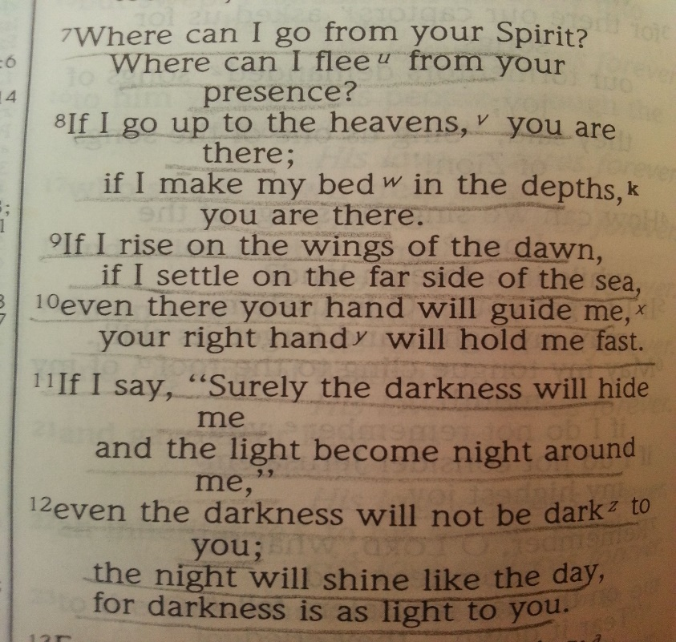
¹³ For you created my inmost being; you knit me together in my mother’s womb.
¹⁴ I praise you because I am fearfully and wonderfully made; your works are wonderful, I know that full well. ¹⁵ My frame was not hidden from you when I was made in the secret place, when I was woven together in the depths of the earth.
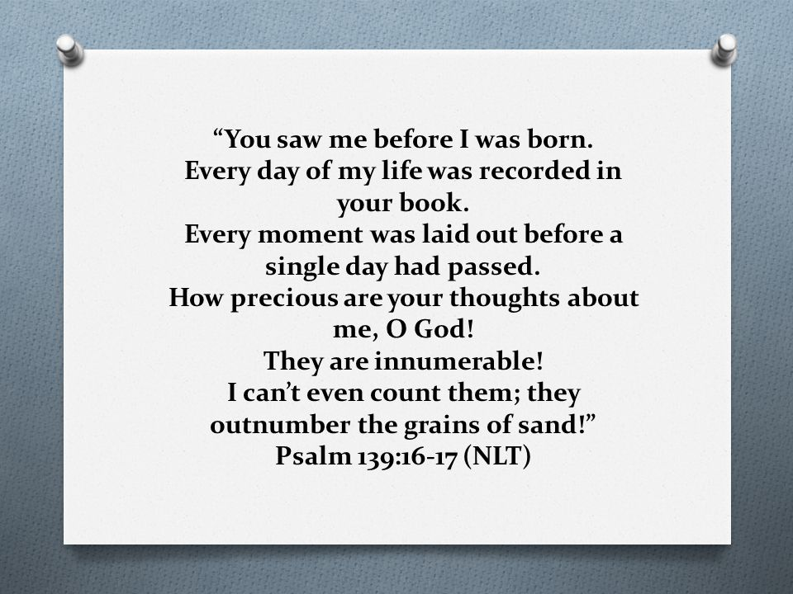

The patience of God was seen in his relationship with Abraham and Sarah - when they got stalled in Haran, God got them moving again.

After waiting eleven years for God to fulfill his promise, Sarah and Abraham took matters into their own hands.
Sarah gave her maidservant, Hagar, to Abraham to be his wife.
Hagar became pregnant and a son was born who was named Ishmael.
God’s justice didn’t clean up the mess that resulted from this decision.
Both Abraham and Sarah had to live with the consequences – which by the way, continue to this day.

In all of their journeys – from Ur to Haran to Canaan to Egypt to Canaan to the Negev to Canaan – God was present with them.

As Stephen moved on to the story of Joseph and then Moses, he again, demonstrated these emphases in the lives of these two men.



But God doesn’t live in any building.
We’ll consider next week what God himself said about this through the prophet Isaiah.

But what was true then is still true.
God doesn’t live in this building.
This structure and the land have been dedicated to being a place of worship; a place where Jesus is made known.

But when we go home, God doesn’t stay here, waiting for us… until we return.

When Jesus returned to his Father’s home, he announced that he and the Father through the Spirit would now make their home in the lives of those who follow Jesus.

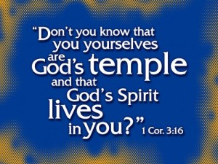
Like Jesus, we, his followers, are portable temples.
Wherever we go, the presence of God goes with us.

We will unpack more of this incredible reality, next week.

When Abraham had arrived in Canaan, God told him that he and his descendants would not inherit the land for another 400 years, but rather would be strangers in a country, not their own.
There in that country, God said they would be enslaved and mistreated, until he rescued them and brought them back to Canaan to worship him.
________________________________________________
There is an important emphasis that we can’t unpack this morning.
But I do want to mention this truth to you.

Just as God determines the days of your life; so God determines the days of every nation. Just as God determines where you were born and what abilities you have, so he determines a nation’s boundaries.

Acts 17:24-27:
“The God who made the world and everything in it is the Lord of heaven and earth and does not live in temples built by human hands. ²⁵ And he is not served by human hands, as if he needed anything. Rather, he himself gives everyone life and breath and everything else.

²⁶ From one man he made all the nations, that they should inhabit the whole earth; and he marked out their appointed times in history and the boundaries of their lands. ²⁷ God did this so that they would seek him and perhaps reach out for him and find him, though he is not far from any one of us.

The Amorite people who lived in Canaan had been given that land by God.
But in that land, they did not seek God, but rather gave themselves up to the worship of the most despicable idols imaginable.

When Abraham was brought to Canaan by God, the LORD told him, the reason he had to wait 400 years, is because, Genesis 15:16, “…the sin of the Amorite has not yet reached its full measure.”

God gave an extended opportunity for the Amorites to turn in repentance to him. But they never did, and so God drove them out; and gave the land of Canaan to Abraham’s descendants that they might worship him there.
And when they chose to worship the same despicable idols they too lost the land.
__________________________________________

