The Ethiopian Eunuch May 5, 2019
Acts 8:26-40

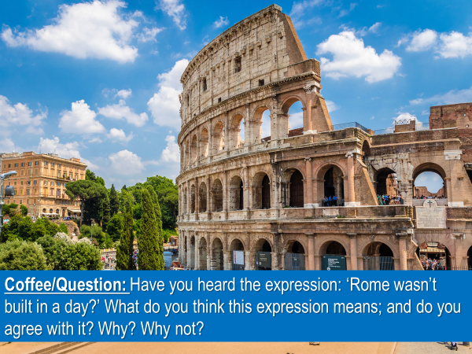

Typically, things of significance, things that are precious… take time and effort.
- The building of a good marriage…. decades of work.
- Bachelor, master and doctor degrees…. years to complete.
- Apprenticeships…the same.
- Life experience… years of living.

But sometimes an opportunity will come along, and though it may seem, insignificant at the moment, it is with the passing of time, that we appreciate its’ importance.

Philip the deacon/evangelist had such an opportunity.
Read Acts 8:26.

Philip had been in the city of Samaria, I would imagine, for at least some weeks, maybe even longer.

He had been God’s human instrument in a great awakening, where:
…many demonized people were set free,
…many paralyzed and lame people were healed,
…many men and women had believed in Jesus and been baptized,
including a great sorcerer named Simon.

And then, well before, anyone would have thought it was time to pack up and move on, surprisingly, God sent an angel to Philip, who told him to leave Samaria.
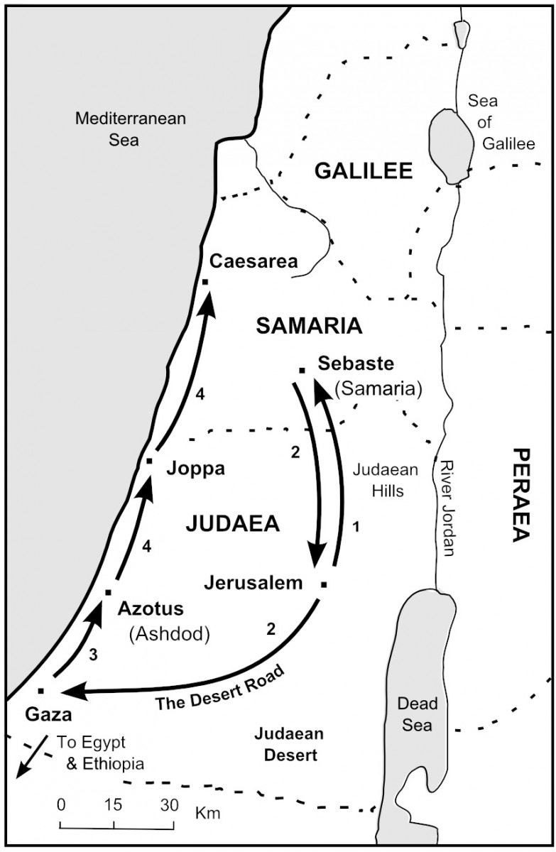
Philip was not told… why …he was to leave; nor was he told… what …he was to do… when… he was on the road heading from Jerusalem to Gaza.

There are times… when God will give to his people a longer-range perspective of what he wants them to do.
But there are also times… when he makes known his will to us, in the moment, as we follow him, step by step.

When this happens, we can be tempted to think or to feel as if God is making it up as we go.
But I assure you, God doesn’t wing it.
In those times, when the LORD leads us, a step at a time, he is:
- intentionally building our trust of him
- deliberately keeping us close to him
- purposefully training our mind to discern and our heart to be attentive to his voice
- growing us up

Read Acts 8:27a.
Philip did as he had been told.
He left Samaria…returned to Jerusalem… and started walking down the Gaza road.

God’s goal for you and I is that we would learn to obey him, not because we are forced to, but because we delight to do so.

As you and I obey the Lord, we prove his faithfulness.
This is how we learn to say of Jesus, what those who lived in the Decapolis said of him:


As our mind is renewed (Romans 12:2) we learn that it is not fate or chance that determines our circumstances, but our loving heavenly Father…
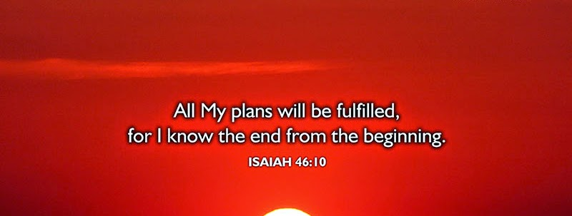
The Scripture assures us, that God’s ways are always good… even when we may not yet …perceive how.

Read Acts 8:27b-28.
The journey from Ethiopia (Kush) to Jerusalem was a long one.
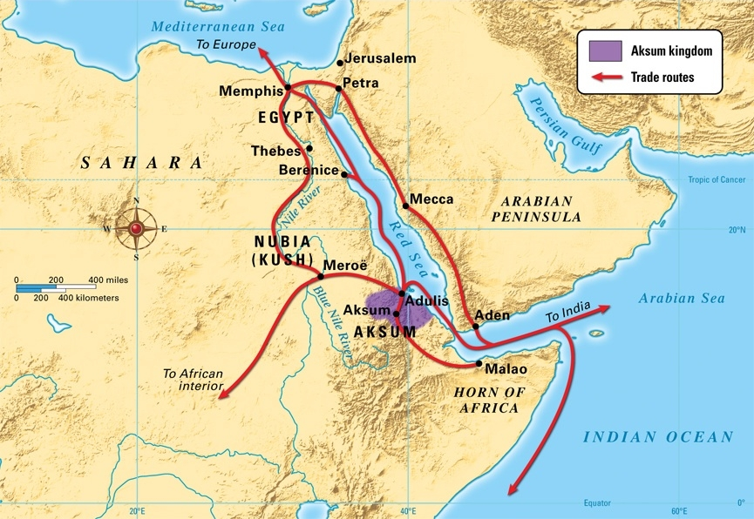
With travel time both ways, and an extended stay in Jerusalem, the eunuch would have been away from his responsibilities for several months.

This fact says to us that he would have needed to have asked his employer, the Kandake…
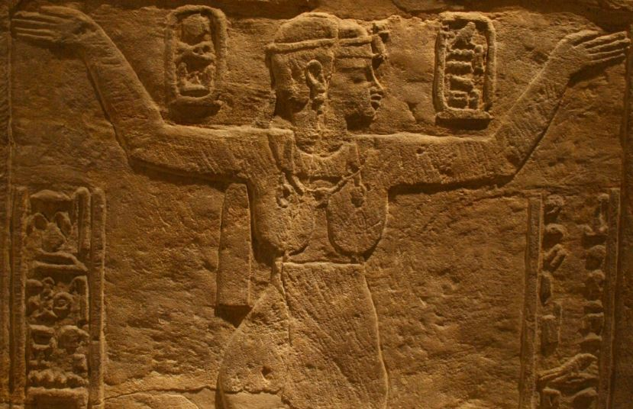
…which means “queen” – for permission to go to Jerusalem.

But his was not a state visit.
He had not come to negotiate a trade treaty.
The eunuch had come to Jerusalem… to worship.

We’re not told who he met in Jerusalem, or any other details about his time there.
But Luke does tell us that as he returned home, the eunuch had in his possession a copy of the book of Isaiah –
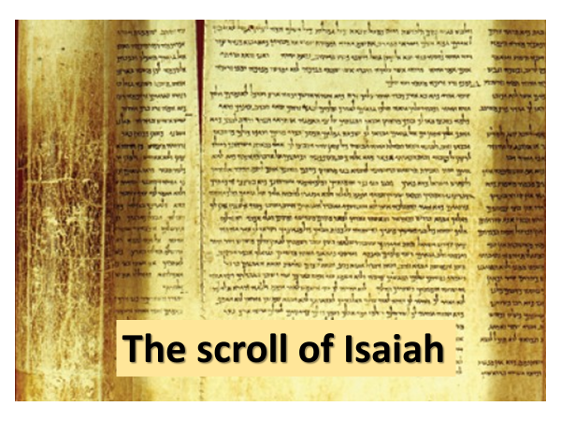
…written, more than likely, in the Greek language.

In those days, books were not produced on a printing press.
They were written out by hand on papyrus scrolls.
This is why it was extremely rare for a person in that day to personally own any book.

It is plausible that the queen had requested the eunuch to bring back as many copies of the Jewish Scriptures as he could… and had authorized him to spend what was necessary to do so.
But the passage does not inform us if this was the case.

Here’s what we do know.
- The eunuch had a great spiritual hunger and thirst within him. This is why he travelled so far to worship.

Could God have revealed himself directly to the eunuch – back in his home country? Yes! But he didn’t.
Could God have arranged for one of the apostles to “bump into” the eunuch while he was in Jerusalem? Yes! But he didn’t.

Instead, God pulled Philip away from a great awakening in Samaria, to speak to this one man.
And the fact that he did so, is supposed to make us wonder… why.

We’ll come to it shortly but let me say this.

As important as it was for Philip to be present in Samaria and to continue to preach the gospel and assist in the establishing of a church in that city, God was on the move to see the gospel of Jesus carried to Kush and beyond.

This teaches us how God works in this world.

When God created the two races of personal beings - angels and humans, he did not do so out of need or loneliness.
Angels and humans were created to enjoy fellowship with God and with one another.

Additionally, the Father, Son and Spirit, who collaborate and work together in everything, also privileged angels and human beings to share in their “fellowship of work.”

This phrase is truly astounding – to be a co-laborer with God – the One who only has to speak, and things come into being.
Example of yesterday – repairing a fence – the help of Sawyer.

There are many things you and I can do with our lives.
But this passage, impresses upon us that working with God in his mission of rescue is the most important.
We need to be reminded of this regularly, lest we forget.

The other truth that comes out is the importance of one person.
While God loves the world, he knows each of us individually.
Every person is precious because we are created in the image of God.

Read Acts 8:29.
It was only when Philip was walking along the road leading from Jerusalem to Gaza, that the Spirit of God provided him with further guidance: “Go to that chariot.”

It is important for us to know that while God lives in eternity, his activity on the earth is time-sensitive.

With God there is always a right time, or as Galatians 4:4 puts it, a “fullness of time.”

Picture this.
The angel had told Philip to leave Samaria, which he did.
Philip had walked to Jerusalem and then taken the road to Gaza.
And then, at that precise moment, his life and the life of the eunuch intersected.

What does this teach us?
God is a God of detail and precision.

We see this in the universe.
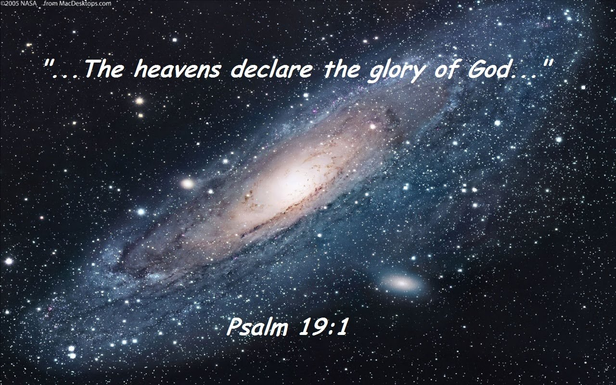
… the skies proclaim the work of his hands.

This is why the Mayan were able to, thousands of years ago, to determine every lunar and solar eclipse up until our time – there is a preciseness to the movement of the stars and the planets!

We see this in the creation; in the changing of the seasons.

And here in Acts 8, we see the Triune God – who is great in love, great in wisdom and great in power….
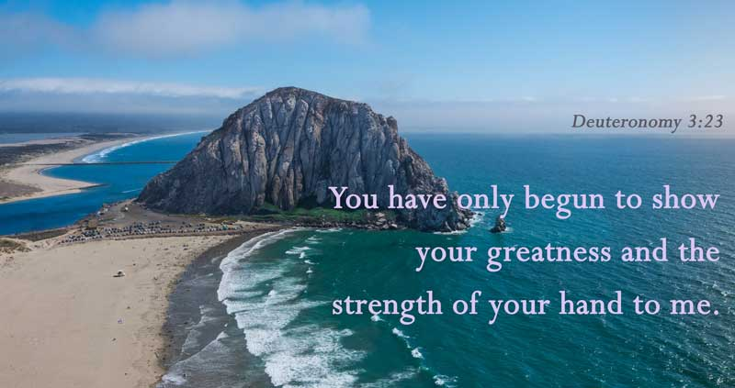
…exercising the same preciseness and detail in his work of rescue among human beings.

What does Philip do after God the Spirit speaks to him?
Read Acts 8:30.
Why did Philip run?
To catch up to the eunuch’s chariot.

And as Philip came alongside the chariot, what did he notice?
He heard the eunuch reading from the book of Isaiah.
God the Spirit had told Philip, “Go join… that… chariot.”

But he had not given Philip any other instruction.

Here is something else that is amazing about God.
As his co-laborers, he allows the followers of Jesus, to take initiative on his behalf.

Philip asked an open-ended question of the eunuch: “Do you understand what you are reading?”

It seemed like a simple enough question.
But it did have risks attached to it.
The eunuch could have ignored Philip.
And Philip might have been left questioning, “Did I hear God wrong?”

Or the eunuch could have told Philip to mind his own business and called for one of the soldiers traveling with him to get rid of Philip.
And maybe…. Philip might have been roughed up a bit, as he was given the boot.

But unless Philip took initiative and asked, he would never have known why God’s Spirit had told him, “Go over and join that chariot.”

Luke wanted his readers to know… how… Philip stepped into this opportunity.
In this instance he did so with a question.

God to this day, does similar things, with the lives of his people.
He will give to us opportunity.
And like Philip, we have to learn to step into those opportunities.

Read Acts 8:31.
Having asked a question, Philip then waited.
In this case, the response of the eunuch was immediate.
He invited Philip to sit with him and to explain the passage to him.

I remind you that Philip did what Jesus did with:
- Nicodemus – John 3
- The woman at the well – John 4
- Zacchaeus – Luke 19
- The mom whose daughter was demonized – Matthew 15

This passage encourages us to be bold; but at the same time, gracious as we speak with people.

Read Acts 8:32-35.
We learn here that when we share the good news of Jesus we are to start where a person is at – whether it is their question(s); their fears; their longings – and then… point them to Jesus – who is the way and the truth and the life.

In this instance, to answer the eunuch’s question, Philip had to explain a challenging passage of Scripture.
This might cause some of us to think – “I don’t know if I could do that.”

But remember…. the Spirit of God had brought Philip to the eunuch, and not one of the apostles in Jerusalem, because God knew that Philip was the best person to speak with him.

The eunuch’s question was one Philip could answer.
And when God brings someone to you or vice versa – it is because he knows you are the best person to speak to them.

As he involves you and I in the family business – which is missions –
remember last week’s quote from Leonard Sweet…
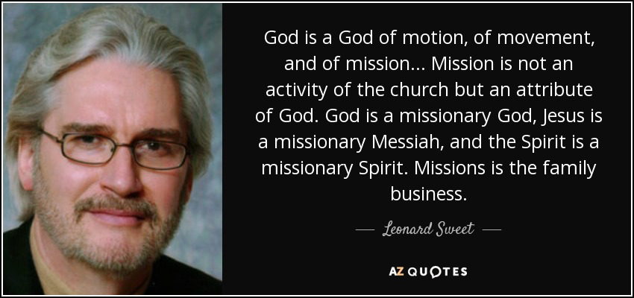
…he will use our unique God story, as well as what we are learning in our walk of faith at that very moment – as we share with another person the news about Jesus.

Read Acts 8:36.
We are not told how long Philip and the eunuch talked.
Nor are we told the specifics of what Philip shared with him, only that he began with the story of the Lamb.

But Dr. Luke did record a further question the eunuch asked of Philip.
This question tells us that the eunuch and Philip had talked about this.
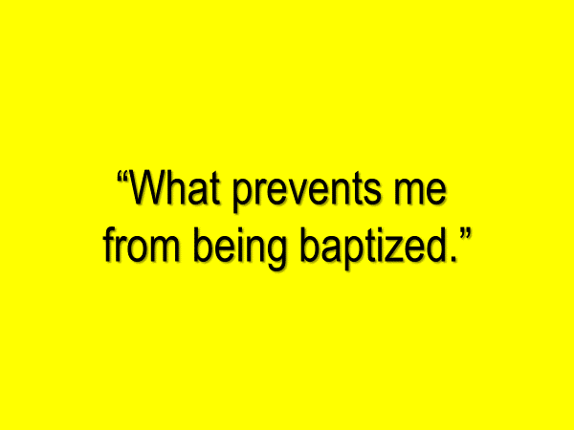

Again, let me point out to you how amazing God is.
Look back at verse 26.
What typically isn’t in abundance in a desert place?
Water.

But no sooner had the eunuch believed in Jesus and received him into his life, then he and Philip come upon what? Water!!!

We are meant to be amazed at this particular detail!
Again, God’s timing… and his attention to detail… is astounding!

Jesus’ final command to his followers was…. go and make disciples of all nations, baptizing them in the name of the Father and of the Son and of the Holy Spirit.

How important is it for a believer… to be baptized?
The Bible teaches that baptism is not an act that saves; but it is an act which demonstrates… one is saved.

We know the thief on the cross wasn’t baptized.
But we also know - he was an exception.

What we see here in Acts 8 is this: when the gospel moved out from Jerusalem and advanced into the kingdom of Kush through the eunuch, Philip taught him that believing in and receiving the good news of Jesus, was to then be publicly declared by being baptized.

How else would people not yet home to God, understand the richness of God’s grace?

The believer’s public baptism declares that the grace of God is not something sparingly given or dribbled out, but is what the follower of Jesus is immersed in.

Read Acts 8:38-39
In the presence of unnamed individuals who travelled with him, the eunuch declared his faith in the One who had found him; the One he had been searching for.

Jesus was the source of the eunuch’s joy.

Let’s pause here for a moment.
Think of the inner thirst of the human soul.
The eunuch had great thirst – we know this because of the long journey he had made.

Jesus is not an option that enhances one’s life.
He is not one of many who can quench human spiritual thirst.
He is living water as he told the woman at the well, because he alone uniquely satisfies human thirst.

The thirst of the human heart; is because of God’s absence within.
Can you remember when you were desperate for God?
Am I describing you this morning?
Can you identify with the eunuch’s thirst?

The greatness of the eunuch’s joy was in response to the greatness of his inner thirst.

Jesus used other analogies as he spoke of this crucial theme.
Matthew 13 – the parable of the hidden treasure; the parable of the pearl of great value.
Both individuals in each of these parables experienced great joy because of the treasure they had found.

This joy is known by all who find the treasure…. Jesus.

The meeting between Philip and the eunuch on the road to Gaza was brief – maybe an hour?
Did Philip realize how strategic this encounter was?
Maybe he did, maybe he didn’t.

But for all of us who follow Jesus – this is a question we don’t have to concern ourselves with.
It is the glory of God to save – Isaiah 48:9-13; 20

God asks us to:


The rest is in his hands.

What has God by his Spirit impressed upon your mind and heart through his word this morning?

When we hear from God, the question always is, “Will I respond – in worship, in obedience, in love, in action - to what God is saying to me?”

There is a risk in obeying God; in moving with him.
But because God is trustworthy, obeying him, really is not a risk, but is our delight, especially when compared to the weight of glory that is to come.

The Blessing
Psalm 46
- the Lord of hosts is with us; the God of Jacob is our fortress – 2x’s
- be still and know that I am God

