The Evidence of God at Work August 18, 2019
Acts 11:19-30

Feedback

Read Acts 11:19

The word “scattered,” which is used in Acts 8:1 and 11:19, in the language of the NT is “diaspeiro,” a word which is made up of two parts – “dia,” meaning throughout – and “speiro,” meaning to sow.
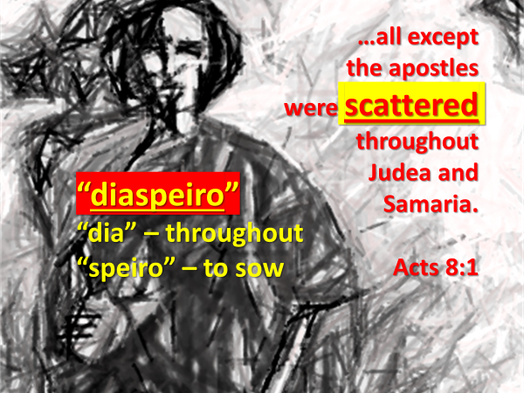
Because of Saul’s persecution, the followers of Jesus who had lived in Jerusalem, or who had stayed there after Pentecost… were physically scattered (sown), not only throughout Judea and Samaria (Acts 8:1), but also throughout Phoenicia, Cyprus and Antioch (Acts 11:19).


While there may be times when it feels like God is not in control; this passage teaches us that he always is – even in those times when we feel like out-of-control circumstances are in control of us.

What did these scattered followers of Jesus do?
Acts 8 and 11 tells us.
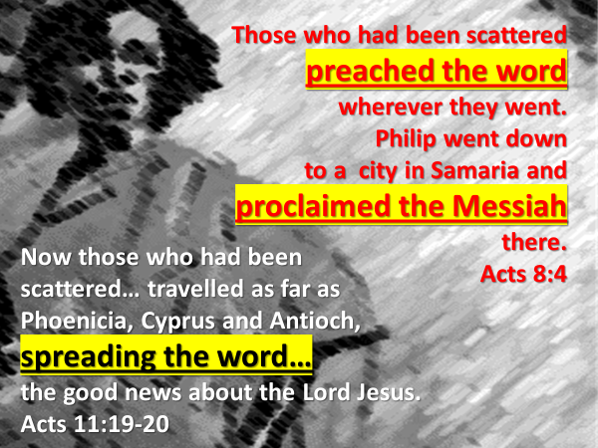
Does this sound like people who were in a panic?
These were a people who had been gripped, not by fear, but whose lives were held by their Lord Jesus.
Jesus was their Rock; they lived each day confident that he was in charge.
This is why Saul’s threat didn’t overwhelm them or close their mouths.

Up until this point in the story being told by Dr. Luke, these followers of Jesus, had only preached the good news of Jesus to Jewish people.
But then something changed.
Read Acts 11:20.

Last week we saw in the first part of chapter 11, how God moved Peter to go from Joppa to Caesarea in order to share with Cornelius, a Roman soldier, the news of how he and his household could be saved through faith in Jesus.

Here in verse 20-21, we are told how some men from Cyprus and Cyrene, went to Antioch, and did what Peter had done in Caesarea.

Who directed these men to do this?
Their Lord Jesus.
He had told them to go into all the world.
Why?
Because…God loves the peoples of the earth.

Jesus lived, died and rose from the dead… because God’s heart and mission is to reconcile to himself his enemies.
Listen to how Dietrich Bonhoeffer described the unfathomable love of God for the world of humanity.
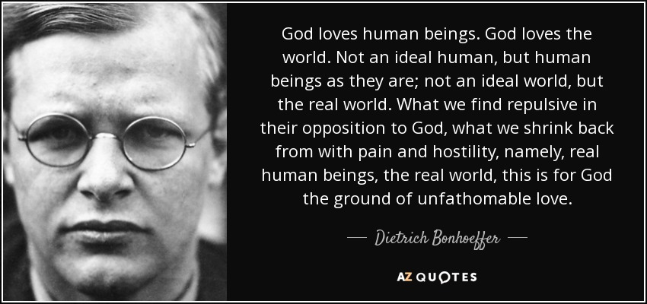
God pursues the disinterested; the broken; the confused and abused; the abandoned; the unlovely and messy; the proud and self-sufficient; the mocker; the greedy; the weak; the powerful.

We are not told the specifics of how these men from Cyprus and Cyrene, moved by their Lord Jesus… became convinced that they were to share the gospel with Greek speaking non-Jews, who lived in Antioch.

But as they did so, look at what happened.

Read Acts 11:21.
The Lord’s hand was with them.
As he had promised before he returned to his Father’s home, Jesus was actively present in Antioch, working along his people.

Read Acts 11:22.
Like it had happened, when the good news of Jesus was believed in Samaria and Caesarea, news of the awakening in Antioch reached the church in Jerusalem, and Barnabus, who was known as an encourager, (see Acts 4:36) was sent to Antioch, to assist in whatever way was needed.

Read Acts 11:23-24.

From Barnabus’ testimony, Dr. Luke records in this passage… specific ways in which God’s grace was seen through the presence of Jesus with his people.

We’ll take note of four of these grace manifestations today, and look at the rest next week.

1. Look at verse 20.
Whenever you observe believers, as Barnabus did, who lived for and spoke of Jesus with courage, boldness and passion, that is the grace of God; the hand of the Lord at work.

This is what the early church in Acts 4 had prayed for.


Is this not what we too should ask God for?

Pause and pray.
- Grace and joy that would pervade our worship and prayers
- Grace, truth and boldness as we speak of Jesus

2. Read verse 21b – “…and a great number of people believed and turned to the Lord.”

2 Corinthians 4:4 describes the spiritual reality of the world in which we live.
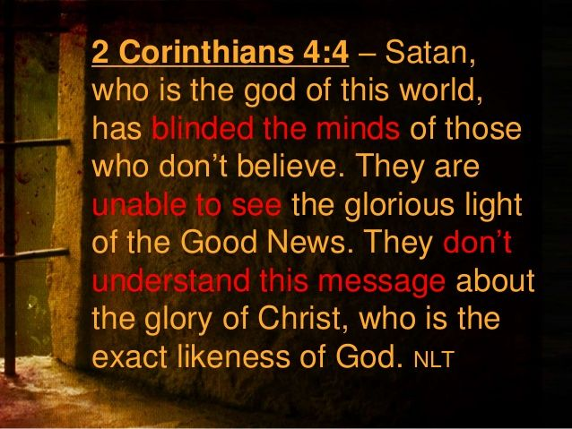
The message of God through his word, is that he is not willing to leave the world of humanity under the power of Satan.
God is not ok with the way things are.
It is good that we regularly remind ourselves of this.

This is why, the kingdom of heaven in the person of Jesus invaded the earth.

This is why, since the resurrection of Jesus Christ, God through his Spirit and his people, has acted to shine into the hearts and minds of men and women, teens and children, through the preaching of the gospel, the light of his glory seen in the person of Jesus.
Do you remember the story in John 9 of when Jesus met a man born blind?
Before Jesus healed the man, he answered a question asked by his disciples, with a statement he had recently made to the Pharisees:
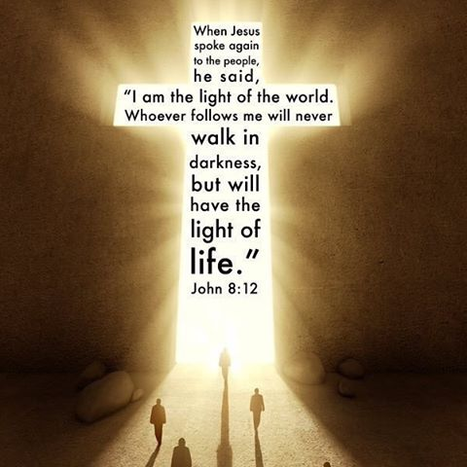
“I am the light of the world.”

The compassion Jesus had for a physically blind person, gives us a glimpse of his great compassion for humanity who has been spiritually blinded by satan.
But Jesus did not just feel compassion.
His compassion moved him to take action.

The miracle that happened in John 9, was intended by God to teach us that the power of heaven can also restore sight to a blinded mind and heart.

The time described by the book of Acts is remarkably similar to our time.
A phrase repeated in verse 21 and 24 is meant to encourage.
When God in mercy acts to bring about an awakening, it is normal for…

…to believe in Jesus and to turn their life to him.

In the case of Antioch this awakening continued for an extended period of time. Verse 21 – it began before Barnabus came.


And…verse 24 – it continued after Barnabus came.

Whenever we observe people believing in Jesus and centering their lives in him, we are observing, as Barnabus did, God’s grace at work.

When we pray as a church for an awakening in Sooke and this region, this is what we are asking for – grace from God that would cause the blinded hearts and minds of men and women, teens and children, to see the beauty of Jesus and to turn their life to him.

Pause and pray.
- Grace that opens blinded hearts and minds
- The love of God that draws

3. Read verse 23b – “[Barnabus] encouraged them all to remain true to the Lord with all their hearts.”

Barnabus didn’t encourage those new believers to be true to the Lord; he encouraged them to remain true… to the Lord… with all their heart.

To follow after Jesus, in the words of Eugene Peterson is…
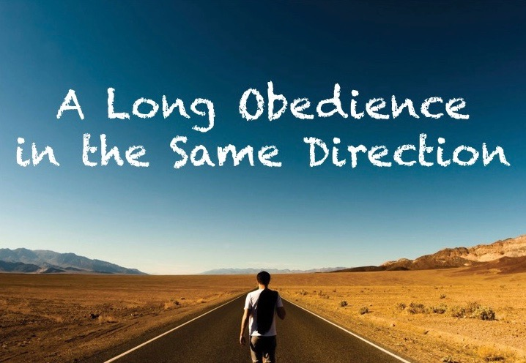
Whenever you see a community of believers, wholeheartedly and sacrificially obeying Jesus… you are seeing God’s grace at work.

Pause and pray.
- Grace to sacrificially obey Jesus
- To be a people who for the sake of Jesus are all in – not lukewarm, not dull, not half-hearted

4. Read verse 26b – “So for a whole year Barnabus and Saul met with the church and taught great numbers of people.”

Saul told the church in Corinth…
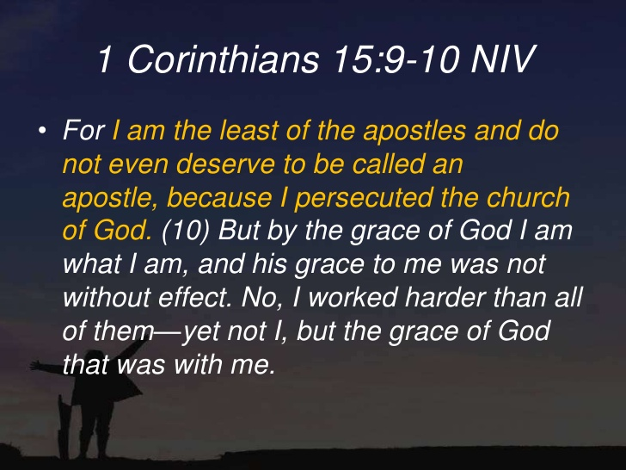

The grace of God defined who Saul was; and what Saul did.

As Saul wrote to the church at Colossae, he told them that he worked hard… as the energy of Christ powerfully worked in him.

George Mueller in his autobiography wrote something that amplifies what the Holy Spirit says to his church from this passage.
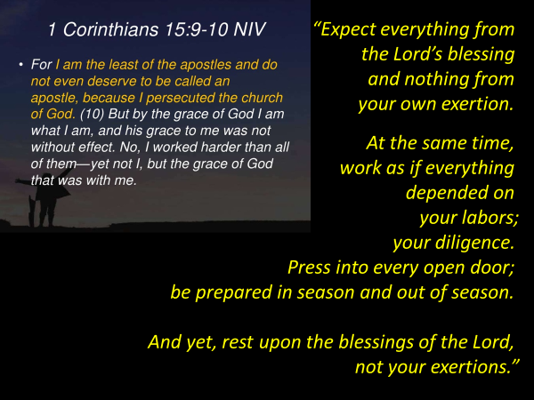
This is not double-talk.
It is the grace of God which enables the people of God to live in this tension of working hard for the cause of Jesus, while resting in him and his provision.
Why do the followers of Jesus live like this?
Because…
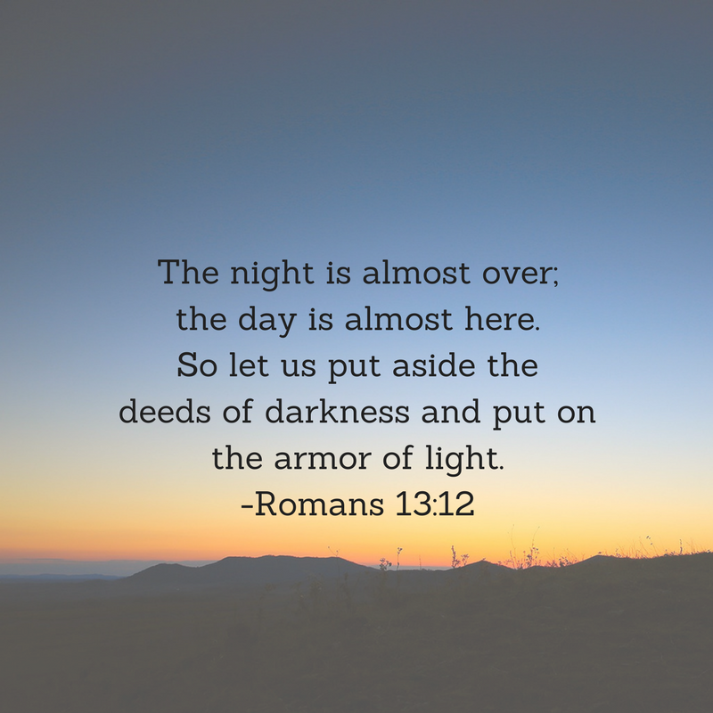

This is why we…
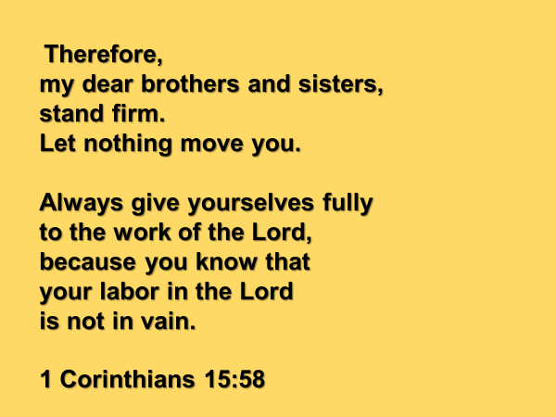

Whenever and wherever you see the people of a church investing their lives… their time and effort into the cause of Jesus, for the glory of his name… there you see the evidence of God’s grace at work.

Pause and pray
- Grace to perceive that the day is almost here
- Grace to put on the armor of light, that we might stand firm and give ourselves fully to the Lord’s work

What we have seen in today’s passage is that as God’s love and grace is received and experienced…. it empowers:
- our personal devotion
- our corporate worship
- our service and witness to others in the name of Jesus.

Blessing

Jesus said to his disciples in Matthew 13:16:
Blessed are your eyes because they see
and your ears because they hear.

May God bless you with discernment.
May your eyes not only see the handiwork of God in the creation that surround you, but may you perceive the activity of God’s Spirit all around you.

And in seeing the evidence of God’s grace, may you be blessed with a passion to spend your life on the things that matter to your God.

