The Increase and Spread of God’s Word September 22, 2019
Acts 12:18-24

Read the passage.

It’s been approximately 11-12 years since Jesus’ death, resurrection and ascension.
We know this because other historical sources confirm that King Herod Agrippa the First, died in 44 A.D., at the age of 54.

In this passage, Dr. Luke intentionally draws a comparison between Herod, the king of the Jews, and the word of God.

Today’s passage in v.22-23, tell us that Herod was motivated by pride to be as God. This is the root of all sin.

This is why Herod had given the order for some in the church to be violently persecuted.
This is why he had given the order for James to be struck down.
This is why he had given the order to arrest Peter.
This is why he had given the order that the sentries who had guarded Peter be put to death.

The word of Herod was powerful.
But he was not match for the Judge of all the earth.

At the moment that he considered right, the Lord gave the order and Herod’s life came to a tragic and premature end.
But the One who lives forever, his word continued to spread and flourish; to increase and multiply.

Here is today’s coffee/question.
Hopefully it will prime our thinking about this verse and what it means.
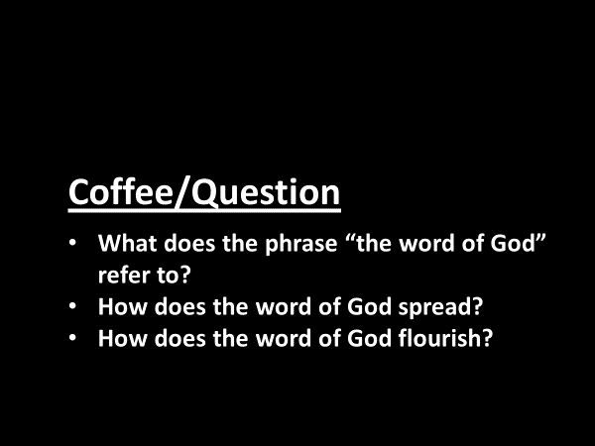

A good method of Bible study is to understand a phrase, a verse, a chapter, even a book…. in its context.
The context of Acts 12 would suggest to us that this phrase is not a reference to the Bible.
Nor is it a reference to the church.

Another important principle of Bible study is to understand a particular word or phrase, by comparing it with other Scripture.
I want us to look at three other places in the Bible where this phrase is used.

- Isaiah 55:10-11: “my word”
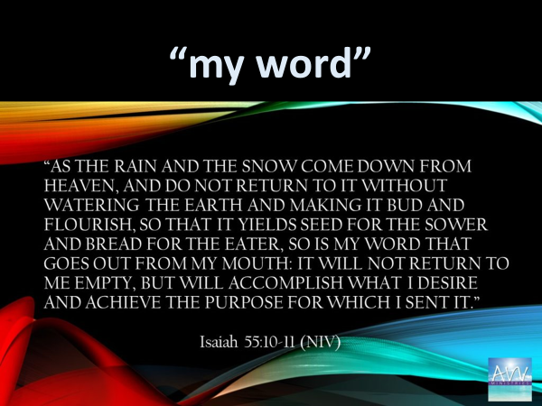
God uses a fascinating analogy.
He compares the speaking of his word and its effect upon those who hear it… to the cycle of water.

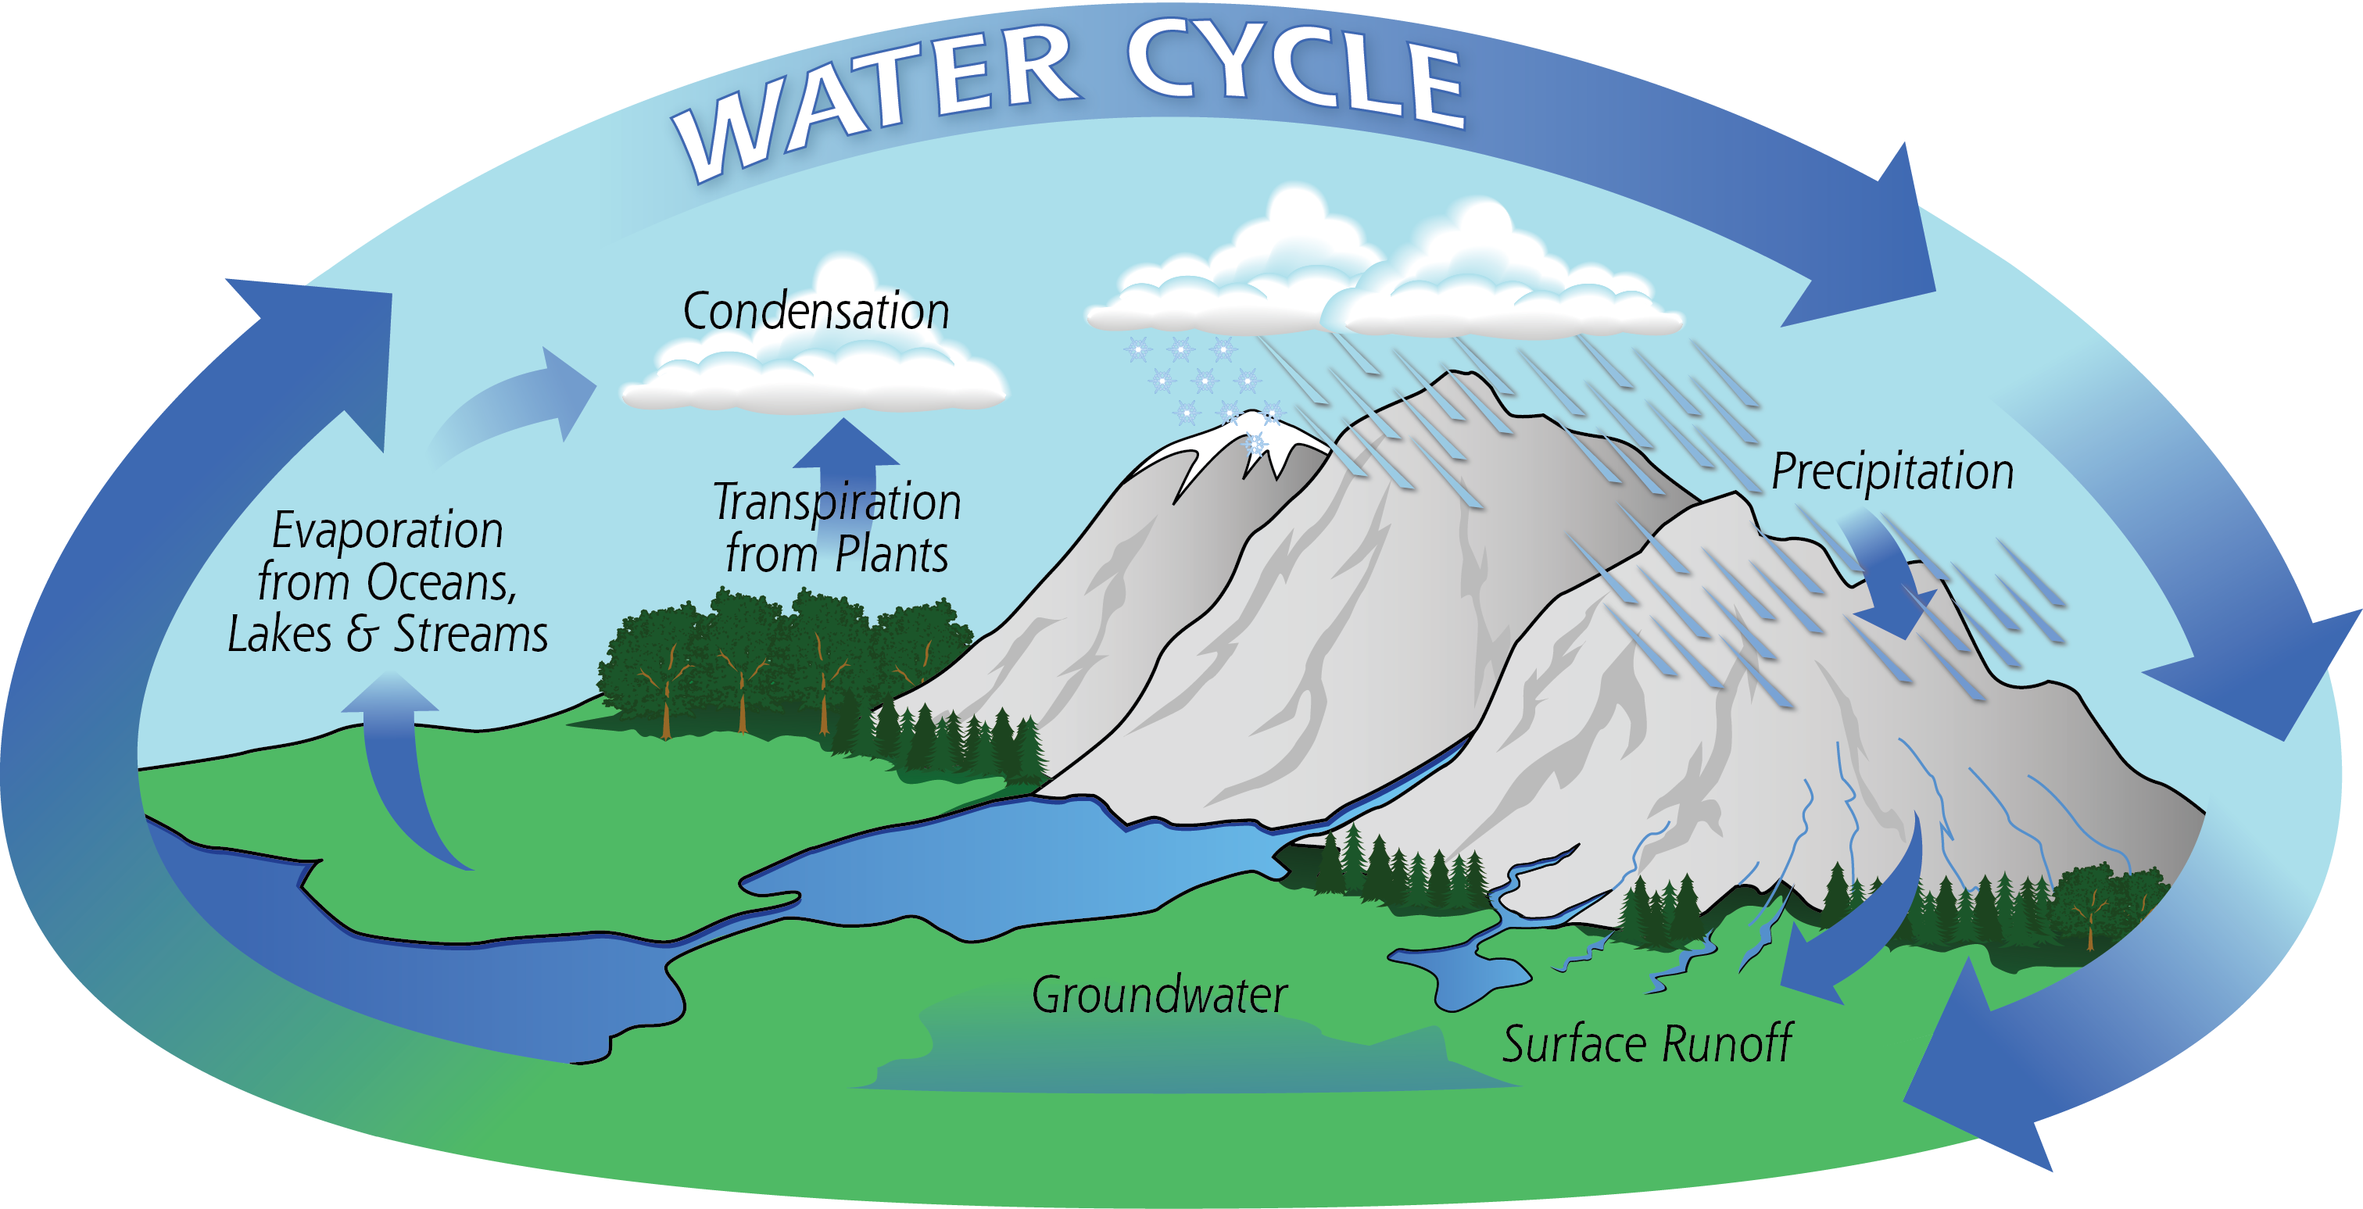
Rain and snow fall upon the earth… water it and then are evaporated…. to again fall upon the earth.
But the cycle itself… doesn’t explain the purpose of rain and snow, which as it waters the earth, causes the growth of plants that become food, that in turn nourish human life.

For what purpose does God speak to mankind?
Let’s use the analogy – God’s word is like water to the human soul.
What is it that God’s word causes to bud and flourish?
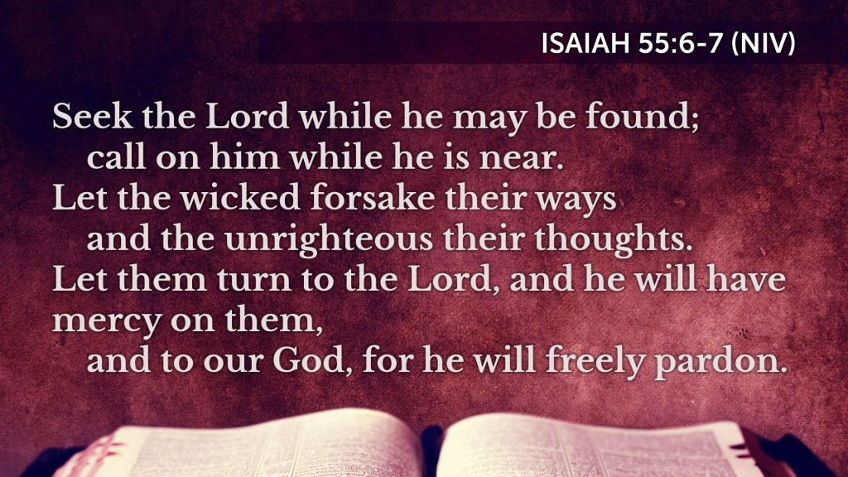
…a seeking
…a calling
…a forsaking
…a turning

God’s word as it water a soul, produces the life of heaven in a person, who responds to God’s initiative.

God’s word - is a word of mercy.
He pardons his enemies and makes family of them.

- Hebrews 4:12-13 – “the word of God”
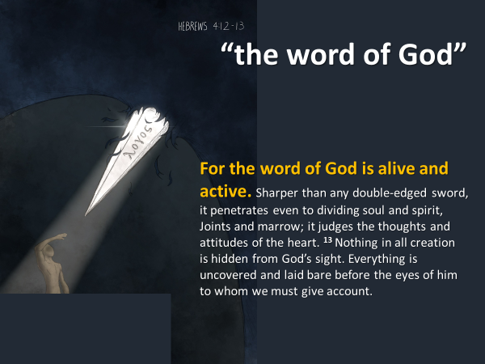
These four books have greatly influenced me.
- The Divine Conspiracy – Dallas Willard
- The Jesus I Never Knew – Philip Yancey
- Surprised by Hope – N.T. Wright
- Mahatma Gandhi: An Interpretation – E. Stanley Jones

These writers have caused me to think deeply about my faith.
And when I read them, they strengthened my resolve to follow Jesus.

But of all the books I’ve read over my lifetime, only this book…(hold up the Bible)… has uniquely transformed me… because these words have been breathed out by God… who is the Life-giver.

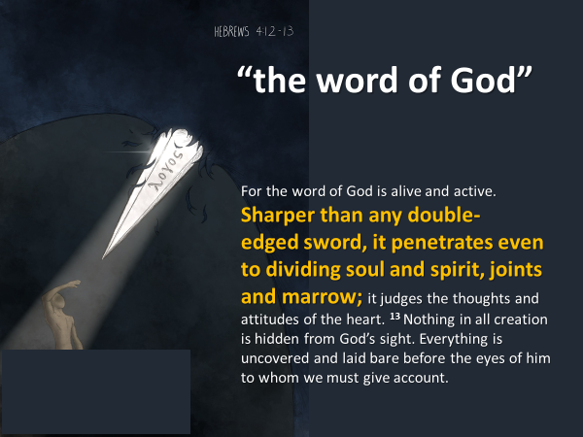
A sword’s sharpness pierces a person’s flesh, revealing what is hidden inside of the body.
The word of God, like a sword, uniquely penetrates a person’s soul,
revealing what is hidden in the heart.
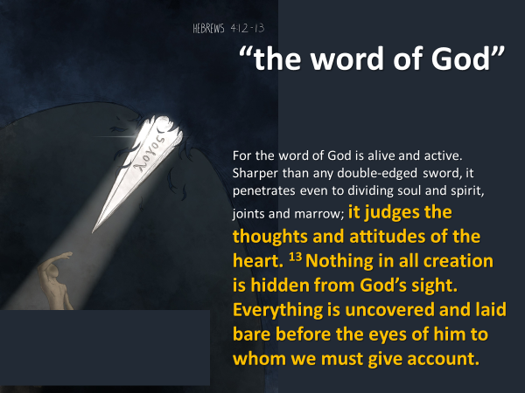
We sense something is wrong, but we do not intuitively know our condition is as serious as it is.

The word of God tells us that we cannot fix what is wrong with our heart.
It truly is beyond cure.
There is no surgery to fix it.
But the God who uncovers our soul, does so in order to save and to give life.

- 1 Peter 1:23 – the living and enduring word of God
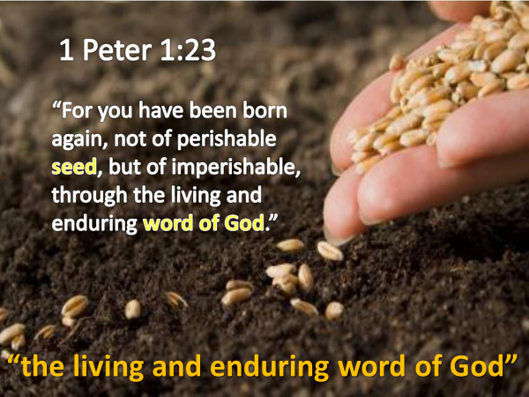
Every one of us needs a heart transplant.
But God doesn’t transplant into us somebody else’s used heart.
The living word of God, the word that endures for all time, the word which in the past spoke the universe into existence, is active in this present time… to birth a new heart in everyone who believes in and receives Jesus.

These three companion passages confirm that the “word of God” cannot be separated from the person and work of God.
This has been the story told by Dr. Luke in his gospel and in the book of Acts.

Since the days of Jesus, the word of God, his expressed purpose to rescue, to redeem, and to restore what sin ruined…had been increasing and spreading – both quantitatively and qualitatively.

Let me summarize.
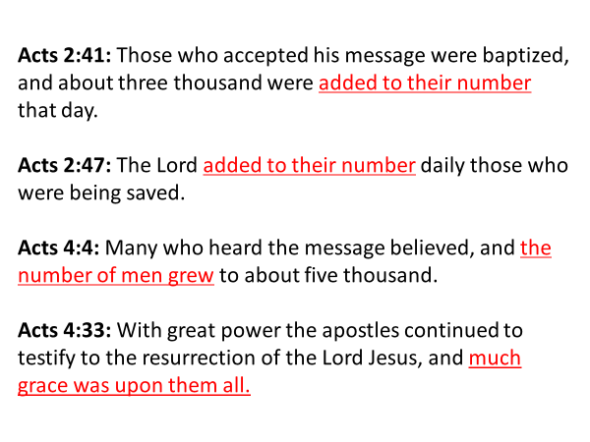
______________________________________________________
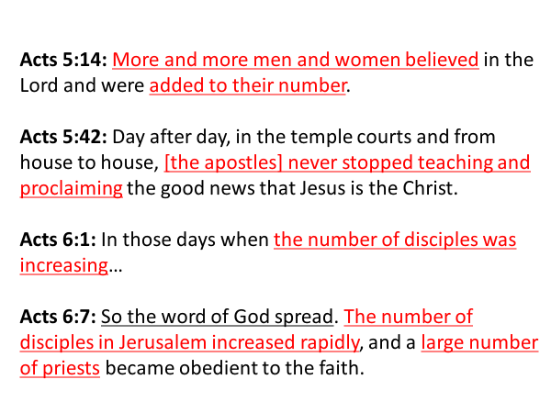
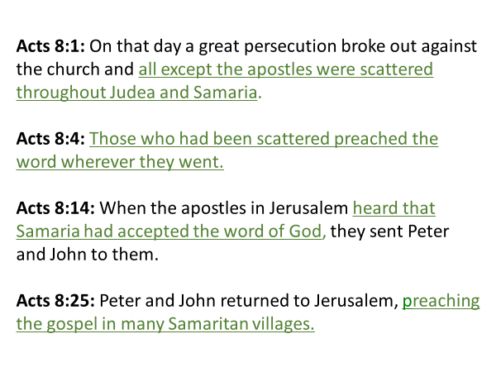
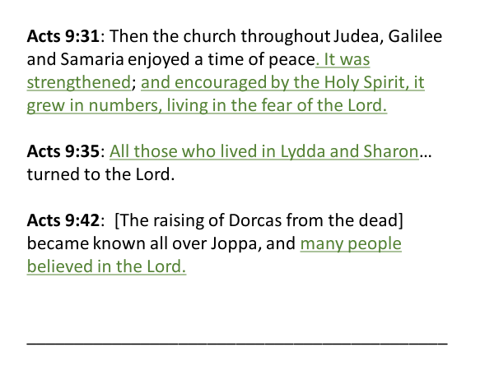
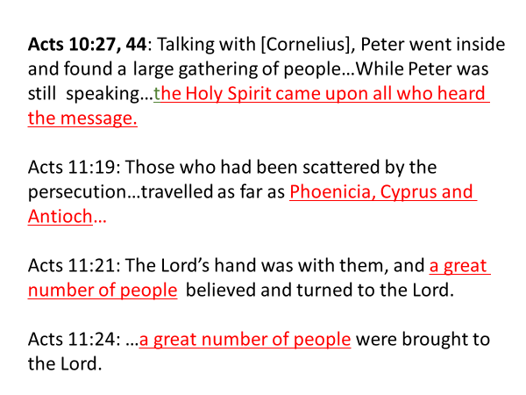

As I mentioned, Luke’s summary statement, “But the word of God continued to spread and flourish,” speaks of a quantitative increase.
The gospel spread to surrounding regions – Judea, Samaria, Phoenicia, Cyprus, Antioch.

The word of God, the gospel as it was preached… was believed by a growing number of people – Jew and Gentile.
- Were added
- More and more
- Increasing
- A great number

This was the point Jesus made in the parable of the mustard seed.
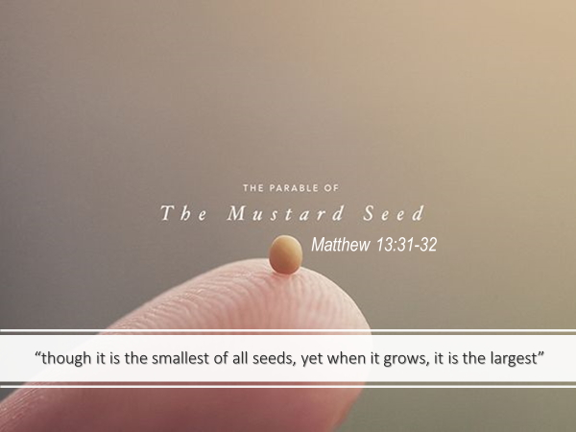

What is fascinating to see in the book of Acts is that the word of God spread through the mouths of Jesus’ followers.
Everywhere those followers went…. they announced the news of Jesus’ life, death, resurrection and ascension.

When he first called them, do you remember what Jesus told his disciples?
I will make you fishers of men.

A fisherman takes a fish out of one environment into another.
When a fish is taken out of its natural environment it dies.
But a fisher of men brings people from an environment of death into one of life.

This summary statement in verse 24, tells us that Jesus fulfilled what he had promised – he made his followers… fishers.

But Jesus’ promise was not just applicable to the twelve.
Jesus desires to make all of his followers’ fishers of men and women.
Do you know why?


God’s divine nature and power, along with his fingerprints are seen in the creation.
But what the heavens do not proclaim…is the glory of the gospel, which reveals the heart of God.

In every generation, physical hunger, poverty and homelessness have been pressing needs.
And as followers of Jesus… our Lord tells us in Matthew 25….that it is important to spend ourselves on behalf of others.

But humanity’s greatest need… is spiritual starvation, alienation from God and spiritual bankruptcy.

The gospel of Jesus is the greater glory because it meets humanity’s greatest need – to be saved from their sin and reconciled to God.

This is why Jesus’ followers spend their lives to make known this glory.
Tim Keller writes:
What it means to become a Christian is you don’t get God coming into your life to meet your needs so that you can reach your agenda, but rather you’re drawn into his agenda.

It is the heart of God that his word spread and flourish in Sooke.
And to the achieving of that end…. it is the promise of Jesus to make you and I fishers of men and women.
Would you ask Jesus this morning to keep making you a fisher?

There was also a qualitative increase to God’s word.
- Much grace was upon them all
- The followers of Jesus were strengthened and encouraged
- The believers lived in the fear of God

This qualitative increase impacts a person individually, but more importantly collectively.

And we all, who with unveiled faces contemplate the Lord’s glory, are being transformed into his image with ever-increasing glory, which comes from the Lord, who is the Spirit.

Mark Dever says of this verse:
“There is one place on earth where heaven’s springtime blossoms and its firstfruits are seen – the church.”

God’s word always accomplishes God’s purposes.
You and I are not yet who we will be.
This church is not yet whom God intends it to be.
But the Lord is active among us right now.
The life of heaven – the blossoms; the first fruits…. Is seen in us, even though it may not be understood.

It is God’s intent that from now until the return of Jesus or he calls us home, that his word spread into and flourish in every aspect of our lives.

This being the case, guard your heart and mind against the temptation to compartmentalize God into select facets of our life.
Jesus is Lord…. he is sovereign….in every aspect of who we are.

Our jobs.
Our marriages.
Our family.
Our free time.
Our money.
Our friendships.
Our interests.
Our studies.

The word of God, which is active among us, encourages us to spur one another, not only that we might finish well, but that in this present time we would live the gospel…well.

The Blessing

May the word of God…
…in our lives
…in this place
…in this town and region
continue to spread and flourish!

Acts 12:24 also tells us that the word of God spread:
- to Judea
- to Samaria
- to coastal Israel (Lydda, Sharon, Joppa)
- to Galilee
- to Phoenicia, Cyprus and Antioch

Like Saul, Herod’s efforts to persecute the church
didn’t stop what God was doing.
The word of God continued to increase and spread.

How does this apply to you and me today?
Let me make several connections.

** A ministry focus that is both local and global.

While much of our effort is focused here in Revelstoke,
because this is where we live,
the leadership of this church is endeavoring
to intentionally cultivate within each person here
a heart for other peoples in other cultures.

It is our dream that as a church we might build significant relationships
with other church communities in other nations of the world.

This is why we are sending a team to Colombia.
They are going on behalf of this church.
While 12 people will go, there is opportunity for all of us to be involved:
in the preparation; in the praying;
in the lending of practical help and support.

** Spiritual results that are both quantitative and qualitative.

While it is God who transforms our character
by the working of his Spirit in us,
you and I do have an important and crucial part to play.

We’ve emphasized today the role of the word of God in our lives.
So in light of that, what is our responsibility when it comes to
our involvement with the word of God?
We are responsible to read and study and think upon God’s word.

As we do so, we expose ourselves
to the words of God that are living and active.
God wants to speak to us.
When we read God’s word we put ourselves in the place to hear from him.

If you want to build into your life the habit
of regularly reading Scripture;
the Read Through the Bible program can help you.

If you started in January and have kept at it, great! Keep going!
If you started and quit for whatever reason, start again.
If you didn’t start in January, start in July.

This is the promise of God when we interact with his word.
2 Timothy 3:15-17:
“…the holy Scriptures…are able to make you wise for salvation through faith in Christ Jesus. All Scripture is God-breathed and is useful for teaching, rebuking, correcting and training in righteousness, so that [you] may be thoroughly equipped for every good work.”

** We have a role to play in what God is doing in our town.
What is it that God invites us to do?
It’s the same role that the believers in Acts were involved in.

They testified.
With great power the apostles continued to testify
to the resurrection of the Lord Jesus
[The apostles] never stopped teaching and proclaiming
the good news that Jesus is the Christ
Those who had been scattered preached the word wherever they went
They preached the gospel in many Samaritan villages
Those who had been scattered by the persecution in connection with Stephen, travelled as far as Phoenicia, Cyprus and Antioch telling [people] the good news about the Lord Jesus

And they prayed.
Acts 1:14 – They all joined together constantly in prayer…
Acts 1:42 – They devoted themselves to the apostles’ teaching
and to the fellowship, to the breaking of bread and to prayer.
Acts 3:1 – They went up to the temple at the time of prayer…
Acts 4:23 – On their release, Peter and John went back to their own people
and reported all that the chief priests and elders had said to them. When they heard this, they raised their voices together in prayer to God.
Acts 4:31 – After they had prayed, the place where they were meeting
was shaken. And they were filled with the Holy Spirit and spoke
the word of God boldly.
Acts 6:6-7 – They presented these men to the apostles, who prayed
and laid their hands on them. So the word of God spread.
Acts 12:5 – Peter was kept in prison, but the church was earnestly praying
for him.

The practice of the church in the time of Acts
challenges to also testify and to pray.
The Scripture remind us that these two activities are inseparable.
Our testifying will convince and compel us to pray.
Our prayers in turn will energize our efforts to testify.

This coming Thursday night, 7-8:30pm is June’s prayer gathering.
I encourage you to come and pray.
We want to grow together, both in learning
and in the practice of praying together.

Starting in September, after Labor Day weekend,
I will be doing a four week teaching series
on sharing our faith entitled, “Pointing People to Jesus.”
We’ll talk more about that as we get closer to September.

The creating of a spiritual awakening, in Acts, or in any other time period,
is not a human responsibility
That is God’s doing.

But God has chosen to involve himself with his people
and to work through them.
The book of Acts teaches us that because he has,
our efforts do make a difference whether or not
God is welcomed or restrained in what he can do.

The Blessing

2 Thessalonians 2:13-17

¹³ …we can’t help but thank God for you, dear brothers and sisters loved by the Lord. We are always thankful that God chose you to be among the first to experience salvation—a salvation that came through the Spirit who makes you holy and through your belief in the truth. ¹⁴ [God] called you to salvation when we told you the Good News; now you can share in the glory of our Lord Jesus Christ.

¹⁵ With all these things in mind, dear brothers and sisters, stand firm and keep a strong grip on the teaching passed on to you both in person and by letter.

May you experience the blessing of God’s encouraging word
being spoken deep into your heart.
And may the blessing of his word strengthen you
in every good thing you do and say.

