The Word of Life November 17, 2019
Acts 13:42-52

Read the passage.

There is phrase repeated four times in this passage.
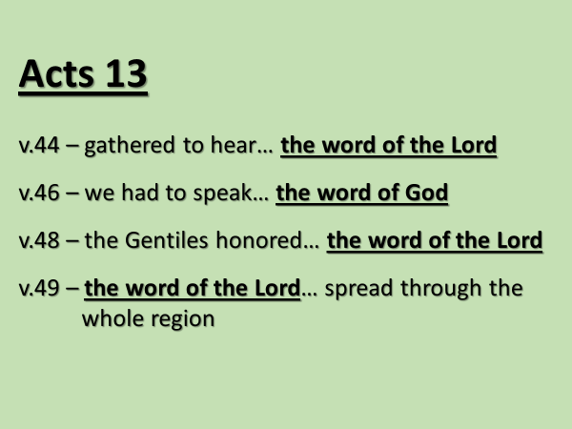
I remind you that word of the Lord refers to God’s written Word, the Scriptures… and to God’s living Word, Jesus the Messiah.

The Sabbath before, Paul and Barnabus had announced startling news: God’s Messiah had come to earth.

But who the Messiah was… turned people’s understanding of Scripture upside down.
- A Messiah who had been rejected and put to death!
- A Messiah who had been buried and then raised to life by God!
- A Messiah who had accomplished what the law of Moses had not been able to accomplish – justification… the forgiveness of sins!

Paul and Barnabus were invited to come and speak again – v.42.
Their news so resonated with people, that the following Sabbath, v.44,
“almost the whole city gathered to hear the word of the Lord.”

Today’s passage informs us there were two very different responses.
There were people who wanted to hear more.
And there were those who had heard enough.

The passage first describes those who had heard enough.

v.45.
God’s good news is not always perceived, nor received.
- Some are not interested in it.
- Some are threatened by it.
- And some are so antagonized, that they fight against it.

For those in Psidian Antioch who rejected the message, what was it that fueled their rejection?
v.45 - Jealousy.
Jealously of what?
v.45 – the crowds who had gathered to hear Paul preach.

The Pharisees and the chief priests in Jerusalem had reacted similarly towards Jesus.

John 11:45-48.
“If we let him go on like this, everyone will believe in him…”
And if that were to happen, what was their fear?
“… then the Romans will come and take away both our place and our nation.”

It is surprising and shocking how good living; God-fearing; respectable people can behave when motivated by pride and jealousy.

This passage reminds us that:

- It’s not just bad people who need Jesus.
- It’s not just immoral people who need Jesus.
- It’s not just irreligious people who need Jesus.
- The Bible says that all of us have sinned and have fallen short of God’s glory.
- The Bible says that all of us are spiritually dead, and that includes good people and religious people.

The gospel of Jesus puts the issues of life… in black and white.
There is only one way to God.
There is salvation in no other name but Jesus.

This passage teaches the follower of Jesus how to respond to those who are hostile towards God and in turn to them. Read v.46a.

Paul and Barnabus responded to their critics…with boldness; not with fear or anger.
What did they boldly say? v.46b-47.
- You rejected the word of God.
- You said you didn’t need; didn’t want eternal life.
Paul and Barnabus’ straightforwardness can sound harsh to us.
But you can’t argue a person into faith; you can’t persuade someone who doesn’t want to believe.

As he did with Paul and Barnabus, God’s Spirit will indicate to the follower of Jesus, when it is time to step back or to move on from a person who rejects Jesus.

This can sound harsh to us.
We can think it means we’re giving up on a person, and we don’t want to do that.
But sometimes, as Romans 1 teaches, God lets a person go, in order that they might come to the end of themselves.

It was only when the prodigal son had lost everything, and was starving, that he came to his senses, and determined that he would head home.

These particular Jews, described in Acts 13, had, without ambiguity, rejected Jesus – they had made it clear they didn’t want anything to do with him.
They had been offered life and they categorically said no.
So, God honored their wish and stepped away from them.

v.48.
There were Gentiles in that crowd that day who wanted to hear more; who didn’t reject, but who honored the word of the Lord by obeying it and welcoming Jesus into their life.

What is meant by this phrase, “eternal life?”
It’s been used twice now, in v.46 and v.48.

Over time words can lose the meaning they originally had.
This is what has happened with this phrase, “eternal life.”
For many people today, this phrase means the life to be lived after death; the life beyond space and time.

But this was not its original meaning.
The phrase “eternal life” actually means “the life that is truly life.”

According to the Bible, there are two ages; the present age and the age to come.
What is the key factor that distinguishes life in the present… from life in the age to come?

Remember what Martha said to Jesus in John 11:24 about her brother Lazarus who had died: “I know he will rise again in the resurrection at the last day.”

The key factor that distinguishes life in the age to come…
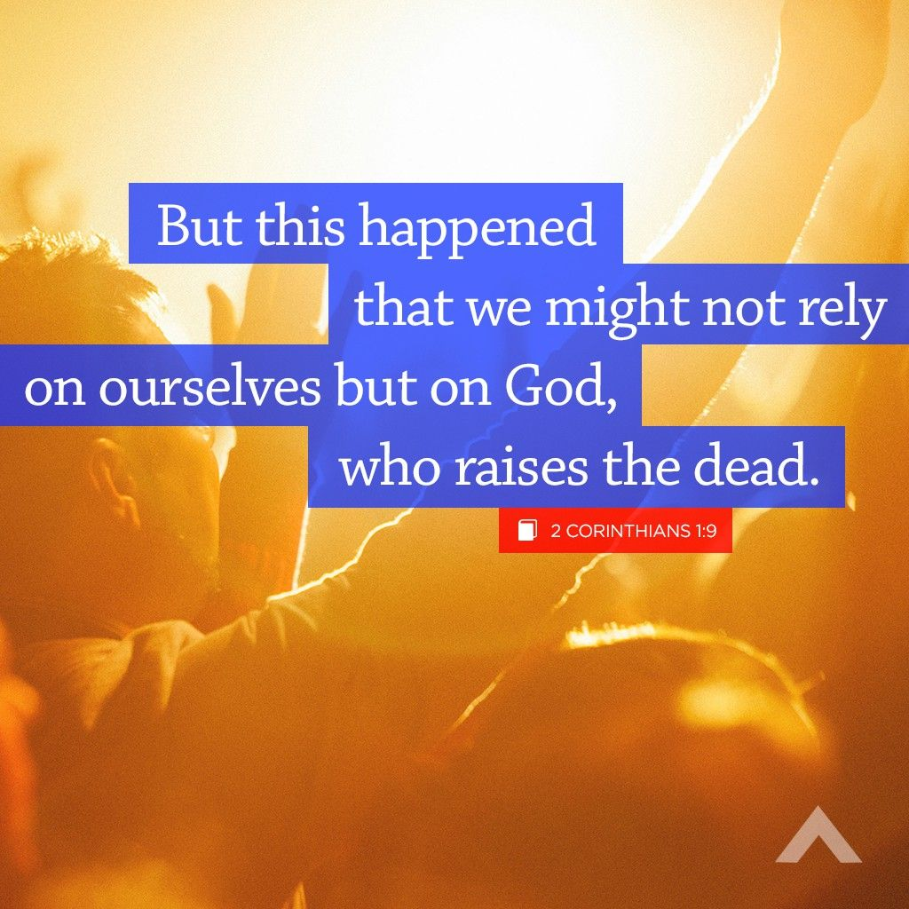
…is God’s resurrecting power which will make dead things live again!!

Through the prophet Isaiah God had promised:

This reality is still to happen.

What made the teaching of Paul and Barnabus so amazing, yet so controversial…was their announcement that with the resurrection of Jesus, God was releasing, into the present, his resurrecting power.

This is the message of the gospel.
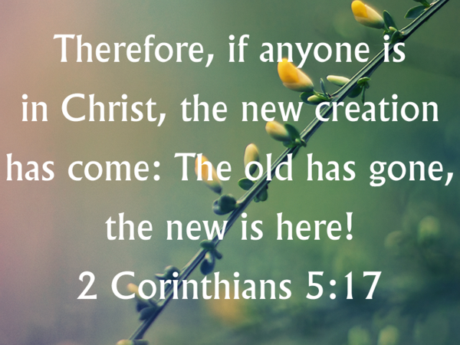
Do you realize how significant that phrase – new creation – is?
God who in the beginning created human beings in his likeness, creates a new nature and spirit in those who trust in his Savior Jesus.

God through Jesus has brought the age to come into the present.
Let me explain.
To be a follower of Jesus is not about turning over a new leaf; or starting to attend church; or determining to live a moral life; it’s about… being made by God through faith in Jesus, into a new creation.

This truth… that the age to come has begun… profoundly gives to the follower of Jesus a unique perspective on life and death.

Revelation 14:13
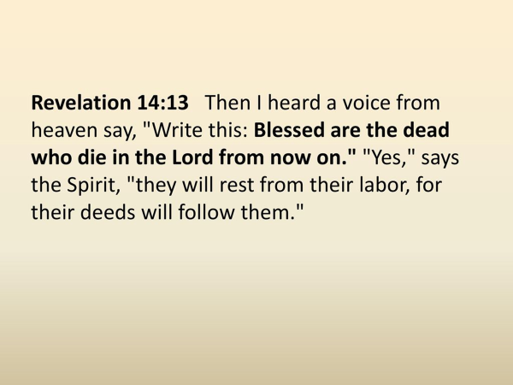
For the follower of Jesus, life here on earth is not disconnected from the life to come; but in actuality it is a continuation.

The implications of what Revelation 14:13 says… are huge.
Everything about us… all that we accomplish… will follow us.
This is why it matters… what we do with our life here on earth.

Additionally, the parable of the talents teaches us, that the responsibility God entrusts to us in the life to come, will be determined by our faithfulness to him in the here and now.

Matthew 25:14-30.

v.20, 22 - “You entrusted me with… I have gained…”
v.21, 23 - “You have been faithful with a few things; I will put you in charge of many things.”
Tom Wright says,

In the age to come, we will not be sitting on clouds playing harps forever.
The followers of Jesus will be put in charge of things.
We will be tasked with the responsibility God had given to humans in the beginning.
We will be entrusted to be stewards of the creation and its creatures, and all for the glory of God.

For those of you who are walking with Jesus we need on a regular basis to be reminded of these things.

v.49-52.
We have in these three verses a summary of what life in the present age will be like until our Lord Jesus return.
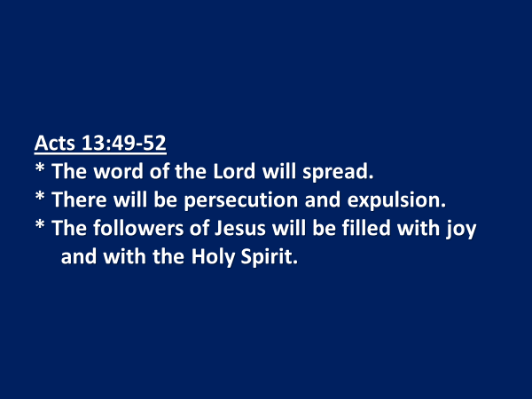
* The word of the Lord will spread.
In Paul and Barnabus’ day, v.49 says, it spread throughout the whole region.
Since that day the word of the Lord has spread throughout the whole earth.
Just as Paul and Barnabus had their part to do; so, do we.

* There will be persecution and expulsion.
Not everyone will choose to love and follow Jesus.
Not everyone will want to hear the gospel through your voice.
Some will stir up others to persecute you; and to exclude you.

* The followers of Jesus will be filled with joy and with the Holy Spirit.
We know how the story ends; we know Jesus has overcome.

Based on what we’ve studied, is God’s Spirit convincing you to live differently?
Is there a promise he is inviting you to hold on to?
Are there adjustments in focus or commitment that the Spirit is urging you to make?

In Jesus’ own words, wise is the person who having heard the word of the Lord, puts into practice.

The Blessing

May you know the blessing of the word of the Lord spreading into every area of your life, just as it is spreading through the nations of the world.

May this church know the blessing of the word of the Lord spreading throughout Sooke and beyond.

May you know the blessing of the Holy Spirit’s encouragement and clear leading when it is time to share the gospel with someone and when it is move on, putting into God’s hands, a person who rejects the gospel of Jesus.

May you know the blessing of God’s exquisite joy that comes from the presence of his Spirit living in you.

