Mary’s Hymn December 22, 19

Luke 1:46-55

When we speak of mercy what pictures come to your mind?

School yard fight: ”Say mercy”
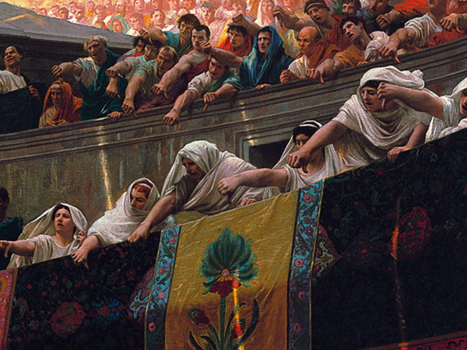
Roman gladiators: Thumbs up, mercy; thumbs down, no mercy.

A court case: the defendant casts themselves upon the mercy of the court.

Take a look at this video clip – Les Miserables
The mercy of the priest was so great; so costly; and so surprising…that it shocked, not only the priest’s wife, the commander of the soldiers, but also the hardened heart of Val Jean.

Never could he have imagined that the priest would do what he did… after Val Jean had done what he had done!

Our passage for today’s study is found in Luke 1:46-55.
These last weeks we have considered Christmas songs found in the bible – the psalm of David, the anthem of Isaiah and today the hymn of Mary.
These songs speak of how in Jesus… heaven graced the earth.
The theme of today’s song is the mercy of God.

Prayer – help us Lord to see, to understand who you are and to be surprised by your ways.

Let’s read the passage together.
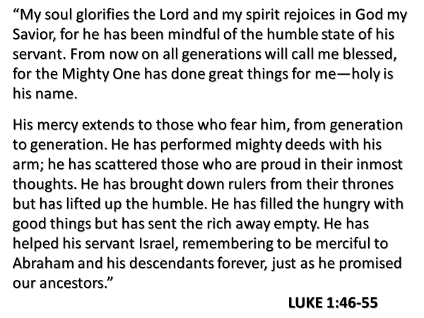

It is important to put this song in context.
Mary received good news from the angel Gabriel – v.31-33.
But immediately a puzzling question came to Mary’s mind – v.34.
The angel explained – v.35.
Even though Gabriel’s news put her engagement at risk… and threatened to negatively impact her reputation… Mary quickly responded – v.38.

Mary’s answer tells us she was clear… not just on who God is and what the Lord is able to do, but on who she was: “I am the Lord’s servant.”

We risk elevating Mary to a position she was not meant to hold, unless we too understand her primary identity as the Lord’s servant…was shaped by the people she belonged to – who saw themselves collectively …as the Lord’s servant – read v.54.
What God asked of Mary…was obviously unique.
But anyone who receives Jesus places their life in his hands to do with as he pleases.
It is not unusual for God to use the lives of his people in the carrying out of his mission of rescue.

Look at what Peter wrote:

What did Mary do after the angel left? Read v.39.
Mary’s trip would have taken several days, which I’m certain would have given her much time to think – not only about the implications of her pregnancy… but also about what Joseph would do – would he believe her or would he divorce her?

When Mary arrived at the home of Zechariah, Elizabeth’s greeting and encouragement motivated Mary to sing to the Lord.
Is that not the intent of encouragement - to inspire a person to take hope in the Lord and to praise him?

Read v.41-45.

There is great blessing for those who believe the Lord; great blessing to those who trust him; great blessing to those who willingly entrust their life to him.

Without question… there can be and there often is a cost to obeying the Lord. But it is nothing if you compare it to the cost of disobedience.

We’re ready now to interact with Mary’s hymn.
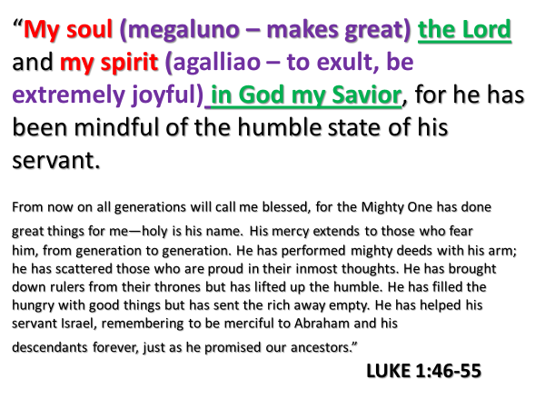
Mary was in awe of the Lord because she knew the privilege being given to her. When she sang of her “humble state,” v.48, what she was acknowledging was her ordinariness.

She knew she was not a princess; she knew she was not of wealth; she knew she did not have great talent. And still…the Lord had been mindful of her – he had noticed her; he had come near to her; he had chosen her to be the mother of the Messiah.

This is why she gloried (made great) the Lord and rejoiced (exulted) in God.

Having experienced the astonishing favor of God, Mary’s heart was filled with joy.
It may seem obvious, but we still need to state it: the believer’s joy is not rooted in our circumstances, but in our God and Savior and what he has done.

Consider these other scriptures.
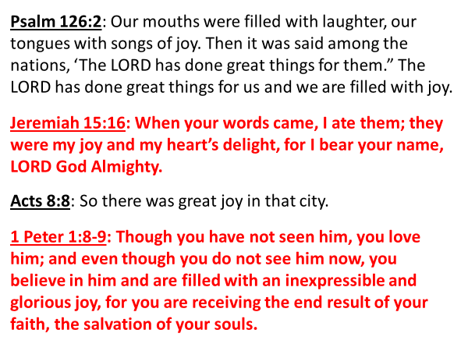

Joy in God fuels our praise of God.

Mary used four different names for God.
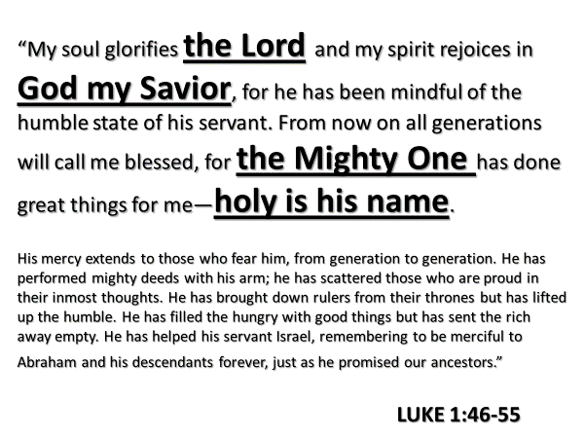
- The Lord – the word is “kurios,” meaning the One who is the Master
- God my Savior – the word Savior is “Soter,” meaning the One who preserves and sustains
- The Mighty One – the word “Mighty” is “dunatos” and speaks of God’s powerful ability to do anything.
- Holy – this speaks to God’s purity

Mary’s praise spoke of who she knew the Lord to be.

God was her Master.
God was her Sustainer.
She knew God to be the Limitless One.
She knew God did all things right because he is distinguished by a brilliant purity.

Again, let me state what seems so obvious: the focus of praise and worship is the Lord.
But praise and worship can easily shift onto us or lesser things, if our experience of God is not fresh and current, and if we are not deliberately intentional to focus on the Lord.
Is that not why the Scripture repeatedly says to the believer – fix your eyes on Jesus?

In addition to singing of the greatness of who she knew God to be, Mary also exulted in and made great…the deeds of God in this world.

Her insight of God’s actions was extraordinary – especially when you realize she was probably 15 years old.
But again, I remind you, of her spiritual heritage.

Mary sang of the Lord’s mercy.
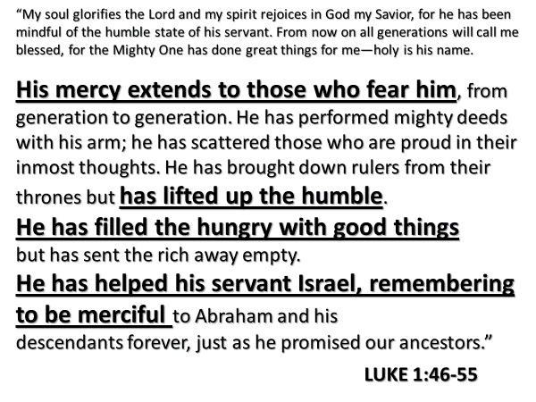
I remind you that Mary knew the spiritual story of her people.
She knew how God had extended mercy across the generations.
Again, and again the Lord had come to the rescue of Abraham’s family.
He had long ago brought them out of Egypt; and in more recent history had brought them back from Babylon.
Through long centuries, God had faithfully kept his promise to Abraham and his descendants.

And now in the child to be born in her, Mary grasped that God would in an astonishing way showed a mercy no one could have envisioned.

Her hymn reminds us that the mercy of God finds us….
…that the mercy of God is not just historical, but current…
…that the mercy of God is practical – it helps us in our need – it lifts us up, and it fills us with good things.

It is not just because God is faithful that he keeps his promise.
Mary’s hymn which makes God great, emphasize that it is also because of his mercy that God keeps his promises.

Mary also sang of how great the Lord’s justice was.
And again, she knew this because she knew the story of the people she belonged to.

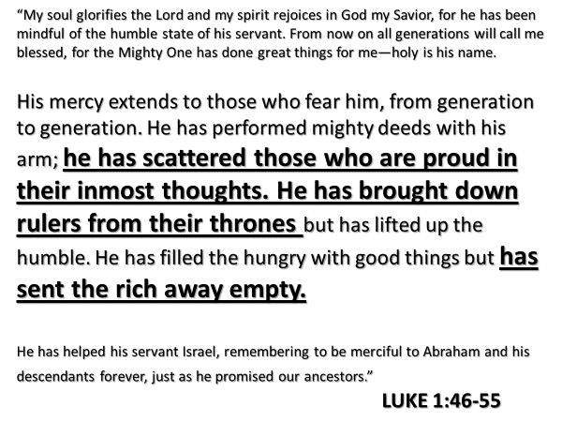

In her hymn, Mary magnified the Lord, who is the God of justice.
The Lord deals with those who do wrong – by scattering, by bringing down, by sending away.

God had done this with Egypt.
God had done so with the Canaanites; the Assyrians; the Babylonians; the Greeks.

Mary knew by what the angel had told her… that the child growing in her, would make all things right.

How does Mary’s hymn connect to our lives?

Our worship
- Her hymn reminds us of the focus of our worship – it is the Lord.
- Her song challenges us to be diligent in the content of the songs we sing – that they make God great; that they speak the truth of who God is and what he has done.
- And while there is a place for lament, our experience of walking with Jesus, fills us with joy that fuels our praise.

The raising of our children in home and in the church
We instruct our children to know the Lord:
- no one intuitively knows God – it is through his word that we know of his mercy; his love; his faithfulness; his holiness
- by grace through faith in Jesus – Ephesians 2:8.

We instruct our children to be a part of the people of God:
- by teaching them the spiritual heritage that is theirs
- who encourage and spur each other on to follow Jesus
- by teaching and modelling the priority of worship
…worship is both taught and caught

What are you saying to us Lord, from your word?

The Blessing

John Stott says, “The symbol of Christianity is the cross, not the scales.”

Do you remember the thief who hung on a cross beside Jesus?
He had been justly sentenced to death for the crimes he had committed.
But in the final moments of his life, he turned towards Jesus… and in faith of him… asked for mercy.

How did Jesus respond to him?
Luke 23:43: …today you will be with me in Paradise.

Why could Jesus do this?
Because as Jesus hung on a Roman cross, the sin of the world that was placed on him, included… the sin of the thief.

This is the blessing we live in - Jesus then and now… is good news of mercy to the undeserving.

It is not always easy to grasp how the mercy and the justice of God complement one another.
But I remind you, lest we make it overly complicated – that Mary, a 15 year old girl, in her hymn, exulted in the God who is both merciful and just.

Look again at verses 54-55.
The Lord revealed to Mary that the hundreds of promises that he had made, since the Garden of Eden, about the Rescuer who would come,
were about to be fulfilled in her, and through the child she would bear.

Through the child in her, God intended to keep his promise to be merciful to Abraham and to Israel.

The mercy of God cannot and does not cancel out his justice; nor does God’s justice negate his mercy.

Through Peter the Holy Spirit confirms: “[The Lord] is patient with you, not wanting anyone to perish, but everyone to come to repentance. 2 Peter 3:9

Throughout the Bible we read of the Lord being both just and merciful.
How are these two qualities not in conflict?

In a general sense, God has revealed that he is merciful to all.
- The sun rises every day.
- The earth spins at a consistent rate.
- The seasons follow one another.
- The earth produces crops.
- The earth has an abundance of resources.
- The air we breathe continues to be produced through natural means.

And because of these things and more, all humanity experiences the mercy and goodness of God.

But what of his justice?
Long ago Abraham said to God, Genesis 18:25:
- that the Lord is the Judge of all the earth
- that the Lord does what is right

Other Scripture confirms there is no darkness in God; no flaw; no deficit.
This is why…

What is Jesus’ longing?
That every person would turn their life towards him, and away from sin.
And while a person is alive here on earth, they have opportunity to respond to God’s kindness by repenting of their sin and believing in Jesus.

if we will place our faith in Jesus,
to be shown mercy.

Jesus died in our place for our sin.
The justice of God was fully satisfied by his death.
When we ask him to forgive us,
he removes from us the penalty of sin.
You don’t have to make a special appointment with God
to receive his offer of clemency.
At anytime, and in any place, you can talk to him,
and yield your life to him.

If you want to know more about initiating a relationship with Jesus,
please speak to me after the service,
or talk with the friend you came with this morning,
or pick up one of these booklets which I will leave on the piano.

Application

When we begin to follow Jesus,
God begins to cultivate at the very core of our being,
- a heart like his,
that is compassionate and kind to those who are undeserving.

Yancey’s story of Sadan and Paul Brand

Are you familiar with the name Millard Fuller?
He was a millionaire entrepreneur who was spiritually challenged
by the radical minister Clarence Jordan.

Fuller gave up his life of luxury and founded an organization
that expressed mercy by building houses
for those who couldn’t afford one.
You know the organization he founded – Habitat for Humanity,
which has built over 100,000 homes.

Jack McConnell helped to develop Tylenol and MRI imaging.
But after his retirement he too was challenged
to act in mercy towards those in need.
McConnel said, It wasn’t until I stopped saying
‘Someone should look into this problem’
and realized I was speaking to myself that it really turned around.
What he did in 1994 was open the Volunteers in Medicine free clinic.
This clinic was staffed by retired doctors, nurses, dentists and lay people.
Since then, 43 other clinics like it are either open or being planned.

Dame Cicely Saunders enrolled in medical school in middle age.
She never practiced medicine.
But she ignited the modern hospice movement,
which ushered in a new way to express mercy and care for the dying.

These are people whose names you did not know.
They are ordinary citizens, energized by their faith,
who acted to advance the cause of justice and mercy.

Maybe you won’t found a Habitat for Humanity. But maybe you will.
Maybe you won’t birth a movement like the hospice movement.
But maybe you will.
May be you won’t start a Volunteers for Medicine clinic.
But maybe you will.

These individuals I’ve described to you
were simply being obedient to act in mercy like their Father.

We are to be merciful, even though
there may be a risk that our kindness be misunderstood,
or taken advantage of. Luke 6:27-36.

Our niece while single, became pregnant.
What were we to do after her baby was born?
Shun her? Rebuke her? Judge her?

We chose to show kindness.
We held a family baby shower for her and her little girl.
There was the risk that she might have misunderstood our actions
as approval of her lifestyle.

But that was a risk we had to take,
because she needed to know through our love and our kindness
that the heart of her heavenly Father longed for her to return to him.

Justice and mercy can be held in rightful tension.
Jesus shows us how.

When a woman was brought to him who had been caught in adultery,
he defended her. He forgave her.
But he also told her, “Go and sin no more.”
It was his kindness that led to her repentance.

So… in what circumstances and to what individuals,
is the Father prompting you to show mercy?
You are to forgive, because you’ve been forgiven.
You are to show mercy, because mercy has been shown to you.

Hosea 6:6 – what does God demand of us? mercy.
Why does he insist on mercy?
Our tendency is to give to people what they deserve.

When we see unrighteousness flourish or we are treated wrongly by others, we find it much easier to pray for judgment, instead of mercy and blessing.
And how does mercy develop in us? When we pray for those who hurt us; when we respond with kindness to words or actions of unkindness. Doing so, develops the muscle of mercy and compassion within us. This is how God can turn what was intended for evil into good – when you respond with mercy to unkindness, that which was intended to hurt you actually contributes towards your spiritual growth.

Habakkuk 3:2 – the prophet asked God in wrath to remember mercy
You will have opportunities to exact justice. But when you choose to act in mercy, you act like your spiritual Father.

Luke 6:27-36

When Elizabeth gave birth to John, it was said, “the Lord has shown great mercy to her.” He helped to give birth to a child in her senior years.

Ex. 33:19 – it is God who decides who qualifies for mercy
Ps. 63:9 – there is linkage between love and mercy

What are the most important aspects of the law?
Justice, mercy, faithfulness
What is our tendency? To magnify the trivial and diminish the important.

God is merciful to those who follow him, but fearsome to those who oppose him.

You know the details of that familiar Bible story Jonah was deeply offended by God’s compassion.
I knew that you are a gracious and compassionate God, slow to anger and abounding in love, a God who relents from sending calamity. 4:2

How did God show mercy to Mary?
Frederick Buechner wrote a book entitled Peculiar Treasures.
One of his character sketches describes
what Gabriel might have thought as he spoke with Mary.

She struck him as hardly old enough to have a child at all, let alone this child. But he had been entrusted with a message to give her, and he gave it. He told her what the child was to be named, who he was to be, and something about the mystery that was to come upon her. “You mustn’t be afraid, Mary,” he said. As he said it, he only hoped she wouldn’t notice that beneath the great golden wings, he himself was trembling with fear to think that the whole future of Creation hung on the answer of a girl.

