The Importance of “How” January 5, 2020
Acts 14:1-7

Read the passage.

Coffee/Question: what does it mean to be effective?
Feedback

v.1 - “…went as usual into the Jewish synagogue.””
It was customary in a Jewish synagogue of that day… to invite a guest to speak.

This phrase “as usual” speaks of a strategy used by Paul and Barnabus – to share the gospel with those with whom they had an affinity….
In their case it was those of their own ethnicity and those whose faith in God, though incomplete, was nonetheless rooted in the covenant God had made with Abraham.

v.1 - “There they spoke…”
What did they speak of?
Verse 3 tells us.
They spoke of the grace of God… revealed in the OT Scriptures and in the person of Jesus.

When I attended Bible college, there was an emphasis placed on friendship evangelism.
This was and still is a good emphasis.
But the scripture, as well as the practice of Paul and Barnabus reminds us that it is also important to speak the gospel.

Romans 10:13-17 tells us why.
* Everyone who calls on the name of the Lord will be saved
What an amazing statement.
* But how can someone call on the Lord if they don’t believe in him?
They can’t.
* And how can they believe in the Lord if they have not heard of him?
They can’t.

* And how can they hear without someone preaching to them?
They can’t.
* And how can anyone preach unless they are sent?
They can’t.

Paul then summarizes why the speaking of the gospel is necessary.
- Because faith comes from hearing the message
- And the message is heard through the word about Christ

A person will not know who the Lord is, and what he did… and place their faith in him, unless someone tells them about Jesus Christ.

This is why we are running Alpha for the next seven weeks.

v.1 - “There they spoke so effectively that a great number of Jews and Greeks believed.”

There was something about how …Paul and Barnabus’ spoke… that was a factor, that facilitated, that contributed… to the response of people in Iconium on that particular day.

If that wasn’t the case, there would have been no need for Dr. Luke to have included the phrase, “…they spoke so effectively...”

What was it?
I believe we find the answer in the closing verses of chapter 13.
Read v.49-52.

When they were expelled from the region of Pisidian Antioch, how did Paul and Barnabus respond?
v.51 - “They shook the dust off their feet as a warning...”
What did that mean?


gotquestions.org explains:
When Jesus sent His disciples out, two by two, to preach the gospel these were his instructions – Luke 10:8-12. In towns where they were welcomed, the disciples were to heal and to announce the news that God’s kingdom had come near.

But in those towns where they were not welcomed, the disciples were to warn the people… that their rejection didn’t change the fact that the kingdom of God had come near. Shaking the dust off their feet was like saying, “We have told you the news. Your decision is yours alone.”
https://www.gotquestions.org/shake-dust-off-feet.html

God will not arm twist a person.
But there is salvation in no other name than the name of Jesus.

This is why how a person responds to Jesus is so important.
It impacts their destiny – it either confirms the present trajectory of their life… or it radically changes it.

Were Paul and Barnabus discouraged at being expelled?
Were the believers they left behind in Pisidian Antioch disheartened?
Is there any indication Paul and Barnabus were tempted to give up and go home?
Is there any suggestion in these verses that they were considering changing their strategy – to be more subtle; more careful; more discreet?

What does the text tell us?
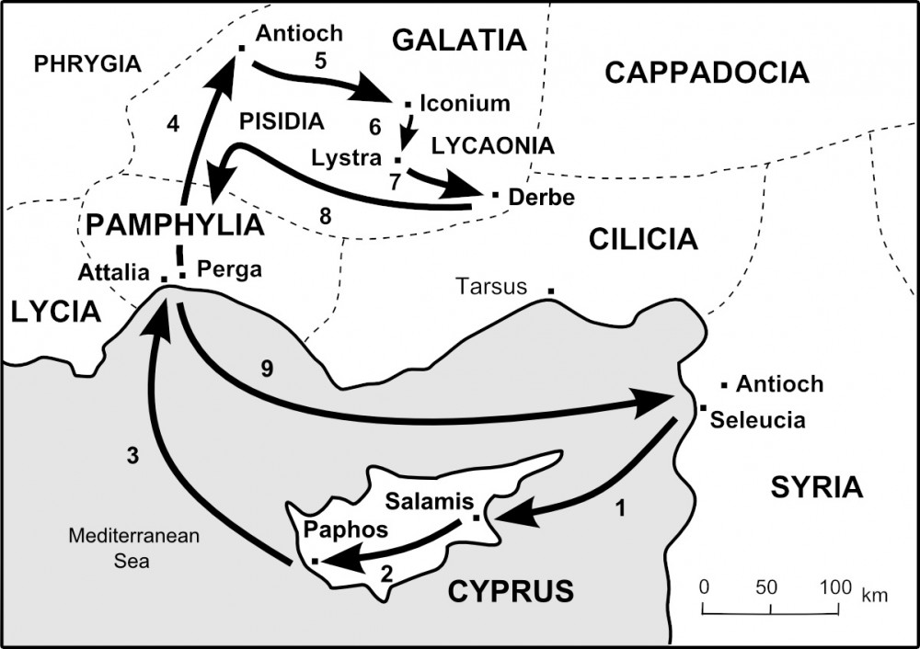
v.51b - “…they went to Iconium.”
That answers the question of whether they were tempted to go home.
They weren’t.

v.52 answers the question whether they were disheartened and/or discouraged?
The disciples being referred to in this verse…. were both Paul and Barnabus… and those who remained in Pisidian Antioch.

It is important that we understand the imagery being communicated through the word “filled.”

We often thinking of filling in this regard – of water poured into a glass.

But this word also describes the action of wind upon the sails of a boat.

It is the wind blowing upon the sails of a boat that moves a boat forward.

Every person is filled with something; and that something moves them; that something sets a direction to their life; that something influences and impacts how a person goes through each day; how they respond or react.

What were the disciples filled with?
What moved Paul and Barnabus as they left Pisidian Antioch and travelled towards Iconium?

Look again at the text. What were they filled with?
v.52b - “…with joy…”
Why joy?
Why not anger, frustration, disappointment, bewilderment, anxiety?

The answer has everything to do with the God they served.


The God of hope filled the disciples with… his joy.

Being filled with his joy doesn’t mean the follower of Jesus never encounters disappointment or grief or great challenges.
Paul and Barnabus faced all these things and more.

What kept Paul from quitting? from sinking into a deep depression?
The promise made by God to him – look at 2 Corinthians 12:8.
That promise flooded his heart and mind with joy – look at 12:10.

The joy of the Lord sustains and empowers the believer.

Paul and Barnabus, according to v.52, were also filled with… the Holy Spirit.
For what purpose did the Spirit fill them?

Acts 2:4 – filled with the Spirit… in order to speak
Acts 4:8 – filled with the Spirit… in order to speak
Acts 4:31 – filled with the Spirit… in order to speak boldly
Acts 7:55 – filled with the Spirit… to see the glory of God… and to speak
Acts 11:24 – filled with the Spirit. But how were a great number of people
brought to the Lord? – by speaking the gospel
Acts 13:9 – filled with the Spirit… to speak

It may sound rhetorical, but let me ask.
Does being filled with joy and with the Holy Spirit really make a difference when it comes to speaking the gospel?
According to Dr. Luke it did.

This is why…
v.1 – a great number of Jews and Greeks believed
v.3 – they spent considerable time there
v.3a – they were bold
v.3b – God did signs and wonders through them

It’s true that there were those who didn’t believe – v.2.
But there always will be.
It’s true that the gospel of Jesus divided the town – v.4.
And this too is a reality of this present time.

It’s also true that as it had been in other places, Paul and Barnabus had to leave the city in a hurry – v.6.
But they never stopped preaching the gospel – v.7.
And the gospel they preached… was not ineffective but was powerful to save all who believed.

The same God who filled Paul and Barnabus will fill us…with his joy and with the Holy Spirit in order that we might effectively live and speak the gospel

To be filled with God’s joy and his Spirit is an act of grace.
But it is also a response to our obedience.

We receive from God what we need, as we need it.
This is the reality we live in – Romans 8:31-39.
Because of the cross, God graciously gives us all things.

This empowers us, but it also fuels our delight in God and grows our vision of him, which in turn impassions our service for him.

The Blessing

Colossians 1:29:
“To this end I labor, struggling with all his energy,
which so powerfully work in me.”

May you know the blessing of laboring,
of working hard in Jesus’ name.
As you do, may you experience
what the old hymn spoke of,
“There is joy in serving Jesus!”

As you serve others in Jesus’ name,
may you know the blessing of struggle;
of learning to offer your best,
while drawing upon his powerful energy
that is released by the Spirit in and through you.

And many refused to believe.

Look at v.4 – the people of Iconium were divided – some chose Jesus; others rejected him.

Jesus had spoken of this.

The gospel of Jesus calls for a response.
And not all who hear the news of Jesus, choose to believe.

Those who refused to believe went on to do two things – v.2.
- They stirred up…the other Gentiles.
This is what the religious leaders had done in Jerusalem when Jesus was brought to Pilate – they persuaded, incited, stirred up the crowd to call out of for Jesus’ crucifixion.

- They poisoned their minds against the brothers.

They distorted the truth using gossip, defamation, slander, lying, and fabrication.

It’s what Potiphar’s wife did against Joseph, that resulted in Joseph being imprisoned.
Its what the ten spies did with their report about the land being filled with giants, so that the nation of Israel refused to go into the promised land.
Its what Absalom did towards his father David, that resulted in David fleeing Jerusalem lest he be killed.
It’s what the devil attempts to do towards us, as he reminds God of our failings.

I like the phrase Joni Eareckson Tada uses: “spectacles of glory.”

It makes me think of Moses
Read Exodus 34:29-35.
Being in the presence of God profoundly and visibly impacted Moses.
That was then, what about now?

Look at what Paul wrote in his second letter to the church in Corinth.
2 Corinthians 3:7-18.

It is not the only reason, but a primary reason why the Holy Spirit fills and transforms the lives of Jesus’ followers, is to enable them to communicate the gospel effectively.

In what way were Paul and Barnabus spectacles of glory?
The gospel had radically changed their lives.
They both had been rescued from darkness and brought into God’s marvelous light – Colossians 1:13.
Their sins, though many, had been forgiven and removed as far as the east is from the west.
They had been given a new identity in Christ.
They had been adopted by God.
They were filled with the joy of salvation.

This is why they preached so effectively.

This joy impacts the way in which all followers of Jesus communicate the gospel.

Ray Stedman said of the preaching at Iconium, “This was no bland presentation…
http://www.wordofgodtoday.com/acts-14/

Paul and Barnabus were spectacles of glory.
The gospel they preached had radically transformed their lives.
They had never gotten over being rescued from darkness and being brought into God’s marvelous light.
Their sins

Paul and Barnabus were not speaking out of duty, in a monotone voice, eager to finish so they could do something else more interesting.

The message they shared had transformed them.
In recent weeks, they had seen the gospel of Jesus, repeatedly transform the lives of people like Sergius Paulus and many others in Pisidian Antioch.

Filled with the Holy Spirit

Verse 3 – “…[they] spent considerable time there…”
Paul and Barnabus stayed in Iconium for a considerable length of time,
in spite of the fact that those who refused to believe
were active to poison the minds of people
and stir up opposition against them.

By staying Paul and Barnabus demonstrated
the kind of tenacious love and genuine interest
that God has for all people.

1 Corinthians 13 speaks of the importance of love in service.

One key reasons why Paul and Barnabus were so effective
is because as they spoke, there was clear evidence
of their genuine interest in and love for the people of Iconium,
that was very much like the kind of love God has for people.

How does this truth principle connect to how we serve?
Our effectiveness in ministry is not dependent upon
simply knowing what to say to someone.

You’ve heard the saying, “Talk is cheap.”
That also applies to our spiritual conversations with people.

Without question, our words need to be in sync with our lives;
our interactions with people
need to demonstrate the truth we’re speaking of;
and…… people need to see in us
that we are genuinely interested in and care for them.

What else helped to make Paul and Barnabus so effective?
Verse 3 – “they [spoke] boldly for the Lord…”
What did they boldly speak about?
“God’s grace” (v.3) and “good news” (v.7)

As we’ve worked through the book of Acts
we have again and again read of the believers
acting and speaking boldly on Jesus’ behalf.

But let’s be clear on what it means to speak boldly for God.
Look at 1 Thessalonians 2:2.

The hostility directed at Paul and his companions was intense.
If they had packed up and left town,
no one would have been surprised.
But they didn’t.
They dared to stay.

Now look at 1 Thessalonians 1:5-6.
Paul’s choice to stay in the face of strong opposition;
and to share the gospel with passion and conviction,
made a deep impression on people.

What his boldness did, was welcome and invite God’s Spirit
to work with power and deep conviction through him.
His boldness helped to make room in people’s minds and hearts
to consider the claims of the gospel.

This is another key reason why Paul was so effective –
he served others with boldness;
by bringing to their attention
the truth of who God is and the message of God’s good news.

It is no different today.
Ministry that is effective is ministry that is bold.

But where does boldness come from?
How do you and I become bold in how we speak;
how we live; how we serve?
Is it something we work up in ourselves?
Or something we stir up in each other?

Look at Acts 4:13.
What stood out about these two men?
It wasn’t their schooling, because they didn’t have any.
Nor was it some extraordinary natural ability, because they were ordinary.
The only thing the Sanhedrin noted about Peter and John was that,
“they had been with Jesus.”

Boldness will develop in us in proportion to the time we spend with Jesus.
As we grow in our understanding
of who he is and what he is capable of,
our confidence in Jesus will also grow.

Boldness to represent Jesus comes out of our confidence in him.
In other words, the quality of our service is directly connected to
the quality of our relationship with Jesus.

Look at Acts 4:31.
We are told the believers spoke the word of God boldly.
But how did they become bold?
By being filled with the Spirit.
And why were they filled with the Spirit?
Because they prayed.

We all know, there are naturally bold people.
But the boldness to speak for God and to share his word
comes from the enabling of God’s Spirit.
There is no ministry boldness without the Spirit.

The filling of God’s Spirit that enables a follower of Jesus
to be bold in their service for God and to others,
is something only God can do; can give.
But we are to ask God for his help.
That’s our part!!

Effective ministry is bold ministry; that is bold because
it is ministry that is saturated with and energized by prayer.

Here’s what we’ve seen so far in terms of what makes ministry effective:
it is inspired by love – for God and people
it is motivated by boldness

Is there anything else that contributes to effective ministry?
There is one more thing I want you to see.
It is implied, but not specifically mentioned in the Acts 14 passage.
Effective ministry happens when one gives their best
as they serve others in Jesus’ name.

I believe Paul and Barnabus spoke so effectively,
because they had prepared themselves;
their speaking that day was the best they could do.

Let’s look at Scripture that speaks of this.
In the book of Malachi God challenged the people of that day
on a number of issues.
One concern that greatly troubled God was how the people
were cutting corners when it came to the sacrifices they made.

Malachi 1:6-14.
In addressing this issue, God reminded the people of who he was.
He was a father deserving of honor – v.6
He was the Lord Almighty – v.8, 9, 10, 13, 14.
His name was great – v.11.
His name was to be feared – v.14.
He was a great king – v.14.

What was the point God made?
In light of who he was; his people needed to give to him their best.

Now look at Hebrews 13:15-16.
After Jesus sacrificed his life to atone for our sins,
it was no longer necessary for those how followed God
to sacrifice animals on the altar at the temple as in the OT days.

But that doesn’t mean that the followers of Jesus
don’t make sacrifices to God in honor of his greatness
and to express to him their gratitude.

This passage in Hebrews 13 identifies three types of sacrifice
that the follower of Jesus is to make.
v.15 – the sacrifice of praise; v.16 – the sacrifice of doing good
v.16 – the sacrifice of sharing with others

The Scripture teaches us to view ministry to others;
as a sacrifice that we gratefully offer to God;
in light of the great sacrifice he made on our behalf.

Whenever a person made a sacrifice to God in OT times,
they were to give their best.
That principle of giving one’s best to God,
doesn’t change now that we live in the NT era.

God is still deserving of our best.
And that best includes the service we do in his name.
Our best honors God; and it inspires others.

As we give our best in ministry, that sacrifice can be used by God
to catch a person’s spiritual attention;
to raise questions in their heart,
about their own relationship with God and their need of his Savior.

I’m not talking about perfection.
What I am saying is that I believe the Scripture teaches us
that when it comes to how we serve God and others,
what we do, is to be done to the best of our ability.

Illustrate with our worship team.
Those who work in Promiseland.
Life Group Leaders.

How do we respond?

Individually we need to ask God to evaluate our personal service.
Is there anything he wants to; he needs to say to you or to me?
Are there changes we need to make –
changes in our understanding of what ministry is;
changes in our preparation for ministry;
changes in our attitude towards God and those we serve?

Each ministry team needs to regularly ask themselves:
does God see our ministry as being effective?
What evidence would suggest we are effective?
Are there changes God is impressing upon us
that together we need to make?

2 Corinthians 13:5 says we are to examine ourselves
to see whether we are in the faith.

Doesn’t it make sense that if we are to ask God to help us search our hearts
in terms of our relationship with him;
that we would welcome him searching our hearts
as to whether our ministry for him and on his behalf is also effective?

The intent of asking God to evaluate us; of evaluating ourselves;
is not to discourage,
but to ensure that our service is inspired by who God is;
that it is rightfully offered as a gift to God;
and that we are properly and adequately making ourselves ready
to serve others in his name.

Lead in prayer

with all of his energy powerfully working in you.

while his presence in you, energizes

By asking God to evaluate how we serve in his name.

When I say our best, I’m not meaning perfect.
In light of the abilities God has given us;
in light of the spiritual gifting he has graced us with;
in light of our experiences;
our service done in the name of Jesus is to be our best.

But we all know when we do something
whether or not we’ve done our best.

Ephesians 6:7; 1 Corinthians 15:58.
Our best is wholehearted.

Not to impress others;
but to honor our God.
Not to make a name for ourselves;
but to enhance the name of our God.
Not just to please people;
but to please our God.

Ministry that is effective is inspired by love of God
and in turn love for people.
Ministry that is effective is motivated by confidence in Jesus
that is expressed as boldness to live for him
and boldness to speak to others on his behalf.

Ministry that is effective is the giving of our best
as a gift to our God.

As far as it relates to us, ministry that is effective
is ministry that is our best.
Not something done haphazardly.
Not something done half-heartedly.
Not something done with little thought or preparation.
But our best.

Do you see the difference?
It’s not about us all serving at a particular level that is defined by

The giving of our best is not
We do not serve others in Jesus’ name

I believe that effective ministry is ministry that is our best.

When we offer to God our best as we serve others, God’s Spirit is free to use that sacrifice in whatever way he chooses.

takes that sacrifice and he uses
And when we offe

Not to impress them; but to honor my God.

I give my best in service, because it is in gratitude for God
that I do what I do.

My service to other is to be an offering of love and gratitude to God.

We do good, we share God’s grace when on behalf of God we serve others.
We will serve others effectively,
when what we do is our best and how we do it is our best effort.

wha

With skillful hands – Psalm 78:72; Psalm 33:3
Sacrifices of doing good – Hebrews 13

