How God suprisingly guides his people March 29, 2020
Acts 16:1-10

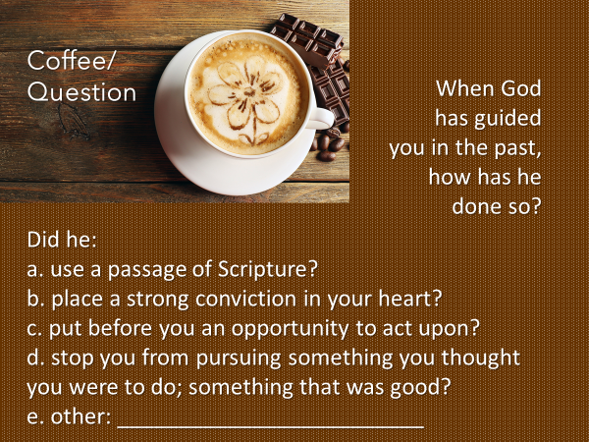

Today’s Bible passage speaks to our coffee/question of how God guides…
of how he makes known to us…. the who, the what, the why, the how and the when….and that he does so in surprising… and unanticipated ways.
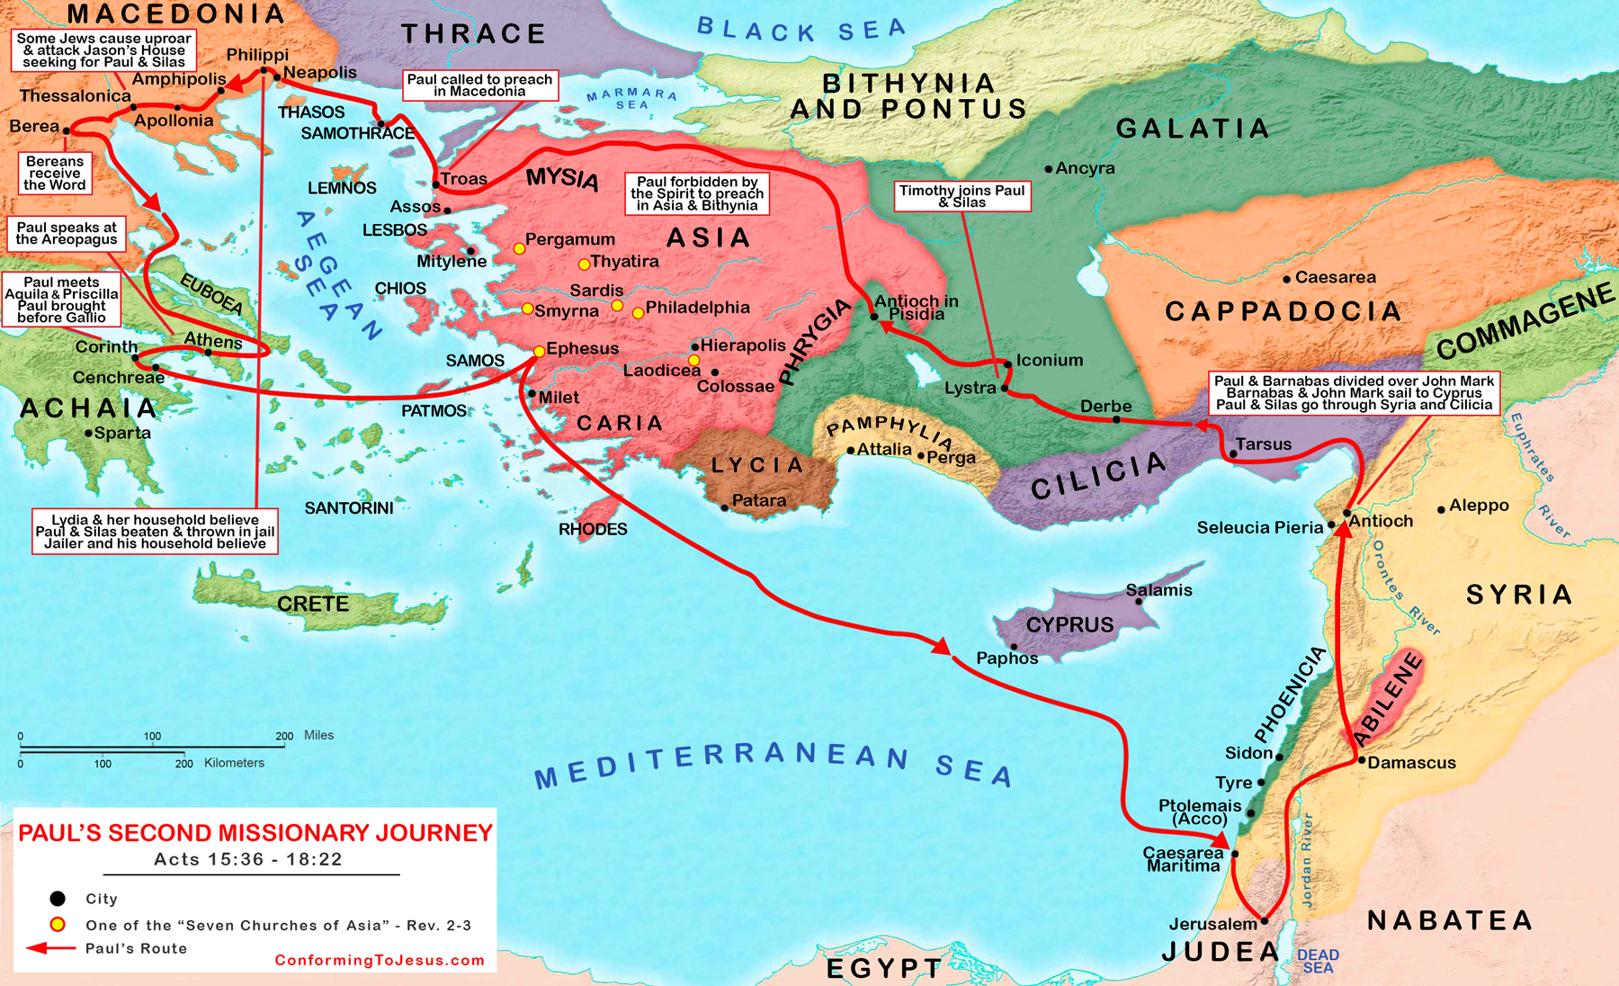
Acts 15:40-16:2.
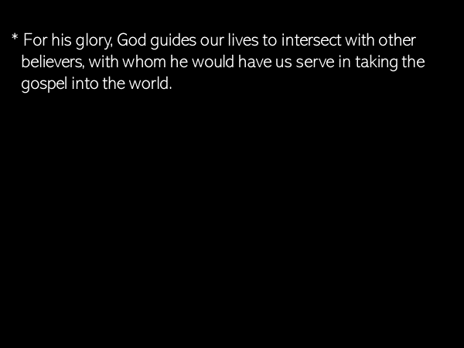
I remind you that Derbe and Lystra were towns which Paul and Barnabus had visited on their first trip, described in chapters 13-14.
As Paul and Silas came to Lystra they met Timothy.
This was a God-ordained encounter.

God is amazing.
He intersects the lives of his followers with other believers… who have been given… life-skills, experiences, and spiritual giftings, in order that together, they might have all that they need in order to do what God is asking them to do.

Has this not been our experience here at SBC?

Acts 16:3a
“Paul wanted to take [Timothy] along on the journey…”
How did Paul determine he should do this…especially in light of what had happened between him and Barnabus regarding John Mark?

Beyond simply meeting Timothy, how did God guide Paul to know that adding Timothy to the team was the right thing to do?
Let’s look again at the passage.

v.1 – [they]… came… to Lystra where a disciple named Timothy lived….

The place where Timothy lived was significant.
Lystra was where the townspeople had stoned Paul, dragged him out of town and left him for dead.
What does this tell us?
Lystra was not an easy place to be a follower of Jesus.

The fact that Timothy had not moved to another town to avoid danger;
the fact that his faith was practiced openly, rather than secretly, with all the risk that would have entailed,
was used, I believe, by the Holy Spirit to confirm to Paul…
here is a young man ready to serve alongside of you and Silas
as you preach the gospel and teach the Word.

Look at v.2 – The believers at Lystra and Iconium spoke well of him.
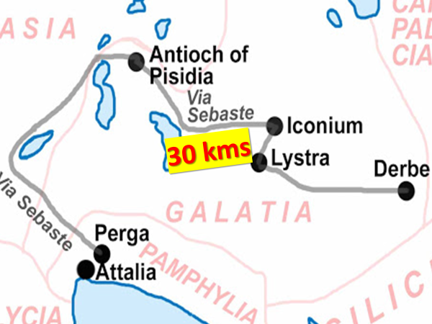
I remind you that the distance from Lystra to Iconium was 30 kms; which would have been in that day… an all-day trip by foot.
Somehow and in some way, maybe it was through his father’s business, Timothy was known in both cities to be an outstanding young man.

This testimony was used by God to confirm to Paul and Silas, “add this young man to your ministry team.”

Is not God good in how he uses other believers to confirm to us what he is leading us to do?!!!

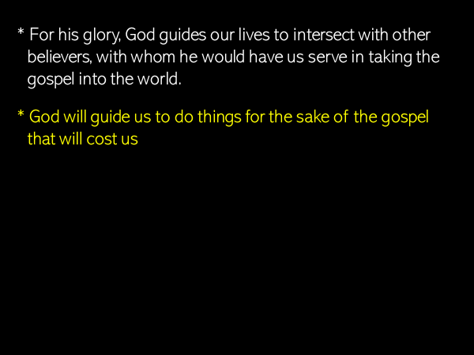
Acts 16:3b.
Why did Paul circumcise Timothy?
He and Silas carried with them a letter… which specified… a Gentile, who trusted in Jesus, did not have to be circumcised and keep the law of Moses in order to be saved.

At the Jerusalem Council, which Paul and Silas had participated in, God had clearly led his church to stand firm upon the essential of the gospel.
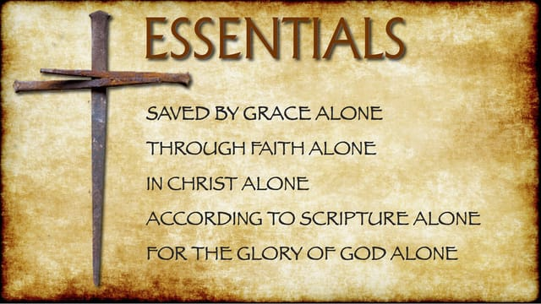

So I ask again – why did God guide Paul to do this; and why did Timothy accept this as from the Lord?

Even though Timothy’s dad was a Greek, Timothy was not considered a Gentile.
Because his mom was Jewish, in the eyes of the Jewish community, Timothy was… a Jew.
Let’s press into this a little more.
Remember what Peter said to Cornelius, “you are well aware that it is against our law for a Jew to associate with or visit a Gentile?” (Acts 10:28).

This being the case, we need to appreciate how scandalous it would have been for Timothy’s mom to marry a Gentile man.
And then…to add scandal on top of scandal, and we don’t know the reason why, Timothy had not been circumcised after his birth, even though he was considered a Jew.

These details were known to the Jews in that area.
And so, Timothy was circumcised, even though he didn’t need to be.

Timothy’s cost in this regard was physical pain.
And Paul’s cost was the risk that some might have thought he had caved; that some might misunderstand his motives.

What Paul later wrote to the church in Corinth provides gospel insight as to why the decision to circumcise was made.
When it comes to the gospel, in light of the great lengths Jesus himself went to in order to save…
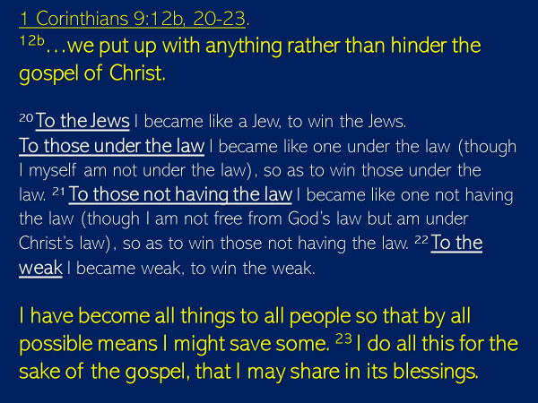
God will guide his people to do hard things.
But when you have been gripped by the grace and love of Jesus Christ, the glory of God becomes your passion, not self-preservation or comfort.

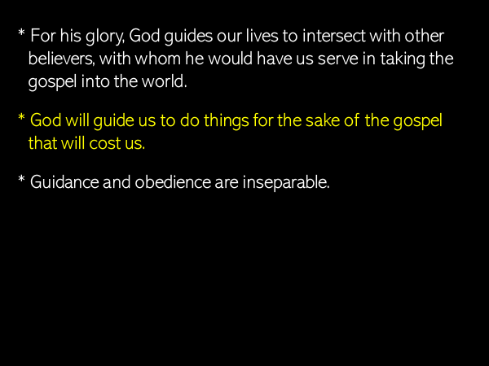
Acts 16:4-5.
The decisions which Paul and Silas delivered to the churches were not themselves Scriptural commands.
But they were… rooted in Scripture.

That is why, the expectation of Paul and team was that the decisions were not optional… but were to be obeyed.

It is subtle in how it was expressed, but there is no mistaking it: guidance and obedience are inseparable.

God will always guide you to obey him.
If something takes you from God… that something is not of God.
If an option before you will diminish the priority of God in your life… then that option is to be rejected.

When the churches embraced the truth of God and lived by it, they grew in their relationship with God, which means, they grew in their capacity to discern his voice and to find delight in following him wholeheartedly.

The other result was also incredible.
The churches… daily… grew in numbers.

Jesus said…. in contrast to the thief who steals, kills and destroys… he had come into the world to give life… to the full, John 10:10.

This statement by John Piper caught my attention this week.
For in it he contrasts the startling difference between the beauty and majesty of God and the counterfeits that have captured the attention of so many in our world.


It is God who draws a person to himself through the word he has spoken.
But God also uses the testimony of his followers – the life of Jesus manifested… in them and… among them, as they lovingly, willingly and joyfully obey him.

This is how we show the people of our world, in the words of the parable our Lord Jesus told, that he is the pearl of great price; that he is the hidden treasure for whom we gave up everything… in order to gain him.

As followers of Jesus we can talk about a strategy to share the gospel to the world, but this passage reminds us of a foundational reality – one of the most powerful gospel tools… is our obedience to God.
This was why the church grew so rapidly in the days in which the book of Acts was written.

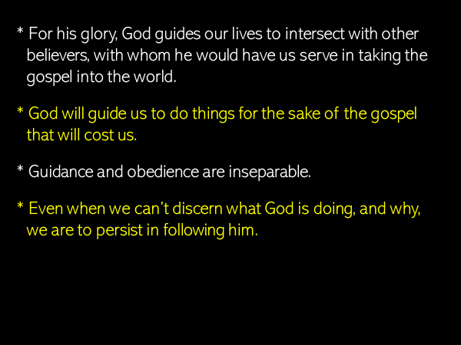
Acts 16:6-10
I’m sure Paul and his companions knew the promise of Psalm 48:14.
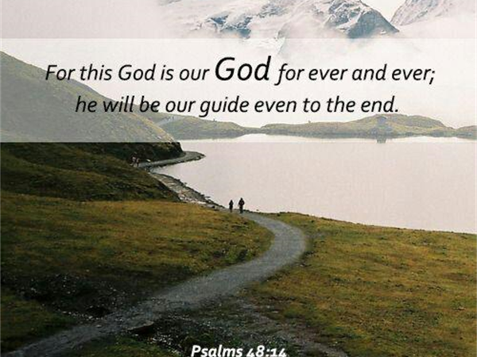
When Paul wrote to the church at Corinth from Ephesus, he said to them,
1 Corinthians 16:9:
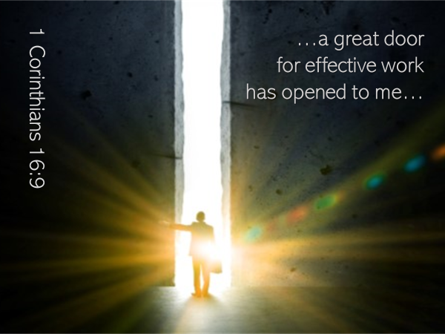
We know that sometimes God guides his followers by placing before them opportunities, which like a door, when walked through, lead to specific tasks he would have them do on his behalf, or to a person with whom he wants them to share the gospel.

But as we just read, in the particular instance described in Acts 16, God’s Spirit did not lead Paul and team by presenting them with circumstances that allowed them to proceed.
Instead of an open door, they encountered a series of doors, which were not just closed, but which the Holy Spirit had closed.
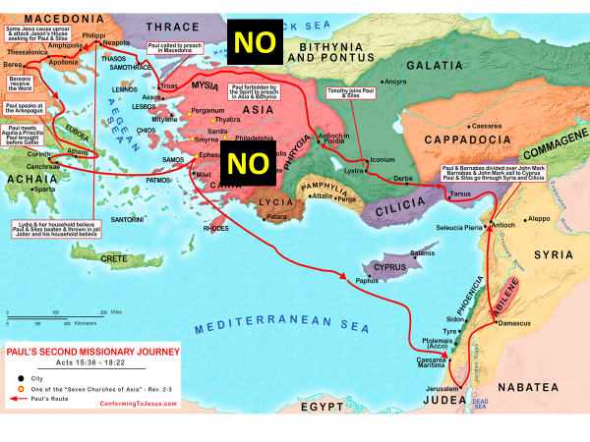

Why did God the Spirit do this?
Why didn’t he just tell them, right from the start… go to Troas?
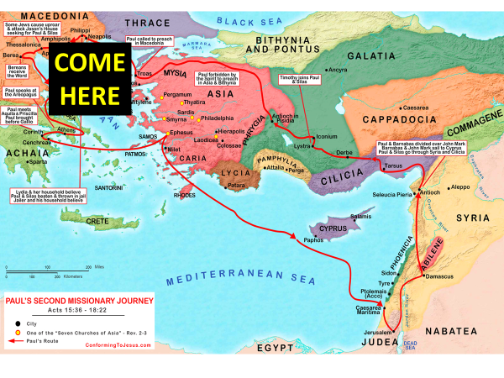
Wouldn’t that have been much simpler, easier, more efficient?
From our perspective – absolutely yes!!
But for God, our fellowship with him, is more important.

Which is why sometimes… in order to deepen our relationship with him, God will do with us as he did with Paul and team.

Sometimes the Lord will delay… sometimes he will seem to guide ever so slow; one baby step at a time… sometimes he will take us, not on the most direct route, but by all kinds of back roads.

What are we to do in those times?
To persist in following God because we trust him.

He will give direction to us; and it will never be late.

God spoke this command through the sons of Korah, 3000 years ago.
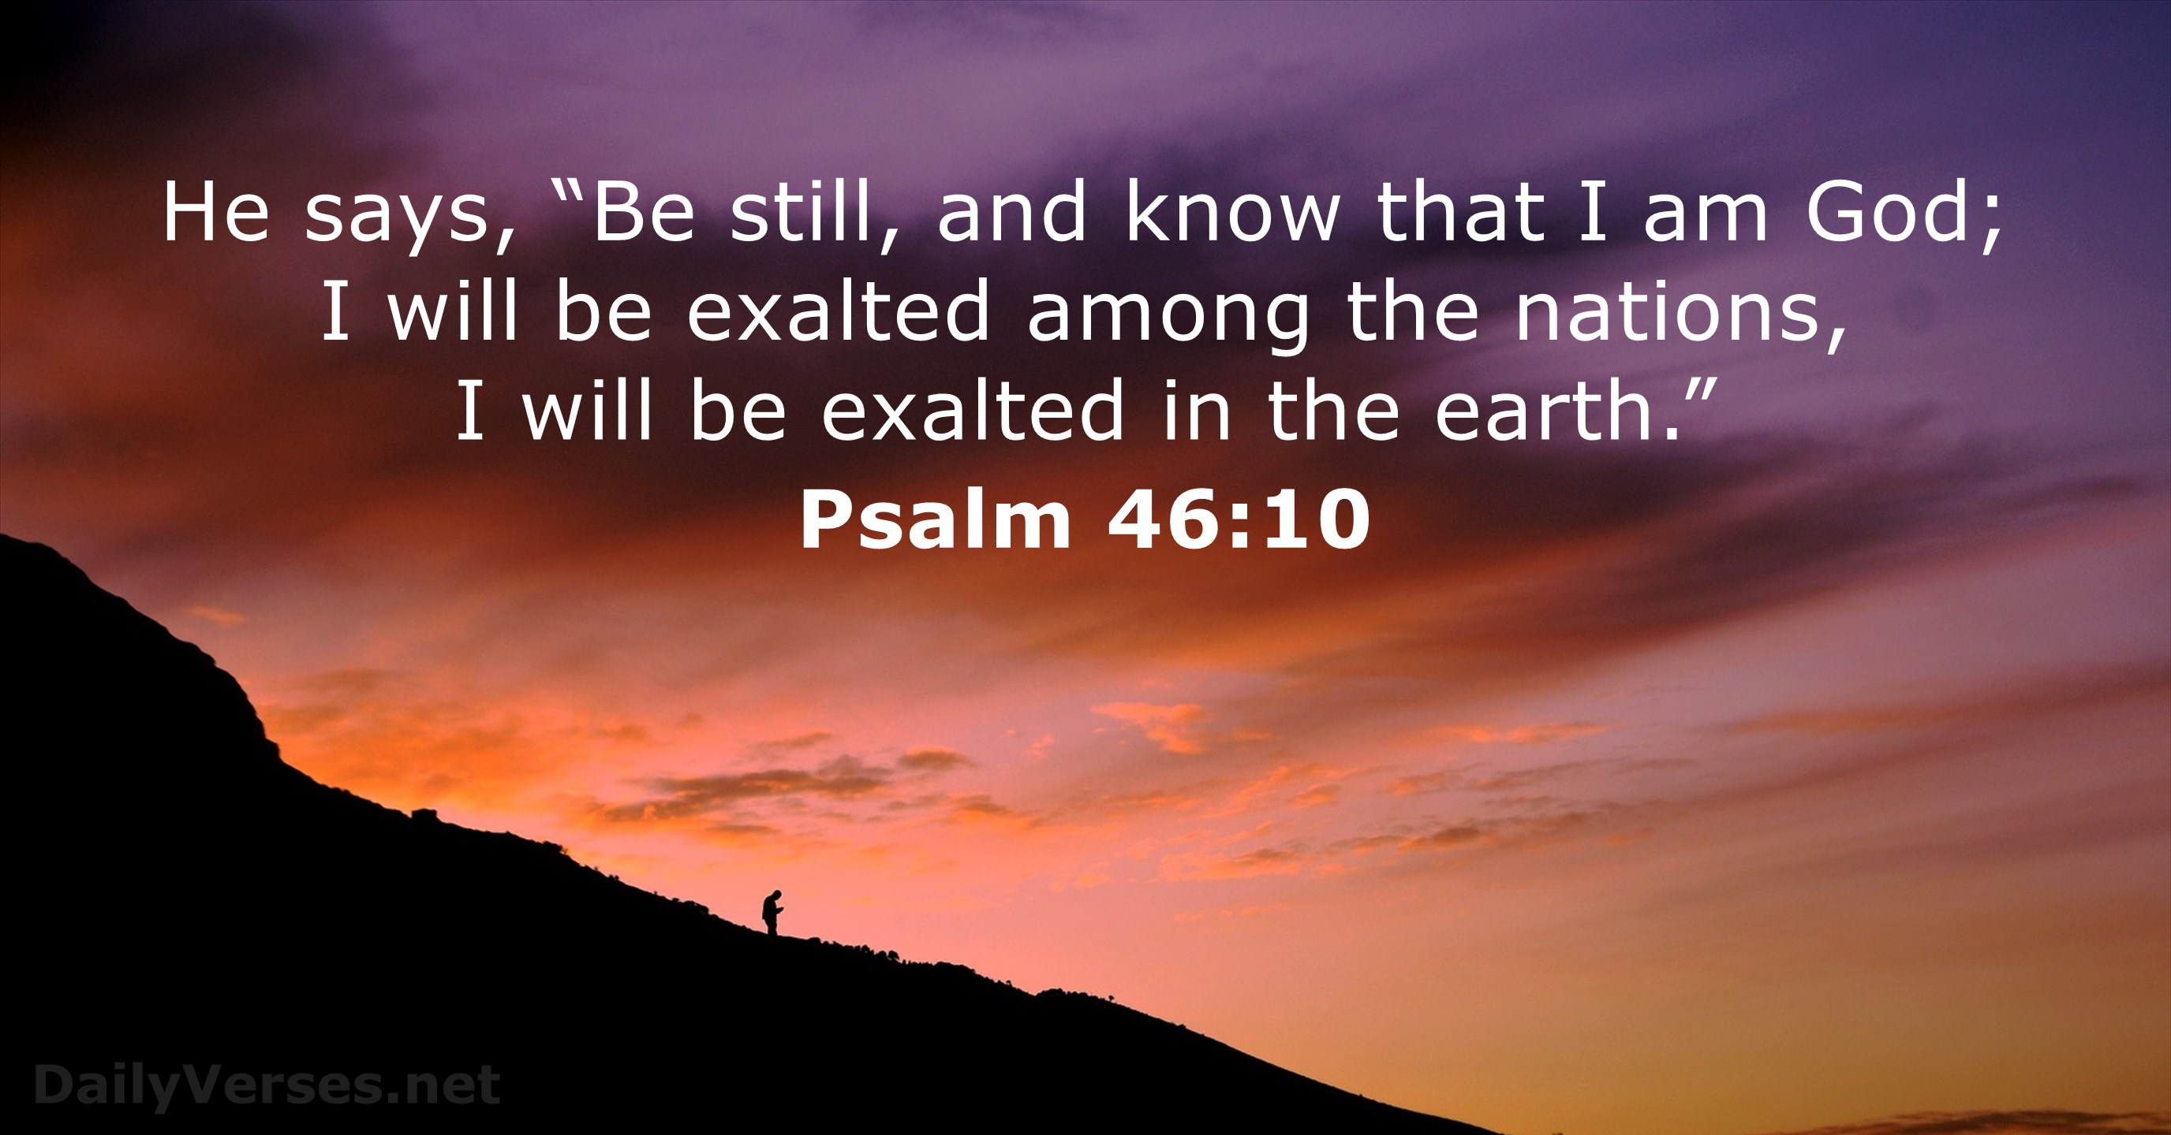
God giving us the address of our next destination is not what matters most to him.
Our fellowship with him… is his priority.

This is why, sometime, he takes us the long way… in order to give us time – time to slow down; time to read and mediate upon his word; time to listen to his voice; time to speak with him; …so that we might know, truly know, in the core of our being…that he is God.

Let me summarize.
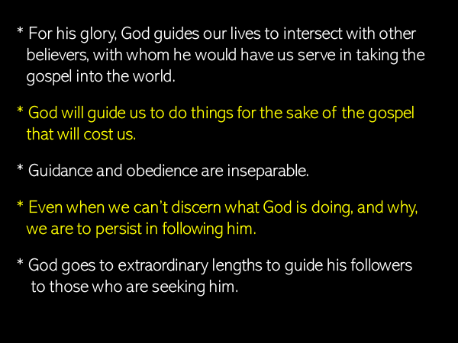

When we return to this passage after Easter, we will press into this last point… the extraordinary lengths God went to in order to proclaim the gospel to individuals he was seeking after: a businesswoman, a fortune-teller; a jailor.

Acts 16 impresses upon us the great worth of a human life.
Each person is created in the image of God.
And even though that image has been corrupted by sin, people so matter to God that Jesus gave his life in sacrifice to pay their debt of sin and to rescue them from the power of death and the devil.

This is what we remember when we celebrate the Lord’s Table.
The bread represents his body.
The juice his blood.

Jesus gave his life in order to make it possible for you and I to come home to God.

When we eat the bread… and drink the juice, we remember that as these elements are taken into our body, through faith in Jesus – Christ lives in us.

Maddi
1 Corinthians 11:23-24
Prayer of thanks for the bread

Rick
1 Corinthians 11:25
Prayer of thanks for the juice

Maddi
1 Corinthians 11:26

Rick – in addition to remembering; to expressing thanks, our eating and drinking is a declaration of faith – we believe Jesus will come again and when he does what he has begun in us will be completed, even as he makes all things new.

In Christ Alone

