The Culmination of the Ages April 26, 2020

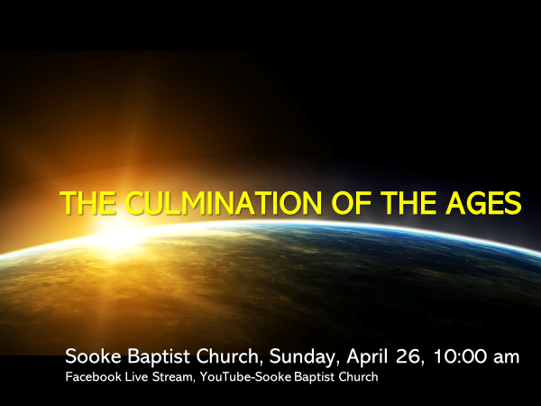

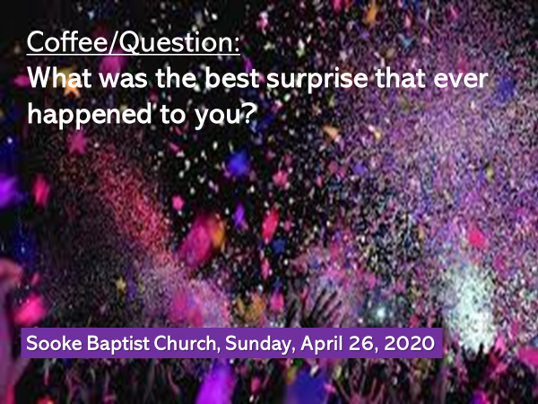

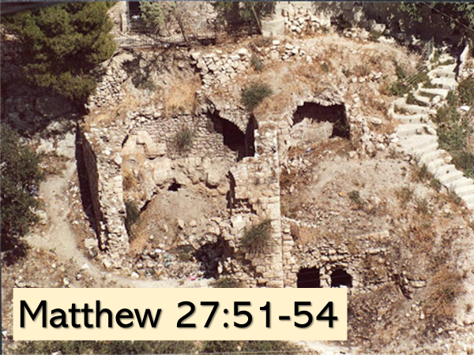
It is important to recognize that a number of sources were helpful to me as I prepared today’s teaching on this passage – particularly, John Piper; gotquestions.org; N.T. Wright

The other gospel writers are silent about the earthquake, the splitting of rocks and the resurrection of many holy people who appeared to many in Jerusalem after Jesus rose from the dead.

That said, Mark, Luke and John include other pertinent details that Matthew didn’t write about.
But when the four gospels are put together, they reveal a surprising reality, that no one expected to happen until the end of time.

The prophet Isaiah in 65:17 foretold what God said he would do.
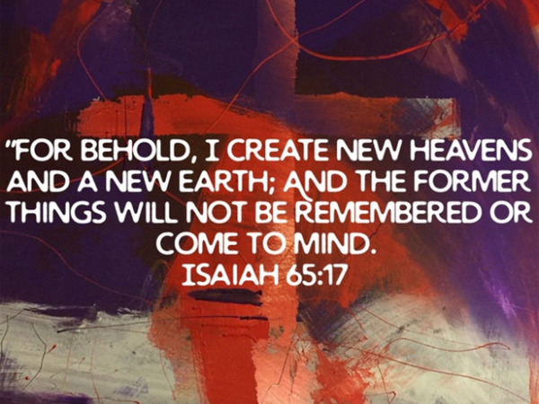
The understanding of all who lived in the time of Jesus was that this prophecy would be fulfilled at the end of time; at the end of this age.

Before he died, Jesus cried from the cross, “It is finished.”
With these three words, he announced that the most profound spiritual event of all history had just taken place - the reign of death was over.

Jesus had accomplished all that was needed for humanity’s salvation, and in doing so, he had also defeated Satan.

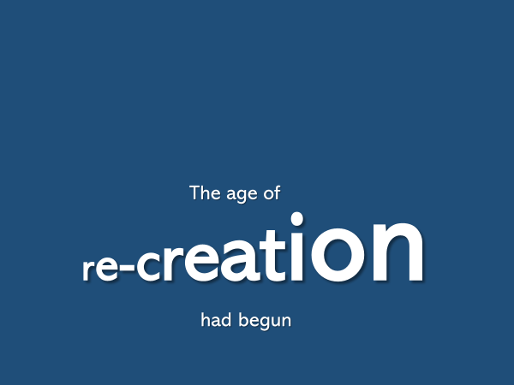
…and not at the end of time as everyone had supposed, but in the middle of it.
Let me explain.
We are meant to hear Jesus’ cry from the cross as an echo.
We are meant to draw connection between what Jesus said on the cross, which announced a new beginning, and what God himself had done after he created everything.

One the sixth day of creation, Genesis 2:1-2 says that God finished the work he had been doing.
As he looked at all he had made, God saw that it was very good.
And on the seventh day he rested.

What day of the week did Jesus cry from the cross, “It is finished?”
It was…the sixth day.
And on the seventh day?
What happened?
Jesus’ lifeless body rested in a borrowed tomb.

The work which the members of the Triune God had planned from eternity past,
the work which had been anticipated in the design of the OT tabernacle and its sacrifices, the work which Jesus had completed by the sacrifice of his innocent life…was the means by which all things would be made new.

This marvelous, wonderful, incomparable grace, freely offered to the fallen sons and daughters of Adam and Eve, was how God would re-create all who would put their faith in Jesus.
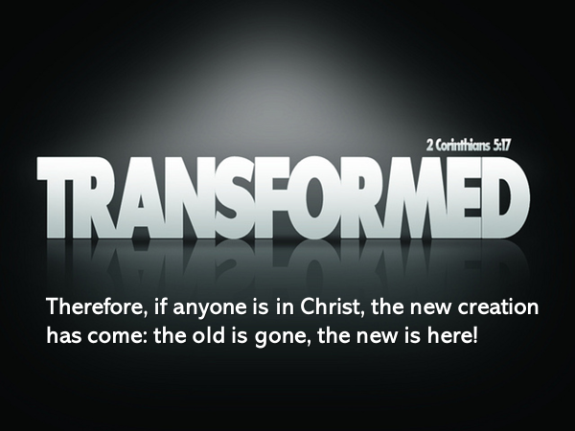
But the work and the victory of Jesus would also ultimately undo the curse of sin that has fallen upon the natural world.
For the promise of God, remember what the prophet Isaiah said…. is that he will recreate… the heavens and the earth.

Romans 8:19-21 speaks of this.
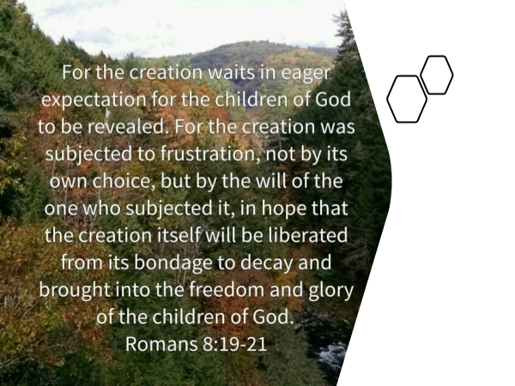
Because of Jesus, everything will be made new.

As John was moved by the Holy Spirit, in his gospel he gave a stunning glimpse to his readers of the unanticipated reality of re-creation.
This glimpse, provided by John, connects to Matthew’s earth shaking, rock splitting, tomb breaking scene of Good Friday.

In John 20, after Peter and John had investigated the women’s claim that the stone had been rolled away, Mary Magdalene remained in the garden.

First, two angels spoke with her from within the empty tomb, asking, “Woman, why are you crying?”
She answered them, “They have taken my Lord away, and I don’t know where they have put him.”

Then Mary turned and saw another person standing near her.
He too, asked of her, “Why are you crying? Who is it that you are looking for?”

Do you know who Mary thought the person talking to her was?
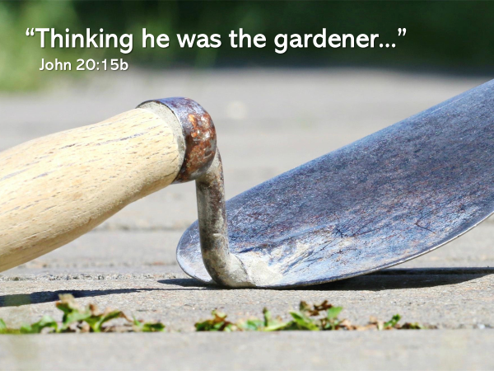
Her mistake… was used by God to subtly communicate, what Matthew also subtly communicated when he described the natural phenomena that happened when Jesus died.

I remind you that in the first creation, Genesis 2:8, God had planted… a garden, and then he created human beings to live in it.
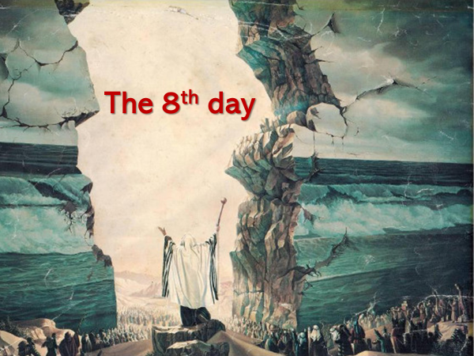
But on the day Jesus rose from the dead, the day which Tom Wright describes as the 8th day – new creation began.
It had not come in all its fullness – we still await that future day.

But it has begun.
This is what followers of Jesus celebrate every week when the church gathers.

We still live and work in a seven-day week.
But we worship Jesus on the first day of the week, in honor of his resurrection… and in recognition of what he began on the eighth day – the work of re-creation!

This background, I believe will help us to understand the details which God had Matthew include in his gospel.

Look again at the three-word phrase that is at the beginning of v.51 –
“At that moment…”
The events that happened in v.51-52… are tied to the death of Jesus.

By way of review: what did the tearing of the curtain in the temple confirm?
The door into the presence of God was now open because Jesus had paid humanity’s sin debt with his life blood.

All who believe in Jesus and who receive him into their life, experience in this present time, an intimacy and fellowship with God that OT believers couldn’t.

Look at how Jesus described it.
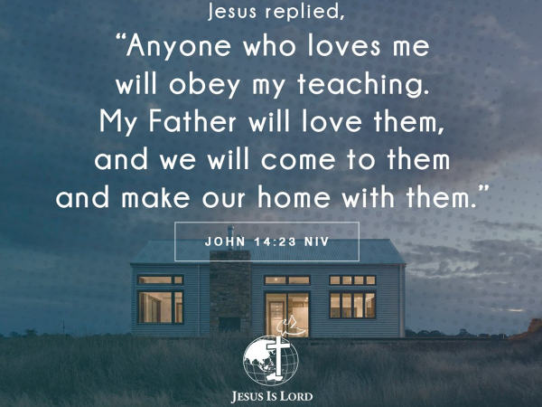
Jesus and the Father now make their home, not in a temple behind a curtain and above the atonement cover and between the two cherubim…
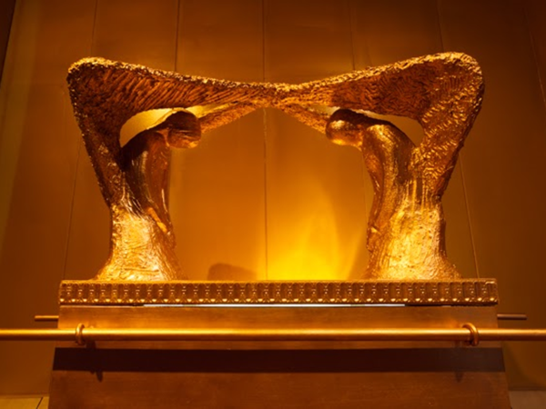
…they now live in those who love Jesus and who obey him.

This is a much-repeated theme of the NT.
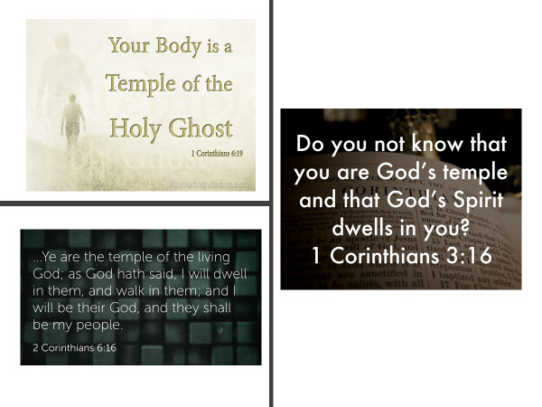
As incredible as this is, when Jesus physically returns to the earth, he will inaugurate a reality even more precious and sweeter.
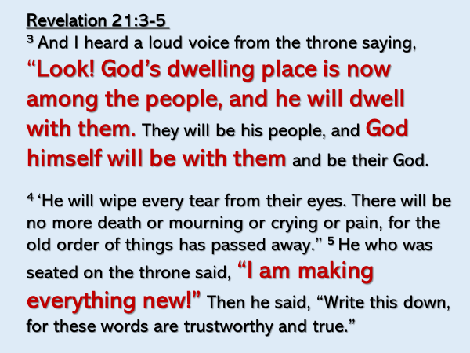
The ultimate end of new creation is to fully restore what the fall ruined.
- sin and death will be undone and forever banished
- the two races, the holy angelic creatures and redeemed humanity will live with God and one another
- the two realms, heaven and earth will again be united.

But you may be thinking, ok Rick, how does the earth shaking, the rocks splitting, and the tombs breaking open, give us a glimpse of new creation?

The writer of Hebrews explains:
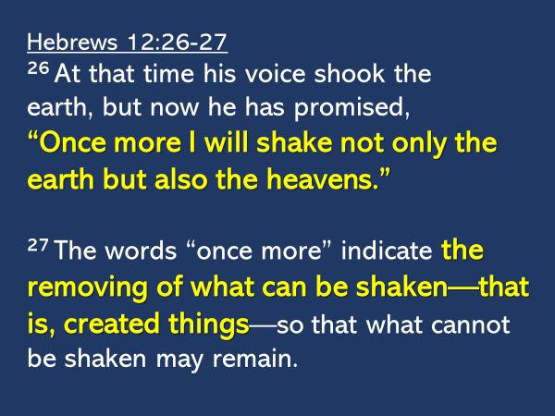
The earthquake and the splitting of the rocks were a signpost.
What happened locally in Jerusalem on that long-ago day, will happen globally at the return of Jesus.

What Jesus began… when he died…. will be gloriously finished.

At the end of this age, the heavens and the earth will be shaken by its Creator.
The writer of Hebrews says the point of the shaking is to remove what can be shaken – created things.

Two other passage helps us to understand what the writer of Hebrews means.
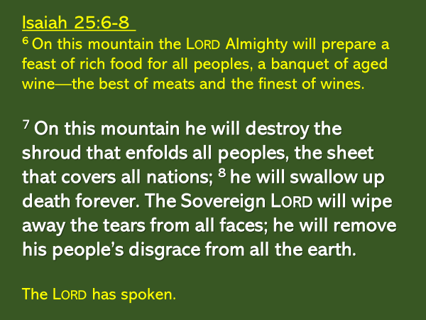
God will shake all things… for the purpose of removing; or in the words of Isaiah the prophet, in order to destroy death…forever.

And when the enemy of death is swallowed up, the disgrace of those who have trusted in God… will be removed… from all the earth.
For though we are saved through faith in Jesus, and will never face the second death, our physical death is the reminder there was a time when we were far from God because we had turned away from his goodness and love; a time when sin corrupted and controlled us.

The phrase, “the Lord has spoken,” is a firm assurance that what God has said will be done.

The other passage that helps us understand what will be shaken and removed… is found in 1 Corinthians 15:50-57:
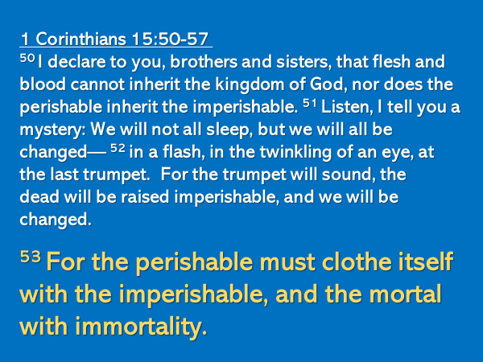
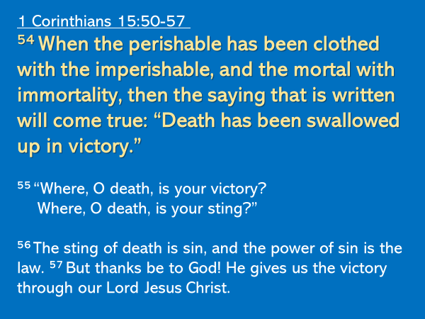
All that is created is presently perishable.

But at the return of Jesus, when God shakes the heavens and the earth, what is perishable, in the blink of an eye, will become imperishable; what is mortal, will become immortal.
In that moment, as Isaiah had prophesied, death will not only be fully defeated, it will be swallowed up in victory, it will no longer be an enemy; it will no longer have power; it will never again cause ruin and heartache and tears.

The shaking of the earth and the splitting of the rocks that happened when Jesus died, were a preview, a signpost of God’s end game; of what would ultimately happen because Jesus paid humanity’s sin debt in full.

What about the bodies of many holy people who had died, whose tombs broke open; who, after the resurrection of Jesus, went into Jerusalem, and appeared to many people? How are we to understand this?
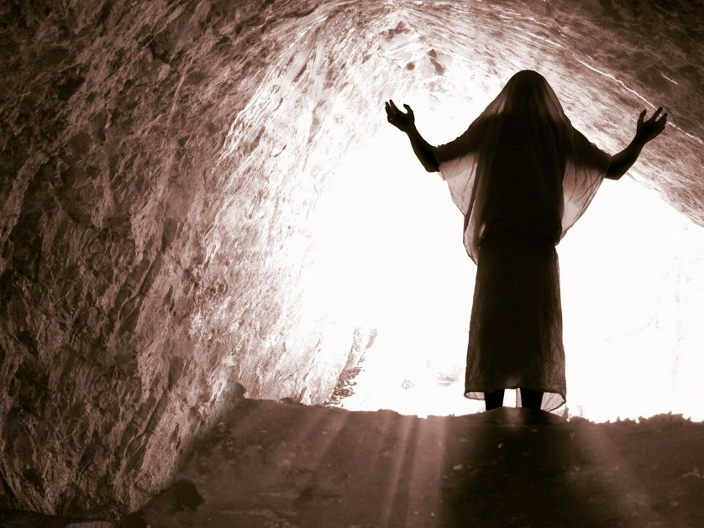
In my thinking, there are only two possible explanations.
It either happened, or, it didn’t happen.

I believe it happened as Matthew wrote.
I believe, these people who loved God and who had lived by faith in the promised Messiah, were raised from the dead.

They were a signpost; a glimpse of what would happen at the end of this age.
God in his goodness, permitted them be raised from the dead on the day Jesus rose in order that there might be this written testimony by Matthew that confirms…yes, what happened to Jesus, will happen to all who put their faith in Jesus.
Many OT Scriptures speak of the resurrection from the dead.
I’m going to reference only one that is connected to this passage in Matthew.
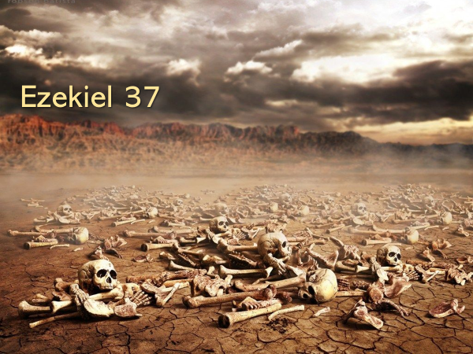
God asked Ezekiel in v.3 – “can these bones live?”
Ezekiel answered God and said, “Sovereign LORD, you alone know.”
In the vision given to Ezekiel by God he saw these dry bones come back to life.

Afterward, God explained the vision – v.11-14a.
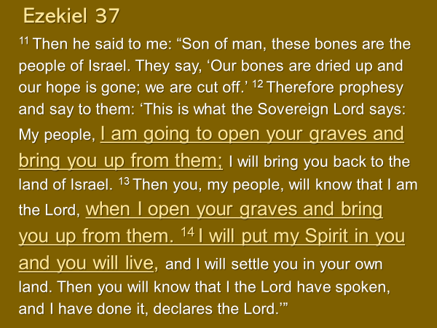
This vision had a double fulfillment.
The first applied to the nation of Israel – after the exile, they again lived as a nation.
And the second applied to the Israel of God (see Galatians 6:16) that includes all who belong to Jesus – on the day Jesus returns, on the day this age ends, our bodies will be raised from the dead to be like the glorious body of Jesus.

What is perishable will become imperishable.
What is mortal will become immortal.

I’m sure there are many other questions that arise from what Matthew described.
What happened to these people who were raised from the dead?
How long did they stay in Jerusalem?
We are not told.

But these events which point us ahead to the return of Jesus…are intended
to encourage and to animate our faith.
This was the goal of the writer of Hebrews.
After speaking of the shaking of heaven and earth, he said:
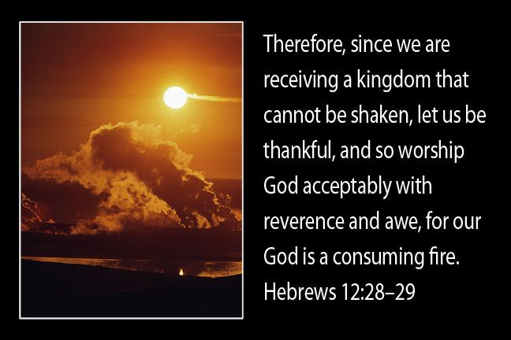

The writer described this unshakeable kingdom in the preceding verses.
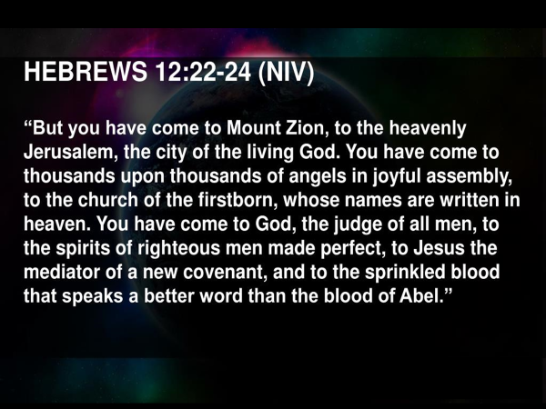
Our hope of this kingdom that cannot be shaken shapes how we live in the here and now.
It produces in us gratitude.
Our salvation in Jesus is not earned.
It is freely given to us.
Our expressions of gratitude are the overflow of being loved by God.
This is why we who follow Jesus are a thankful people.

We have experienced God’s grace and his kindness.
God is the constant of our life, not our circumstances.
We find our joy in living in him.

The second response is influenced by the first.
Our gratitude fuels our worship.
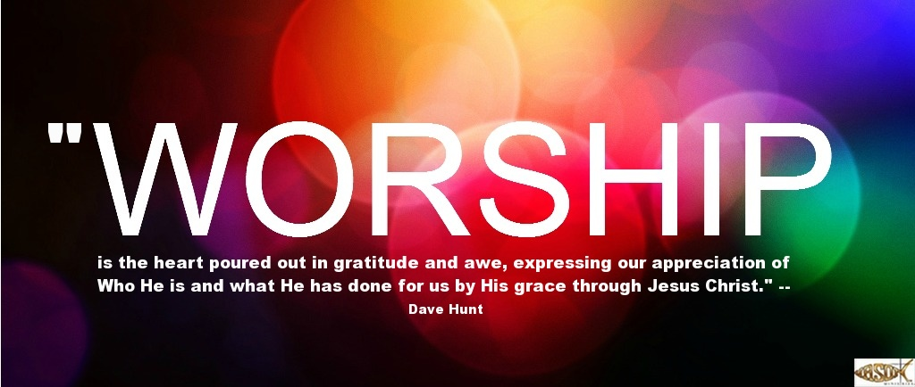
Worship is our response to the majesty, the beauty, the weight of God’s person, and what he did for us in Jesus Christ.
This is why the writer urges us to worship God with reverence and with awe.
Don Carson writes:
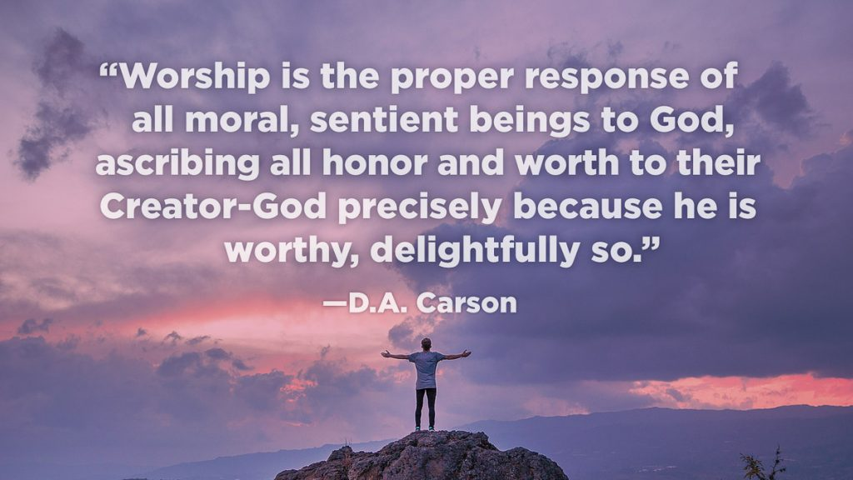
In light of new creation, in light of what God has done for us in Jesus Christ, in light of who God is – a consuming fire… reverence and awe are the most appropriate heart responses of which God is deserving, along with the ascribing of honor and worth to him.
I close with this quote by Francis Chan:
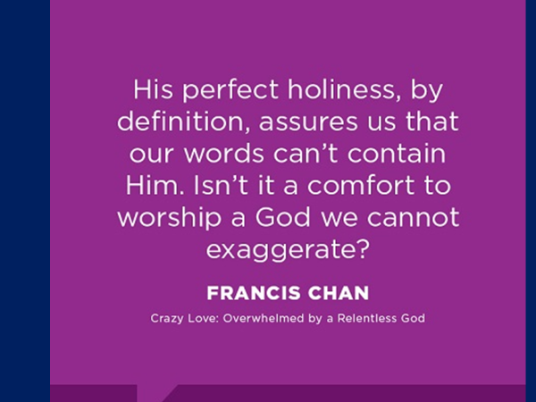
The God of resurrection; the God of new creation… is worthy of our worship.

We can never in our praise, in our devotion, in our prayers, in our manner of living ever exaggerate his greatness!!!
Great is the Lord and greatly to be praised.

The Blessing
Ephesians 3:20-21

