**The Curtain was Torn** April 19, 2020

Matthew 27:50-53

This morning, I want to further explore with you, the theme of exodus…. which is a major theme in both the Old and the New Testaments.

As we saw last week…Jesus, by his death and resurrection, leads his followers, those who believe in him… on an exodus, not from slavery to a political power, but from the tyranny and reign of death.

The OT sign post we want to consider today, when it was first provided by God:

* testified to the complete otherness of Yahweh
* it confirmed…just how sinful… sin is.
* and most remarkably… it pointed ahead to what Jesus would lead his followers into.



I’ve said this before – but it bears repeating: the Bible, which is comprised of the Old and New Testaments, sixty-six books, written in three languages, on three continents by forty different human authors over a time period of approximately sixteen hundred years… is the enduring, verbal word of God, given to us, that we might know who God is, who we are and what God has done to save us through Jesus Christ.

We encounter the wisdom of God in the Bible…and as we do, it leaves us breathless and brings us to our knees in awe.

Let’s begin to unpack what was accomplished when Jesus said, “It is finished,” and then bowed his head and committed his spirit into his Father’s hands.

Today’s Bible passage is a compilation from the four gospels.

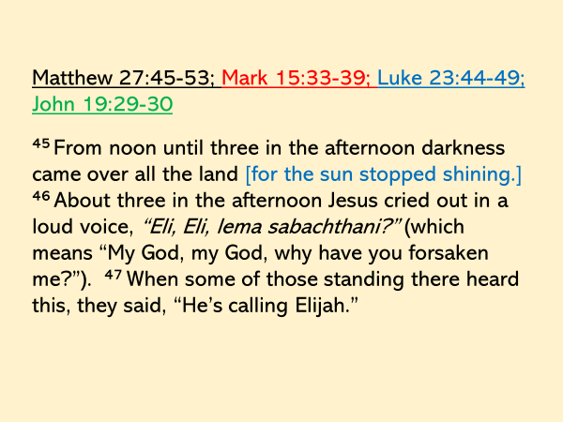

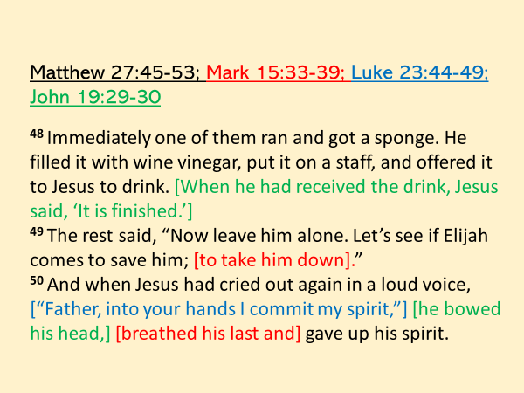

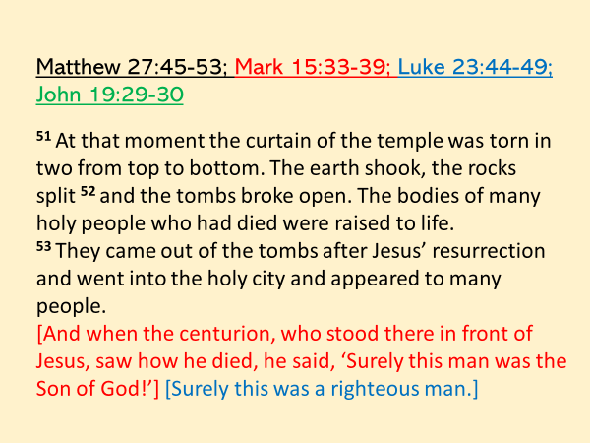

_________________________________________________________

When Jesus said, “It is finished,” and then “Father, into your hands I commit my spirit,” at the very moment he died, the curtain in the temple was torn in two from top to bottom.

As we’ve just read there were other dramatic supernatural things that happened.

But our focus this morning is on the curtain that was torn.

There are some questions we need to ask and answer.

* What was this curtain?
* And more importantly - what purpose did it serve?

To answer these questions, we need to go back to the book of Exodus.

After Moses led the nation of Israel out of Egypt and through the Red Sea, three months later… (to the very day) they came to Mt. Sinai where they camped in front of the mountain for approximately 9-10 months.

God had rescued them from their bondage in Egypt in order to bring them into relationship with himself.

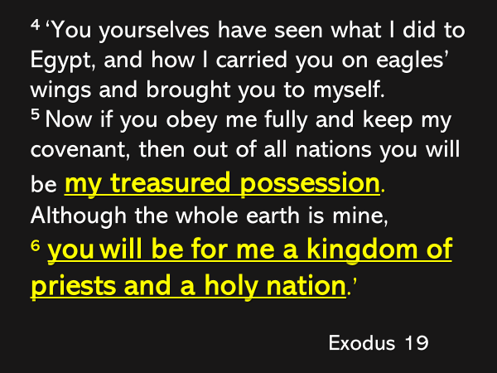

God had chosen Israel to be his treasured possession.

And he had entrusted them with a great responsibility – they were to be a kingdom of priests!

What was the response of the people to what God had done for them and what he proposed and what he asked of them?

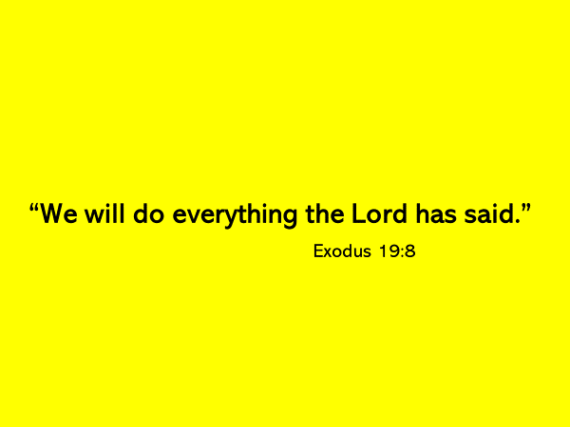

**We see here, but also throughout the scripture, God always is the initiator.**

**Before they chose God, he chose them.**

**This is how it is…always.**

In response to their response God told Moses …

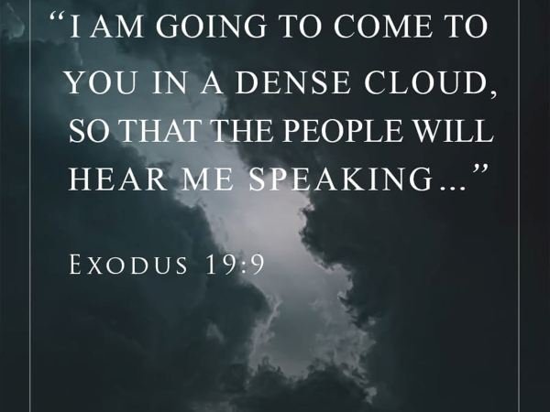

Why did God do this?

Why as he came near, did he hide himself in a dense cloud?

The answer is actually simple: in order to protect them from his brilliant glory.

But why?

The answer is found further on in the book of Exodus.

In chapter 33, Moses asked God:

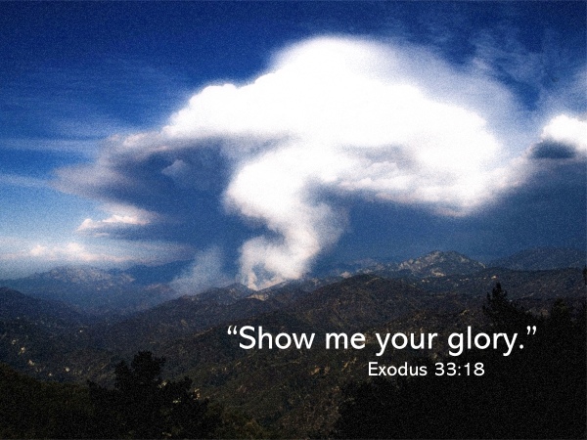

God answered Moses and said:

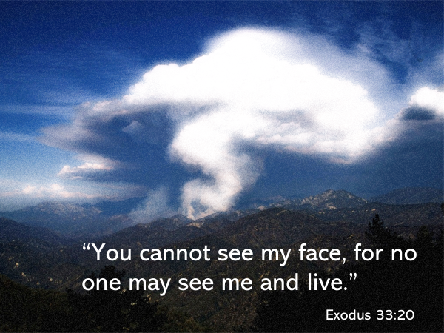

Do you know why that is?

1 Timothy 6:16 explains: because God lives in… “unapproachable light.”

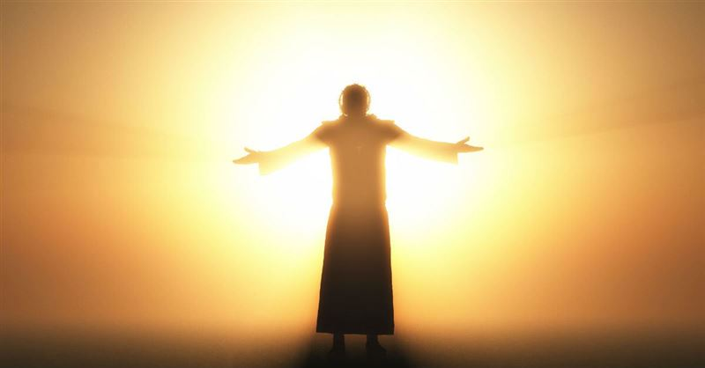

Have you ever tried to stare at the sun?

What happens?

Your eyes water and sting so quickly that you have to close them.

You cannot look directly at the sun.

The unapproachable light that emanates from God comes from his moral purity.

**God’s provision of the dense cloud at Mt. Sinai was an act of mercy.**

**The relationship God entered into with Israel was an act of mercy – he had come to live among them.**

**This alone…. was astounding, especially when you understand what happened in the beginning.**

Before Adam and Eve ate the fruit… from the one tree… God had forbidden, Yahweh had daily walked and fellowshipped with them.

In those early days, the two realms, heaven and earth, were united.

But when our first parents sinned, even as he pronounced judgement on them, God mercifully drove them out of the garden – in order that they might be saved.

This consequence was bitter - God no longer walked with them; they had lost his fellowship.

But God promised Eve… that an offspring of hers would come and he would rescue; he bring them home to God.

As God entered into a relationship with the nation of Israel at Mt. Sinai… he did so in order to live among them.

The instructions God gave to the nation of Israel, through Moses, were instructions of mercy - of how they would live… as a Holy God’s… treasured possession.

A moveable tabernacle was to be built and a priesthood established that would offer sacrifices of atonement to God for the people.

We will come back to this.

But first you need to know that these plans for the tabernacle were not thought up in the mind of Moses but were shown to him.

See Exodus 26:30.

Hebrews 8:5 tells us that these plans were a copy and shadow of what is in heaven.

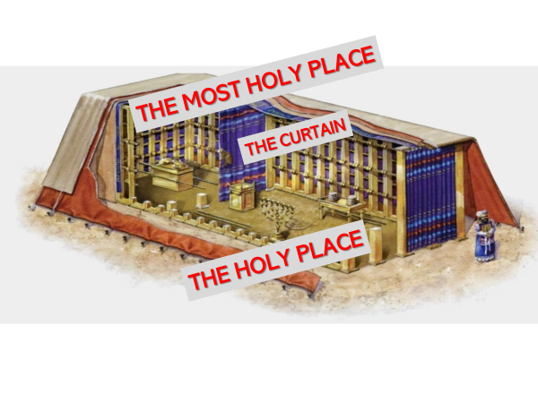

The tabernacle had two parts to it, the most holy place and the holy place, which were separated from each other by a curtain.

There isn’t time to speak of the items that were placed in the holy place.

We are only going to focus on what was in the most holy place and the curtain that divided it from the holy place.

In “The Most Holy Place,” there was only one thing: an ark, which contained the two tablets of the covenant, written by God’s own finger.

The ark had a lid, which was known as the atonement cover.

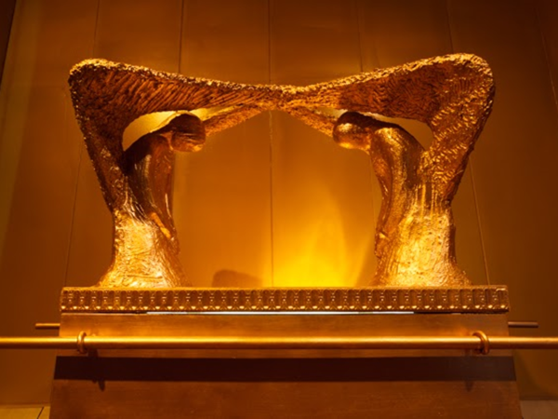

On this cover were two cherubim, facing each other, with their wings spread upward, and their eyes looking downward.

God explained to Moses the significance of the space between the two cherubim.

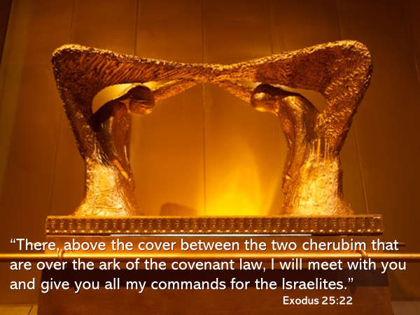

The presence of God was manifested above the atonement cover.

This was where heaven and earth intersected.

This was the place where God said he would live among the Israelites.

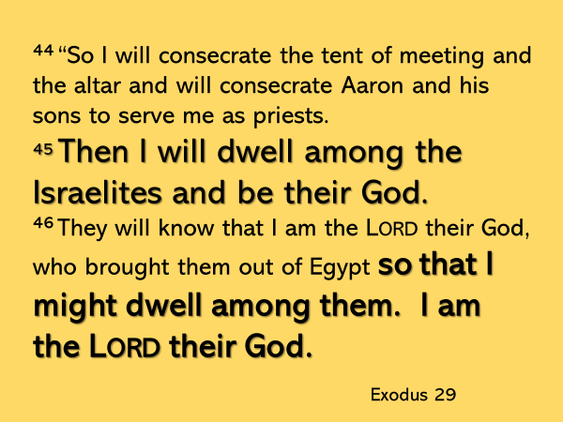

But we’re back to this question of how.

How could Israel be the Lord’s treasured possession?

How could a Holy God live among a sinful people?

Only if sacrifice were to be made to atone for their sin.



In the very place where God’s presence was manifested…. in the most holy place, the high priest would come… once a year…. to sprinkle the blood of a goat… in front of and on the ark’s cover in order to atone for the sins of the Israelites.

Without the shedding of blood there could be no forgiveness of sin.

But this blood of a substitute only temporarily covered their sin.

The sacrifice had to be repeated…yearly.

Yes, God lived among them.

But it was not like it had been in the garden.

God lived among them, but the curtain enforced a separation.

No one could just walk into the presence of God.

When the nation of Israel was settled in the land of Canaan, the tabernacle was replaced by a temple which was built by Solomon.

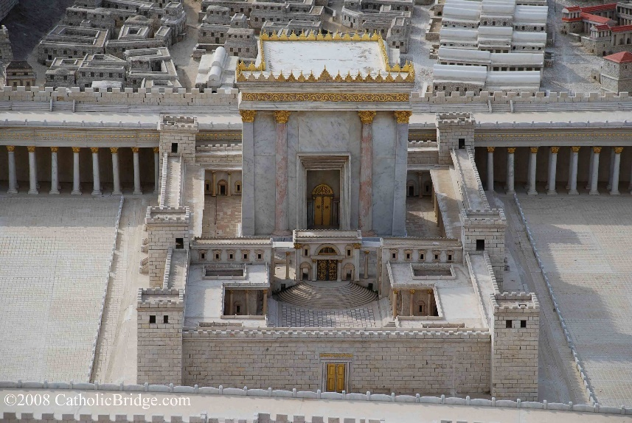

As it was in the tabernacle, so it was in the temple – there hung a curtain that separated the most holy place from the holy place.

As it was in the tabernacle, so it was in the temple - no one was permitted to go into the most holy place, where God’s presence was manifested, except the high priest, who went once a year, for the purpose of sprinkling blood to atone for the sin of the nation.

The curtain while it mercifully restricted access to God, was also a most painful reminder of the tragic cost of sin.

Remember what God told Moses – no one can see my face and live.

The fact that the curtain was torn at the very moment Jesus died, was the announcement of a great spiritual seismic shift.

What had been done?

Had someone gathered the blood that dripped off of the body of Jesus and somehow carried it into the Most Holy Place and there sprinkled it on the atonement cover of the ark?

The scripture explains.

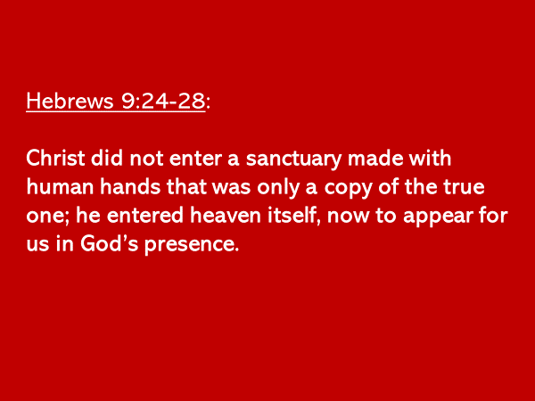

The blood of Jesus Christ was sprinkled in God’s presence.

But not in the temple at Jerusalem.

Jesus’ blood was presented where?

In heaven itself.

When he breathed his last breath, Jesus walked through the curtain that had separated us from coming near to God, and there he presented his blood as an atonement for our sin.

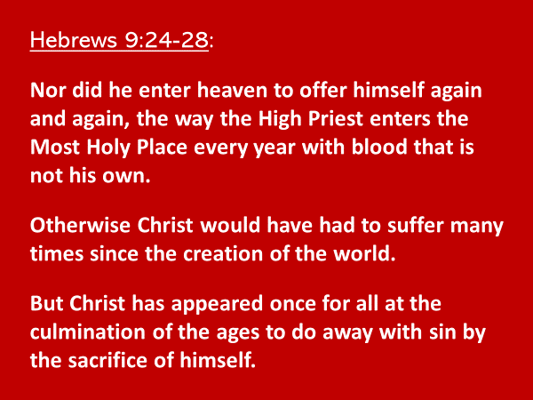

The sacrifice of Jesus was enough.

It did not need to be repeated. Jesus’ blood did away with sin, once and for all.

There is a phrase here that confirms and explains just how profound the sacrifice of Jesus was …

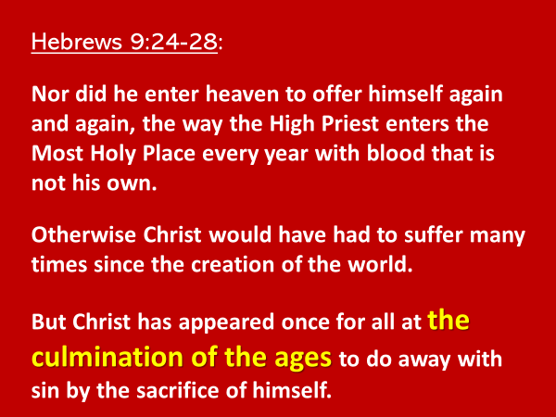

Culmination means the climatic point.

According to this verse what was the climatic point of the ages?

It was the coming of Jesus to the earth to do away with sin by the sacrifice of himself.

How can we know this is true?

Because Jesus rose from the dead – and now lives in heaven in a glorified physical body that cannot die, age or become sick.

But there is another proof - the tearing of the curtain in the temple.

Think about it - who tore the curtain?

The temple curtain was 60 feet long and 30 feet wide and it is thought to have been an inch thick.

**Show the book.**

If humans were the agents of the tearing, the curtain would have been torn from the bottom to the top.

The fact that it was torn from the top to the bottom leaves us but one option.

God himself tore the curtain.

And he did so, to dramatically communicate that in the sacrifice of Jesus, there is provision for all who put their faith in Jesus to come home to him.

Think of it.

The same God who had driven humanity out of the garden, and away from his presence, did everything in Jesus Christ to bring us back to himself.

Jesus’ sacrifice didn’t just cover sin as the blood of animals had temporarily done so in the time of the Old Testament.

The sacrifice of his life took away our sin.

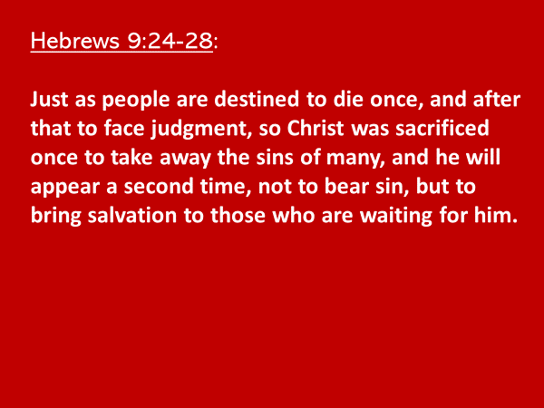

We know that the death and sacrifice of Jesus is appropriated when a person puts their faith and trust in him.

But do you realize what else is freely given because the curtain has been torn in two?

I encourage you, in this next week, to come back to the two passages I’m going to show you.

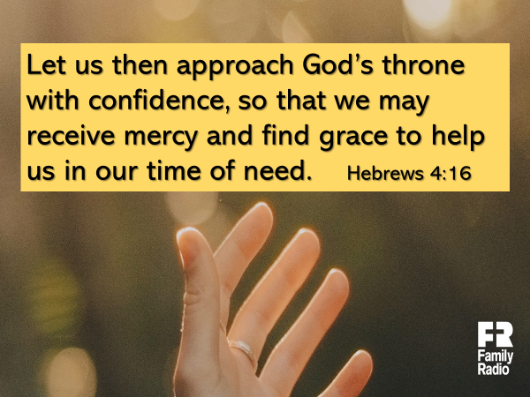

Because the curtain has been torn in two, you can approach God.

You don’t need a high priest to go to God on your behalf.

Because of Jesus the way is wide open.

You can come to God…not with fear, but with confidence, because…your sin has been removed by Jesus.

God is your Father.

He provided in Jesus everything for your salvation.

Having done this, you are assured that whatever mercy and grace you need for today, he will give it to you.

Is that not incredible?

Because the curtain has been torn, because Jesus has ascended into heaven, because he will give us grace and mercy in our time of need, look at what Hebrews 4:14 says:

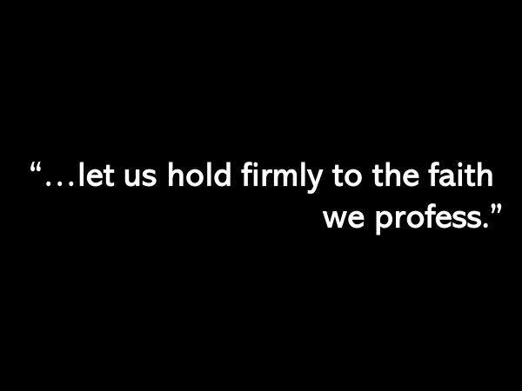

Our confidence is not in the strength of the faith we profess, but in the strength of the One who is our Savior.

We hold firmly to him because he holds us firmly.

The other passage in the book of Hebrews that draws application from the curtain that was torn in two…. is found in 10:19-25.

I know that many times when I’ve read this passage, I’ve focused on verses 22-25, and missed the preceding verses that set up the encouragement and the challenge given in verses 22-25.

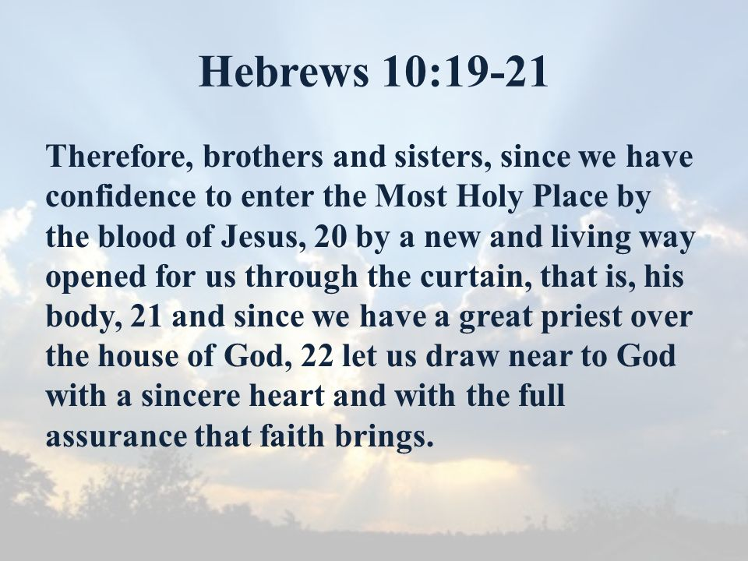

Similar to chapter 4, these verses also encourage the follower of Jesus to draw near to God.

And by draw near, the writer is explicitly clear what he means.

We have confidence to enter…where?

The Most Holy Place – where God is.

Because of Jesus’ sacrifice that atoned for our sin, we can now experience the kind of fellowship with God that Adam and Eve enjoyed.

That is what the writer has in mind when he urges us…. to draw near to God.

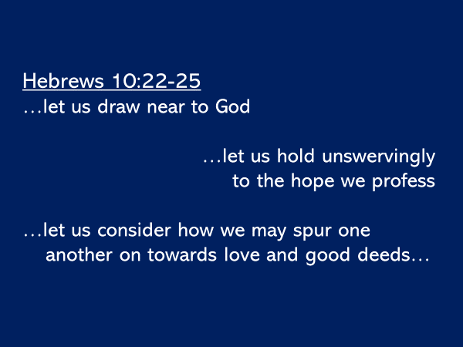

Even in the challenges that his life brings, the discouragements that can happen, the uncertainties of what will come, the writer again, as he did in chapter 4, urges the reader… to hold unswervingly to the hope they profess.

Unswervingly means to not turn aside, to not give up on.

We have a glorious Savior and a glorious future.

The best is yet to come.

Hold on!

And lastly, because the curtain has been torn in two, we are to look for the ways to remind each other of what a great salvation we have; and to spur each other on in living our lives for the glory of Jesus.

The Declaration